**Market Efficiency Notes.**

Efficiency: The production of goods or services at the lowest possible cost.

Equity: The redistribution of income throughout the economy, which allows everyone to have a minimum standard of living.

* Vertical equity means that those who earn a higher income should pay a higher tax rate. This is shown by the Australian tax table. The more you earn, the more you should pay (progressive tax system.)
* Horizontal equity means that everyone should be treated equally and have equal opportunities.

Demand curve: Actually a willingness to pay curve. The demand curve shows the marginal benefits the consumer gets from a good, so it’s technically a marginal benefit curve.

Consumer surplus: the difference between what consumers have to pay and what they’re willing to pay. The more that a consumer purchases, the higher the total surplus is.

Producer surplus: The difference between what a producers is willing to receive (minimum supply price or cost of production), and what they actually receive.

Total revenue: Measured by PxQ, it’s the total amount of revenue made from selling goods and services.

Market efficiency: Attained when the allocation of resources maximizes total surplus.

Economic wellbeing: Measures the sum of consumer surplus and producer surplus. It’s aka total surplus.

Deadweight loss: occurs when the market produces a different output to the equilibrium output. Total surplus is maximized at the equilibrium, and producing less than or more than the equilibrium output results in a decrease in economic welfare. It’s determined by how large a tax is, or the elasticity, etc.

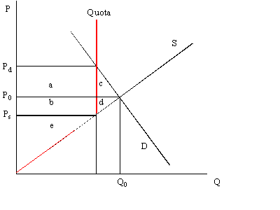

Restrictions on production of goods and services: A competitive taxi market operates where demand equals supply – at the equilibrium Pe and Qe, total surplus is maximized. Taxi regulation of licenses results in a fixed supply of taxis. This results in shortages and higher prices. The regulated quantity is reduced to Qr and as a result average taxi fares rise to Pr. By restricting the quantity of taxi licenses total surplus is decreased – there is a deadweight loss.

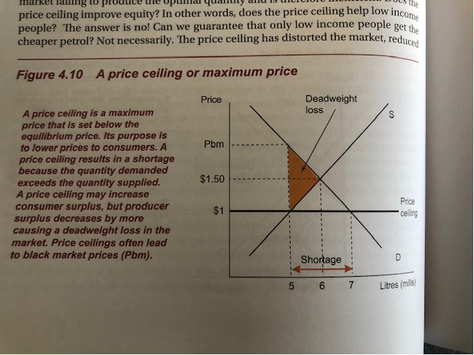

Price ceiling: A maximum legislated price which is set below equilibrium price. Its purpose is to lower prices to consumers. A price ceiling results in a shortage because the quantity demanded is higher than that supplied. It can increase consumer surplus, but producer surplus decreases by more causing a deadweight loss in the market. Price ceilings often lead to black market prices.

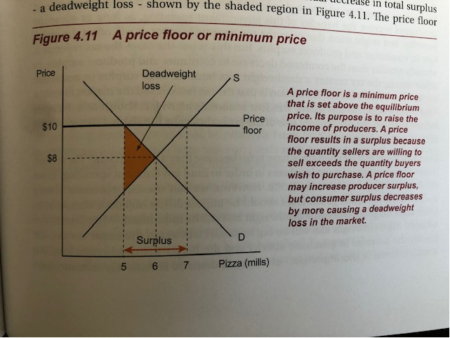

Price floor: A minimum legislated price that is set above the equilibrium price. The purpose of it is to raise the income of producers. A price floor results in a surplus because the quantity sellers are willing to sell exceeds the quantity buyers wish to purchase. A price floor may increase producer surplus, but consumer surplus decreases by more causing a deadweight loss in the market.

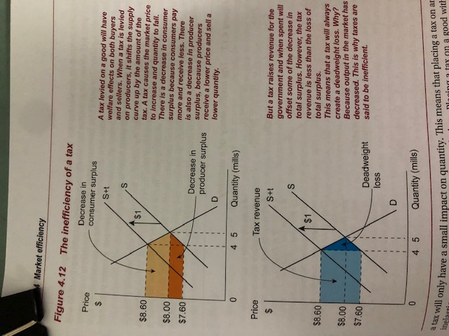

Tax levied on a good: A tax levied on a good will have welfare effects on both buyers and sellers. When a tax is levied on producers, it shifts supply curve up by the amount of the tax. A tax causes the market price to increase and the quantity to fall. There’s a decrease in consumer surplus because consumers pay more and receive less, and there is a decrease in producer surplus because producers receive a lower price and sell a lower quantity. But a tax raises revenue for the government and when spent will offset some of the decrease in total surplus. However, the tax revenue is less than the loss of total surplus. Therefore, a tax will always create a deadweight loss because the output has decreased. That’s why taxes are inefficient.

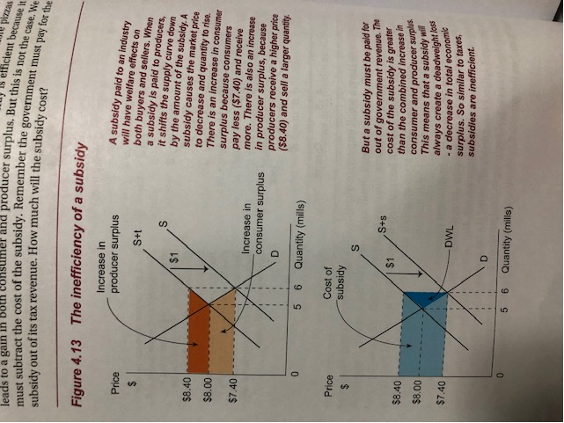

Subsidy: The supply curve shifts down by the amount of the subsidy. A subsidy causes market price to decrease and quantity to rise. There is an increase in consumer surplus because consumers pay less. However since subsidies are payed for by government revenue. The cost of the subsidy is less than the combined increase in consumer and producer surplus, and therefore there is a deadweight loss, meaning they are inefficient.