|  |  |
| --- | --- |
| Year 12 Economics ATARUnit 4Tax tops crucial reform list | |
| Description of task | Students will read an article titled “*Tax Tops Crucial Reform List*” that describes how West Australian businesses could benefit from a reform of Australia’s Taxation system. Students then answer a series of questions related to the article. |
| Assessment Conditions | Students will have 50 minutes to answer all questions.  30 marks in total. |
| Content from the Year 11 Economics ATAR curriculum | **Taxation**types of Commonwealth taxes, including personal and income tax, goods and services tax, company tax, capital gains tax, fringe benefits tax and excise duty  * the concepts of equity, efficiency and simplicity in the context of Australia’s taxation system |
| Content from the Year 12 Economics ATAR curriculum | **Measures to improve productivity**  1. recent (the last ten years) government policies that promote productivity and economic growth, such as labour market reform, taxation reform, trade liberalisation, deregulation and competition policy, investment in infrastructure, education and training, research and innovation 2. the impact of productivity on the achievement of macroeconomic objectives |
| Economic Skills | * Economic Reasoning and Interpretation * Communication |
| Task preparation | |
| Prior learning | Students are familiar with the following economic knowledge and understandings:types of Commonwealth taxes, including personal and income tax, goods and services tax, company tax, capital gains tax, fringe benefits tax and excise duty  1. the concepts of equity, efficiency and simplicity in the context of Australia’s taxation system 2. the concept of productivity 3. the distinction between labour productivity and multifactor productivity 4. the relationship between productivity and economic growth 5. the impact of productivity on the achievement of macroeconomic objectives |
| Assessment task | |
| Resources | **“Tax tops crucial reform list”** from The West Australian, April 30th 2020. Retrieved April 2020, from <https://edition.thewest.com.au/html5/Default.aspx> |

**Question 1**

This question refers to the article below, by Aaron Morey, Chief Economist of the Chamber of Commerce and Industry WA that appeared in The West Australian in Thursday 30th April 2020.

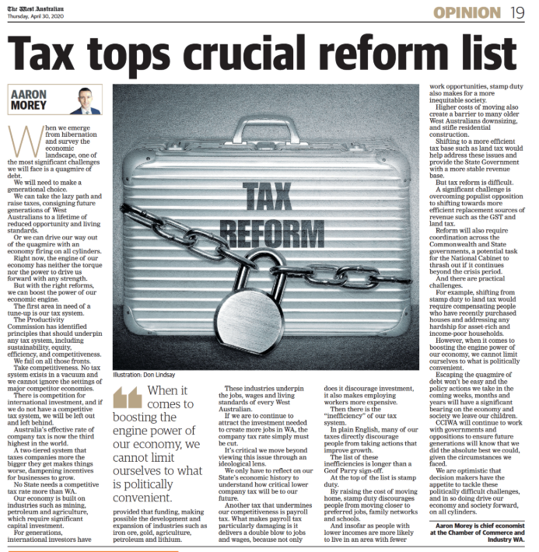

1. Identify the four principles that should underpin any tax system, according to the Productivity Commission. (from Year 11 syllabus) (1 mark)
2. According to the source, describe how the Australian Tax System ‘stacks up’ against those sets of principles? (4 marks)
3. Identify two challenges exist for Government when attempting tax reform? (2 marks)
4. Using a suitable economic model, demonstrate the impact of tax reform on Australia’s macroeconomy. (4 marks)
5. What advice is provided in the article to improve the competitiveness of Australia’s Taxation system and how might this proposed change in our tax system impact on:
   1. local businesses
   2. foreign investment flows and
   3. macroeconomic activity in Western Australia

(7 marks)

**Question 2**

Other than reform of the tax system, discuss three policies or action demonstrating how the government can promote productivity growth. Use the AD/AS model to show the impact of productivity growth on the achievement of the government’s macroeconomic objectives. (12 marks)

|  |  |
| --- | --- |
| **Sample marking key** | |
| **Question 1** | |
| **Description** | Marks |
| a) Identify the four principles that should underpin any tax system, according to the Productivity Commission. | |
| Identification of all FOUR principles | 1 |
| Total | **1** |
| Answers should include:EquityEfficiencySustainabilityCompetitiveness | |
| **Description** | Marks |
| b) According to the source, describe how the Australian Tax System ‘stacks up’ against those sets of principles? | |
| Describes two or more reasons as to why the Australian Tax system fails against both the competitiveness and efficiency measures | 4 |
| Describes two or more reasons as to why the Australian Tax system fails against either the competitiveness and efficiency measures | 3 |
| Describes one reason as to why the Australian Tax system fails against both the competitiveness and efficiency measures | 2 |
| Describes one reason as to why the Australian Tax system fails against either the competitiveness and efficiency measures | 1 |
| **Total** | **4** |
| Answers could include:  * Lack of competitiveness due to a very high effective rate of company tax (3rd highest in the world) * Impact is high in WA due to our reliance on industries such as mining, petroleum and agriculture * Higher company tax deters investment in capital intensive industries – this includes foreign sources of investment * Payroll Tax – delivers a double blow to jobs and wages as it both discourages investment and makes employing workers more expensive – lower levels of employment * Inefficient – stamp duty increases costs of moving and discourages people from moving closer to preferred jobs, family networks and schools | |
| **Description** | **Marks** |
| c) Identify two challenges exist for Government when attempting tax reform? | |
| Identifies two challenges that exist for government when proposing a policy change | 2 |
| Identifies one challenge that exists for government when proposing a policy change | 1 |
| **Total** | **2** |
| Answers could include:   * Trying to implement a more efficient tax base to generate a more stable revenue can be unpopular with the voting public * Coordination across both Commonwealth and State Governments can be difficult because their motives don’t always align | |
| **Description** | **Marks** |
| 1. Using the Keynesian AE model, demonstrate and describe the impact of tax reform on Australia’s macroeconomy. | |
| Explanation | |
| Describes the effect of increased investment on the economy with the multiplier concept used to explain outcome | 2 |
| Outlines the changes in the economy due to increased investment | 1 |
| **Subtotal** | **2** |
| Model | |
| Fully labelled aggregate expenditure model correctly showing more than proportional increase in Real GDP/income compared to increase in investment (expenditure) | 2 |
| Outlines aggregate expenditure model with change in aggregate expenditure curve and effect on real GDP/income | 1 |
| **Subtotal** | **2** |
| **Total** | **4** |
| Answers should include:  Explanation   * Tax reform such as a reduction in company tax should provide an incentive for business investment in capital * This autonomous investment creates additional income for individuals who supply goods, services and labour to the company responsible for the initial investment. * This income is spent on other goods and services – increased consumption expenditure on both consumables and consumer durables * Creates a multiplier effect - Other businesses will increase demand for resources (including labour) as they increase aggregate output * Output will rise along with aggregate expenditure (at a pace in keeping with the consumption function and the slope of aggregate expenditure line)   Model   * vertical axis: aggregate expenditure, horizontal axis: real GDP/income * 45-degree line represents macroeconomic equilibrium * rise in aggregate expenditure line increasing equilibrium from Y1 to Y2 * horizontal increase in Y greater than vertical increase in aggregate expenditure.   Real GDP/Income  Y2  Y1  E2  D $A  AE2  45° line  0  E1  AE1  Expenditure | |
| **Description** | **Marks** |
| e) What advice is provided in the article to improve the competitiveness of Australia’s Taxation system and how might this proposed change in our tax system impact on: | |
| Reduce Company Tax and abolish Payroll tax | **1** |
| **Subtotal** | **1** |
| Local business | |
| Increased capital investment as businesses retain more profits | 1 |
| Increased demand for labour as workers are now less expensive to hire | 1 |
| **Subtotal** | **2** |
| Foreign investment flows | |
| Increased profitability of businesses should attract interested investors from foreign sources | 2 |
| Higher levels of economic activity should increase the cost of borrowing (rate of interest) thus increasing the attractiveness for foreign investors | 1 |
| **Subtotal** | 2 |
| Macroeconomic activity in Western Australia | |
| Lower prices as firm increase their level of efficiency | 1 |
| Increase output (economic growth) and | 1 |
| **Subtotal** | 2 |
| **Total** | 7 |
| **Question 2** | |
| **Description** | Marks |
| Other than reform of the tax system, discuss three policies or action demonstrating how the government can promote productivity growth. Use the AD/AS model to show the impact of productivity growth on the achievement of the government’s macroeconomic objectives. | |
| For each suggested government policy or action (x3) the student: |  |
| Detailed discussion of a relevant policy or action that promotes productivity and economic growth citing recent examples and includes details of its impact on the macroeconomy | 3 |
| Describes a relevant policy that promotes productivity and economic growth citing recent examples (the last ten years) | 2 |
| Identifies a relevant policy that promotes productivity and economic growth | 1 |
| Subtotal | **9** |
| Model | |
| Fully labelled AD/AS model correctly showing a rightward shift of the AS Curve or the SRAS and LRAS curves resulting in lower prices, higher levels of Read GDP as firms become more efficient. | 3 |
| Mostly correct AD/AS model showing changes in aggregate supply and increase in real GDP/income | 2 |
| Outlines AD/AS model with an increase in aggregate supply | 1 |
| Subtotal | **3** |
| Total | **12** |
| Answers could include, but are not limited to:   * increased investment – increasing the K/L ratio. This is arguably one of the simplest ways to increase productivity – giving workers more & better capital equipment; * government providing more social infrastructure – improving roads, rail networks to reduce transport costs & traffic congestion; NBN improving communication and increase efficiency for firms * investing in human capital – education & training * measures that promote innovation – increased incentives for research & development such as subsidies which will boost multi-factor productivity * trade liberalisation such as FTAs will reduce costs, increase efficiency & increase productivity * AD/AS model showing shift of AS curves to the right, increasing real GDP & lowering the price level – this will help government achieve objectives of growth, price stability & full employment * Rightward shift of the AS Curve or the SRAS and LRAS curves resulting in lower prices, higher levels of Read GDP as firms become more efficient.   Real GDP  Y2  Y1  P2  AD  LRAS1  Price Level  0  P1  LRAS2 | |
| **Total Marks** | **30** |