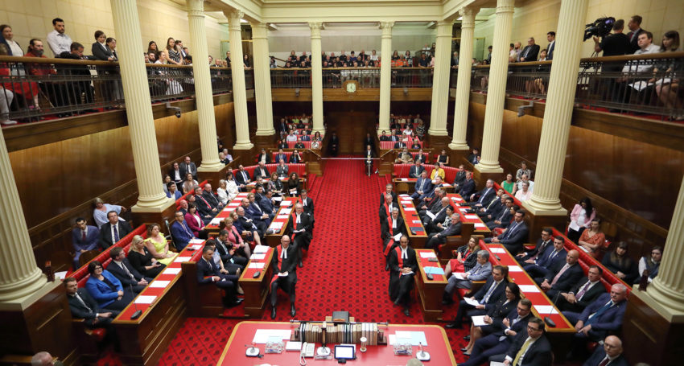

Economic Policies

mAJOR AND MINOR PARTIES

Table of Contents

*Introduction:* 2

*Australian Political Parties:* 2

*Left Wing Candidates:* 2

*Right Wing Candidates:* 2

*Minor Party:* 3

Major Party: 3

Summary: 5

Appendix: 6

Bibliography and References: 8

## 

## Introduction:

To keep the money circulating with the economy, practices such as taxation and government spending is necessary to ensure an economy is stimulated or slowed down under control. This is called the fiscal policy. Using the fiscal policy in this report in the youth forum will evaluate political policies and proposals from a macroeconomic perspective and, to evaluate economic objectives: Price stability, full employment, and sustainable economic growth.

## Australian Political Parties:

Moreton candidates in the upcoming state election include Peter Power, a candidate for the Australian Federation Party (Centre), Neil Swann who is running for Pauline Hanson's One Nation (Right Wing), Perret Graham, a candidate for Australian Labor Party (Centre-Left), Claire Garton from the Queensland Greens (Left Wing), Steven Huang from the Liberal National Party of Queensland (Right Wing), and finally Chelsea Follet from United Australia Party (Right Wing), many more candidates from the major parties and minor parties may run for the position, giving Australians a better choice of representatives (Moreton Candidates , 2022).

## Left Wing Candidates:

Graham Perret is the Shadow Minister for Education for the Labor Party. He is a firm believer in fairness and equality, and an advocate for opportunity for all. He's on the left wing of the political spectrum and is thus opposed to the current administration. Claire Garton is a LGBT advocate that believes everyone should have the same opportunities and access to services. She wants the community to be heard and is tired of the government putting businesses ahead of the community and for these reasons is far left.

## Right Wing Candidates:

Peter Power has a conservative position on the political spectrum, supporting the use of traditional values and deregulation. He may be more liberal on social issues, but as an employer and business owner, he is on the right. Neil Swan has a far-right position on the political spectrum, supporting businesses with a conservative approach. Steven Huang, a part of the liberal national party as a Moreton candidate is a social conservative who sits on the right wing wants to represent local communities and help local families. Lastly, Chelsea Follet is a part of the United Australia Party. She is a firm believer in justice and has long campaigned for equal rights and opportunities, her political ideology is centre-right. Minor parties have many economic policies and beliefs that can help boost the Australian economy.

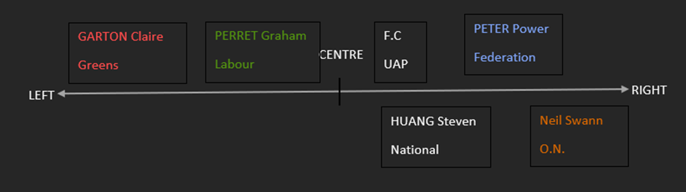

## Minor Party:

By boosting the economy and cutting debt, the far-right United Australia Party plans to help Australian’s by proposing many economic policies such as, processing Australian minerals at home, ending Australia's energy crisis, and convincing Australians to only buy "Australian", but its most prominent policy is the repayment of national debt (United Australia Party, 2022). Compared to other minor parties the United Australia party proposes long-term economic plans that will boost the economy, such as a policy to repay national government debt. National Debt is a centre-right policy because it deregulates the economy, business, and industry. Federal government spending is the cause of national debt. While this creates a budget deficit, government spending is necessary to expand the economy (GDP). This is known as the expansionary fiscal policy. Using the business cycle **(Source 1)** when there is rapid growth in GDP, there is more employment and price stability. By expanding the money supply in the economy and using budgetary tools to cut taxes or increase spending, the government can increase GDP.  However, in the long run as debt in Australia increases **(Source 3)** it can hurt economic objectives such as, higher GDP, inequality, and healthcare due to inefficient resource allocation.

## 

## Major Party:

The largest parties in Australia, the Australian Labor Party (ALP), the Liberals, the Nationals. These major parties all have wildly different policies. The ALP sits on the centre-left. The Liberals and Nationals have conservative ideologies and sit on the centre-right on the political spectrum. But these major parliamentary parties have one main policy which as a coalition can reach: Reducing taxes (Australian Labor Party, 2022). The 2021-2022 Federal Budget is aimed to be expansionary. As a coalition, to maintain a strong economy, these major parties seek to accomplish economic objectives using policies: stable prices, full employment, and economic growth. In Australia, there are several taxes that affect the economy. These include income tax, capital gains tax (CGT), and Goods and Services Tax (GST); these sit on the left side of the political spectrum due to it focusing on helping employees. Federal-level governments set all these taxes. Reduced tax rates could also encourage saving and investment, boosting the economy's productive capacity which are correlated with the business cycle. Using **(Source 1);** tax rates increase in booms and fall in recessions. The government reduces income tax and corporate tax, which speeds up demand by increasing disposable income. Disposable income allows for more consumption and investment into the economy. Reducing income tax also encourages businesses to hire more workers by having more unemployed people have incentives to work because of higher redistribution of income and invest in new projects, while also increasing the federal budget deficit. This will reduce national savings and boost aggregate demand. **Source 4**shows that increasing taxes does the opposite of this and decreases demand for goods and services. Further proof in **(Source 4)**shows that during tax reductions in 1993-2001 led to much higher GDP and employment, whereas during the 2001 tax increase, GDP and employment dropped dramatically. During recessions, people and companies are more likely to lower spending and invest less, which can exacerbate problems by reducing production and further slowing the economy. To encourage growth for businesses and economic development, the government may consider reducing or eliminating certain taxes. There are two main types of fiscal policies, expansionary and contractionary. A contractionary fiscal policy aims to tax more then it spends and is used to slow down the economy usually during times in economic prosperities. However, reducing taxes is an expansionary fiscal policy, which is an economic tool that can stimulate growth in a recession or economic slowdown, which aims to increase individual productivity and improve quality of life. An expansionary policy can also impact macro stability positively, such as an increase in economic output, which adds to an aggregated effect. Increasing GDP. **(Source 2)**showstaxes (T) imposed by the government reduce the flow of income. However, reducing income tax can lead to externalities such as inequality and the risk of inflation. Reducing income tax can lead to inequality because of less equity in the distribution of income. This is conservative because there will be less subsidies expenditure because of the government having reduced amounts of money, meaning that there will be more government intervention in the economy. This leads to less efficient resource allocation opportunities like healthcare may not be accessible to people with different salaries, reduced government spending and there will be a balanced budget for example, before reducing income tax: If someone makes $40,000 a year, they will go to the same doctor as someone who earns $150,000 a year. Reducing income tax can lead to inflation by having higher disposable income, which will increase demand and cause supply shortages due to rising consumer demand. This leads to prices of goods and services becoming higher **(Source 5).** However, inflation can translate to more spending, which can aggregate demand in the long-term.

## Summary:

Fiscal policy should be sustainable and must align with federal budget goals, the federal budget is expansionary, and its trend is to lower deficit and not just reach economic goals but also social, while maintaining fiscal discipline, meaning that deficits are necessary and that they will not last forever. Despite both parties approaching economic problems from different problems, they both aim to boost the Australian economy by reducing tax and repaying national debt. Evidently, the minor party United Australia Party (UAP) has many economic policies compared to other minor parties that will boost the economy. This is because the UAP has proposed policies such as repaying national debt. Repaying national debt helps economic objectives such as increasing GDP, maintaining full employment and helping income equality. Lastly, the major parties had one consistent policy that as a coalition can reach: Reducing Tax which leads to a linked higher GDP and employment rates, as well as providing price stability.

## 

## Appendix:

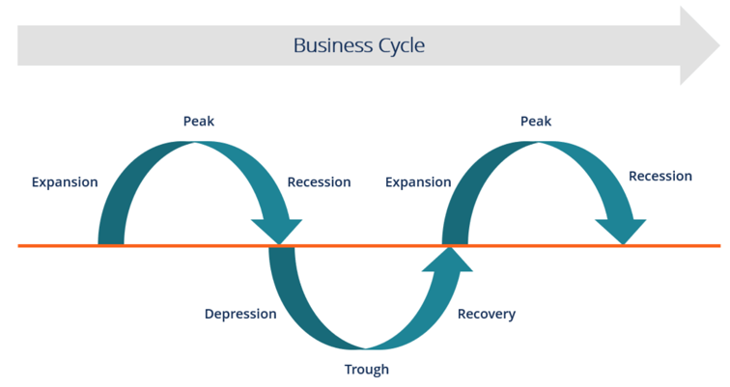

(Source 1)

(Source 2)

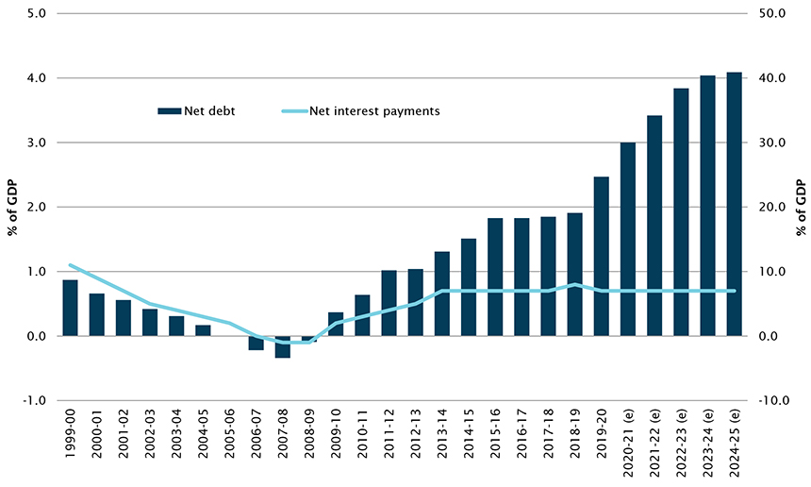

(Source 3)

(Source 4)

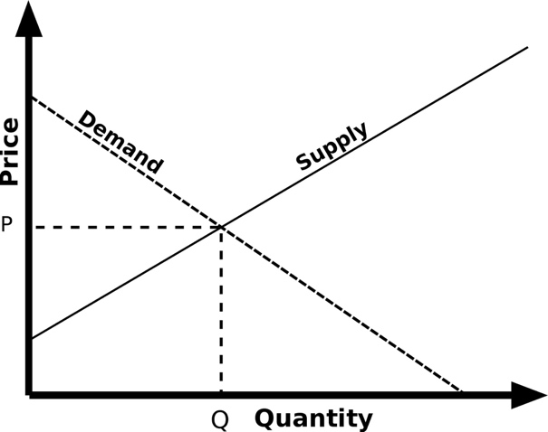

(Source 5)

## 

## Bibliography and References:

[Minor and Major Parties](https://www.aph.gov.au/About_Parliament/House_of_Representatives/Powers_practice_and_procedure/00_-_Infosheets/Infosheet_22_-_Political_parties#:~:text=Minor%20parties%20and%20independents&text=Australian%20Labour%20Party%20(Anti%2DCommunist,)%20%E2%80%93%202010%20(one%20Member)) | 12/05/22

[One Nation Policies](https://www.onenation.org.au/issues) | 12/05/22

[Candidates for Moreton](https://www.abc.net.au/news/elections/federal/2022/guide/more) | 12/05/22 (Moreton Candidates , 2022).

[The Greens](https://greens.org.au/) | 12/05/22

[Katter Party](https://www.parliament.curriculum.edu.au/parties_katter.html%20() | 12/05/22

[United Australia Party](https://www.unitedaustraliaparty.org.au/national_policy/) | 12/05/22 (United Australia Party, 2022)

[Centre alliance](https://centrealliance.org.au/policies/) | 12/05/22

[Australian Labour Party](https://www.alp.org.au/policies) | 12/05/22 (Australian Labor Party, 2022)

[Liberal Party](https://www.liberal.org.au/our-policies) | 12/05/22

[The Nationals](https://nationals.org.au/policies/) | 12/05/22

[Taxes Information](https://www.austrade.gov.au/international/invest/guide-to-investing/running-a-business/understanding-australian-taxes/australian-business-taxes) | 13/05/22

[CFM Picture](https://commons.wikimedia.org/wiki/File:Five_Sector_Circular_Flow_of_Income_Model.jpg) | 15/05/22

[Business Cycle Graph](https://corporatefinanceinstitute.com/resources/knowledge/economics/business-cycle/) | 15/05/22

[GDP and Employment Graph](https://www.brookings.edu/wp-content/uploads/2016/06/09_effects_income_tax_changes_economic_growth_gale_samwick.pdf) | 15/05/22

[National Debt Australia](https://www.aph.gov.au/About_Parliament/Parliamentary_Departments/Parliamentary_Library/pubs/rp/BudgetReview202122/CommonwealthDebt)| 15/05/22

[Fiscal Policy /Expansionary Fiscal Policy](https://sgp.fas.org/crs/misc/R45723.pdf) | 13/05/22