**Chapter 6 - Macroeconomic Activity**

Macroeconomics is a study of the economy. Macroeconomics is on why the economy grows and why the economy activity fluctuates over time. It is concerned with the business cycle, economic growth, inflation, unemployment and government economic policies developed in response to changes in these variables.

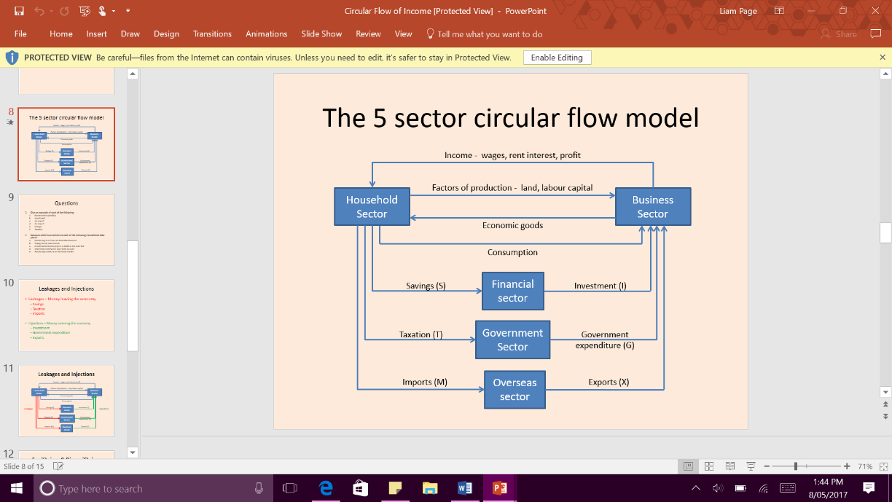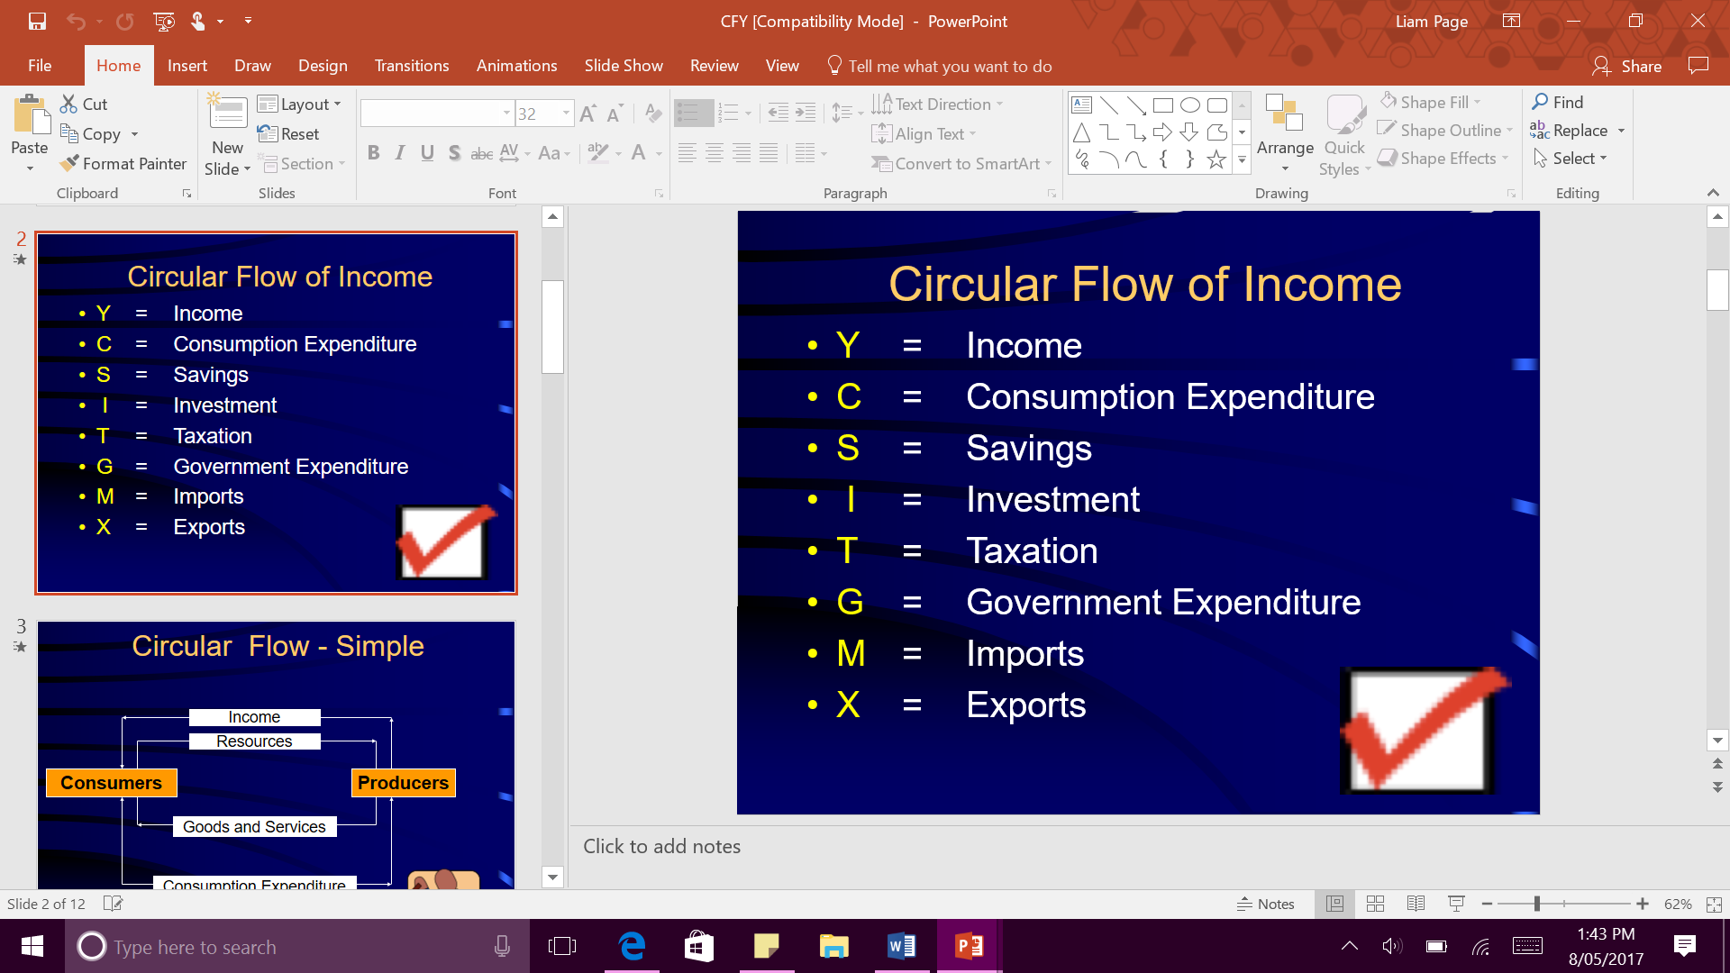**Circular Flow of Income**

The circular flow of income model describes the flow or resources goods and services and income between people that make them.

**Households and Firms**

The basic circular flow model assumes a few things

* There are only two sectors in the economy- households and firms
* Households spend all their income so there is no saving
* There is no government sector
* There is no overseas trade

**Saving and Investment**

Saving is defined as the portion of income not spent on goods and services for current consumption. Saving represent a leakage from the circular flow because it reduces the amount of money in the flow.

Investment is defined as expenditure on goods and services which are not intended for current consumption. Investment is considered an injection in the circular flow of income. This is because there is extra money being put in the flow.

**The Government Sector**

The government plays a significant role in the economy, both as a consumer and producer. As a consumer, the government buys good and services from businesses. As a producer or goods and services such as education, health and businesses. Government also regulates the economy so it runs smoothly and equitably. Households pay taxes which is considered a leakage but the money gets put back into the economy through government expenditure. Government expenditure is paid for by income tax and goes towards things like infrastructure and Schools.

**The Overseas Sector**

All people’s incomes are often spent of overseas goods that are imported. This is bad because it is a leakage from the economy as money is leaving the circular flow. On the other hand, we should let the economy be open because it lets other economy's purchase things that they would not normally be able to acquire.

**The full circular flow model**

* A capital market exists to match the needs of households with surplus income and the firms that wish to borrow for investment.
* The government provides many community needs, financed by taxation.
* Trade with other countries provides the needs we cannot produce ourselves in return for goods and services that are surplus to our needs.

**Macroeconomic equilibrium**

In the circular flow, the value of output must equal the value of income paid to resource owners, which must in turn equal the value of spending by the households to produce the output.

This equality can be represented by:

**O = Y = E**

When O is output, Y is income and E is expenditure. The equation says ‘the sum of all output equals the sum of all income equals the sum of all Expenditure. This is considered equilibrium.

* When savings exceed planned investment the flow of income in the economy must contract, as Leakages exceed injections. TOTAL spending will be less than output, so unsold stocks of goods are held by businesses and inventories increase. This will force companies to reduce production, forcing people out of work. This will continue until savings equal investment at a lower income.
* When planned investment exceeds savings the total expenditure will exceed current output causing inventory levels to reduce and cause more workers to be employed for the new requested amount of stock. Incomes will then increase because more workers are needed. Only when saving equal planned investment will it be in greater economic activity.

Aggregate expenditure

**Chapter 7 - The Business Cycle**

Macroeconomics is concerned with aggregate economic activity. It is on the one hand a study of the business cycle and on the other, a study of economic growth. The business cycle refers to the fluctuation in economic activity over time and is measures by chances in real GDP.

**Boom**

* High levels of consumption expenditure, particularly on durable goods and luxuries.
* A general mood of confidence throughout the economy
* The profit share of GDP is relatively high
* Business firms are working near full capacity, and production bottlenecks may exist
* Cyclical unemployment is relatively low
* Participation rates of labour in the workforce are high
* Inflationary pressure is more likely, especially because the pressure on resources means their prices are bid upwards in factor markets.
* Imports increase
* The level of borrowing may be high even if interest rates have risen

**The Trough**

* Higher cyclical unemployment
* Lower company profits
* Slower growth rates of retail spending, especially on consumer durables
* Lower levels of consumer and business confidence
* Reduced pressure on prices
* Rising levels of saving as households reduce spending (especially if job losses are occurring)

**Economic indicators**

The only way we know whether the economy is expanding or contracting is by viewing economic indicators. There are leading indicators which are things like building approvals. There are coincident indicators which are things like manufacturing output. There is lagging indicators which are interest rates.

Leading indicators predict trends in economic activity, changing before a direction becomes evident in the rest of the economy.

Coincident indicators are those that appear to move in a line with the level of economic activity.

Lagging indicators are not expected to show any change until after trends in the rest of the economy have been confirmed. Lagging indicators react to developments

**Chapter 8 - Economic Growth**

Economic Growth refers to the increase of economy’s output over time. It can be depicted as a shift of the economy’s production possibility frontier outwards. It means that the economy can produce more goods and services and can then satisfy more needs and wants.

Economic Growth can be defined as the increasing capacity of the economy to satisfy the material wants of its members.

Higher economic growth provides higher standard of living, higher real income, higher levels of consumption, increased leisure time, improved quality of goods and pressure on the environment.

Economic growth is measured by the annual change in real Gross Domestic Product. For Australia, the desirable rate is 3.5 per cent per annum.

Price Stability occurs when rates of inflation are low. The official target rate in Australia is between 2 and 3 per cent per annum.

Full employment occurs when everyone who is willing to work can find employment. The natural unemployment rate now is around 4.5-5 per cent.

The production possibility frontier shows all the combinations of output which an economy can produce using is available resources.

Real GDP is used because it considers inflation. If you divide this by the population then you will have real GDP per capita, and this now considers increases in the population.

**GDP(increase)=GDP(year1)-GDP(year2)/GDP(year1) x100**

Growth is an organic process built on a desire of people to make better use of resources and achieve a higher standard of living. The rate can be influenced by:

* The rate of population changes
* The rate of increase in capital equipment per worker
* Technological processes and the application of new ideas the productive process
* Improvements in the skills and productivity of the labour force
* The size of the natural resource base
* The willingness of an economy to trade with overseas countries

Technical Efficiency- Combining resources more productively, so that the same amount of resources can produce greater quantity or value of goods and services.

Allocative Efficiency- minimising waste by directing resources to the usage in which they have most value.

Dynamic Efficiency- The ability of an economy to adapt over time.

**Human Resources**

Human Capital can be defined as the stock of knowledge and skills that people develop through education and experience. It is developed by:

* The provision of the basic building blocks of a productive workforce.
* The provision of education, which develops the skills, knowledge and understandings that enable people to take their place in the community, as well as developing knowledge and skills which can be used in the workplace.
* The provision of ongoing training, which develops job-related skills.

**Investment and capital accumulation**

Another important aspect to economic growth in developed countries is an increase in the capital to labour ratio to equip workers with a greater stock of physical capital to enable them to work more productively. Two types of investment in capital can be distinguished:

* Public investment, which creates the framework on which economic activity is founded. Public investment provides the majority of infrastructure such as roads, schools, hospitals, water supply and power.
* Private investment, which includes buildings, machinery and equipment.

**Chapter 9 - Inflation**

Economists define inflation as a persistent and appreciable rise in the general level of prices. It’s the term used to describe the price increases that occur across time, across a range of goods and services.

**The Measure of inflation**

The inflation is measured with a thing called CPI. It stands for consumer price index. A basket full of goods and services are out together every year and the prices are measured over time. About 100 thousand goods and services are measured each year.

**Rate=CPI (year x) – CPI (year x-1)/CPI (year x-1) x 100**

**The GDP deflator**

The GDP deflator is an index which measures the change in the prices of all goods and services included in GDP. It is arguably a more accurate measure of inflation compared to the CPI which just measures consumer inflation.

**Demand Pull Inflation**

The simplest definition is ‘too much money chasing too few goods’- high levels of demand caused by high levels of aggregate expenditure. Demand pull inflation normally happens in an upswing. It is indicated by:

* High levels of durable consumption spending
* Excess demand for labour in some sectors of the economy, forcing up wages, and thus prices
* Excess money supply

**Cost Push Inflation**

Cost push inflation occurs when rising production costs are passed on to consumers, who then must pay higher prices for final goods and services. Can be triggered by:

* When wages go up
* When prices of imports rise
* When oil prices rise
* When government charges and taxes rise

**The concepts of income and wealth**

* The concepts on income are wages and salaries, income from investment, income from superannuation
* The concepts of gross income are determined by adding any transfer payments a household receives from the government.
* Th concepts of disposable income is just the total minus the indirect and direct taxes.
* Final income is some form of indirect or direct.

**Unemployment – Chapter 10**

The working age population is all the people that are over 15 and not in retirement, that are physically able to work.

**Participation rate = labour force/working age population x 100**

**Unemployment rate= number of underemployed/labour force x 100**

**The types of unemployment**

Unemployment is considered as voluntary if a worker decides to leave a job to search for another position. Involuntary unemployment occurs when a worker is laid off from their place of work.

Frictional Unemployment is when someone leave their job and is in the job search for another job.

Cyclical unemployment is when the employment levels follow the ups and downs of the business cycle.

Structural unemployment is when you job gets replaced by a cheaper and more efficient option like a robot.

Seasonal unemployment is when there are only specific jobs in certain seasons like fruit picking.

The natural rate of unemployment is currently 5.6%.

**Trade and Balance of Payments – Chapter 11**

**The reasons for trade**

* Endowment of natural resources
* Differences in labour and capital resources
* Differences in technology

**The benefits of trade**

* Exports enable a greater level of production and income.

**Economic Macroeconomic objectives of the Australian Government**

* Sustainable economic growth with the target being 3-3.5%
* Price stability for inflation Target being 2-3%
* Full employment, Natural rate of unemployment is 4.5-5%
* Efficient resource allocation
* More equitable distribution of income

It is important that Australia continues to participate in international trade, both imports and exports bring benefits to the economy. Participating in international trade boosts economic development and growth and raises living standards.

A trade surplus occurs if the total value of goods and services exports exceeds the total value of goods and services imports. A trade deficit on the other hand, occurs when the total value of imports exceeds the total value of exports.

The balance of payments is a record of all economic transactions between residents of Australia and the residents of the rest of the world. Residents include; individuals, firms and governments. Balance of payments must always balance. A current account deficit will be matched with an equivalent capital/financial account surplus.

The balance of payments is split into two categories:

**Current Account:**

* Goods (debits and credits)
* Services (debits and credits)
* Income (debits and credits)

**Capital and Financial Account**

* Capital transfer (credits and debits)
* Non-financial assets (credits and debits)
* Foreign and Australian investment (credits and debits)

**Income Distribution – Chapter 12**

Income and wealth are different concepts- one represents flow of funds, the other a stock of assets. Most households have different forms of private income such as:

* Gross income is determined by adding any transfer payments a household receives from government, such as pension or allowance.
* Disposable income are direct and indirect taxes deducted from your private income.
* Final income also considers any form of indirect benefits such as assistance with school fees or health care costs.

Wealth on the other hand refers to the current value of the assets a household has accumulated overtime, through savings, financial investments, business profits and inheritance. The correct definition is the difference between a household’s asset’s and its liabilities.

A useful tool used to measure wealth distribution is a Lorenz curve. It maps the cumulative proportion of the population ranked by income against their cumulative share of income. With the Lorenz curve, the further out the line is the more inequality there is. The measure for this is the Gini coefficient, this formula fins out the area between the perfect equality line and the line of the economy. A economy with perfect inequality would be 1 and perfect equality would be 0.

Some reasons why Australia’s economy could not be perfectly distributed would be:

* Education
* Occupational conditions
* Personal aptitude
* Opportunity
* Involuntary factors

**Income Redistribution**

A free market will make no effort to redistribute the income. On the other hand, we are in Australian and seen as it is a modified economy. As a result, the government often intervenes to redistribute the income. The key element of this is direct taxes. Personal tax is progressive so if you earn more you pay more tax. The government also uses its money to close the gap in incomes with transfer payments, giving direct income support for a number of groups of Australians.

**Taxation – Chapter 13**

Direct Taxation is collected from the tax payer’s income, so the impact is directly on him.

Indirect Taxation are collected from the tax payer’s expenditure like GST or excise tax.

Progressive taxes claim an increasing proportion of income as income increases. The burden is theoretically being higher at you go up the income sectors.

Regressive taxes are the opposite the burden is more on the people with lower incomes. E.g. paying GST if you are a low-income earner.

Proportional tax takes a constant proportion of income no matter what level of income is earned.

**A good Tax system**

Fairness can also be called equity. A good tax system will feature both horizontal and vertical equity. A good tax system should be relatively simple. Finally, the tax system should be efficient. The benefits of the tax must outweigh its cost of collection.

**Types of Taxes**

Personal income tax: This is levied on all wage and salary income, at rates which specify how much of the last dollar will be paid as tax. Personal income tax is direct as the impact and incidence of the tax both fall on the same person.

Company tax: Company tax is a proportional tax whose impact falls on the individual company, even though the incidence will probably fall on the consumer as they will increase prices.

Fringe Benefits Tax: Fringe benefits tax is levied on the value the value of non-cash benefits given to the employees of company as part of their salary package.

Resource Taxes: The tax revenue share increases as the resource rent increases so the tax is based on the ability to pay. The tax will neither encourage over investment or discourage investment, and will not be affect the investor decisions on production, consumption or trade. As natural resources belong to the public, some of the rents derived from the taxes will be handed back to the hands of the public.

**Tax Reforms**

Over the years Australian tax system has been up, the system has gone through several reforms. Some are:

* A capital gains tax. The tax is based on the gains made through the profit of the sale of assets. (1985)
* A fringe Benefits tax. Taxes on non-cash benefits a person can get from an employer. (1986)
* The single rate GST 10%. There is now more certainty in the system. (2000)
* A new tax collection system. PAYG system replaces complicated previous systems. (2000)
* Self-assessment of tax liability. This means that the tax office will rely upon information provided by the taxpayer. Rather than checking every assessment form. A small portion of people are audited and this reduces the cost of the system.

**The Public Sector – Chapter 14**

**The role of the Government**

In a free market system people and groups make decisions in their own private interest, for their own benefit. The problem with this system is producers would not allocate resources equitably.

The term modified market economy is used to describe these economies including the Australian. A modified economy is considered to have:

* The provision of public goods and services
* The redistribution of income
* The regulation of business enterprises
* Macroeconomic management

**The Provision of Goods and Services**

People pay for their goods from their pockets, which allows them exclusive rights of use. The free market will provide adequate amounts of private goods because consumers are willing to pay for their purchase. Governments often take control of the sale of private resources such as electricity, water, gas and communication. The reasons being:

* Private companies would not be able to afford the expensive infrastructure to run the facility’s.
* Governments often thought they had to take control of the sale of these resources because they don’t want companies exploiting and taking advantage of the resources.
* Governments were often considered monopolies, where is more efficient for one big firm to control all the resources.

When a government stops providing its goods such as electricity I can sell the business to private owners, they were often listed as floated on the stock market. This action is called privatisation.

If private businesses were left to their own they would not provide enough of the essential goods and services, they cannot provide public or common property goods. These goods are subject to free riders. Free riders are consumers who enjoy the benefits of consumption without paying for the cost of provision.

Common property goods often need government intervention as anyone can consume as much as they want. This means that people can abuse the free good.

Merit goods are another type of good that the government provides, they are essentially private goods that are associated with large positive externalities. Good examples are health services and education.

For public goods, common property goods and merit goods, government intervention positively affects the allocation of resources. The governments motives are:

* Public goods are beneficial to the community would not be provided in sufficient quantities by the free market, because they cannot be priced.
* Common property goods would be subject to the tragedy of the commons and their use needs to be regulated to prevent exploitation.
* The government providing greater quantities of merit goods at a lower price to encourage increased consumption.

**Regulation of the Business Enterprise**

Regulation of business activity is all around us, in general regulation is an important and effective mechanism to achieve economic and social goals. Business firms are subject to many regulations such as advertising, occupational health and safety.

**The three tiers of Government**

National Governments take on a broader approach on things such as defence, foreign affairs, international trade, currency and banking regulation.

State governments are responsible for provision of law and order, health, education and transport.

Local governments are typically used for urban planning, refuse collection and parks and gardens

