1. A tightening of monetary policy would likely involve the Reserve Bank of Australia the cash rate. This would most likely cause an of Foreign investment and cause the Australian dollar to
   1. Raising, outflow, appreciate
   2. Raising, inflow, appreciate
   3. Lowering, outflow, depreciate
   4. Raising, inflow, depreciate

2. The ‘transmission mechanism’ refers to the way a change in interest rates affects economic activity. The transmission occurs via a number of channels. The channel that affects decisions by those in the economy with existing variable rate home loans is known as the

A. asset values channel.

B. exchange rate channel.

C. cost of credit channel.

D. cash flow channel.

3. Which one of the following is a weakness of using monetary policy to achieve the Australian Government’s macroeconomic goals?

A. Monetary policy requires political approval.

B. Indebted households are very sensitive to interest rate changes.

C. Banks are not legally required to pass on any changes in the cash rate.

D. Monetary policy is relatively inflexible in response to changing economic circumstances.

4. Assume that the graph below shows that the Australian economy has moved from point *X* to point *Y*.



Which policy mix is the most appropriate for this economy?

A. The Reserve Bank increases the cash rate and the Federal Government increases the budget deficit.

B. The Reserve Bank decreases the cash rate and the Federal Government increases the budget deficit.

C. The Reserve Bank increases the cash rate and the Federal Government decreases the budget surplus.

D. The Reserve Bank decreases the cash rate and the Federal Government increases the budget surplus.

5. In the short run, an increase in the cash rate

A. lowers the real interest rate, decreases investment, and shifts the *AD* curve rightward.

B. lowers the real interest rate, increases investment, and shifts the *AD* curve leftward.

C. raises the real interest rate, increases investment, and shifts the *AD* curve rightward.

D. raises the real interest rate, decreases investment, and shifts the *AD* curve leftward.

6. During 2016, the Australian economy was growing

A. above its long term average and unemployment was below the natural rate.

B. above its long term average and unemployment was above the natural rate.

C. below its long term average and unemployment was below the natural rate.

D. below its long term average and unemployment was above the natural rate.

7. Which of the following is **least** likely to result from the Reserve Bank of Australia (RBA) achieving an inflation rate of 2–3 per cent, on average, over the cycle?

A. Low unemployment

B. Stability of the currency

C. Sustainable economic growth

D. A decrease in international competitiveness

8. Which of the following events, or combination of events, may result in the Reserve Bank of Australia (RBA) adopting a more restrictive monetary policy stance?

A.An increase in the world oil price over two consecutive months

B.An increase in the growth of both credit and household debt to income ratio, combined with the rapid depreciation of the Australian dollar

C.An increase in the official ABS unemployment rate and evidence of a higher level of labour force under-utilisation

D.A decrease in consumer confidence, accompanied by concerns about declining rates of economic growth in Australia’s major trading partners

9. Which of the following factors best illustrates the difference between monetary policy and fiscal policy?

A. Monetary policy is quicker to implement than fiscal policy, and is more effective in stimulating the economy than in slowing it down.

B. Monetary policy is quicker to implement than fiscal policy, and is more effective in slowing down the economy than in stimulating it.

C. Monetary policy is slower to implement than fiscal policy, and has a longer time lag than fiscal policy in bringing about changes.

D. Monetary policy is slower to implement than fiscal policy, and has a shorter time lag than fiscal policy in bringing about changes.

1. Contractionary Monetary policy is most likely to be used when:
   1. inflation is high, unemployment is low and consumer spending is high.
   2. inflation is low, unemployment is high and consumer spending is low.
   3. inflation is high, unemployment is high and consumer spending is low.
   4. inflation is low, unemployment is low and consumer spending is high.
2. A significant strength of monetary policy by comparison to fiscal policy is that it:
   1. is more direct in its impact on the economy.
   2. is more flexible.
   3. is relatively more effective when economic activity is low.
   4. can be directed to particular sectors of the economy.

**Question 27 (12 Marks)**

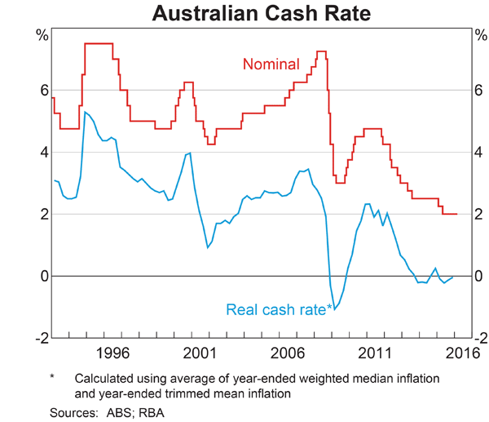

1. (i) Define real interest rate. (1 Mark)

(ii) According to the graph what was the value of inflation in early 2016? (1 Mark)

1. Identify and explain two factors that contributed to the RBA lowering the cash rate in 2015. (4 Marks)

1. Using the transmission mechanism, explain how the RBA may impact economic activity through expansionary monetary policy. (6 Marks)

**Question 25 (12 marks)**

**Statement by Glenn Stevens, Governor: Monetary Policy Decision (May 3, 2016)**

*At its meeting today, the Board decided to lower the cash rate by 25 basis points to 1.75 per cent. This follows information showing inflationary pressures are lower than expected.*

*The global economy is continuing to grow, though at a slightly lower pace than earlier expected, with forecasts having been revised down a little further recently. China's growth rate moderated further in the first part of the year. Commodity prices have firmed noticeably from recent lows, but this follows very substantial declines over the past couple of years. Australia's terms of trade remain much lower than they had been in recent years.*

*In Australia, the available information suggests that the economy is continuing to rebalance following the mining investment boom. Indications are that growth is continuing in 2016, though probably at a more moderate pace. Labour market indicators have been more mixed of late. Inflation has been quite low for some time and recent data were unexpectedly low.*

*Monetary policy has been accommodative for quite some time. Low interest rates have been supporting demand and the lower exchange rate overall has helped the traded sector. Credit growth to households continues at a moderate pace, while that to businesses has picked up over the past year or so. These factors are all assisting the economy to make the necessary economic adjustments, though an appreciating exchange rate could complicate this.*

*Source: Media Release, Reserve Bank of Australia*

a. i. What is the main reason the Reserve Bank lowered the cash rate? (1 mark)

____________________________________________________________________________

ii. Explain why there have been substantial falls in commodity prices over recent years. (1 mark)

____________________________________________________________________________

b. Prior to the announcement the AUD was trading at US77.07c but after the decision it fell to US75.67c. Use an exchange rate model to explain why the dollar depreciated. (3 marks)

____________________________________________________________________________

____________________________________________________________________________

____________________________________________________________________________

____________________________________________________________________________

***See next page***

_____________________________

_____________________________

_____________________________

_____________________________

_____________________________

_____________________________

_____________________________

_____________________________

c. Explain how a lower exchange rate helps the traded sector? (3 marks)

____________________________________________________________________________

____________________________________________________________________________

d. Discuss the effectiveness of using monetary policy in the current economic climate. (4 marks)

____________________________________________________________________________

____________________________________________________________________________

____________________________________________________________________________

____________________________________________________________________________

____________________________________________________________________________

____________________________________________________________________________

____________________________________________________________________________

____________________________________________________________________________

____________________________________________________________________________

____________________________________________________________________________

____________________________________________________________________________

____________________________________________________________________________

____________________________________________________________________________

____________________________________________________________________________

____________________________________________________________________________

**Question 31 (20 Marks)**

1. Describe the conditions upon which the RBA may raise the cash rate and the impact this may have on Australian households, firms and the overseas sector. (12 Marks)
2. Discuss how effective monetary policy has been in achieving the RBA’s economic policy objectives in recent years. (8 Marks)

**Question 31** **(20 marks)**

a. Explain the circumstances under which the RBA would increase the cash rate

and describe how this change would affect the level of economic activity. (10 marks)

b. Discuss the strengths and weaknesses of monetary policy. (10 marks)

**Question 29** **(20 marks)**

Analyse the monetary policy stance adopted by the Reserve Bank of Australia (RBA) during 2016-17. Provide reasons for the stance and using **three** monetary policy transmission mechanisms or channels, explain how this stance is likely to have an impact on the goals of strong and sustainable economic growth and full employment. Include a model to support your answer.