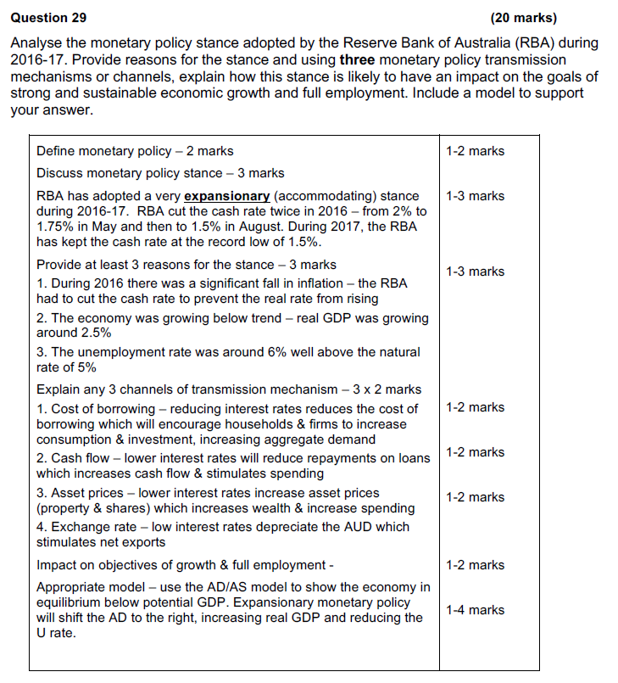

**Question 31** **(20 marks)**

a. Explain the circumstances under which the RBA would increase the cash rate

and how this change would affect the level of economic activity. (10 marks)

b. Discuss the strengths and weaknesses of monetary policy. (10 marks)

|  |  |
| --- | --- |
| a. **5 marks** - Discuss circumstances the RBA would increase the cash rate: basically to contract the economy & reduce inflation  i. The economy is growing too fast (‘overheating’) – real GDP has increased above potential GDP  ii. Inflation rate has increased above the 3% upper bound  iii. the unemployment rate has fallen below the natural rate of 5%  iv. Housing market ‘bubble’ – house prices have increased to excessive levels  **5 marks** – effects of a rise in the cash rate on the economy  A rise in the cash rate would cause other i/rs to rise which would have a contractionary effect on spending (AD).  Need to describe the impact on 3 channels of the transmission mechanism  i. a rise in i/rs would increase cost of borrowing reducing the demand for credit & decrease C & I  ii. a rise in i/rs would increase repayments & decrease cash flow of households & firms decreasing C & I  iii. a rise in i/rs would appreciate the $A which would reduce net exports  As a result, aggregate demand would decrease reducing real GDP, employment & the price level | 1 mark  1 mark  1 mark  1 mark  1 mark  1 mark  1-3 marks  1 mark |
| b. **Strengths** – 5 marks (Need to discuss at least 3)  Very flexible – RBA board meets monthly so MP can be changed relatively easily & frequently  No political bias – RBA is independent of the government  Complements a free exchange rate – e.g. a rise in i/rs will also increase $A so that both will have a contractionary effect  Short decision making (implementation) lag  MP is most effective when economy is in a boom  **Weaknesses** – 5 marks (Need to discuss at least 3)  Very indirect – MP affects i/rs which then have to effect C & I  ‘Blunt’ instrument – i/rs cannot be used selectively for different states or industries  Long effect lag – MP may take 12-18 months to work by which stage the economy may have changed  MP may have little effect when economy is in contraction/recession – can’t force people to borrow | 1-5 marks  1-5 marks |

**Question 31 (20 Marks)**

1. Describe the conditions upon which the RBA may raise the cash rate and the impact this may have on Australian households, firms and the overseas sector. (12 marks)

|  |  |
| --- | --- |
| **Description** | **Marks** |
| **Describe the conditions upon which the RBA may raise the cash rate.**  Students should describe at least three of the following:   * Rise in the cash rate is applied when the economy is at risk of ‘overheating’, designed to have a contractionary effect = contractionary monetary policy * Inflationary pressure will be present. Inflation is at risk of rising above the target of 2-3% * The economy will be close to full employment * Consumption and investment spending are strong * High levels of borrowing | 1-3 |
| **Impact on Australian Households**:   * Higher interest rates will dampen household consumption due to:   + increased cost of purchasing on credit.   + Decreased disposable income due to increased mortgage and credit card repayments   + Lower expectations about the future, fear of further interest rate rises   + Increased savings due to higher returns on deposits with financial institutions   + Asset prices such as shares decline due to decreased return compared to bonds leading to decreased wealth | 1-3 |
| **Impact on Australian Firms**:   * Higher interest rates will dampen Firm’s investment due to:   + Reduced cash flow due to increased repayments on borrowing   + May draw investment demand curve to illustrate negative relationship between interest rates and investment     - Less likely to increase employment in such conditions | 1-3 |
| **Impact on Overseas Sector:**   * Higher interest rate will increase the interest rate differential between Australia and overseas countries   + increased demand for Australian capital from overseas ➔inflow of foreign investment.   + Increased demand for $AUD➔ appreciation of the $AUD.   + Higher $AUD will decrease demand for X and increased demand for M➔ decreased net exports. | 1-3 |
| **Total** | **12** |

1. Discuss how effective monetary policy has been in achieving the RBA’s economic policy objectives in recent years. (8 marks)

|  |  |
| --- | --- |
| **Description** | **Marks** |
| **Identifies RBA objectives in correct order**:   * Price stability * Maintenance of full employment * Economic prosperity and welfare of the Australian people | 3 |
| **Identifies 2 of the following points to acknowledge the monetary policy stance used in recent years**   * Expansionary in order to encourage economic activity * 2 small (0.25%) cuts in cash rate in both 2016 and 2015 * historically low rate, states current rate * May potentially discuss contractionary stance used prior to 2011 | 1-2 |
| **Discusses effectiveness of expansionary MP in recent years:**   * in the last few years MP has not been particularly effective at targeting the RBA’s objectives with inflation lower, growth lower and unemployment higher than RBA’s targets (gives statistics). * Provides at least 2 reasons why: * Monetary policy is less effective when the economy is weak * Firms less motivated to invest due to low confidence and political instability (election of 2016) * Low interest rates have not lead to increased consumption and investment - “you can lead a horse to water but you can’t make it drink” * Being a blunt instrument monetary policy has not been able to target those sectors of the economy that need a boost more than others | 1-3 |
| **Total** | **8** |