**Year 12 Economics Practice Questions**

**Question 1 (20 marks)**

The Australian Government’s planned budget outcome for 2017–18 was a deficit of −1.6% of GDP. The mid-year budget update revised the budget outcome to −1.3% of GDP. The underlying cash balance had improved by $9.3 billion.

Account for the difference in the budget outcomes and explain the likely government fiscal

policy stance if the economy reached a level beyond that required for full employment. Use an aggregate demand and aggregate supply (AD/AS) model to support your answer.

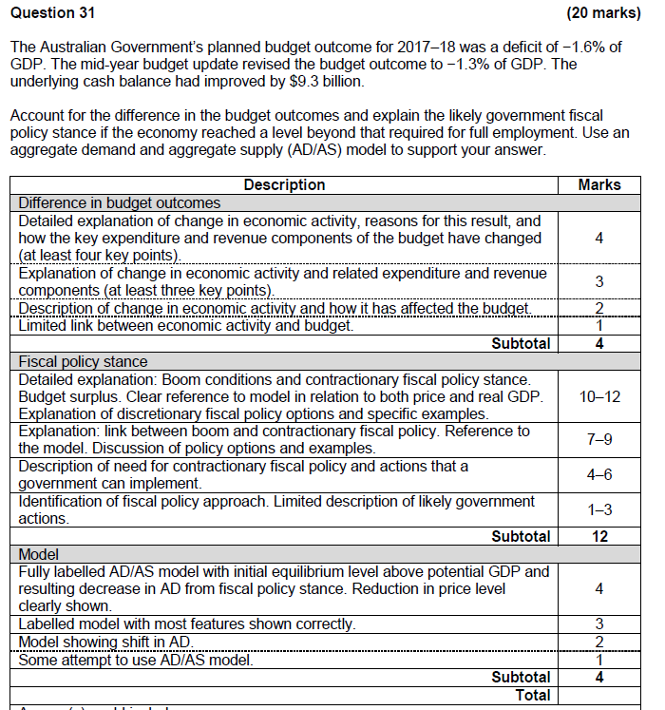

**Question 2 –**

(a) Describe the terms ‘structural budget balance’ and ‘cyclical budget balance’ and discuss their significance. (8 marks)

(b) Explain two advantages and two disadvantages of using fiscal policy over monetary and supply-side measures. (12 marks)

**Question 3 – Extended Answer Question**

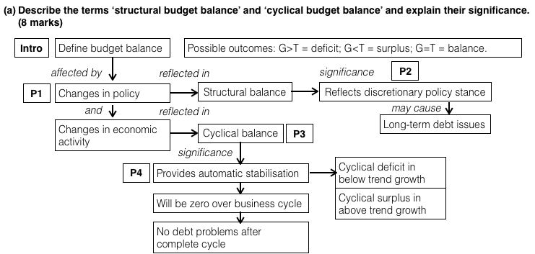

|  |  |
| --- | --- |
| Intro | The overall budget balance or outcome is the difference between government spending (G) and taxation revenue (T) during the financial year. If G > T the budget is in deficit and if G < T it is in surplus. |
| Body paragraph 1 | Both government spending and taxation are affected by changes in government policy and changes in the level of economic activity. The balance of government spending and tax linked to the delivery of policy measures (such as spending on infrastructure) is called the structural balance, and the balance of government spending and taxation linked to the level of the economy (e.g. spending on welfare benefits) is called the cyclical balance. |
| Body paragraph 2 | The significance of the structural balance is that it reflects a deliberate or discretionary policy choice. A structural surplus or deficit can persist over time and therefore can affect the level of sovereign or public debt. |
| Body paragraph 3 | The significance of the cyclical balance is that it provides an element of automatic stabilisation to the economy. For example, when the economy is in a downturn, tax revenue falls and government welfare spending rises, leading, in turn to a net injection into the economy and a boost to economic activity. |
| Body paragraph 4 | Over the life of one business cycle the cyclical balance will be zero and, therefore, there will be not be a change in sovereign debt over time. In the short-run, however, it is possible for the overall budget to be in surplus or deficit but still to be structurally balanced or neutral. |
| Conclusion | The Government’s plans for spending and taxation revenue are seldom realized. In addition to there being unanticipated changes in the level of economic activity, other assumptions or events that underpin the budget figures may turn out to be inaccurate (e.g. the price of iron ore, the exchange rate, spending needed for border security and military engagements). |

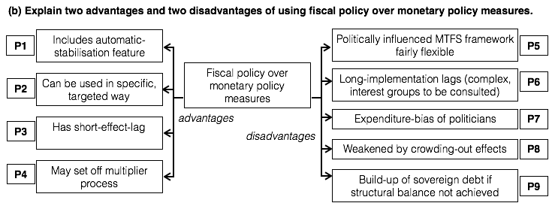

|  |  |
| --- | --- |
| Intro | Fiscal policy has both advantages and disadvantages over monetary policy when used to mange the aggregate demand in the economy in order to achieve macroeconomic objectives. |
| Body paragraph 1 | (S) The first advantage of fiscal policy is that, through the structure of some areas of government spending and taxation, it contains a built-in automatic stabilisation mechanism.  (E) When, for example, the economy is growing above trend, taxation revenue will rise, e.g. because of higher income tax, company tax and GST receipts, and government spending on welfare will fall. This provides a leakage from the economy and causes the growth rate to fall. There is no automatic stabiliser in monetary policy. |
| Body paragraph 2 | (S) The second advantage is that fiscal policy measures can be specific and targeted.  (E) For example, the government can spend money on health care and transport infrastructure in Tasmania and not elsewhere. The impact of monetary policy is, by contrast, blunt and general, as there is only one cash rate that applies to everyone. |
| Body paragraph 3 | (S) Fiscal policy measures are quick to impact on the economy and, therefore, have a relative short effect lag.  (E) For example, work can start on some construction projects quite quickly. By contrast monetary policy has a long effect lag. |
| Body paragraph 4 | (S) Fiscal policy stimulus can set-off a strong multiplier effect, especially in the short-run.  (E) Spending in one area may generate incomes and spending in associated areas across the economy. Multiplier effects from monetary policy might be weaker and slow to impact on the economy. |
| Body paragraph 5 | (S) However, fiscal policy also has a number of weaknesses compared to monetary policy. The first weakness is that the framework for the conduct of fiscal policy, the medium-term fiscal strategy (MTFS) is fairly flexible and capable of reinterpretation to meet political needs.  (E) The framework for monetary policy, the inflation target, is clear and the RBA operate at arms length from government influence. |
| Body paragraph 6 | (S) The second disadvantage is the long implementation lag associated with fiscal policy.  (E) Changing government spending and taxation is a complex process and involves consultation and compromise with many different interest groups. The process of forming a budget lasts for months. By contrast, monetary policy changes can be regularly by the RBA Board. |
| Body paragraph 7 | (S) The third weakness of fiscal policy is the expenditure bias of politicians. Politicians are biased towards spending money, rather than balancing the books.  (E) Politicians need to be reselected in their constituencies and maintain popularity. Monetary policy is, however, administered by independent members of the Board chosen for their expertise and public standing. |
| Body paragraph 8 | (S) The fourth weakness of fiscal policy is that the multiplier process may be weakened by side-effects, so the end effect will be small and possible negative.  (E) These side-effects include financial, exchange rate and resource crowding out. Financial crowding out is caused by extra government borrowing pushing up interest rates, exchange rate crowding out is caused by the higher interest rates, and resource crowding results in a fall in private sector spending as it is replaced by government spending. |
| Body paragraph 9 | (S) Finally, expansionary fiscal policy measures lead to a build-up of sovereign or public debt.  (E) Government spending in excess of taxation revenue has to be financed by borrowing or a sale of assets. Borrowing leads to debt. Debt has to be serviced and sustained over time that leads to a drain on revenue and involves an opportunity cost of foregone spending in other areas. |

**Question 3**

(a) Outline the government’s medium term fiscal strategy. (6 marks)

(b) Discuss the whether the elimination of the budget deficit is an appropriate fiscal strategy. (14 marks)

**Question 4 – Extended Answer Question**

|  |  |
| --- | --- |
| Title | (a) Outline the government’s medium term fiscal strategy.  (b) Discuss the whether the elimination of the budget deficit is an appropriate fiscal strategy. |
| PART A | The medium term fiscal strategy is designed to show that the Government’s management of the nation’s finances is responsible and disciplined. The strategy is designed to deliver ‘budget repair’ by a steady reduction in the budget deficit until a budget surplus is achieved in 2020-21, as long as growth picks up and unemployment falls.  More specifically, there are four aspects to the Government's medium‑term fiscal strategy. The first is the achievement of budget surpluses, on average, over the course of the economic cycle. The second is the reduction in Government spending as a share of GDP from its present level of 25.9%. The third is to cap the tax-to-GDP ratio at 23.9%. The final aspect is the stabilisation and then reduction the level of net public debt over time. The MTFS is flexible in the sense that the timetable for budget repair can be altered to meet unexpected economic shocks |
| PART B  Reasons for budget repair  Body paragraph 1 | There are six reasons why a reduction in the budget deficit is not appropriate in current circumstances of sluggish below trend growth and 6% unemployment.  The first reason is that automatic fiscal stabilisation tends to generate cyclical budget deficits when growth is below trend because, when growth is weak, tax revenue tends to fall (e.g. due to lower income tax and GST payments) and some areas of government spending tends to rise (e.g. on welfare and social security). Eliminating the deficit when the economy is weak would counter the impact of automatic stabilisation. |
| Body paragraph 2 | The second reason is that a budget deficit can be used to provide a Keynesian style injection and ‘pump prime’ the economy. This stimulus would be effective if the multiplier process is positive and of significant strength and is not weakened by sovereign or public debt issues. |
| Body paragraph 3 | The third reason is that the RBA seems unable to stimulate the economy by cutting interest rates. Internationally central bankers appear to have no idea what to do to boost economic activity. |
| Body paragraph 4 | The fourth reason is that political constraints mean there is a long implementation lag in delivering supply-side economic reforms, reform that, at the best of times, have a long effect lag before they provide a boost to growth. |
| Body paragraph 5 | The fifth reason is that government spending on infrastructure can be financed at historically low interest rates. |
| Body paragraph 6 | Finally steps to achieve deficit reduction have been perceived as unfair and unduly harsh on vulnerable groups. |
| Counter-argument  Body paragraph 1 | However, there are a similar number of counter-arguments to suggest that deficit reduction is appropriate. First, there is a belief that the level of sovereign or public debt is a cause for concern. Debt has to be serviced (interest paid) and sustained (refinanced). This may become problematic when there is a new financial crisis and interest rates are not so low. There will be no leeway to provide a fiscal stimulus in the next financial crisis. |
| Body paragraph 2 | Second, the effective size of the multiplier is, in fact, low and may even be negative. This results from financial, exchange rate and resource crowding out. Financial crowding out is caused by government borrowing pushing up interest rates, exchange rate crowding out results from the rise in interest rates and resource crowding out leads to government spending replacing private sector spending. |
| Body paragraph 3 | Third, there is concern that government spending will simply be frittered away (e.g. on subsidies and transfers) without leaving a legacy of infrastructure or productive industries. Government spending ‘feather-beds’ people in society and reduces moral hazard. Government spending tends to favour rent-seekers and special interest groups. |
| Body paragraph 4 | Fourth, the RBA would reject the view that monetary policy is not working. The current interest rate settings are ‘accommodative’ and provide the foundation for planned investment spending in the private sector. |
| Body paragraph 5 | Fifth, restraining government spending is important to counter the expansionary bias of politicians who would rather spend money than withdraw programs. |
| Conclusion | Decision may be political rather than economic. Depends also on whether other policies (monetary and supply-side) start to have an impact. |

**Question 26 (12 marks)**



Refer to the graph given below and answer the questions that follow.

(a.i.) Calculate the estimated Budget Outcome for 2018-19. (1 mark)

(a.ii) The annual economic growth rate in 2017-18 _____________ (1 mark)

(b) Discuss **two** weaknesses regarding the current fiscal policy stance. (4 marks)

(c) Explain how the change in Australia’s economic growth rate (EGR) from 2015-16 to 2017-18 would have impacted the Budget Outcome of 2017-18.

(6 marks)

**Question 26 (12 marks)**

Refer to the graph given below and answer the questions that follow.

|  |  |
| --- | --- |
| **Description** | **Marks** |
| (a.i.) Calculate the estimated Budget Outcome for 2018-19.  **-$25000m to -$30000m deficit (261900m deficit)**  (a.ii) 1.8% - no marks if % sign is missing | 1  1 |
| **Total** | **1 + 1** |

(b) Discuss two weaknesses regarding the current setting of the monetary policy. (4 marks)

|  |  |
| --- | --- |
| **Description** | **Marks** |
| * Current setting – expansionary -Cash rate @1.5% * In a downturn – long impact lag * Low confidence means low interest rates – ineffective * If interest rates left too low for too long (since August 2016) then it may lead to liquidity trap * Blunt instrument – hurting savers – low returns * Lowers ird (interest rate differential) – lowers Foreign investment | 1m  Any 2 points explained  (0.5 for identifying and 1 m for explanation |
| **Total** | **4** |

(c) With reference to the data given, explain how the change in Australia’s economic growth rate from 2015-16 to 2017-18 rate is likely to impact the Budget Outcome. (6 marks)

|  |  |
| --- | --- |
| **Description** | **Marks** |
| * From 2015-16 to 2017-18 – domestic EGR has decreased from 2.5% (approx..) to 1.8% approximately and hence the Budget balance has decreased from approx. $30000m deficit to $ 50000m deficit. * Mainly due to automatic stabilisers – in a downturn revenue decreases due to decrease in income tax receipts, GST receipts and company tax receipts and also due to increase in welfare spending * Could be due to discretionary stabilisers deployed to restore stability in the economy | 1-2m  3-4  1 |
| **Total** | **6** |