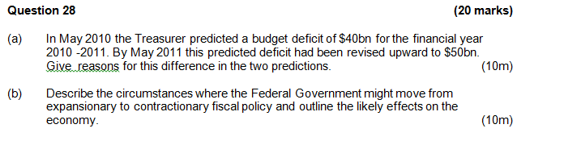

 

**Question 26 (12 marks)**

**Contributions to Growth 2012-13**

(Treasury’s forecast for 2012-13)

Source: www.treasury.gov.au

(a) (i) The economic growth rate expected for 2012-2013 is __________ (1 mark)

(ii) The largest contributor to economic growth is expected to be __________. (1 mark)

(b) In 2011-12 business investment increased by 5.6%. Explain two possible reasons for the forecast larger increase in business investment in 2012-13. (4 marks)

_______________________________________

______________________________________

(c) Using data from the graph, comment on expected economic activity in the Australian economy over the next few years. (6 marks)

_______________________________________

_______________________________________

_______________________________________

_______________________________________

_______________________________________

_______________________________________

_______________________________________

_______________________________________

_______________________________________

_______________________________________

**Question 29 (20 marks)**

(a) *In September 2012, as a result of plummeting iron ore prices, Fortescue Metals Group and BHP shelved expansion plans in the North West totalling approximately $22 billion.*

Using a diagram(s), demonstrate and explain how this decision by mining firms could have a multiplied effect on economic activity in Australia. (12 marks)

(b) Explain reasons for the slowdown in growth of consumption and investment in recent years. (8 marks)



**Question 26 (12 marks)**

(a)(i) The economic growth rate expected for 2012-2013 is __________. (1 mark)

|  |  |
| --- | --- |
| **Description** | **Marks** |
| 3% | 1 |
| **Total** | **1** |

(a)(ii) The largest contributor to economic growth is expected to be __________.(1 mark)

|  |  |
| --- | --- |
| **Description** | **Marks** |
| Business investment | 1 |
| **Total** | **1** |

(b) In 2011-12 business investment increased by 5.6%. Explain two possible reasons for the forecast larger increase in business investment. (4 marks)

|  |  |
| --- | --- |
| **Description** | **Marks** |
| High prices for iron ore/coal →↑I to take advantage of higher profits.  Change in MEC/ir ratio eg improved business confidence.  Decrease in ir, thus higher profit →↑I. Example required.  Other eg technology change | 2  2  2  2 |
| **Total** | **4** |

(c) Using data from the graph, comment on expected economic activity in the Australian economy over the next few years. (6 marks)

|  |  |
| --- | --- |
| **Description** | **Marks** |
| GDP and Business Investment indicate increased activity (output, spending, Y and N).  Budget surplus (-ve public spending) is indicative of a growing economy.  Low C growth may be due to higher savings and thus lower activity in the future.  Low (non-existent) dwelling I (leading indicator) indicates future fall in activity  Other eg two-speed economy | 4  2  2  2  2 |
| **Total** | **6** |





