1)

* Prior to birth, millions of **oogonia** develop in the ovaries.
* Diploid number of chromosomes (*2n*)
* Divide by mitosis.

2)

* By birth, oogonia have undergone growth phase to become **primary oocytes** (400,000).
* Begins prophase stage of meiosis 1 but arrests at this stage (chromosomes coil, become visible, homologous pairs form, crossing-over).
* Surrounded by single layer of cells forming **primary follicle.**

3)

* At puberty, follicle growth and maturation occurs.
* Primary oocyte completes meiosis 1, producing two daughter haploid (*n*) cells, unequal in size.
* **Secondary oocyte -** Contains haploid *n* chromosomes and almost all of cytoplasm
* **First polar body** - Contains haploid *n* chromosomes but little cytoplasm. May undergo meiosis 2 to produce 2 polar bodies but all eventually disintegrate.

4)

* **Secondary oocyte** commences meiosis 2 but stops at metaphase 2.
* **Ovulation** occurs – follicle ruptures, secondary oocyte and its polar body is expelled and enters uterine tube.
* If fertilization occurs, meiosis 2 completes. Produce 2 cells of unequal size – smaller cell (**second polar body**) and larger cell (**ovum).**
* Nuclei of ovum and sperm fuse, forming diploid **zygote (2n).** Develops into **embryo.**

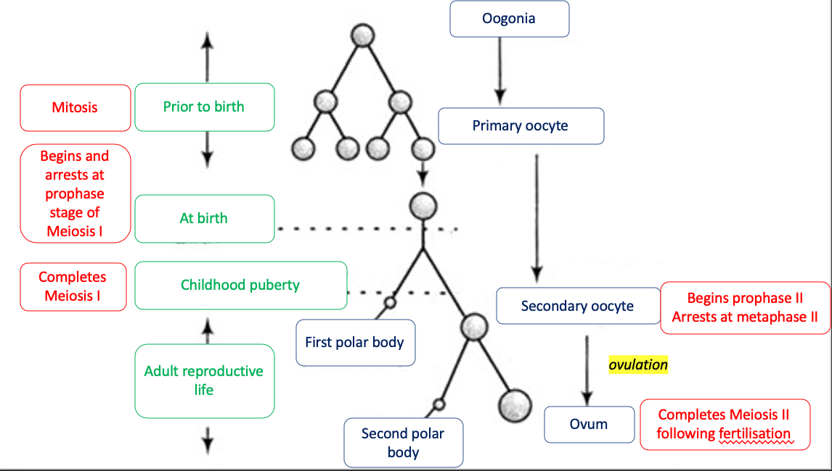

|  |  |  |
| --- | --- | --- |
| **Spermatogenesis** |  | **Oogenesis** |
| Puberty | When does it begin? | Prior to birth |
| Ongoing from puberty | When does Meiosis I occur? | From puberty (arrests at metaphase 2) |
| Ongoing from puberty | When does Meiosis II occur? | From fertilisation |
| Ongoing until old age | When does it end? | Ongoing until menopause |
| *From 1x spermatogonium*  8x spermatozoa, haploid (n), head-midpiece-tail, motile | Products  (name, quantity, # of chromosomes, shape, motility) | *From 1x oogonium*  2x ova, haploid (n), round cell, non-motile |