Worksheet 15.1 Pedigree charts

**1** Examine the pedigree below and answer the following questions.

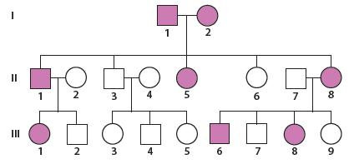

**a**  What type of inheritance is shown? Explain.

|  |
| --- |
|  |
|  |
|  |

**b** Using the symbols ‘A’ and ‘a’, give the genotypes for:

• Individual (I2):

• Individual (II5):

• Individual (III6):

• Individual (II2):

• Individual (III4):

• Individual (III9):

**2** Examine the pedigree chart below.

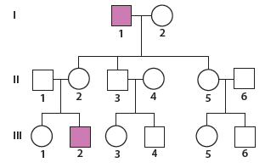

**a** What evidence (from the pedigree) demonstrates that the characteristic is an X-linked recessive trait?

|  |
| --- |
|  |
|  |
|  |

**b** State a possible genotype for individual (III2) and provide a key for the symbols used.

|  |
| --- |
|  |
|  |

**3** The following pedigree chart begins with a mating between a man with black hair and a woman with blonde hair.

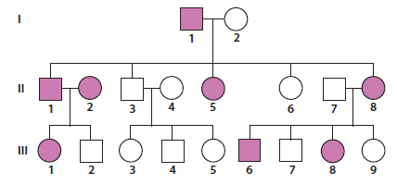

**a** What pattern of inheritance is shown? Explain.

|  |
| --- |
|  |
|  |
|  |

**b** Using the symbols ‘B’ and ‘b’, determine the genotypes for all individuals in the pedigree. (Show all genotypes on the pedigree.)

**c** Are there any individuals whose genotypes you are unsure about? If so, which individuals and why?

|  |
| --- |
|  |
|  |

**4** Examine the pedigree chart below.

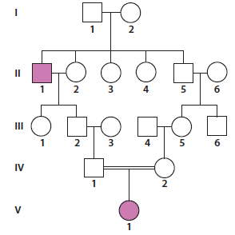

**a** What is the relationship between individual (IV1) and individual (IV2)?

|  |
| --- |
|  |
|  |
|  |

**b** Can the genotype for individual (V1) be explained by her parents’ marriage? Why or why not?

|  |
| --- |
|  |
|  |
|  |

**5** Examine the pedigree below and answer the following questions.

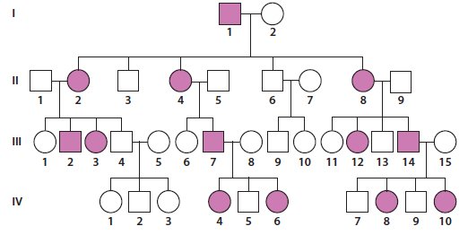

**a** What type of inheritance is shown? Explain.

|  |
| --- |
|  |
|  |
|  |

**b** Give the genotypes for the following individuals.

• Individual (I2):

• Individual (II5):

• Individual (III14):

• Individual (II2):

• Individual (III3):

• Individual (IV5):

**6** Jacque has the condition Huntington’s disease. She is married to Jason and their first son and first daughter also have the condition. The second son and second daughter do not. Jacque is the youngest of five children. Her unmarried sister Julie and the first-born Jack also have the condition. Jack has two children and the daughter does not have Huntington’s disease, but the son does.

**a** Draw a pedigree chart for the family described, labelling each individual with possible genotypes.

**b** What can you tell about the genotypes of Jacque’s parents? Explain.

|  |
| --- |
|  |

**c** What is the phenotype of Jack’s wife? Explain.

|  |
| --- |
|  |
|  |
|  |