|  |  |  |
| --- | --- | --- |
| |  |  | | --- | --- | | |  | | --- | | *Human Perspectives ATAR Units 1 & 2* | | |

Worksheet 15.1 Pedigree charts

Answers

**1** Examine the pedigree below and answer the following questions.

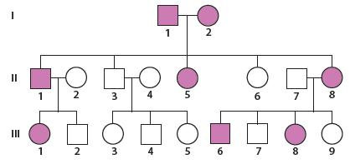

**a**  What type of inheritance is shown? Explain.

Answer: Autosomal dominant. The condition appears in every generation. There is equal representation of males and females with the trait. Affected parents Gen I 1 and 2, have produced unaffected offspring Gen II 3 and 6.

**b** Using the symbols ‘A’ and ‘a’, give the genotypes for:

• Individual (I2): Aa

• Individual (II5): AA / Aa

• Individual (III6): Aa

• Individual (II2): aa

• Individual (III4): aa

• Individual (III9): aa

**2** Examine the pedigree chart below.

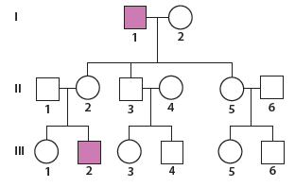

**a** What evidence (from the pedigree) demonstrates that the characteristic is an X-linked recessive trait?

*Answer:* Only males affected, the characteristic has skipped a generation.

Gen I 1 has produced a carrier daughter Gen II 2, who has produced the affected son Gen III 2.

**b** State a possible genotype for individual (III2) and provide a key for the symbols used.

*Answer:* XaY

A = dominant allele a = recessive allele

XY Male genotype

**3** The following pedigree chart begins with a mating between a man with black hair and a woman with blonde hair.

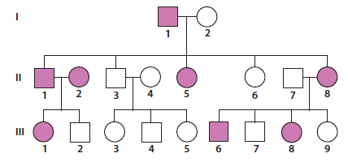

**a** What pattern of inheritance is shown? Explain.

*Answer:* Autosomal dominant, with black hair being dominant over blonde hair.

Affected parents Gen II 1 & 2 have produced an unaffected daughter Gen III 2.

The characteristic appears in every generation and has equal representation in males and females.

**b** Using the symbols ‘B’ and ‘b’, determine the genotypes for all individuals in the pedigree. (Show all genotypes on the pedigree.)

*Answer:*

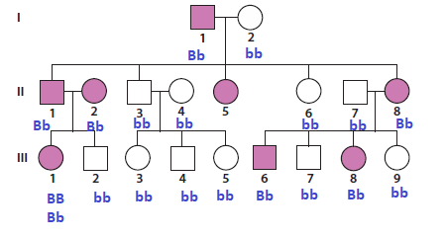

**c** Are there any individuals whose genotypes you are unsure about? If so, which individuals and why?

*Answer:* Gen III 1. Individual could be BB (homozygote dominant) or Bb (heterozygote) as their parents are both heterozygote.

**4** Examine the pedigree chart below.

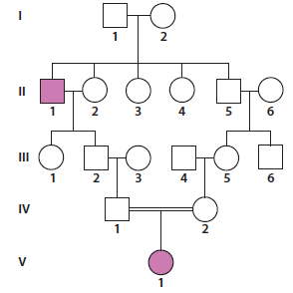

**a** What is the relationship between individual (IV1) and individual (IV2)?

*Answer:* They are cousins

**b** Can the genotype for individual (V1) be explained by her parents’ marriage? Why or why not?

*Answer:* Yes. The condition is very rare, having only appeared once prior three generations before Gen V 1. The closeness of relation (cousins) has resulted in the two recessive alleles being inherited, whereas had the relationship not been so close, the chance of a homozygote recessive individual would be significantly less.

**5** Examine the pedigree below and answer the following questions.

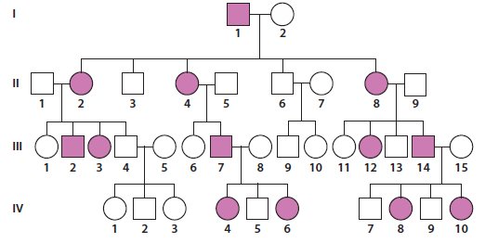

**a** What type of inheritance is shown? Explain.

Answer: Autosomal dominant. Characteristic appears in every generation. Each affected individual has at least one affected parent. Equal representation in males and females.

**b** Give the genotypes for the following individuals.

• Individual (I2): aa

• Individual (II5): aa

• Individual (III14): aa

• Individual (II2): Aa

• Individual (III3): Aa

• Individual (IV5): aa

**6** Jacque has the condition Huntington’s disease. She is married to Jason and their first son and first daughter also have the condition. The second son and second daughter do not. Jacque is the youngest of five children. Her unmarried sister Julie and the first-born Jack also have the condition. Jack has two children and the daughter does not have Huntington’s disease, but the son does.

**a** Draw a pedigree chart for the family described, labelling each individual with their possible genotypes.

Answer:

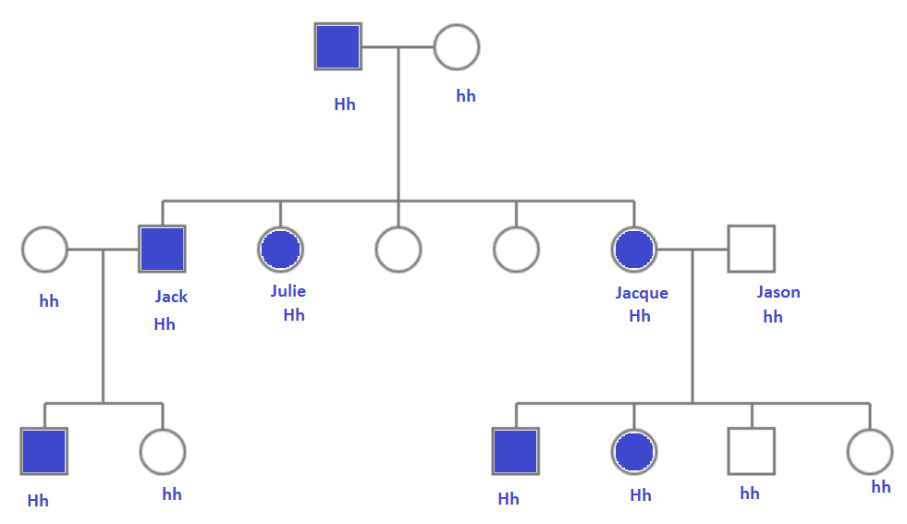

**b** What can you tell about the genotypes of Jacque’s parents? Explain.

Answer: At least one of her parents must have also had Huntington’s disease. Possibly both were heterozygous for Huntington’s disease.

**c** What is the phenotype of Jack’s wife? Explain.

*Answer:* Jack’s wife must be homozygous recessive, as their daughter does not have the disorder.

Huntington’s disease is an autosomal dominant disorder, only 1 allele is required to develop the disease. To produce a non-affected daughter, Jack must be a heterozygote and his wife must be homozygous recessive.