**Digestive System – Notes**

Alimentary canal:

1. Mouth cavity.
2. Pharynx.
3. Oesophagus.
4. Stomach.
5. Pyloric sphincter.
6. Duodenum.
7. Small intestine.
8. Caecum.
9. Ascending colon.
10. Transverse colon.
11. Descending colon.
12. Rectum.
13. Anus.

Accessory organs: Liver, gall bladder and pancreas.

The organs of the digestive system carry out the basic activities:

* Ingestion of food and water.
* Mechanical digestion of food.
* Chemical digestion of food.
* Movement of food along the alimentary canal.
* Absorption of digested food and water into the blood and lymph.
* Elimination of material that isn’t absorbed.

**Alimentary canal**:

* **Mouth cavity** does mechanical digestion by teeth and chemical digestion of starch by saliva (through the enzyme salivary amylase). Saliva contains salivary amylase enzymes to chemically break down carbohydrates into disaccharides.

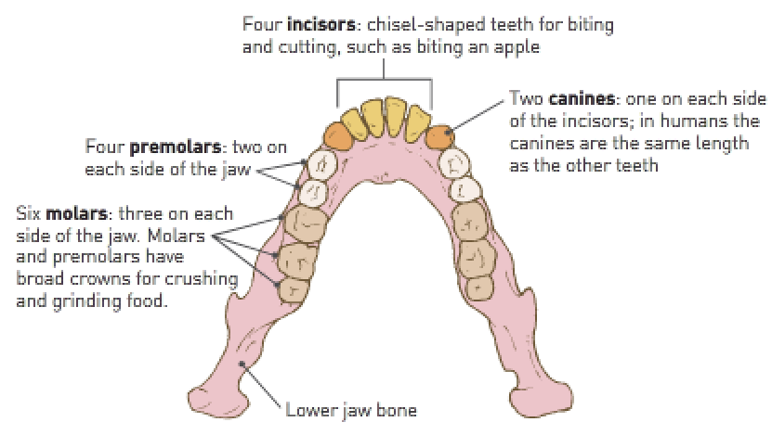

* The **salivary glands** are 3 pairs of glands that produce saliva which dissolves food so it can be tasted. It contains mucus which lubricates the mouth and food and holds food in a lump for swallowing. It also contains the enzyme salivary amylase which begins starch digestion.
* The **oesophagus** carries food from the mouth to the stomach via peristalsis (contraction of smooth muscle). It passes through the diaphragm into the abdominal cavity.

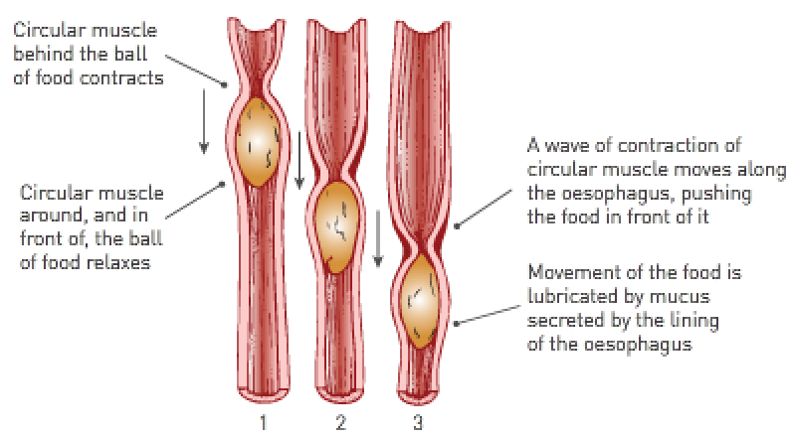

* The **stomach** does mechanical digestion by churning action and chemical digestion by pepsin which begins protein digestion.

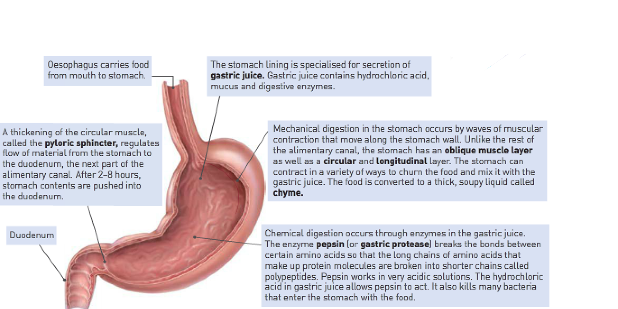

* The **pyloric sphincter** is a band of muscular tissue which regulates the flow of material from the stomach to the duodenum.
* The **duodenum** is the first part of the small intestine.
* The **small intestine** is about 6m long. Its lining secretes intestinal juice which contains many enzymes. The internal surface is lined with villi for absorption of digested food.
* The **caecum** is the first part of the large intestine.
* The **ascending colon, transcending colon** and **descending colon** are the largest parts of the large intestine. They absorb water, minerals and vitamins.
* The **rectum** is the final part of the large intestine where faces is formed.
* The **anus** is an opening surrounded by the anal sphincter. It’s a muscle which can be voluntarily controlled.

**Accessory organs**:

* The **liver** produces bile which is stored and concentrated in the gall bladder. Bile emulsifies lipids in the small intestine.
* The **gall bladder** stores bile and releases it into the small intestine where the bile emulsifies lipids.
* The **pancreas** produces pancreatic juice which contains enzymes for digesting proteins, lipids, and nucleic acids.

Stomach:

* Gastric juice is responsible for chemical digestion in the stomach.
* Gastric juice is secreted by gastric glands which are located in gastric pits.
* Churning of the stomach muscles causes the food to mix with gastric juices (mechanical digestion).
* Note: Gastric juice contains HCl and gastric protease enzymes (called pepsin).
* Once the food is mixed with gastric juice, it’s called chyme.
* Pepsinogen + HCl Pepsin
* Gastric pits are found in the stomach lining (mucosa).
* Pyloric sphincter at the lower end of the stomach constricts to prevent the stomach contents moving through unless pushed along by peristalsis.

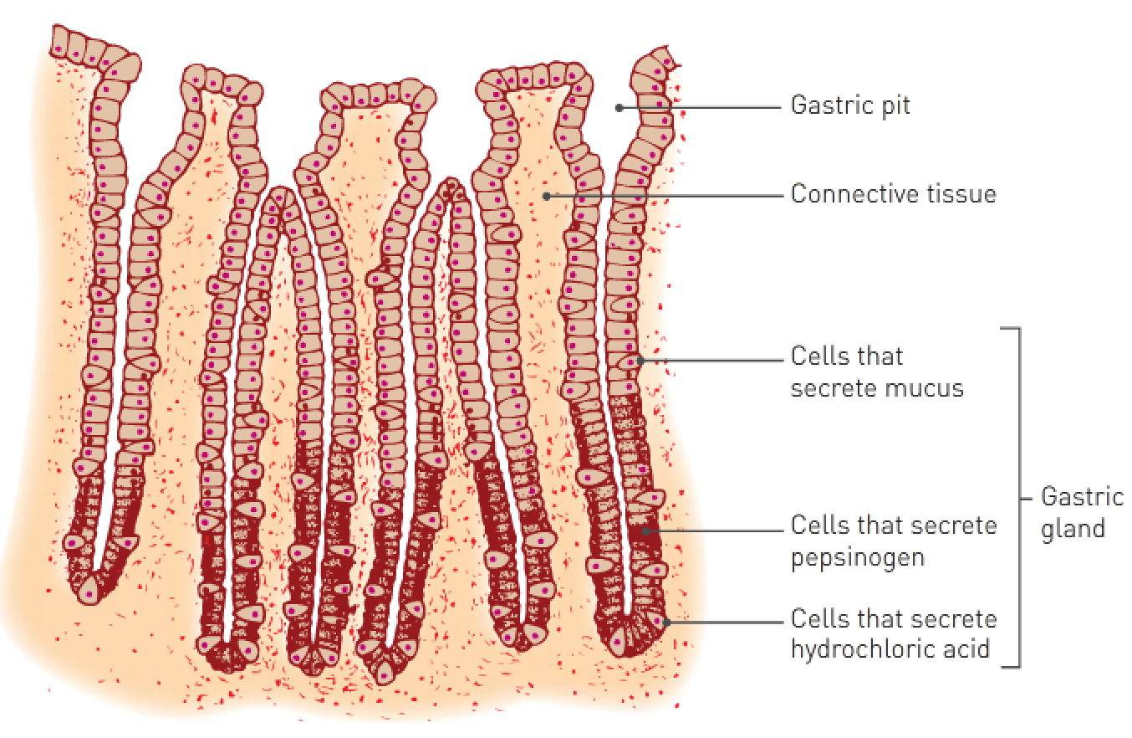

Small intestine:

* The part that connects to the stomach is called the duodenum.
* Stomach contents empty into the duodenum along with pancreatic juice and bile that empty into the duodenum from the common bile duct.
* The duodenum has an alkaline pH so that HCl from the stomach is neutralised.
* Mechanical digestion occurs through a “sloshing” process called segmentation.
* Bile doesn’t contain any digestive enzymes, but bile salts are important in the digestion of fats; mechanical digestion occurs through a process called emulsification (breaking down of fats by bile).
* Contains 3 juices: Intestinal juice (secreted by glands in the lining), pancreatic juice (secreted by the pancreas) and bile (secreted by the liver but stored in the gall bladder).

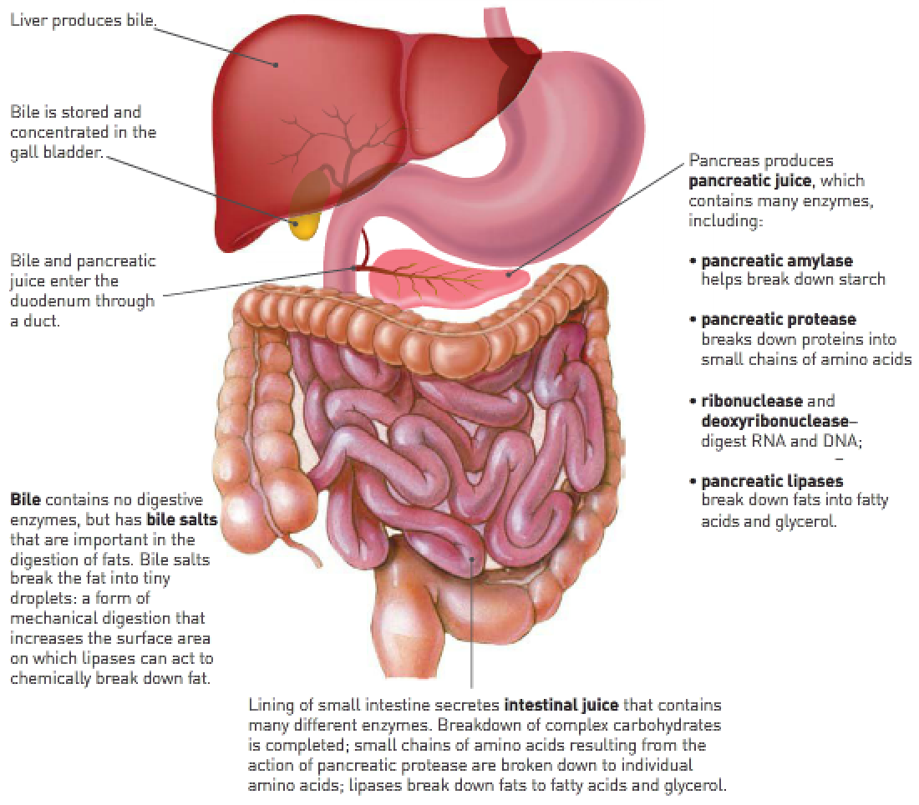

Pancreatic juice contains:

* Pancreatic protease (trypsin) – Breaks down proteins and polypeptides into peptides.
* Pancreatic amylase – Breaks down starch into disaccharides.
* Pancreatic ribonuclease + deoxyribonuclease (nucleases) – Breaks down RNA and DNA.
* Pancreatic lipase – Breaks down lipids into fatty acids and glycerol.

Intestinal juice contains:

* Intestinal amylase – Breaks down disaccharides into simple sugars (glucose).
* Intestinal lipase – Breaks down lipids into fatty acids and glycerol.
* Intestinal peptidase – Breaks down peptides into amino acids.

A large surface area of the small intestine is achieved in a number of ways:

* Small intestine is very long (about 6m).
* Inner lining (mucosa) has folds that extent into the interior.
* Mucosa has small, finger-like projections called villi that extend from the folded surface.
* Cells covering the outside of the villi have tiny microscopic projections from their external surfaces called microvilli.

Absorption:

* The process of glucose and amino acids moving from the small intestine into the bloodstream (capillaries) and chylomicrons moving from the small intestine into the lymphatic system (lacteal).
* The walls of the small intestine have many folds called villi.
* Glucose and amino acids move from the small intestine space into the villus capillaries via **active transport**.
* Chylomicrons split up into fatty acids and glycerol and move via **simple diffusion** into the lacteal (lymphatic system).
* Fatty acids and glycerol recombine in the cells of the villi to form fats and, along with the fat-soluble vitamins, enter the lacteals.
* Water and water-soluble vitamins move into the capillaries.
* Fat-soluble vitamins move into the lacteal.

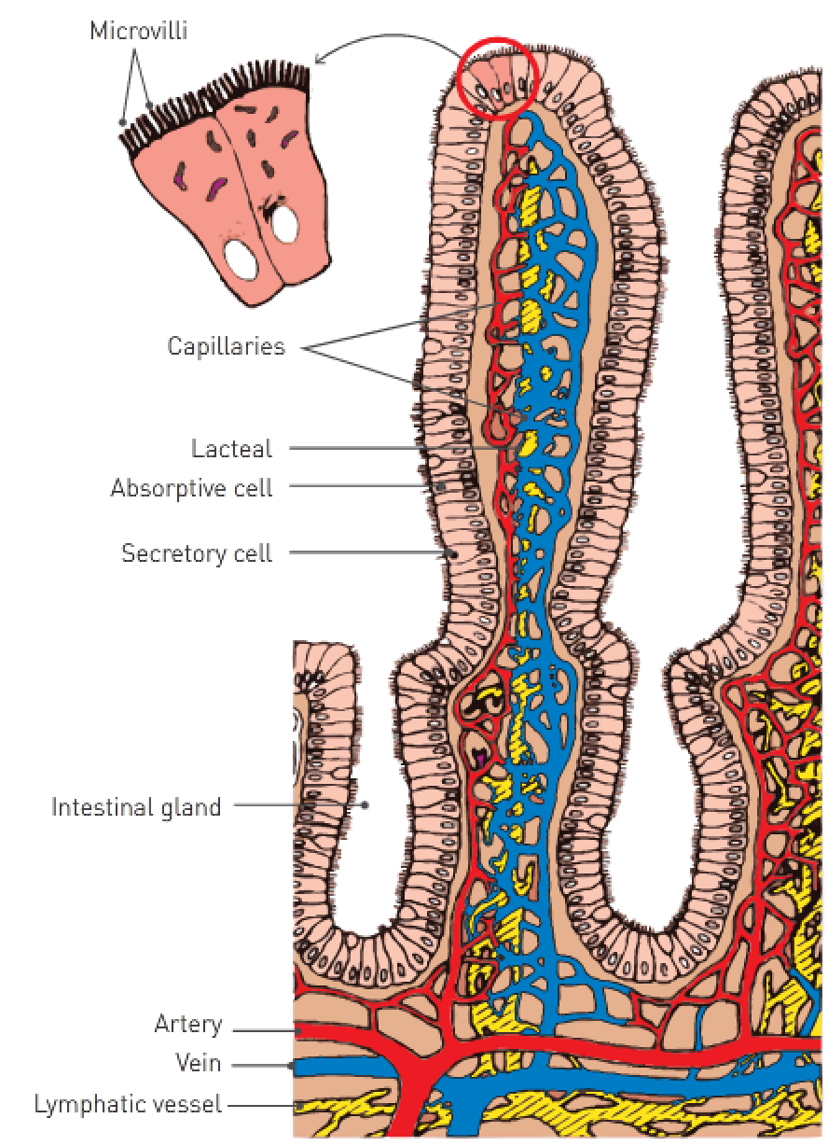

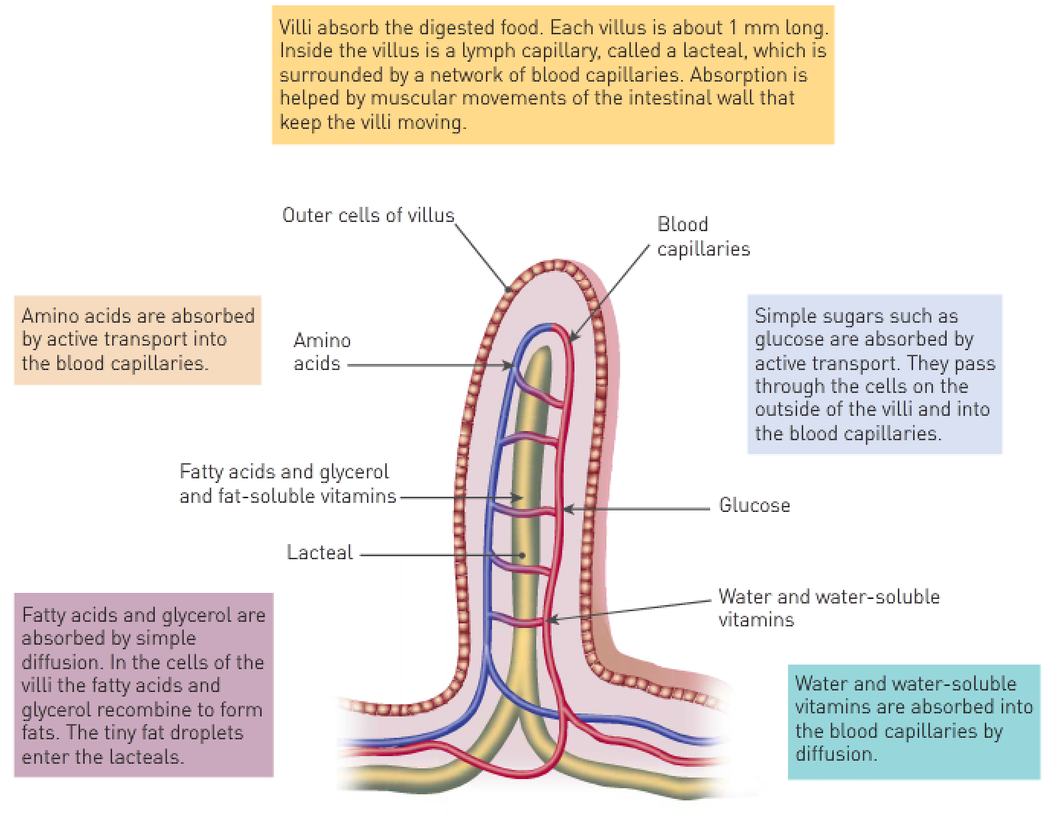

* Glucose molecule 🡪 capillaries.
* Amino acid 🡪 capillaries.
* Fatty acids and glycerol (not coated in bile) 🡪 lacteal 🡪 subclavian artery 🡪 bloodstream.

The structure of the villus is ideally suited to its function of nutrient absorption because:

* Each villus is about 1mm long and is covered by a single layer of cells.
* Inside the villus is a lymph capillary called a lacteal that’s surrounded by a network of blood capillaries.
* Continual movement of the villi by the intestinal wall further enhances absorption.

Large intestine:

* A large amount of water is absorbed from the large intestine back into large intestines.
* Bacteria break down much of the remaining organic compounds.
* Vitamins and minerals are absorbed back into the blood. Note: Helpful bacteria assists this process.
* Indigestible wastes such as cellulose forms faeces which is eliminated from the anus.

|  |  |  |  |
| --- | --- | --- | --- |
| **Organ**: | **Mechanical digestion**: | **Chemical digestion**: | **Other functions**: |
| Mouth | Breaks food into smaller particles by chewing. | Saliva (which contains salivary amylase) begins starch digestion. | Food is dissolved in saliva so that it can be tasted. |
| Oesophagus |  |  | Carries food from the mouth to the stomach. |
| Stomach | Muscular contractions churn food; bile salts emulsify lipids. | Gastric juice (which contains pepsin) breaks down proteins to polypeptides. | Stores large quantities of food as it’s eaten and absorbs certain drugs including some alcohol. |
| Small intestine | Muscular contractions churn food; bile salts emulsify lipids. | Pancreatic juice and intestinal juice contain enzymes to break down nutrients. | Absorbs simple sugars, amino acids, fatty acids, glycerol, vitamins, mineral nutrients and water. |
| Large intestine |  |  | Absorbs water and vitamins; stores faeces; defecation. |

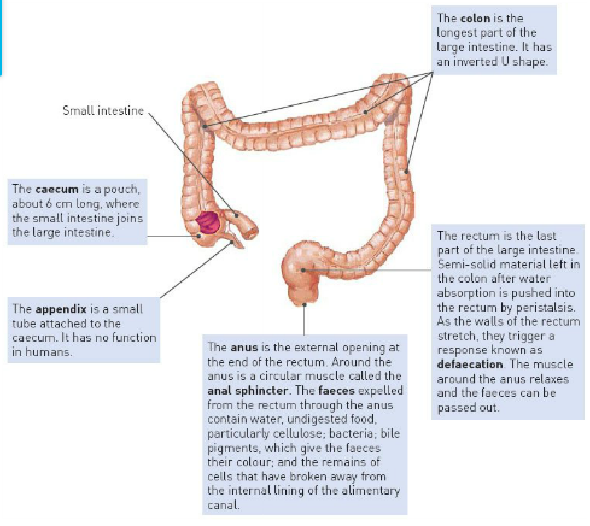

|  |  |  |
| --- | --- | --- |
| **Disorder**: | **Cause**: | **Symptoms**: |
| Constipation | * Too much water absorbed into the blood from the large intestine to cause hard, immovable faeces. * Lack of fibre in the diet. | * Stomach cramps. * Difficulty defecating. |
| Diarrhoea | * Virus or bacteria from food poisoning. * Insufficient amounts of H2O absorbed from the large intestine into the capillaries. | * Very watery, runny faeces. |
| Bowel cancer | * Uncontrollable division (mitosis) of cells in the large intestine. * A high intake of alcohol, smoking and a diet low in fibre and high in processed meats can cause bowel cancer. | * Pain in the stomach area. |
| Coeliac disease | * Body is unable to digest the protein gluten. As a result, the immune system attacks villi and absorption can’t occur. | * Constant hunger. * Muscle cramps. * Joint pain. |