Biotechnology

***Biotechnology uses cellular processes to make products that are of use to humans and genetic testing***

- DNA sequencing

- DNA profiling

- polymerase chain reaction

- gel electrophoresis

**The human genome**

- Human genome project 1990

- International research aimed at mapping the location of genes in all 46 chromosomes

- A ***Genome*** is the complete set of genetic information of an organism

- Project was completed in 2003

- 2100 genes located and identified

- 4000+ genetic disorders now identified

**DNA Sequencing – The order of A’s, T’s, C’s and G’s**

- Precise order of nucleotides in a sample of DNA

- Frederick Sanger 🡪 devised method most frequently used 🡪 ***Sanger Method***

- This technique allows a sequence of DNA to firstly be identified and then compared 🡪 Identify changes in sequences that have lead to changes in alleles 🡪 Point Mutation, insertions and deletions

- Predict whether a person will develop an inherited disease 🡪 options for effective treatment or possible prevention

**Structure of Nucleotides**

- 3 phosphates, deoxyribose sugar and nitrogen base

- nucleotides join together (bond) at the hydroxyl group (OH) on the sugar

- can only be joined in one direction 5’🡪3’

- DNA polymerase 🡪 enzyme that makes complimentary strand of DNA during DNA replication

**How does the Sanger Method for DNA sequencing work?**

- understanding that each nucleotide binds to the OH (hydroxyl) group of the previous sugar in a 5’ 🡪 3’ direction

- DNA polymerase requires the OH group to attach the next nucleotide

- No OH group 🡪 Addition of nucleotides stops

- This means……. We can manipulate DNA replication and make it “stop” when it adds a nucleotide without an OH group

- Stopping DNA replication at different places will make DNA strands of different lengths

Nucleotides can be made in a laboratory with or without the OH group

|  |  |  |
| --- | --- | --- |
| **Nucleotide** | **Deoxynucleotide (dNTP)**  **(With OH)** | **Dideoxynucleotide (ddNTP)**  **(Without OH)** |
| Adenine | dATP | ddATP |
| Thymine | dTTP | ddTTP |
| Guanine | dGTP | ddGTP |
| Cytosine | dCTP | ddCTP |

1. Take a section of DNA which requires sequencing
2. Separate the strands and select a single strand for replication (the new strand will be built in a 5’ to 3’ direction)
3. Choose a **DNA primer** complementary to start of DNA strand 🡪 DNA polymerase needs to know where to start from
4. Add **DNA polymerase**
5. Add free **Deoxynucleotides (dNTP – With OH)** for DNA polymerase to use to form a complementary strand
   1. dATP (Adenine)
   2. dTTP (Thymine)
   3. dGTP (Guanine)
   4. dCTP (Cytosine)
6. Add one type of **Dideoxynucleotide (ddNTP – Without OH)**

** Each type of ddNTP is **added on its own** to a separate sample;

ddTTP, ddGTP and ddCTP **

1. Each sample is placed in a separate well of an electrophoresis gel
2. Electric current is run through the gel  
   Negatively charged DNA moves towards the positive electrode  
   Smaller pieces of DNA move faster 🡪 travel further down the gel
3. Result is a series of bands called a DNA profile
4. Position of bands can be used to determine sequence of bases

* Must have OH (hydroxyl group) to add next phosphate
* Every single nucleotide in body has a hydroxyl group
* In a lab they have no OH group
* DNA polymerase must have hydroxyl group – if none then DNA polymerase can not (forcing it to stop)
* Primer – tells DNA polymerase where to start, base numbers does not include primer
* End up with lots of pieces of DNA which are different lengths
* Electrophoresis
  + Smaller pieces of DNA travel faster = travel further
  + Samples must be in different wells
  + To find out letters start at lowest number, then go to next band and so on…

<https://www.youtube.com/watch?v=IAf_6TZ6BYc>

**Polymerase chain reaction**

targeted process

* make copies
* look for the viral DNA – use PCR to amplify it
* primer indicates where polymerase need to start
* cycles of heating and cooling
* DNA polymerase- enzyme works at optimum 37 degrees – have to use higher then this for PCR so have to use a heat stable polymerase Taq Polymerase
* Need normal nucleotides (no synthetic ones)

Step by step process

1. Use restriction enzyme to cut DNA around region of interest
2. **Denaturing** 🡪 Sample is heated 🡪 strands of the DNA separate because they are exposed to heat (bonds are broken)
3. **Annealing** 🡪 sample is cooled 🡪 primer binds to each strand
4. **Elongation** 🡪 use Taq polymerase to build a complimentary strand of DNA with free nucleotides using both strands of DNA as a template

**DNA sequencing – Sanger method**

**Purpose and when it is used:**

To determine the precise order of nucleotides in a sample of DNA.

Allows a sequence of DNA to be compared 🡪 Detect changes in alleles 🡪 Point mutations, insertions and deletions

Predict whether a person will develop an inherited disease 🡪 Options for effective treatment or possible prevention

**Need:**

* Section of DNA
* Primer
* DNA polymerase
* Free deoxynucleotides **with** OH group (dNTP – dATP, dTTP, dGTP, dCTP) 🡪 Lots of these
* Dideoxynucleotides **without** OH group (ddNTP – ddATP, ddTTP, ddGTP, ddCTP ) 🡪 Small amount of these

**Steps:**

1. Take a section of DNA which requires sequencing
2. Separate the strands and select a single strand for replication
3. Choose a **DNA primer** complementary to start of DNA strand 🡪 DNA polymerase needs to know where to start from
4. Add **DNA polymerase**
5. Add **free deoxynucleotides (dNTP – With OH)** for DNA polymerase to form a complementary strand with; dATP dTTP dGTP dCTP
6. Add one type of **dideoxynucleotide (ddNTP – Without OH)** ** Each type of ddNTP is **added on its own** to a separate sample; ddATP ddTTP ddGTP ddCTP **

**SAMPLE 2 – ddTTP**

* DNA sample
* Primer
* dATP, dTTP, dGTP, dCTP
* **ddTTP – Small amount**

**SAMPLE 1 – ddATP**

* DNA sample
* Primer
* dATP, dTTP, dGTP, dCTP
* **ddATP – Small amount**

**SAMPLE 4 – ddCTP**

* DNA sample
* Primer
* dATP, dTTP, dGTP, dCTP
* **ddCTP – Small amount**

**SAMPLE 3 – ddGTP**

* DNA sample
* Primer
* dATP, dTTP, dGTP, dCTP
* **ddGTP – Small amount**

1. DNA polymerase constructs a complimentary strand of DNA using the free dNTP nucleotides (with OH group). When a ddNTP is added (without OH group) DNA polymerase is unable to add any more nucleotides. This creates pieces of DNA of various lengths.
2. Each sample (1 – 4) is placed in to a separate well of an electrophoresis gel
3. When an electrical current is passed through DNA moves from the negative electrode to the positive electrode. Shorter lengths of DNA travel faster and further through the gel
4. The bands of the gel can be analysed to detail a person’s DNA profile

**Polymerase Chain Reaction (PCR)**

**Purpose and when it is used:**

To amplify a section of DNA from a small sample 🡪 Forensics, fossils

To detect hereditary diseases 🡪 Amplify the desired sequence of DNA and detect mutations

Detect viral diseases 🡪 Collect sample from patient and amplify the section of viral DNA

**Need:**

* Section of DNA
* Restriction enzyme to cut DNA
* Primer
* Taq polymerase (heat stable – DNA polymerase wont work for PCR)
* Free nucleotides

**Steps:**

1. Restriction enzyme cuts DNA around region of interest
2. **Denaturing** 🡪 Sample is **heated** 🡪 Strands of DNA **separate**
3. **Annealing** 🡪 Sample is **cooled** 🡪 **Primer** binds to each strand
4. **Elongation** 🡪 **Taq polymerase** builds a complimentary strand of DNA with free nucleotides using both strands of DNA as a template
5. Sample is **heated** 🡪 Strands of DNA **separate** 🡪 Now **4 strands** are present
6. Cycle starts again; Sample is cooled 🡪 Primer binds to each strand (4)🡪 Taq polymerase builds a complimentary strand of DNA with free nucleotides using each strands of DNA as a template
7. Sample is heated 🡪 Strands of DNA separate 🡪 Now 8 strands are present
8. And so on…….. **Amplification!**

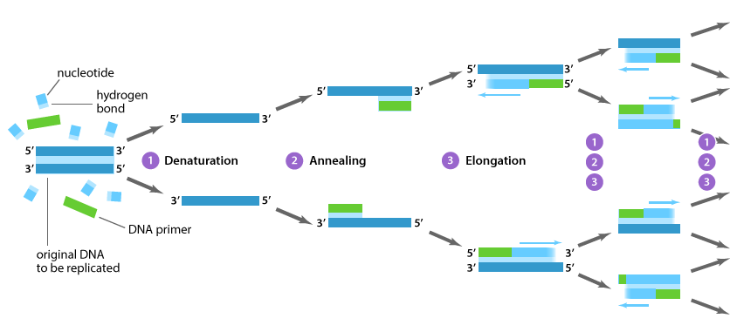**Recombinant DNA Technology**

**Purpose and when it is used:**

Introduce genes in to foreign cells

Potential for faulty gene replacement and cell replacement therapies

Enables large quantities of pure proteins to be manufactured for medical products 🡪 Insulin, growth hormone, factor VIII, FSH 🡪 Reduces risk of infection and immune response

Vaccinations 🡪 Hepatitis B

**Steps:**

1. **Restriction enzyme** cuts DNA with gene for desired protein 🡪 Straight cut with **blunt ends** OR Staggered cut with **sticky ends**
2. Same restriction enzyme cuts **plasmid** (with same ends) 🡪 Gene is inserted into plasmid (**splicing**) 🡪 **DNA ligase** ‘glues’ inserted gene in plasmid 🡪 Called a recombinant plasmid
3. Recombinant plasmid is **cloned** to form several copies
4. **Bacterial cell is treated** so it ‘takes up’ the recombinant plasmid
5. Bacteria will **produce** the desired protein 🡪 **Harvested** for use

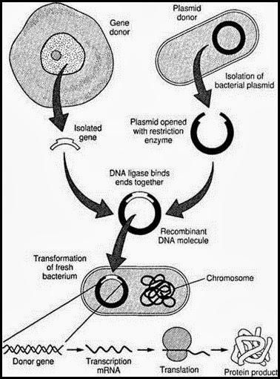

5. The order of bases in a section of DNA is TGGACG. The mRNA formed from this would be  
(a) UCCTGC.  
(b) UGGTCG.  
(c) ACCUGC.  
(d) ACCTGC.