**Relational Influences and Communication**

**Caelan Lu, Term 2**

**Extended Response: 14th May**

**Notes from Mindmap and PowerPoint**

**Relational Influences**

**TYPES OF RELATIONSHIPS: PRO-SOCIAL AND ANTI-SOCIAL:**

**PRO-SOCIAL**

* Voluntary, intentional helping behavior or acts of kindness that are intended to benefit others
* Altruistic behaviour

Empathy: an emotional response to another person’s feelings due to human’s ability to take the perspective of another person

* Motivation to help others

Empathy has two parts: a cognitive and affective component

|  |  |
| --- | --- |
| Cognitive component | Ability to understand another person’s emotional state |
| Affective component | The emotional response to this |

Murder Of Kitty Genovese (Bystander Effect)

* Murdered outside her home in New York, 1964
* Several bystanders, up to 38
* Several went to the window and watched and did nothing
* Except for one man who said “leave that women alone”
* This made Kitty’s attacker leave at first, but once he left, no other bystanders came to help the already injured women
* So the attacker came back and severely butchered (cut her hands off) and raped Kitty
* After the attacker left, several minutes later a bystander called the police and comforted Kitty until she died
* The attacker had a wife and family and later confessed to raping and murdering several other innocent women and children
* Bystander effect: the more people witnessing a violent attack, the less likely an individual will help

**Three Theories About Why People Help Others:**

1. Pro-social behaviour is inherited
2. Pro-social behaviour is learned
3. Pro-social behaviour is empathy

Inherited:

‘the tendency to help others is innate, instinctive and inborn‘

* Humans are biologically inclined to help other (family members)

Learned:

Pro-social behaviour can be learned, for example, rewarding good behaviour leading to changes in behavior

Empathy:

There are social influences on children’s pro-social behaviours.

When children (around 4) begin to come into greater contact with peers they start sharing and turn-taking.

Their ability to empathise develops:

* Take the perspective of another person
* Share and understand how another person is thinking, feeling and acting

Empathy Components:

* + The affective component is biological as it can be seen early in infancy
  + Affective component: emotional response
  + Babies crying when they hear other babies crying
  + The ­cognitive component is learned via interacting with others
  + Research suggests that we: act to reduce unpleasant feelings we are dealing with when we see a person in distress
  + We are more likely to help a person we can identify (even somebody in the same uniform or race)

**ANTI-SOCIAL**

Voluntary, intentional behaviour that is designed to hurt or cause distress in another person

* Opposite of pro-social
* An example is bullying

To combat bullying, some schools use restorative justice:

* Takes punishable incidents and turns then into opportunity to reflect
* Get students to understand the consequences of and take steps to change their behaviour

Anti-social behaviour is learnt:

* Children brought up in abusive and low affection households show higher levels of aggression
* Exposure to violent video-games increases aggression and can lead to physiological desensitization

Research by Carnagay (2006)

* College students who played video games felt numb when exposes to violence
* Those who didn’t experienced more emotions

**Bullying:**

Expressed in two ways:

1. Overt aggression
2. Relational aggression

|  |  |
| --- | --- |
| Overt Aggression | Acts meant to harm a person physically or threats to do so |
| Relational Aggression | Relationships and status level as a source of control and as a means of inflicting harm on others |

Research by Owens, Shvet and Slee:

* 54 Australia 16 year old girls interviewed
* Three most common ways of relational aggression

1. Talking about someone (gossiping) and spreading rumours
2. Exclusion and/or ignoring a friend
3. Non-verbal – dirty looks

The idea of power imbalance is key to bullying. Children view their classmate as “disadvantaged” or “advantaged” or otherwise as “different”.

Research by Fletcher and Hayward (2003)

* Boys use more overt aggression
* Girls use more relational aggression

**DETERMINANTS OF LIKING: PROXIMITY, SIMILARITY AND RECIPROCITY**

Proximity: physical closeness (propinquity) to enable friendships to develop

* Familiarity from repeated meetings
* Availability including living close by

Similarity: communication between potential friends where they can talk about similar topics due to the mutual attraction to certain things

Reciprocity: based on the principle that we give what we (expect to) receive

* Social exchange theory (very popular theory)
* Whether you like someone is determined by the cost-benefit ratio
* We seek to maximize rewards and minimize costs
  + Example: being nice to a teacher
* Thibout and Kelly (1959)
  + If you scratch my back, I’ll scratch yours

**RELATIONSHIP DEVELOPMENT IN ADOLESCENT GROUPS: DUNPHY**

Thibaut and Kelly (1959) identified four stages in the development of a relationship

1. Sampling
2. Bargaining
3. Commitment

Rewards in friendships include having fun and feeling good

Costs in friendships include embarrassment and wasted effort

1. Institutionalization

**Fair Exchange:**

* Critical feature of the social exchange theory
* Define a comparison level againts which other behaviour is measured
* Profit and loss experiences (above) are based on previous experience and standards

**Relationships with Parents:**

* Young people move away from strong relationships with their parents
* To form relationships with peers
* Social and cultural differences between young people and adults is called generation gap
* Generation gap was an older concept from researches, many now believe that parents and friends simply have different roles in a young person’s life
* Conflicts may arise when an adolescent becomes more independent and start learning higher cognitive abilities like arguing logically

**Peer Groups in Adolescence:**

Identified by Dexter Dunphy in 1963

He placed himself into a friendship group, high school age, and over a 6 month period observed them, careful not to interrupt their normal activities and not form any close friendships

This type of research is called natural observation

Peer groups in adolescence include:

1. Dyads (pair)
2. Clique (small group)

* Tight structure with a respected authority figure

1. Crowd (large group)

**Stages of friendship:**

*Stage 1: (single unisex clique)*

Young people form a unisex (same sex) clique who meet   
up to plan social events, share secrets and gossip

*Stage 2: (two or more unisex cliques: crowd)*

Two or more unisex cliques interact, beginnings of a crowd, interactions most evident at weekends

*Stage 3: (heterosexual clique in crowd)*

Structure of the crowd changes, high ranking members form their own heterosexual (mixed gender) cliques

*Stage 4: (crowd with couples)*

**Dress Codes**

Important and can signal group membership (belong to a crowd).

Phenomenon known as social conformity.

Fully developed crowd with a number of couples

*Stage 5: (disintergration)*

Couples go their own way, crowd disintegrates

**Research By Barbe, Eccles and Stone:**

* Asked American high school students to compare themselves to character identities in the movie The Breakfast Club

|  |  |  |  |  |
| --- | --- | --- | --- | --- |
| 1. Criminal | 2. Brain (pro-social) | 3. Princess | 4. Jock/Sport | 5. Isolate |

* Participation in pro-social activities like community-based activities at 10th grade predicted *lower substance abuse and greater self esteem* 8 years later
* Participation in performing arts at 10th grade predicted a *higher abuse of alcohol (18-21) and higher rates of suicide (24)*
* Participation in team sports at 10th grade predicted *higher educational and occupational outcomes but higher rates of durg abuse*
* Both participation in pro-social activities and identifying as “Brain’ led to *lower rates of drug abuse and higher self esteem*
  + - This may be due to overlapping membership in activity and identity categories
* Overall research shows that participation in activities is very important as social identity develops
* Social identity: how you see yourself and is in accordance to memberships of certain groups
* Through norms that are developed and supported by the peer group, adolescents gain a socially validated identity
* Through membership to a group, adolescents feel a sense of belonging to the world
  + Belonging to a group and establishing an identity is viewed as a positive part of a young person’s development

**Sexual Relationships in Young People**

Peer interaction develops sexual interest and attraction

2013 survey found that a majority of young people (high school) were sexually active:

|  |  |
| --- | --- |
| Deep kissing (68%) | Genital touching (52%) |
| Oral sex (23%) | Vaginal intercourse (23% year 10, 50% year 12) – 48% used condoms |

_____________________________________________________________________

**Communication**

**Intro:**

When establishing and maintaining social relationships **interaction** and **communication is key**

Communication: sending and receiving messages

* From birth, we communicate via messages

Communication involves conservation, meeting and greeting, expressing emotions, ideas, thoughts and feelings, sharing knowledge and teaching others

1. When in shock, our pupils dilate
2. When in fear, our pupils shrink

Research from Mehrabian (1967)

7% (of communication) is **verbal**

55% is **body language**

35% is **tone**

**NON-VERBAL COMMUNICATION**

When words are not used

|  |  |
| --- | --- |
| * Crying as a baby can mean “I’m hungry” | * Slouching can convey boredom or unhappiness |

**Facial expression** is a powerful form of non-verbal communication: for xample staring, frowning, smiling

**Gestures and touching** have different meanings in different cultures

* thumbs up can mean good job here but can mean up your ass in different places

**Smell and appearance** are another type of communication – clothing designers and perfume companies profit from this

Girls tend to be better at sending non-verbal messages then boys: both expressing **and faking** emotions

Parents tend to model and reward different behaviours in girls and boys:

* girls are smiled at more
* mothers show fewer negative emotions (they’re own) to sons and daughters

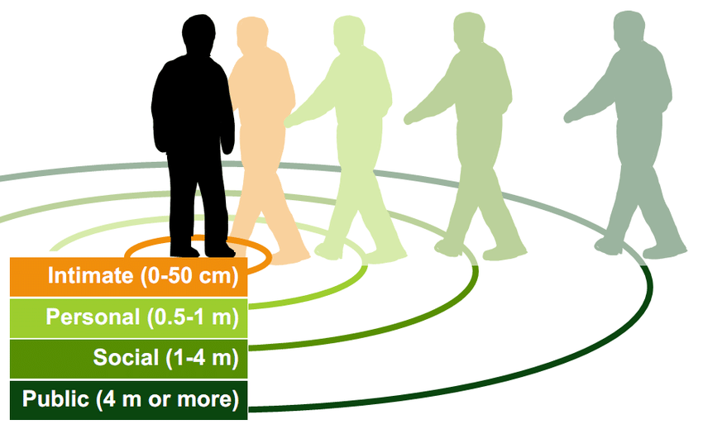**Physical Distance:**

The distance between two people conveys a meaning

|  |  |
| --- | --- |
| 1. intimate zone | 1. personal zone |
| 1. social zone | 1. public zone |

Hall (1966) outlined 4 levels of interpersonal spaces or “distance zones”

Southern European people are more comfortable standing close together than Anglo-Saxon people

Two chairs together can symbolise warmth and interest while a desk in-between is more business like

**Effective Communication:**

when the listener receives, interprets and understands the message as it was intended from the speaker

* this includes active listening, working collaboratively and assertive communication

Listeners can make communication difficult by:

1. being distracted by their own thoughts
2. failing to ask what is meant
3. technological distraction

Research by Roberston (1970) found that children under 6 were more likely to blame the listener for miscommunications

**Assertive Listener/Communication:**

|  |  |
| --- | --- |
| Listener   1. Shows genuine interest 2. Ask questions for clarification 3. Restate the message to show you understand 4. Maintain eye contact and nod 5. Smile and have good posture, slight tilt of the head | Assertive Communication   * Expression opinions and feelings in a way that does not infringe the rights of others  1. Express/understand the other person’s position, use “I” statements not “you” 2. State the problem and what you will do to change, and do change 3. Try to understand the problem and not pick a fight |

**________________________________________________________________________________________**

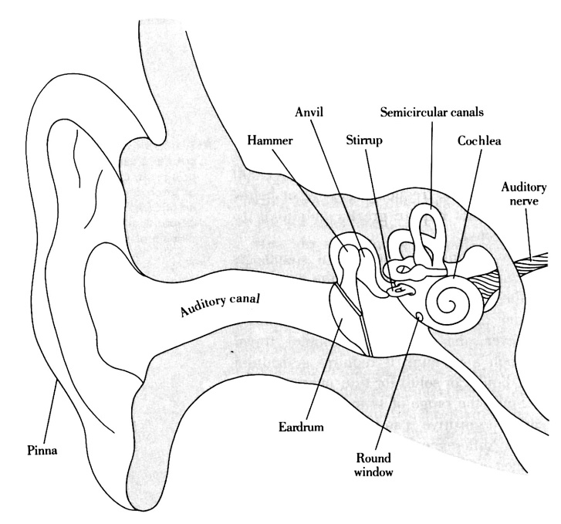**IMPACT OF HEARING IMPAIRMENT AND LANGUAGE DELAY: (not in test, in exam)**

10% of school-aged children have a communication problem where their language is delayed or impaired

A major cause is **hearing impairment** (**deafness**) of which there is two types:

* **Conductive** hearing loss
  + Problems in the **outer** or **middle ear** that prevent sounds from being conducted to the inner ear or hearing nerves
* **Sensorineural** hearing loss
  + Problems in the **cochlea** (sensory part of the ear) or the **hearing nerve** (neural part)
* Hearing impairments are more common in boys than girls
* Hearing loss due to ear infections is common in Australian indigenous children
* Hearing loss present at birth/before language is learnt is more disruptive than after language is learnt
* Hearing impairments noticed when children are not developing language at similar rates to peers
* Hearing impaired may babble, but stop after they cannot hear their own sounds and the sounds of others
* The speech of hearing-impaired children is unintelligible by patterns of prosody (stress, tone and pitch or language) and the mispronunciations of sounds
* They often have difficulties with grammar and writing is repetitive and simple
* Auslan is the recognised sign language in Australia (uses finger spelling)
* Sign language and speech at the same time is called **total communication**

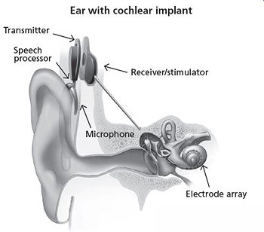

* Traditional learning aids amplify certain sounds
  + They have multiple-tone controls tailored to the specific hearing loss for the person
* Cochlear implants (bionic ear)
  + Directly stimulate the auditory nerve to restore hearing
  + Artificially arouses the inner ear nerves to produce hearing
  + Individually customised – electrical patterns are different for each person

**________________________________________________________________________________________**

**ROLE OF LANGUAGE IN INITIATING, MAINTAINING & REGULATING INTERPERSONAL SOCIAL RELATIONSHIP:**

We understand the importance of knowing how much the listener knows

* Kindergarten kids assume they have this knowledge
* Over time they realise they have to provide more info

**Glucksberg and Krauss (1967):**

Psychologists have studied the ability of young children to take the listener’s knowledge into consideration via a referential communication task where two children sit on either side of the screen: one a listener, the other a speaker

* Children under 7 found the task hard
* Sometimes they developed names for the shapes like “mothers dress”
* By 7-8 they provided helpful descriptions based on differences between objects

**Communication** plays an important part in **initiation, maintaining and regulating relationships**

**Specific Language Impairment (SLI):**

SLI is diagnosed when a person has language skills that are significantly below the level expected for their age despite having normal IQ and hearing

As well as having reduced interaction with peers, children with SLI talk more to adults (more understanding)

* They still talk much less

**Gertner (1994):**

Children with Specific Language Impairment are less popular and will have less friends

**Brinton (1998):**

Children aged 8-12 with SLI:

* have more immature negotiation skills
* more likely to resolve conflicts physically

**Male** friendshipare based on **shared interests**

**Female** friendshipsare based on **intimacy and trust**

Adolescents will use **negotiation and persuasion** rather than **power** to **assert** themselves and achieve a **win-win** outcome

**ROBINSONS SOCIAL SKILLS:**

Robinson (2003):

How adults communicate to regulate and mark social relationships:

1. Shaking hands
2. Terms of address
3. Being polite
   1. Social distance
   2. Power difference
   3. Imposition (how big of an request)

Forms of address:

Three patterns of communication:

1. Mutual T: informal
2. Mutual V: formal
3. T<>V relationships

TV: informal to a formal person

VT: formal to an informal person

TT: both informal

In ancient times: nobility exchanged V, common people exchanged T

Mutual V is the default now but with growing egalitarianism, this is becoming less frequent

Shaking hands:

* A long firm handshake may be misconstrued by a new acquaintance
* A limp handshake can mean a lack of interest

Three main rules:

1. Way you extend your hand (palm up or down)
2. Pressure applied
3. Length of handshake

terms of address also include title and last   
name or just first name