**Cognition**

memory: internal representation of events & things or info

Model: helps explain memory formation model – simplified representations

Atkinson + Shiffrin model of memory (1968)   
sensations > perception: we made sense of some sensations – attention   
selective attention: attend to some stimulus

Sensory Memory: information deemed important > stm > memory worthy > rehearsal > ltm   
recall memory to short term – forget = decay

SM: hold memory for short period of time  
auditory + visual + olfactory bulb

Sensory: less than 1 second > large capacity > sense specific

Iconic: fleeting mental image + represents unencoded visual sensory info   
 0.2 – 0.4 seconds > unlimited   
Echoic: store auditory info for a brief period + process auditory info   
3 – 4 seconds > unlimited

STM: 20 – 30 seconds > 7 ± 2 bits > repetition – auditory form

PL: deals w written + spoken material  
PLS: processes speech perception & stores spoken word for 1-2 seconds  
AC: processes speech production + rehearse & stores verbal info in PLS

VSSP: stores visual + spatial info   
used for navigation (spatial layout of places held in LTM)

EB: incorporates slave systems + LTM – uses units of spatial + visual + verbal components w time

CE: integrates info from PL & VSSP & LTM: 18 – 30 seconds   
decides which info needs attention or ignore + planning & decision

LTM: forever > infinite > semantic – meaning we assign

Procedural: how we do things   
expressed as actions as memory retained as skills in ltm   
e.g., riding a bike

Declarative: stores factual info (names + faces + dates)   
semantic: basic factual knowledge (names + days + words + language)   
general knowledge of world stored as facts   
episodic: distinct personal events – time & place – first to disappear as we age   
e.g., 10th birthday party

Atkinson & Shiffrin (1968) Multi-store Model of Memory

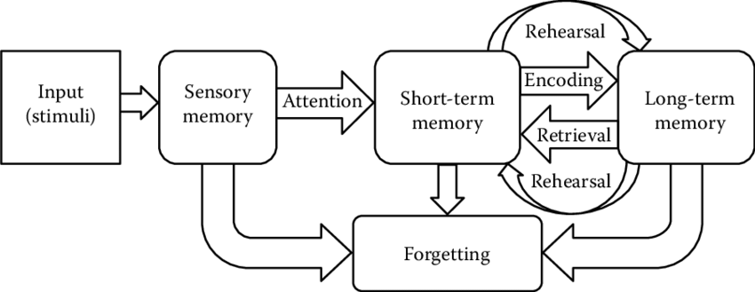

Baddeley & Hitch (1974) Working Memory Model

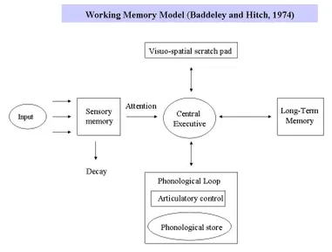

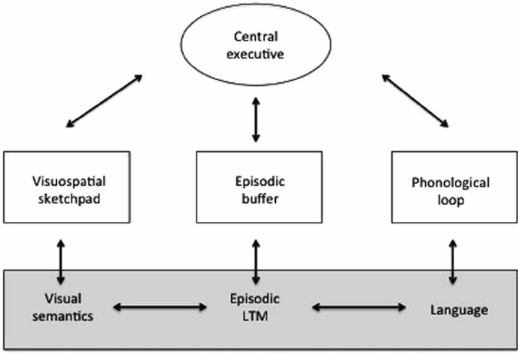

**Remembering & Forgetting**

Remembering  
recall: facts or info can be retrieved without cues (declarative memory)   
recognition: info can be retrieved using cues or prompts   
re-learning: occurs when material that has been learned previously, but cannot be remembered   
can be learned again in shorter time (method of savings)

Forgetting  
decay: fading of memory overtime   
primary or recency: when given a series of info – most recent + first item in series is most likely remembered

Causes of Decay: time + disease (organs) + injury

Retrieval Failure: inability to recall info without the use of cues   
Motivated Forgetting: when material is forgotten because this provides some sort of benefit   
e.g., forgetting an accident (trauma)   
Interference: when recall of information is confused by competing information

Retroactive: old memories are confused by learning new information  
e.g., learning new theories causes you to forget previously learned theories   
Proactive: learning new info + recall of new memories is confused by older memories  
e.g., gotten used to writing 2020 but a new year is here > write 2020 instead of 2021