AEPSY Semester One 2017

EXAMINATION

REVISION



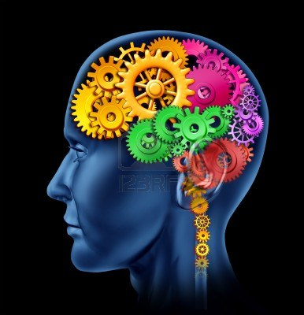

Each Section Contains:

* Key Terminology
* Revision questions
* PRACTISE questions

CONTENTS:

Research Methods

Biological influences/bases of behaviour

Cognition/Intelligence

Relational Influences

Communication

Extended Answer Section

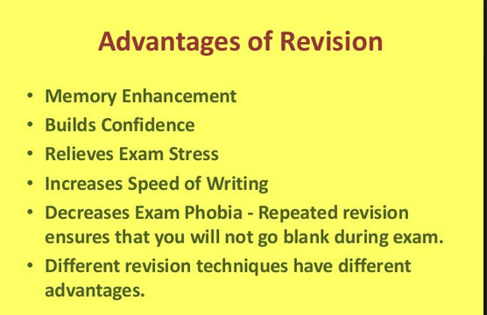

Research Methods

Key terminology:

Independent Variable

Dependent Variable

Correlation

(Operational )Hypothesis

Ethics

Mean

Median

Mode

Quantitative and Qualitative data

Experimental and non-experimental

Population

Range

Sample

**VARIABLES AND HYPOTHSIS**

A Psychology class recently investigated whether test scores could be improved by playing music while studying. One class containing 30 students was split into two groups. 15 students played music when studying for their exam and the other 15 students did not.

Identify the Independent (IV) and dependent variable (DV)

* IV ____________________________________________________________________________
* DV ___________________________________________________________________________

Write a suitable operational hypothesis (A hypothesis should include IV, DV, population and prediction as measured by……)

____________________________________________________________________________________________________________________________________________________________________________________________________________________________________________________________________________________________________________________________________________________

Who is the experimental group in this scenario?

_____________________________________________________________________________________

Who is the control group in this scenario?

_____________________________________________________________________________________

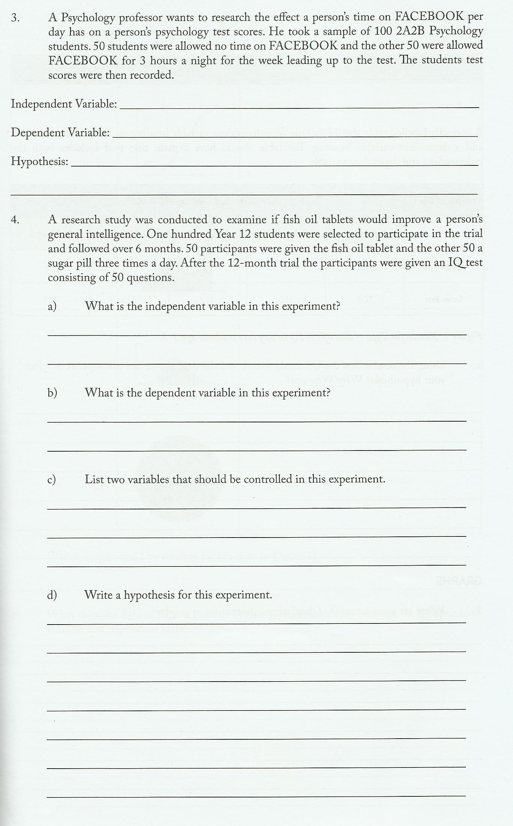

**ETHICAL CONSIDERATIONS**

Ethics are moral principles that all psychologists must comply with. A code of Ethics was developed by the Australian Psychological Society to assist psychologists with research.

Ethical considerations include: Informed Consent, Confidentiality, Voluntary Participation, Withdrawal Rights and Deception in Research. Describe each principle below and apply these principles in the scenarios to follow.

Informed Consent: ____________________________________________________________________________________________________________________________________________________________________________________________________________________________________________________________________________________________________________________________________________________

Confidentiality

____________________________________________________________________________________________________________________________________________________________________________________________________________________________________________________________________________________________________________________________________________________

Voluntary Participation

____________________________________________________________________________________________________________________________________________________________________________________________________________________________________________________________________________________________________________________________________________________

Withdrawal Rights

____________________________________________________________________________________________________________________________________________________________________________________________________________________________________________________________________________________________________________________________________________________

Deception in Research

____________________________________________________________________________________________________________________________________________________________________________________________________________________________________________________________________________________________________________________________________________________

In this scenario – identify what ethics the researcher has adhered to.

A new energy drink was designed to improve a student’s performance during an exam. The researcher asked students to participate in a study to test the new energy drink. The researcher asked for the student’s parents to sign a form allowing the students to drink the energy drink before they sat their examination.

Ten students were asked to drink the energy drink 1 hour prior before sitting their Psychology exam; the other ten students drank water 1 hour prior to their exam. Their examination results were compared and teachers and possible manufacturers of the drink were notified of the findings.

________________________________________________________________________________________________________________________________________________________________________________________________________________________________________________________________________________________________________________________________________________________________________________________________________________________________________________________________________________________________________________________________________________________________________________________________________________________________________________________________________________________________________

In this scenario – identify what ethics the researcher breached.

A psychology student wanted to find out if primary school students’ eating habits affected their grades in school. She asked a local primary school id she could hand out a survey on eating habits to their students. The students who were willing filled out the survey after lunch and handed it back to the psychology student. She requested their recent report cards and matched the results from the survey to the students’ grade. She found that students who had a high sugar diet received a grade of C or below and those who had a low sugar diet received a grade average of B or above. She published her findings in the weekly school newsletter.

________________________________________________________________________________________________________________________________________________________________________________________________________________________________________________________________________________________________________________________________________________________________________________________________________________________________________________________________________________________________________________________________________________________________________________________________________________________________________________________________________________________________________

**DATA COLLECTION**

Complete this table

|  |  |  |  |  |
| --- | --- | --- | --- | --- |
| Type of Data | Description | Advantage | Disadvantage | Example |
| Qualitative |  |  |  | Open ended responses or observations |
| Quantitative |  |  |  | Rating scales |

**OTHER DATA**

How do you calculate the:

Mean_____________________________________________________________________________________________________________________________________________________________________

Mode_____________________________________________________________________________________________________________________________________________________________________

Median___________________________________________________________________________________________________________________________________________________________________

Range_____________________________________________________________________________________________________________________________________________________________________

**Processing and evaluating psychological research**

**CORRELATION**

Correlation is the strength of the relationship between two variables.

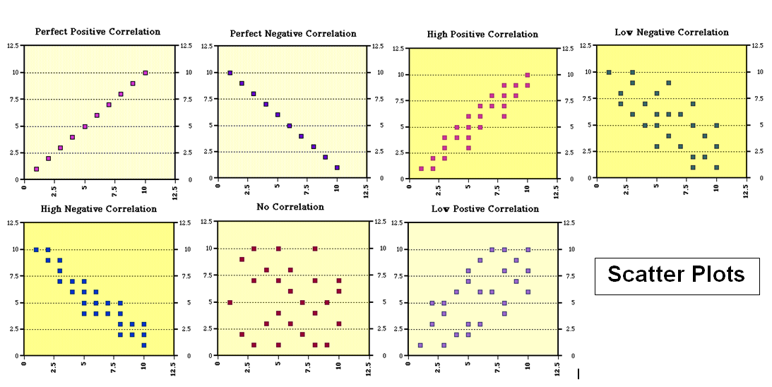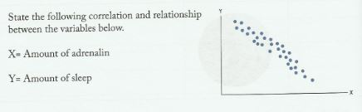

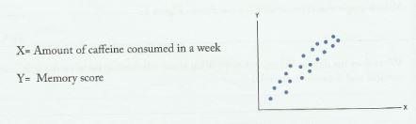

* **Correlation DOES NOT mean causation – as other variables could be involved.**

**SOURCES OF ERROR**

Sources of error in an experiment can include, but are not limited to:

* Small sample size
* Extraneous variables
* No control group
* Unrepresentative sample

What is the difference between a sample and the population?

____________________________________________________________________________________________________________________________________________________________________________________________________________________________________________________________________________________________________________________________________________________

Provide examples of extraneous variables.

____________________________________________________________________________________________________________________________________________________________________________________________________________________________________________________________________________________________________________________________________________________

Review question:

A psychology student collected examination results from 40 Year 11 students from an all-girls school. Before the examination the Year 11 participants filled in the questionnaire to determine the number of hours they slept the night before the exam. The researcher found that those who slept over 8 hours scored higher in the examination.

Write a hypothesis for this study.

____________________________________________________________________________________________________________________________________________________________________________________________________________________________________________________________________________________________________________________________________________________

Identify two sources of error in this research study. For each source of error state one way of reducing this error.

________________________________________________________________________________________________________________________________________________________________________________________________________________________________________________________________________________________________________________________________________________________________________________________________________________________________________________________________________________________________________________________________________________________________________________________________________________________________________________________________________________________________________

**PRACTISE QUESTIONS**

1. In psychological research, the main purpose of **ethical standards** is to: (1 mark)

______________________________________________________________________

1. A psychologist studied differences in the behaviour of newborn babies who are breastfed and newborn babies who are bottle-fed. The psychologist conducted the research with 20 mothers and their newborn infants at the Royal Women’s Hospital (RWH). The 20 mothers (and infants) were selected from a group of 45 mothers at the RWH who had all volunteered to participate in the experiment. There were another 50 mothers with newborn infants at the hospital, but these mothers did not volunteer to be in the experiment. (1 mark)
2. In this experiment, there were _________________ mothers (and their infants) in the **sample.**

**(ii)** ________________ mothers (and their infants) in the **population**.

1. A psychologist interested in the effects of anxiety on exam performance asked research participants to describe how they feel during an exam when they come across a question they know they will get wrong. The participants’ responses were tape-recorded so that they could be analysed at a later time. (1 mark)

The **type of data** obtained by the researcher is best described as _____________ data.

1. When the researcher replayed the tape of participants’ responses to the questions asked in the experiment described in question 3, it was decided to summarise the data using a table which showed the number of times certain anxiety-related words, such as ‘worried’ and ‘scared’, and non anxiety-related words such as ‘nothing’ and ‘didn’t care’, were used. (1 mark)

The **type of data** obtained by the researcher is best described as ______________ data.

1. A large body of evidence suggests that factors related to family relationships, such as conflict, communication and closeness are associated with a young person’s mental well- being. A psychology teacher, who is interested in the well-being of the students in his class, decides to look at this association amongst his students. He plans to ask his students to complete questionnaires about their family relationships and about their own emotional well-being.

**(a)** A number of ethical issues arise from a study such as this. Identify **two (2)** important ethical issues that need to be considered. (2 marks)

________________________________________________________________________________________________________________________________________________________________________________________________________________________________________________________________________________________________________________________________________________________________________________________________________________________________________________________________________________________________________________________________________________________________________________________________________________________________

**(b)** Many of the students at the school have recently arrived from overseas, where their families were in danger from ongoing conflict. The teacher also wishes to look at the family relationships of these refugee students in the school to find out whether the same association exists for refugee student families.

When conducting research with people from other cultures, additional factors must be taken into account in order to design reliable and valid investigations.

Describe **one (1)** factor that the teacher would have to take into account in order to ensure the *reliability* and *validity* of the study when it is extended to refugee adolescents. (1 mark)

____________________________________________________________________________________________________________________________________________________________________________________________________________________________________________________________________________________________

**(c)** Outline **one (1)** strategy the teacher could use to address the factor you identified in Question **5(b).**  (1 mark)

____________________________________________________________________________________________________________________________________________________________________________________________________________________________________

1. A researcher conducted an experiment to measure the effect of caffeine on a person’s ability to complete a jigsaw puzzle.

One hundred university students aged between 20 and 25 years were randomly selected and allocated to one of two groups. The experiment was conducted over one day.

Group 1 consumed a caffeine-based drink. Group 2 consumed a non-caffeine-based drink. After 30 minutes, participants from both groups were given the same simple jigsaw puzzle to complete. Participants were timed for this activity.

The results are as follows:

|  |  |  |
| --- | --- | --- |
| Group 1 | caffeine group | 10 seconds ( mean score) |
| Group 2 | non-caffeine group | 16 seconds ( mean score) |

**(a)** State the **hypothesis** the researcher could have developed for this study. (1 mark)

________________________________________________________________________________________________________________________________________________________________________________________________________________________________________________________________________________________________________________

**(b)** Identify the **independent** and **dependent** variables. (2 marks)

**IV:** _______________________________________________________________

**DV:** ______________________________________________________________

**(c)** State the **conclusion** the researcher could draw from the results. (3 marks)

________________________________________________________________________________________________________________________________________________________________________________________________________________________________________________________________________________________________________________________________________________________________________________________________________________________________________________________________________

**9.** A researcher wanted to find out whether the presence of nicotine in the bloodstream is linked to sleep loss, specifically sleep loss resulting from spending more time trying to fall asleep. In order to test this belief, one group of 15 volunteer students who were smokers and enrolled in the first year of the Psychology course at a Victorian regional university (Group 1) were required to attend the university’s gym at 9.00 pm on Tuesday evening, smoke ten, 8 mg cigarettes during a 90-minute period whilst listening to classical music, and then go to sleep as quickly as they could in one of the standard single beds at the other end of the gymnasium. On Friday evening later that week, the procedure was repeated with another group of 12 volunteer smokers who were also enrolled in the first year Psychology course (Group 2). However, participants in this group were not permitted to smoke any cigarettes in the one-hour period before being asked to go to sleep in one of the beds.

Both groups were carefully observed from outside the gym by two research assistants through a monitor hooked up to infra-red cameras. The research assistants recorded the precise time when each participant was observed to fall asleep.

The results showed that Group 1 took a mean (average) time of 43 minutes to fall asleep; whereas Group 2 took a mean time of 41 minutes to fall asleep. The researcher concluded that neither smoking nor the presence of nicotine in the bloodstream cause sleep loss.

1. Identify the population for the experiment. (1 mark)

________________________________________________________________________________________________________________________________________________________

1. Is the researcher collecting qualitative or quantitative data? (1 mark)

____________________________________________________________________­­­

1. Identify the independent and dependent variables. (2 marks)

**IV:** ________________________________________________________________

**DV:** _______________________________________________________________

1. Identify the experimental and control groups. (2 marks)

**EG**: _______________________________________________________________

**CG:** _______________________________________________________________

**Biological influences/bases of behaviour**

Key terminology:

Axon

Dendrite

Depressant

Hallucinogen

Myelin sheath

Stimulant

Recreational drug

Predisposition

**PARTS OF THE BRAIN**

Describe the functions of the following parts of the brain:

Hindbrain ____________________________________________________________________________________________________________________________________________________________________________________________________________________________________________________________________________________________________________________________________________________

Midbrain ____________________________________________________________________________________________________________________________________________________________________________________________________________________________________________________________________________________________________________________________________________________

Forebrain

____________________________________________________________________________________________________________________________________________________________________________________________________________________________________________________________________________________________________________________________________________________

Corpus Callosum

____________________________________________________________________________________________________________________________________________________________________________________________________________________________________________________________________________________________________________________________________________________

Left and Right Hemispheres

____________________________________________________________________________________________________________________________________________________________________________________________________________________________________________________________________________________________________________________________________________________

Label the four lobes of the cerebral cortex

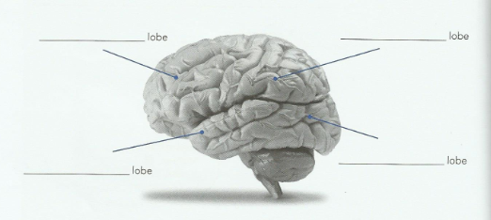

Describe the key functions of each lobe of the cerebral cortex

Frontal

____________________________________________________________________________________________________________________________________________________________________________________________________________________________________________________________________________________________________________________________________________________

Occipital ____________________________________________________________________________________________________________________________________________________________________________________________________________________________________________________________________________________________________________________________________________________

Parietal

____________________________________________________________________________________________________________________________________________________________________________________________________________________________________________________________________________________________________________________________________________________

Temporal

____________________________________________________________________________________________________________________________________________________________________________________________________________________________________________________________________________________________________________________________________________________

Draw a structure of a neuron and label the following parts: cell body, axon, dendrites, myelin sheath.

Describe the purpose of the axon

____________________________________________________________________________________________________________________________________________________________________________________________________________________________________________________________________________________________________________________________________________________

List **two** effects of the hormone adrenalin. __________________________________________________________________________________________________________________________________________________________________________

Outline **one** way in which exercise can affect emotion.

__________________________________________________________________________________________________________________________________________________________________________

Describe the body’s reaction in a **‘flight or fight’** response.

__________________________________________________________________________________________________________________________________________________________________________

__________________________________________________________________________________________________________________________________________________________________________

Describe the effect on the production and understanding of language caused by damage to:

Broca’s area __________________________________________________________________________________________________________________________________________________________________________

__________________________________________________________________________________________________________________________________________________________________________

Wernicke’s area __________________________________________________________________________________________________________________________________________________________________________

__________________________________________________________________________________________________________________________________________________________________________

Match the terms in the first column with the explanations in the second column using the corresponding number to answer the question.

|  |  |  |
| --- | --- | --- |
| Wernicke’s area | Thick band of nerve fibres that connect the right and left hemispheres |  |
| Frontal lobe | Responsible for processing visual information |  |
| Parietal lobe | Responsible for a number of functions, most notably that of abstract thought |  |
| Temporal lobe | Concerned with the production of language |  |
| Occipital lobe | concerned with balance and coordination |  |
| Cerebellum | Responsible for processing information relating to touch, movement, and the location of the body and other objects in space |  |
| Brain Stem | Controls the basic functions essential to maintaining life |  |
| Broca’s area | Responsible for the processing of auditory information, also important to some memory functions |  |
| Corpus callosum | Where language comprehension occurs |  |

### There are three major biological influences that can affect behaviour. List the three influences and an example of the affects they could have on our behaviour. (HHD)

H __________________________________________________________________________________________________________________________________________________________________________

__________________________________________________________________________________________________________________________________________________________________________

H

__________________________________________________________________________________________________________________________________________________________________________

__________________________________________________________________________________________________________________________________________________________________________

D

__________________________________________________________________________________________________________________________________________________________________________

__________________________________________________________________________________________________________________________________________________________________________

**PRACTISE QUESTIONS**

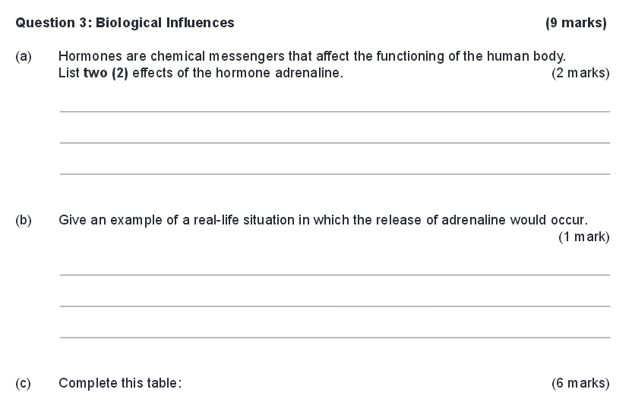

|  |  |  |
| --- | --- | --- |
| **Class of recreational drug** | **One effect on Physiological and Psychological behaviour** | **Example of this**  **category of drug** |
| Hallucinogen |  |  |
| Depressant |  |  |
| Stimulant |  |  |

Give **one** example of each of the following methods of investigating brain function.

1. External recording: _____________________________________
2. Still picture scan: ______________________________________
3. Dynamic picture scan: __________________________________

Case Studies can also be used to investigate brain function. Animals and humans are used to examine damaged and healthy brains. Phineas Gage is one famous case study. Explain how Phineas Gage was able to assist researchers in investigating brain function.

__________________________________________________________________________________________________________________________________________________________________________

__________________________________________________________________________________________________________________________________________________________________________

__________________________________________________________________________________________________________________________________________________________________________

__________________________________________________________________________________________________________________________________________________________________________

__________________________________________________________________________________________________________________________________________________________________________

__________________________________________________________________________________________________________________________________________________________________________

__________________________________________________________________________________________________________________________________________________________________________

__________________________________________________________________________________________________________________________________________________________________________

Using empirical evidence, give two examples how physical activity can affect our wellbeing.

__________________________________________________________________________________________________________________________________________________________________________

__________________________________________________________________________________________________________________________________________________________________________

__________________________________________________________________________________________________________________________________________________________________________

__________________________________________________________________________________________________________________________________________________________________________

__________________________________________________________________________________________________________________________________________________________________________

__________________________________________________________________________________________________________________________________________________________________________

__________________________________________________________________________________________________________________________________________________________________________

__________________________________________________________________________________________________________________________________________________________________________

**COGNITION - INTELLIGENCE**

Key terminology:

Intelligence – General, Emotional, Multiple

Intelligence Quotient

Mental Age

Visual perception

Sensation

Reception

Transduction

Altered States of Consciousness

Dishabituation

Illusions

Attention – selected, divided, habituation, dishabituation

What is a widely accepted definition of intelligence and how it is determined?

__________________________________________________________________________________________________________________________________________________________________________

__________________________________________________________________________________________________________________________________________________________________________

In what ways might this definition differ within different cultural groups in our society? For example, how might intelligence be viewed by Aboriginal people? People with English-speaking backgrounds? People with non-English-speaking backgrounds? Give reasons for your answers.

__________________________________________________________________________________________________________________________________________________________________________

__________________________________________________________________________________________________________________________________________________________________________

__________________________________________________________________________________________________________________________________________________________________________

__________________________________________________________________________________________________________________________________________________________________________

Describe intelligence testing?

__________________________________________________________________________________________________________________________________________________________________________

__________________________________________________________________________________________________________________________________________________________________________

__________________________________________________________________________________________________________________________________________________________________________

|  |  |  |
| --- | --- | --- |
| **INTELLIGENCE  THEORY** | **THOERIST/S** | **EXPLANATION OF KEY FINDINGS** |
| **General Intelligence** |  |  |
| **Multiple Intelligence** |  |  |
| **Empirical approaches to Intelligence** |  |  |
| **Measuring Intelligence** |  |  |
| **Emotional Intelligence** |  |  |

List two advantages and disadvantages for group and individual intelligence testing.

****(This could also be displayed as a table)

Group

__________________________________________________________________________________________________________________________________________________________________________

__________________________________________________________________________________________________________________________________________________________________________

__________________________________________________________________________________________________________________________________________________________________________

__________________________________________________________________________________________________________________________________________________________________________

Individual

__________________________________________________________________________________________________________________________________________________________________________

__________________________________________________________________________________________________________________________________________________________________________

__________________________________________________________________________________________________________________________________________________________________________

__________________________________________________________________________________________________________________________________________________________________________

Explain how mental age and IQ are measured

__________________________________________________________________________________________________________________________________________________________________________

__________________________________________________________________________________________________________________________________________________________________________

__________________________________________________________________________________________________________________________________________________________________________

__________________________________________________________________________________________________________________________________________________________________________

__________________________________________________________________________________________________________________________________________________________________________

__________________________________________________________________________________________________________________________________________________________________________

In what way can visual sensation and visual perception be distinguished?

__________________________________________________________________________________________________________________________________________________________________________

__________________________________________________________________________________________________________________________________________________________________________

__________________________________________________________________________________________________________________________________________________________________________

How do illusions change our perception?

__________________________________________________________________________________________________________________________________________________________________________

__________________________________________________________________________________________________________________________________________________________________________

__________________________________________________________________________________________________________________________________________________________________________

How do the following indicate different states of consciousness?

Electrical activity of the brain

____________________________________________________________________________________________________________________________________________________________________________________________________________________________________________________________________________________________________________________________________________________

Heart rate ____________________________________________________________________________________________________________________________________________________________________________________________________________________________________________________________________________________________________________________________________________________

Body temperature

____________________________________________________________________________________________________________________________________________________________________________________________________________________________________________________________________________________________________________________________________________________

Galvanic skin response

____________________________________________________________________________________________________________________________________________________________________________________________________________________________________________________________________________________________________________________________________________________

**PRACTISE QUESTIONS**

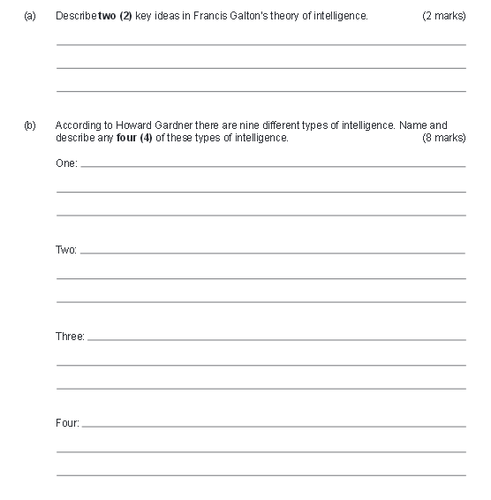

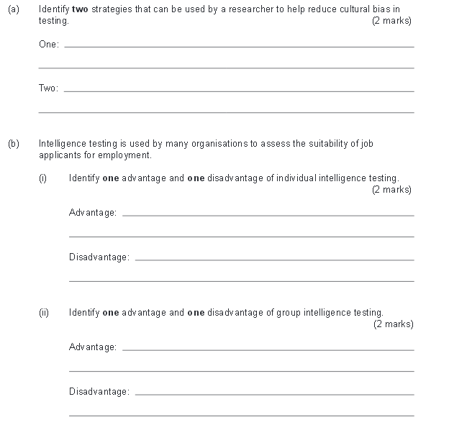



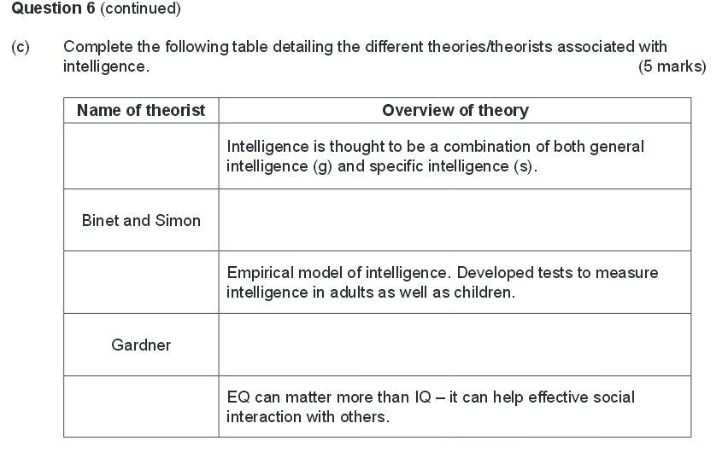

**RELATIONAL INFLUENCES**

Key terminology:

Clique

Crowd

Dyad

Proximity

Reciprocity

|  |  |  |
| --- | --- | --- |
| BEHAVIOUR | DEFINTION | EXAMPLES |
| ANTI-SOCIAL |  |  |
| PRO-SOCIAL |  |  |

Using an example explain the term reciprocity

____________________________________________________________________________________________________________________________________________________________________________________________________________________________________________________________________________________________________________________________________________________

Explain the term similarity using an example

____________________________________________________________________________________________________________________________________________________________________________________________________________________________________________________________________________________________________________________________________________________

Explain two factors of proximity that support the formation of relationships

____________________________________________________________________________________________________________________________________________________________________________________________________________________________________________________________________________________________________________________________________________________

__________________________________________________________________________________________________________________________________________________________________________

Explain Dunphy’s five stages of adolescent relationships.

____________________________________________________________________________________________________________________________________________________________________________________________________________________________________________________________________________________________________________________________________________________

__________________________________________________________________________________________________________________________________________________________________________

____________________________________________________________________________________________________________________________________________________________________________________________________________________________________________________________________________________________________________________________________________________

__________________________________________________________________________________________________________________________________________________________________________

Explain the meaning of the term situational factor in relation to the occurence of pro-social behaviour.

__________________________________________________________________________________________________________________________________________________________________________

____________________________________________________________________________________________________________________________________________________________________________________________________________________________________________________________________________________________________________________________________________________

__________________________________________________________________________________________________________________________________________________________________________

What are social norms? Provide an example

__________________________________________________________________________________________________________________________________________________________________________

__________________________________________________________________________________________________________________________________________________________________________

Explain the meaning of altruism

__________________________________________________________________________________________________________________________________________________________________________

__________________________________________________________________________________________________________________________________________________________________________

Distinguish altruistic behaviour form ordinary helping behaviour

__________________________________________________________________________________________________________________________________________________________________________

__________________________________________________________________________________________________________________________________________________________________________

Describe the bystander effect

__________________________________________________________________________________________________________________________________________________________________________

__________________________________________________________________________________________________________________________________________________________________________

Describe aggressive behaviour

__________________________________________________________________________________________________________________________________________________________________________

__________________________________________________________________________________________________________________________________________________________________________

**PRACTISE QUESTIONS**

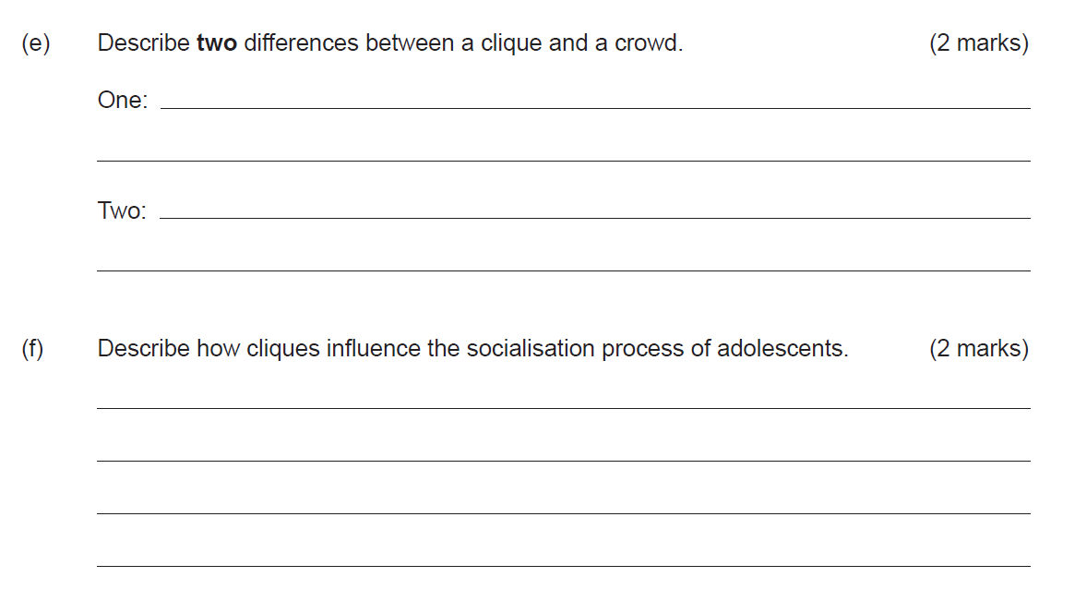

**COMMUNICATION**

Key terminology:

Active listening

Assertive (effective) communication

Communication

Non-verbal communication

|  |  |  |
| --- | --- | --- |
| **TYPES OF NON-VERBAL COMMUNCAITON** | **EXAMPLE** | **CULTURAL VARIABLES** |
| **BODY LANGUAGE** |  |  |
| **GESTURES** |  |  |
| **PHYSICAL DISTANCE** |  |  |
| **FACIAL EXPRESSIONS** |  |  |
| **TOUCH AND SMELL** |  |  |

List three attributes to being a good listener.

__________________________________________________________________________________________________________________________________________________________________________

__________________________________________________________________________________________________________________________________________________________________________

What are three steps used when communication assertively.

__________________________________________________________________________________________________________________________________________________________________________

__________________________________________________________________________________________________________________________________________________________________________

Explain two common obstacles to effective communication.

__________________________________________________________________________________________________________________________________________________________________________

__________________________________________________________________________________________________________________________________________________________________________

Explain how Robinson’s social skills help to regulate and maintain relationships.

Shaking hands:

__________________________________________________________________________________________________________________________________________________________________________

__________________________________________________________________________________________________________________________________________________________________________

__________________________________________________________________________________________________________________________________________________________________________

__________________________________________________________________________________________________________________________________________________________________________

Formal address:

__________________________________________________________________________________________________________________________________________________________________________

__________________________________________________________________________________________________________________________________________________________________________

__________________________________________________________________________________________________________________________________________________________________________

__________________________________________________________________________________________________________________________________________________________________________

Politeness:

__________________________________________________________________________________________________________________________________________________________________________

__________________________________________________________________________________________________________________________________________________________________________

__________________________________________________________________________________________________________________________________________________________________________

__________________________________________________________________________________________________________________________________________________________________________

Explain how Robinson’s social skills can differ in two cultures.

Shaking hands:

__________________________________________________________________________________________________________________________________________________________________________

__________________________________________________________________________________________________________________________________________________________________________

__________________________________________________________________________________________________________________________________________________________________________

__________________________________________________________________________________________________________________________________________________________________________

Formal address:

__________________________________________________________________________________________________________________________________________________________________________

__________________________________________________________________________________________________________________________________________________________________________

__________________________________________________________________________________________________________________________________________________________________________

__________________________________________________________________________________________________________________________________________________________________________

Politeness:

__________________________________________________________________________________________________________________________________________________________________________

__________________________________________________________________________________________________________________________________________________________________________

__________________________________________________________________________________________________________________________________________________________________________

__________________________________________________________________________________________________________________________________________________________________________

Explain how hearing impairment impacts a person’s communication.

__________________________________________________________________________________________________________________________________________________________________________

__________________________________________________________________________________________________________________________________________________________________________

Explain two ways in which a person with hearing loss can learn to communicate.

__________________________________________________________________________________________________________________________________________________________________________

__________________________________________________________________________________________________________________________________________________________________________

**PRACTISE QUESTIONS**

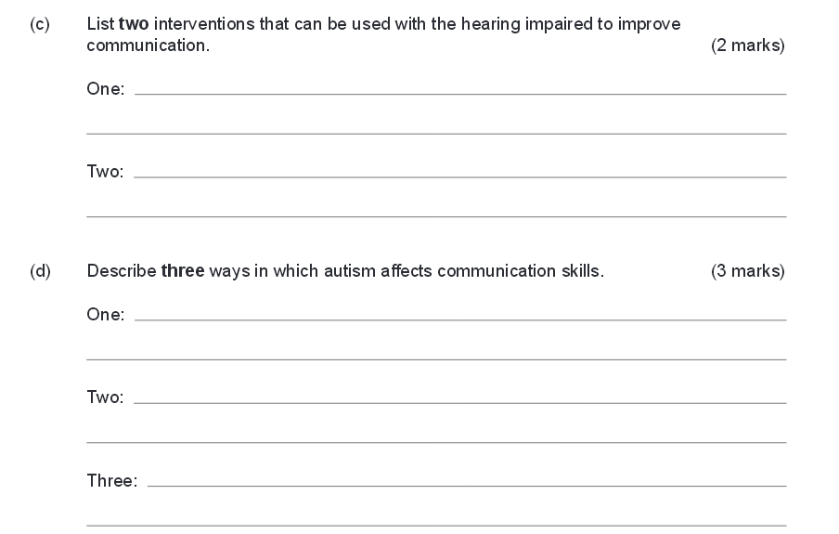

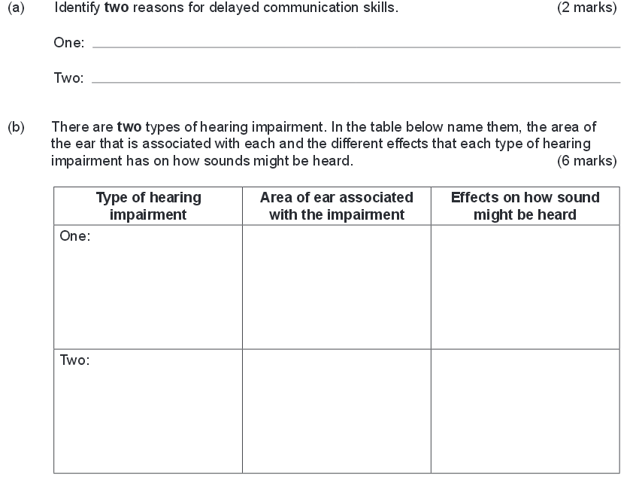

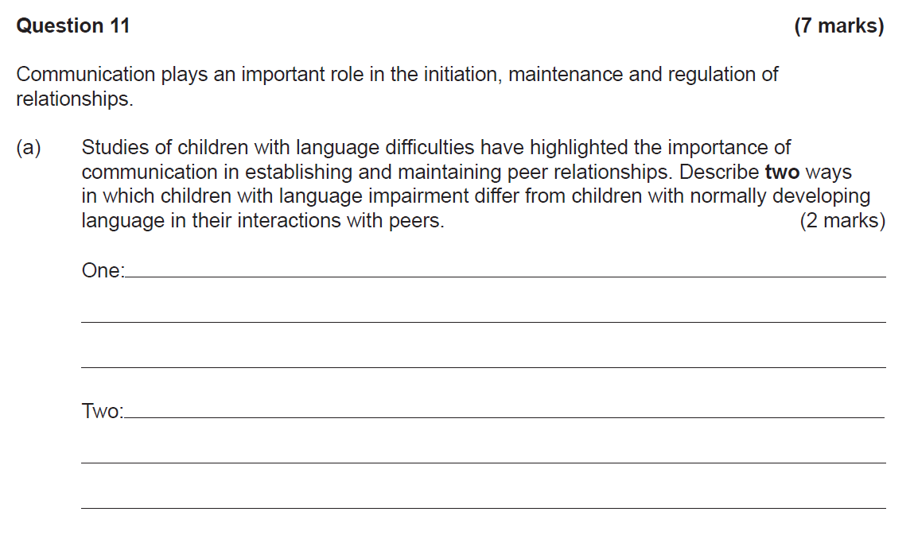

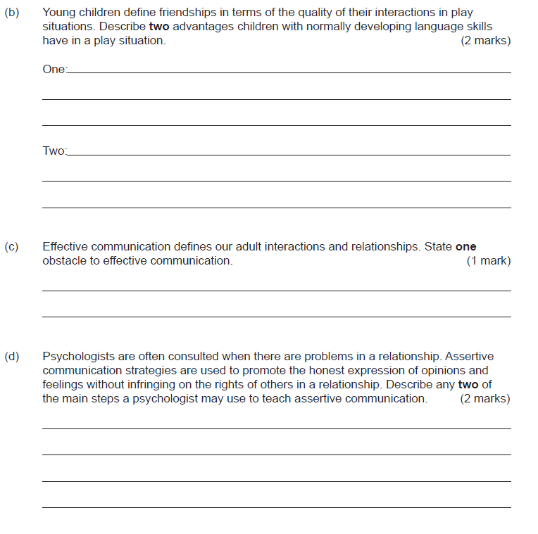

**Extended Response**

**This is a sample only and they are not questions in your exam!**

This section has **XX (XX)** questions. You are to choose **ONE** question and answer accordingly.

*The candidate writes a structured response to demonstrate their psychological understandings and knowledge of human behaviour. Candidates will be asked to describe or explain psychological concepts, and cite theorists to support their response. Answers can include diagrams, tables and graphs.*

Pages are included at the end of the two questions for planning and writing your answers.

• Planning: If you use a page for planning, indicate this clearly at the top of the page.

• You should refer to relevant psychological concepts, theories and research in your answer.

____________________________________________________________________________

**Question One**

A university student is interested in exploring the effects of physical activity on the way adolescents think, feel and behave. They are questioning whether to use a case study or an experimental design to gather such information. As a Psychology student prepare a paper that could help the university student with their research. In your response:

* Compare and contrast the strengths and limitations of using a case study and an experimental design. Include one relevant case study as an example.
* Outline the psychological and physiological effects of physical activity.
* Refer to empirical evidence.

**Question Two**

Part of the role of a psychologist is to assess people’s intelligence in workplaces. Different theories of intelligence include the intelligence quotient (IQ), emotional intelligence and multiple intelligences. Describe **two (2)** of these different theories of intelligences and how they may be used to understand an individual.

In your answer, you should:

* Define intelligence, IQ, emotional intelligence and multiple intelligences.
* Describe how an understanding of different theories of intelligence may be useful.
* Refer to theorists related to different understandings of intelligence.
* Finish with a conclusion

**Question Three**

Discuss factors influencing pro-social behaviour.

In your answer, ensure that you:

* define pro-social behaviour
* discuss factors influencing pro-social behaviour, as exemplified by helping and/or altruism
* discuss factors influencing reluctance to help
* accurately explain key concepts
* use appropriate examples
* refer to relevant research findings