**Self - Personality**

**PERSONALITY DEFINITION: PERSONALITY IS THE CHARACTERISTIC WAYS OF THINKING FEELING AND BEHAVING THAT MAKE A PERSON UNIQUE (INDIVIDUAL)**

# TRAIT THEORY

**What is a trait?** Personality traits describe the stable forms of behaviour that people display in any and every situation. Characteristics behaviours and feelings that are consistent and long lasting.

(personality traits are characteristics, behaviours and feelings that are believed to be consistent and long lasting. They are genetically based, predictable across time and used to identify differences between people)

- Traits are inferred from behaviour and it is expected that people behave in similar ways in different circumstances

A trait is:

genetically based

* relatively stable and enduring
* Used to predict behaviour
* Consistent across time and situations
* Used to identify differences between people
* Identifiable, describable and measurable
* A cognitive, emotional or behavioural tendency

**The big five factor theory:**

**OCEAN acronym**

1. **Neuroticism**
2. **Extraversion**
3. **Openness to experiences**
4. **Agreeableness**
5. **Conscientiousness**

The model organises all personality traits along a continuum of five factors. The factors are used are assumed to represent the basic structure behind all personality traits.

- The number of human personality traits can be reduced to five factors, and that all of the other traits fit within these five factors

- Groups things together which are similar or related to each other

- To determine the ‘Big Five’, researchers analysed thousands of personality surveys to determine which traits tend to occur together, and then used factor analysis to group related traits together under broad dimensions

|  |  |  |  |
| --- | --- | --- | --- |
| **Trait** | **Description** | **High Score** | **Low Score** |
| **Openness to Experience** | continuum between being curious and cautious | - be creative, inventive, and adventurous  - have a great deal of intellectual curiosity, prefer to avoid routine and seek out novel experiences | be careful and consistent  Appreciate routines and are often wary or even resistant to change  make decisions on carefully considered data |
| **Conscientiousness** | continuum between being highly efficient and very careless | - be high in level of thoughtfulness  - have good impulse control  - have a goal-directed behaviour  - be organised and mindful of details | be easy-going and often thoughtless regarding their own actions or other people  - while they are often seen as relaxed, they can sometimes be perceived as sloppy/lazy  - makes messes and doesn’t take care of things  - dislikes structure and schedules |
| **Extraversion** | very outgoing and very reserved | gain energy from social interactions  be outgoing around others  like starting conversations | feel drained after spending time socializing  be reserved around others  find it difficult to start conversations |
| **Agreeableness** | being cooperative/helpful and antagonistic/disagreeable | be prosocial, kind and trusting  be friendly, likeable and good-natured  be gullible, naïve or over trusting if extremely agreeable | be more competitive, be manipulative, be distrusting, detached from other people |
| **Neuroticism** | being emotionally unstable (neurotic) and emotionally stable | - experience unpleasant emotions such as sadness, anger and anxiety more often then other people  experience moodiness and irritability  experience stress  worry about many different things | be calm and even tempered  be more stable and emotionally resilient  deal well with stress  rarely feels sad or depressed |

**Consistency of personality traits across time (strength):**

* A claim of all trait theories is that personality traits are stable and enduring characteristics
* If there is a continuity in personality over time, each person should be basically the same person that they were 3 or 4 years ago, should be the same person in 5, 10- or 15-years’ time
* research indicates once adulthood is reached personality becomes relatively stable over time
* **Helle Pullam and colleagues (2006) research:** conducted longitudinal research over a two-year period with Estonian adolescents ranging in age from 12-18 years to look at several aspects of personality stability
* **Jesse Gordon (2009) research:** examined numerous studies to determine the extent of personality change throughout the lifespan

**Rank-order consistency/stability:**

* An individual’s relative placement within a population
* Assess whether people show uniform changes within a population
* Measured through test-retest correlations e.g. does a person who scores high or low on a particular trait compared with their peers remain high or low relative to peers, even if the whole group changes?

**Helle Pullman (2006)**

* Examined degree to which relative ordering od individuals on each of the five traits dimensions was maintained over time
* By age of 16 🡪 adolescences had reached rand-order stability typical of young adults

**Jesse Gordon (2009) research:**

* Appears to consistently increase and develop in relation to the population, across the adult lifespan
* Personality was found to be equally stable for males and females over the age 30 and for all participants in the adult age range – personality is unchanging once an individual reaches approximately 30 years of age

**Individual continuity/level change:**

* Refers to the magnitude of change exhibited by individuals on any given trait
* For example, does an individual participant’s level of extroversion remain stable over time?

**Helle Pullman and colleagues (2006) research:**

* Used the NEO Five-factorial inventory – a measure of the Big Five personality factors
* Found the mean levels of personality traits among adolescents were very similar to adults from the same population
* When comparing the different age groups in their sample, they found only modest change in the mean level of the trait scores on three of the five traits, and no change in the other two
* The level of openness increased, and the levels of agreeableness and conscientiousness decreased between the ages of 12 and 18 years

**Jesse Gordon (2009) research:**

* Appears to reach a plateau at age 50, while average trait levels experience heightened significant development between ages 20 and 40
* The amount of change shown by individuals on specific traits exhibited predictable consistency in relation to maturity development rather than age

**Mean-level stability/consistency:**

Refers to increases and decreases in the average trait level of a population and I commonly associated with normative change in personality

measured by way of longitudinal research studies e.g. are there changes in mean scores on each of the traits for each age group over time?

**Helle Pullman and colleagues (2006) research:**

* Had the minimal change in the individual’s trait level occurred due to actual stability in the individual, or when the mean levels of the traits were calculated half the group had moved in one direction and the other half the other, giving the appearance of individual stability?
* Analysis of the results indicated the first scenario to be true – approximately 80% of individuals in each of the age groups reported their personality traits in a consistent manner over the two years of the study
* This indicates that the very low change in mean-level of personality traits should be taken at face value, and that adolescents are very similar to young adults in the stability of their personality traits at an individual level

**Jesse Gordon (2009) research:**

* Appears to consistently increase and develop in relation to the population, across the adult lifespan
* Until the age of 30, mean levels of personality traits change with development
* However, by age 30 when adulthood is reached, stability characterises the five factors
* Over time, there were cross-cultural declines in neuroticism, extroversion and openness to experience, and increases in conscientiousness and agreeableness
* It can be concluded that significant mean level change of personality does not exist after adulthood

**Strengths of trait theory:**

- the big five traits are universal 🡪 study that looked at people from 50 different cultures and found that the five dimensions could be accurately used to describe personality. Based on this research, many psychologists now believe that the five personality dimensions are not only universal, but they also have biological origins

- **traits categorise observable behaviours**: observing the behaviours of an individual over time and in varying circumstances has provided evidence for the personality traits categorised in trait theories

- **trait theories use objective criteria for categorising and measuring traits:** several trait theories have been developed independently of each other when factor analysis was used to conclude a specific set of traits – while the theories were developed independently of each other, the trait theorists often arrived at a similar set of traits

**Limitations of trait theory:**

* Questions as to whether a individual express their personality consistently across situations 🡪 both traits and the situation interact therefor both need to be taken into account if consistency in behaviour is to be achieved
* Trait theories do not explain why an individual behaves in a certain way 🡪 no indication as to why these traits interact the way they do
* Trait theories rely upon personal observations or subjective self-reports to measure traits 🡪 subjective and suffer from observer bias
* - trait theorists can jot agree on how many traits are needs 🡪 some argue that more than 5 traits are needed to account for wide range of personality differences among people (Ashton) 🡪 other argue five traits are too much (Eysenck)

**Explain why there are endless possible combinations of the five personality traits?**

- everyone has all five traits

- each trait id a spectrum

- amount of each trait an individual has differed

**What factors influence the big five traits?**

- twin studies suggest that both nature and nurture play a role in the development of each of the five personality traits

- longitudinal studies also suggest that these big five personality traits tend to be relatively stable over the course of adult hood.

Ashton and lee’s addition of a sixth dimension (for extended responses)

- theorised HEXACO model:

- honesty-humility

- extraversion

- emotionality

- agreeableness

- Openness to experience

# SOCIAL COGNITIVE THEORY

* Social cognitive theories argue that personality by itself does not determine behaviour and, even if personality is stable, it only influences behaviour (does not determine)
* Social cognitive theory provides an alternative to psychodynamic and behaviourists theories in explaining human behaviour
* There are other internal determinants that influence our behaviour that is not personality, those are beliefs, thoughts and expectations that interact with rewards and punishments.

FEATURES OF BANDURA’S MODEL:

**(use word: environment as context)**

* Included concept of observation learning, as one of main theoretical points
* Reciprocal determinism suggested that children play a much more active and interactive role
  + They do not simply react as a result of learned associations or reinforcements
  + The child’s own personal characteristics, thoughts, feelings, and behaviours impact how they interact with the world
* Bandura agreed that environment causes behaviour, but behaviour can also cause environment
* He later proposed a third factor that must be considered – the persons psychological processes (cognitions)
* Bandura called these bi-directional relationships between personal, behavioural and environmental factors with **reciprocal determinism**

**RECIPROCAL DETERMINISM**

**Reciprocal determinism is the interaction of cognitive processes, behaviour, and context (environment), with each factor simultaneously influencing and being influenced by others.**

The three factors include:

* Cognitive processes: the characteristics that the individual has been rewarded for in the past, including the individual’s expectations, beliefs, and unique personality characteristics.
* Behaviour controlled or determined by the individual, though cognitive processes, and by the environment, through external social influence stimulus events
* Environment (context): made up of the physical surroundings around the individual that contain the presence or absence of reinforcing stimuli.

MISCHEL’S SOCIAL COGNITIVE THEORY

**Intro to Mischel’s social cognitive theory:**

* Similar to bandura 🡪 both put an emphasis on the role of environment on behaviour
* An individual only behaves in a similar way when these actions are likely to produce the same results.
* A persons behaviour is influenced by two things
  + The specific attributes of a given situation
  + the way in which the person perceives the situation
* trait theories suggest argued that an individual’s behaviour is mostly dependant on traits and these traits are likely expected to be consistent across situations, HOWEVER, Mischel’s experiments suggested that an individual’s behaviour is not simply the result of their traits, but fundamentally dependant on situational cues – the needs of a given situation
* he argued that an individual only behaves in a similar way when these actions are likely to produce the same result (so the situation MUST be taken into account to determine the same result is probable)

**Personality signature: an individual’s pattern of situation-behaviour reactions proposed by Mischel to predict behaviour**

There **are five person variables** that contribute to the conditions of a specific situation – these are used in predicting how a person will most likely behave:

* **Competencies**
  + the persons intellectual capabilities and social skills
  + includes what the person knows, what they can do, and their ability to generate certain cognitive and behavioural outcomes
* **Cognitive strategies**
  + The different perceptions and interpretations of events that happen (e.g. what one person may believe if frightening, another person could perceive this as something else)
  + Interpreting events around you, and your past events
  + The way a person processes incoming information (mediational processes)
* **Expectancies** 
  + Expectations regarding the situation
  + The perceived outcomes that may be expected
* **Subjective/personal values** 
  + The respective value placed on each possible outcome of behaviour
  + The importance the person attaches to stimuli, events, people and activities in their environment
* **Self-regulatory systems** 
  + The rules and standards that people adjust to control their behaviour
  + The rules the person had developed for guiding their performance, setting goals and evaluating the persons effectiveness

# HUMNAISTIC THEORY

An introduction to humanistic theories:

* Humanistic theorists share two central beliefs:
  + That all humans are born good
  + That all people will strive to reach their potential throughout their lives (self-actualise)
* Personality develops from a person trying to reach their potential
* How does a person self-actualise?
  + Abraham Maslow: through satisfying their needs according to the hierarchy of needs
  + Carl Rodgers: through self-actualising tendency and the development of a healthy self-concept

**Self-actualisation: living up to one’s potential, including psychological growth, fulfilment and satisfaction in life**

* what Rodgers saw as a strength, other people saw as a weakness 🡪 it is unscientific, we not lab rats we are humans

ABRAHAM MASLOW’S THEORY

* Human beings are motivated by a hierarchy of needs (includes five motivational needs)
* The five-stage model can be divided into basic or deficiency needs an growth needs
* Basic needs 🡪 said to motivate people when they are unmet 🡪 the need to fulfill such needs gets stronger the longer they are unmet
* One must satisfy low level basic needs before progressing
* One needs reasonably satisfied = able to reach self-actualization
* Progress to achieve self-actualisation can be disrupted by failure to meet lower level needs (e.g. life experiences including divorce and unemployment may cause a person to fluctuate between levels of the hierarchy)
* **Physiological needs: food, water, warmth, rest**
* physical requirements for human survival
* 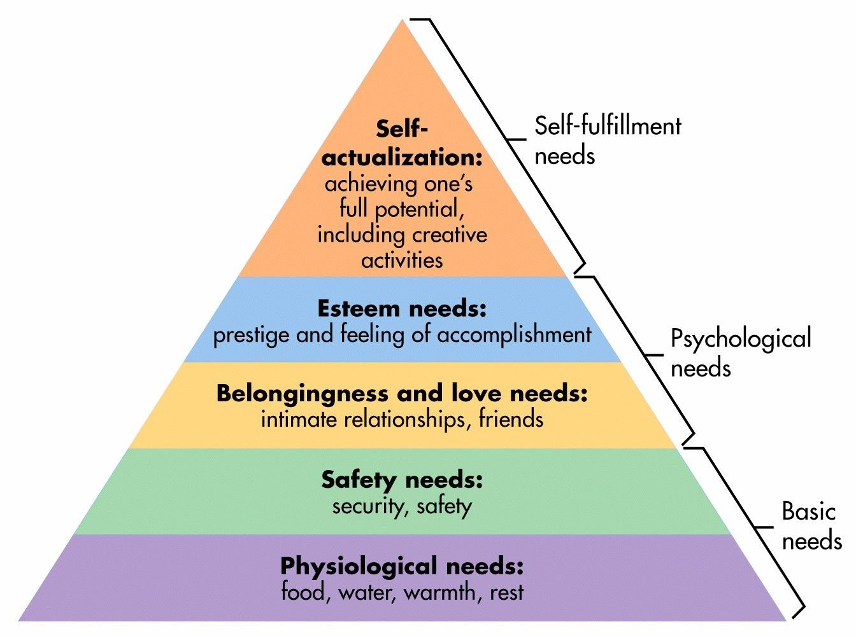If these needs not met 🡪 human body can’t function properly
* Thought to be the most important needs; they should be met first
* E.g. in a society with famine, where people are just trying to live day to day

**Safety needs: security**

* When physical needs are satisfied; safety needs take precedence and dominate behaviour
* In the absence of physical safety – people may experience PTSD or transgenerational trauma
* More likely to be found in children because they generally have a greater need to feel safe
* E.g. War, natural disaster, family violence, childhood abuse etc.

**Love and belonging**

* After safety needs are fulfilled
* Involves feelings of belongingness
* String in childhood and can override the need for safety as witnessed in children who cling to abusive parents

**Esteem**

* All humans have the need to feel respected
* Presents the typical human desire to be accepted and valued by others
* People often engage in a profession or bobby to gain recognition 🡪 Give the person a sense of contribution
* Low self-esteem may result from imbalances during this level

**According to Maslow, what is self-actualisation? 🡪** Occurs when people are fulfilled and doing all they are capable of

**Peak experiences:** when a person experiences the world totally for what it is, and there are feelings of euphoria, joy and wonder

**Behaviour leading to self-actualisation**

* Experiencing life like a child, will full absorption and concentration
* Trying new things (not sticking to one path)
* Listening to own feelings in evaluating experiences instead of the voice of tradition, authority and/or majority
* Avoiding pretence and being honest
* Being prepared to be unpopular
* Taking responsibility and working hard

**Self-actualisation**

* Refers to what a person’s full potential is and realization of that potential
* Desire to accomplish everything that one can do, to become the most that one can be
* Individuals may perceive or focus on this need very specifically
* E.g. one individual may have the strong desire to become an ideal parent, in another the desire may be expressed athletically

**Characteristics of a self-actualised person:**

- accept themselves and others for what they are

- are problem centred (not self-centred)

- highly creative

- seek peak experiences

**Limitations** of Maslow’s theory:

* **Methodology:** formulated the characteristics of self-actualised individuals from undertaking a qualitative method called biographical analysis, has the following weaknesses:
  + It is highly unscientific, as it is extremely subjective and based entirely on the opinion of the researcher
  + Personal opinion is always prone to bias = reduces the validity of any data obtained
  + Therefore, Maslow’s operational definition of self-actualisation cannot be accepted as scientific fact
* **Sample:** the sample used makes it difficult to generalise his theories to females and individuals from lower social classes or different ethnicities:
  + Maslow’s sample was highly biased
  + His sample of self-actualised people was limited to highly educated white males
  + Only a few women such as Eleanor Roosevelt and Mother Teresa were in his sample
* **Order of needs:** Maslow’s assumption that the lower order needs must be satisfied before a person can self-actualise is not always the case:
  + Through examining cultures in which large numbers of people live in poverty (such as India) it is clear that people are still capable of higher order needs such as love and belongingness (consider Mumbai’s Dharavi Slum)
  + According to Maslow, this should not occur as people who have difficulty achieving very basic physiological needs are not capable of meeting higher growth needs
  + Additionally, many creative people, such as authors and artists (e.g. Van Gogh) lived in poverty throughout their lifetime, yet it could be argued they achieved self-actualisation
* **Lacks empirical testing:** it is extremely difficult to empirically test Maslow’s concept of self-actualisation in a way that causal relationships can be established
* **Overly optimistic:** the two basic tenets of humanistic theories – that all people are born good and will strive to reach their potential throughout their lives – is highly optimistic and open to debate

CARL ROGERS - 1959

* Believed people are born good, with the potential for enormous growth, like the seed of a big tree
* Important people in our lives help us grow by providing;
  + **Genuineness:** honest and open
  + **Acceptance:** prepared to take us as we are, value us (unconditional positive regard)
  + **Empathy:** understand and sees from our perspective
* We need to experience GAE from significant figures, e.g. parents, in order to feel free to make any changes we want to make in ourselves, to grow and self-actualise
* **Unconditional positive regard:** accepting and loving a whole person and is not withdrawn if any person makes a mistake
* **Conditional positive regard:** child not loved for the person they are, but on condition they behave in ways approved by parent
* Therapists reflect positives in patient’s life, so they can separate the person from the problem
* If you’ve got genuine people around you = good sense of self 🡪 congruence
* He believed for a person to be self-actualised they must be in a state if congruence
  + **True self:** the person that you actually are
  + **Self-image:** the person you think you are
  + **Ideal self:** person you wish you were
* rogers considered that while we are never all we want to be, the greater gap between our ideal self, self-image and behaviour, the more likely we will feel anxious and stressed
* people need a congruency between the selves to feel good about themselves and have a good balance in personality. Rarely does a total state of congruence exist, all are incongruent
* Scott and O’Hawa (1993) found that students whose ideal and self-images were discrepant were anxious and depressed
* roger’s theory assumes people are born good and have free will

**Criticisms**

* lack of empirical evidence
* psychologists consider that such extreme focus on the subjective experiences of the individual does little to explain or appreciate the impact of society on personality development
* ignores unconscious mind
* ignores biology
* too optimistic