### Self

Biological influences/bases of behaviour

* **structure and function of the nervous system**
* *central nervous system*
* the CNS is the brain and spinal column
* the brainstem connects the brain with the spinal cord and takes responsibility for breathing, sleep patterns, hunger and thirst, blood pressure, heart rhythms and body temperature. In addition, it helps to regulate the
* CNS
* *brain*
* 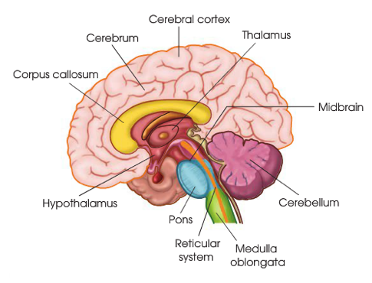case studies are frequently used in studies of brain functions. In case studies, patients who have suffered a brain injury are observes and studied in detail and in-depth and over time, so a comprehensive picture can be brought up on their behaviours
* case studies cannot be generalised to others as the consequences may be idiosyncratic and may not be necessarily be a true reflection of a more general relationship between brain activity and behaviour
* Divided into the forebrain, the cerebellum and the brain stem
* The outer brain areas are involved in perception, learning, motor and conceptual activities, while those areas near the centre of the brain are involved in internal and automatic bodily functions
* *spinal cord*
* 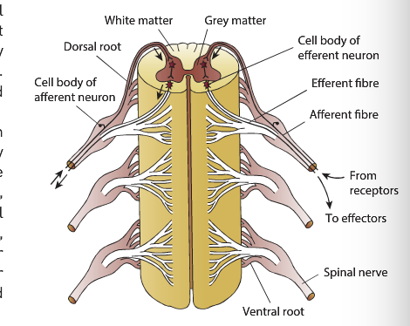runs down from the brainstem and is a major thoroughfare for messages between the brain and the rest of the body
* neurons that transmit messages away from the brain (efferent) and messages that go to the brain (afferent)
* organised into 31 segments, with sensory nerves leading into the dorsal (back) side of each segment and motor nerves exiting from the ventral (abdominal) sides.
* The PNS originates in the 31 pairs of spinal nerves and the 12 pairs of cranial nerves that leave the brainstem at the top of the spinal cord
* *peripheral nervous system*
* consists of the nerves outside the brain and spinal cord
* function: to connect the CNS to the rest of the body, specifically the limbs, skin, muscles and organs, serving as a communication pathway that goes back and forth between the brain and the extremities
* *somatic nervous system*
* important for monitoring bodily functions
* 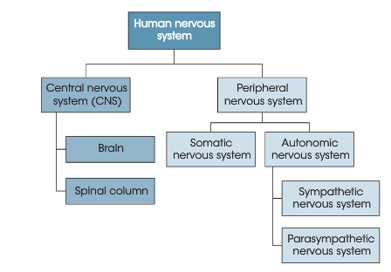receives sensory information from organs such as the skin, eyes and ears.
* Carries messages from the CNS along nerves to enable the muscles to move voluntarily
* *autonomic nervous system –*
* neurons that transmit messages between the brain and the smooth muscles found in the heart, lungs, blood vessels and glands
* regulates involuntary functions
* sympathetic: arouses the body to perform, act and react
* parasympathetic: works to maintain and conserve energy, calms the body down and to slowly return the body to normal functioning
* in an emergency the sympathetic nervous system activates bodily systems to react to the threat, crisis or disaster. Symptoms include, rapid heartbeat, faster breathing, expanded lung capacity, dry mouth, dilated pupils,
* ‘Fight or Flight’
* **process of neural transmission**
* *role of synapses*
* 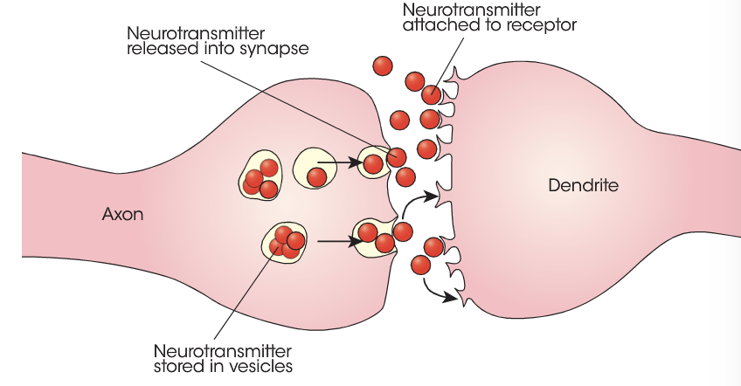models of synaptic transmission rely on chemical balances in the cell and electrical transmission through the neuron.
* Chemical gaps allow messages to be transmitted from one neuron to the next.
* *role of neurotransmitters – serotonin, dopamine*
* chemicals that enable activity to travel across the synaptic gap between neurons
* dopamine is involved in learning, attention and pleasurable sensations. The degeneration of neuron that produce dopamine in one area causes Parkinson’s disease, characterised by tremors, rigid movements and poor balance
* Serotonin is involved in sleep and mode and a deficit of serotonin has been linked to depression.
* Noradrenaline helps the body deal with danger or threat as well as being important in memory retrieval. Noradrenaline dysfunction is associated with mental disorders
* Endorphins are neurotransmitters that regulate our feelings and perceptions of pain. They are the body’s natural pain-killing drugs and are released when the body is stress or experiencing a positive mood.
* **roles of the four lobes of the cerebral cortex**
* *frontal lobe –*
* Broca's area – linked to the production of speech and is found in the left frontal lobe. Impairment to this area is called Broca’s

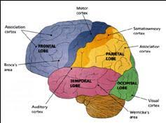

* aphasia (non-fluent aphasia). Speech is broken and lacks conjunctions, but the person can understand language.
* primary motor cortex – generates neural impulses that pass down to the spinal cord to plan and control the execution of movement, through the control of skeletal muscles. Left frontal love controls the right side and vice
* Associated with thinking, decision making, feeling and behaviour. It also performs a coordinating role, and coordinates many of the functions of other lobes and determines the behavioural response.
* *parietal lobe –*
* sits behind the frontal lobe and is responsible for bodily sensations, touch and other skin sensations such as temperature and pain
* spatial awareness and some aspects of speech
* enables individuals to read, write and solve mathematical problems
* sensory inputs from the right side go to the left side and vice versa
* primary sensory cortex – adjacent to the primary motor cortex and located at the front of the parietal lobe
* *occipital lobe –*
* sits directly behind and below the parietal lobe and is primarily responsible for visual functions of the eyes
* damage in this area can lead to different types of visual problems
* primary visual cortex – receives visual input from the retina and the visual signals are interpreted in the occipital lobe. It is involved in both visual perception and colour recognition
* not prone to accidental damage
* *temporal lobe –*
* located at the base of the cortex and is important in auditory perception such as hearing, as well as language and speech production and memory.
* It receives information from the ears and interprets the different sounds the ear hears.
* Wernicke's area – linked to the Broca’s area and is concerned with the understanding of language. Wernicke’s aphasia is a condition where language comprehension is impaired while speech production remains normal
* primary auditory cortex – is involved in the reception and processing of auditory stimuli.
* **factors that affect behaviour, emotion and thought, including:**
* *heredity – the role of genetics*
* plays a big role in physical growth and development and intelligence
* Zygote – new cell containing genetic material
* Genes – the basic unit of heredity
* Chromosomes – comprised of genes - 23 pairs
* Mitosis - the process of zygote division to form new cells
* Meiosis – the process of chromosome pairs breaking and exchanging genetic material.
* *hormones – the effects of adrenaline and noradrenaline*
* hormones are chemical messengers produced by endocrine glands. They travel through the bloodstream and affect other parts of the body
* Adrenaline – triggers ‘fight or flight’, occurs in emergency situations, Works in conjunction with the sympathetic NS, reactions include: muscle contraction, increased respiration and heart rate, deeper and faster breathing and pupil dilation.
* *psychoactive drugs – the effects of;*
* depressants – ‘downers’ that calm the activity of the nervous system and slow down the body’s functions, alcohol
* stimulants - ‘uppers’ that excite the nervous system and arouse the body’s functions, caffeine, nicotine and amphetamines
* hallucinogens – these substances change our perceptions and give us sensory images without input from the senses, ice, LSD and marijuana.

Cognition

* **Psychological concepts and processes associated with memory and their relationship to behaviour**
* *multi store model of memory – Atkinson and Shiffrin, 1969*
* memory is the internal record of some previous event or experience
* represents things that we have seen though, spoken or experienced
* 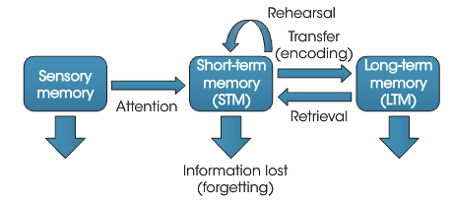Atkinson and Shiffrin developed a three-stage model which is characterised by three differences;
* Capacity: how much information?
* Duration: how long can the information be stored?
* Function: what is done with the stored information?
* Believed the human memory had two components that controlled memory:
* Structural features: permanent, built in fixed features of memory that do not change from one situation to another.
* Control processes: are selected and used by the individual depending on the situation, includes attention, rehearsal and retrieval.
* *sensory register*
* memory that is retained for a very brief period
* stores all incoming sensory information
  + duration – 5 seconds
  + capacity – very limited
  + encoding: the conversion of sensory information into a form that can be processed by the brain e.g. visually, acoustically or through meaning
* Iconic memory – visual memory
* Echoic memory – auditory sounds
* *short-term memory (working memory)*
* information may be rehearsed for transfer of the information to the long-term memory.
* Refers to the information you are aware of, which means that the thoughts, words and images are available for decision-making and problem-solving
  + duration – 30 seconds
  + capacity – 7 items + or - 2
  + encoding – rehearsal;
* maintenance rehearsal – when you remember things for immediate use e.g. a telephone number
* elaborative rehearsal – actively process and encode the information, making the material more meaningful so it can be used later
* chunking – material is combined into larger and meaningful groups
  + *working memory model – Baddeley and Hitch, 1974*
* emphasises the active nature of processing memory
* consists of two slave systems for short-term maintenance of information and one central executive responsible for organising and coordinating the slave systems
* 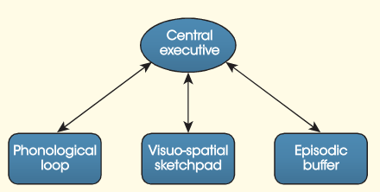Phonological loop – stores and processes phonological information and rehearses it silently.
* The visuo-spatial sketchpad – stores visual and spatial information, and constructs and manipulates visual images including details of shape, colour, motion, pattern and position, and represents mental maps.
* *long-term memory*
* relatively permanent store of information
* LTM can decay over time, meaning it naturally fades
  + duration – rained forever
  + capacity – infinite capacity
  + procedural memory – stores the way we do things, the ‘how to’ of memory.
* Sometimes called ‘implicit memory’ as it is not a conscious memory process and mainly refers to the learning of motor skills
* Procedural memories require little effort to retrieve and retrieval takes place more or less automatically.
  + declarative memory – the ‘what’ of memory,
* sometimes called ‘explicit memory’ and requires conscious effort for retrieval.
* Semantic - knowledge of facts and information based on understanding and interpretation.
* Episodic – memory for past and personal events and it is an internal representation of experiences in life.
* *recall, recognition, re-learning*
* Recall – retrieve information from memory without cues
* Recognition – identifying information from a number of alternatives
* Relearning – the most sensitive measure of memory, a person relearns information.
* *forgetting:*
* the failure to retrieve information that has been previously stored, or use it as required.
* retrieval failure – the inability to retrieve a certain piece of information, successful retrieval requires the use of cues that act as mental reminders.
* Interference – forgetting Is a result of retrieval difficulties due to competing, similar, information being stored
* Retroactive interference. – new information interferes retroactively with old information.
* Proactive interference – information previously leaned interferes with new learning.
* motivated forgetting – the inability to retrieve information because there is some advantage to not remembering it. This is a self-protection defence and can be seen as forgetting because you don’t want to think about it.
* Decay – simple fading away of memory over time. More evident in sensory storage and WM
* **theories and processes of learning**
* the stimulus-response approach, which assumed that changed in observed behaviours as a result of the environment were learning**.**
* *classical conditioning*
* it is learning caused by the pairing or association of two stimuli.
* An association forms between two stimuli, one which is not normally associated with the desired response.
* Pavlov’s Dogs;

Unconditioned stimulus (UCS) – the food

Unconditioned response (UCR) - Salivation

Conditioned Stimuli (CS) – the buzzer

Conditioned response (CR) - salivation

* *operant conditioning*
* learning through consequences
* theorist include E.L Thorndike and B.F Skinner – The Skinner Box (rodents and Pigeons)
* *observational learning*
* sometimes called ‘modelling’ or ‘imitation’
* developed by Bandura who coined the idea of reciprocal determinism - an individual’s behaviours influences and is influenced by both social and personal characteristics
* learning occurs when we observe and imitate the behaviour of others, strongest with the same gender
* O.L takes place when a new behaviour is learned or modified as a result of watching others or watching the consequences of the behaviour of others.
* **techniques for modifying behaviour**
* *token economies*
* artificial systems of reward and reinforcement where symbolic markers are used to reward behaviour
* these markers can be exchanged for something more tangible
* in reinforcement, the person whose behaviour is being changed can become ‘full’, the person ceases to respond to the reinforcement because they are full.
* The accumulation of points leads to a secondary enforcer, so you can never become full.
* Been criticised as when used in prisons and hospitals it is difficult to maintain the improvement in behaviour once the person has left the institution.
* *systematic desensitisation*
* the application of classical conditioning to fears and phobias in humans.
* Fears and phobias are undesirable behaviours and the idea is to replace then with more productive and desirable behaviours.
* The fear response is replaced with a more relaxed response and the first part of therapy is to practice relaxation and relaxation techniques.
* The process of systematic desensitisation involves drawing uo a list of the most fear-provoking situation to the least. The psychologist gradually introduces these from least to most fearful, during therapy. This is called graded exposure
* The person is first taught to relax generally and then is exposed to the least frightening situation and practices relaxation techniques until they are comfortable to proceed to the next situation
* *Cognitive Behaviour Therapy (CBT)*
* Based on the premise that cognitions influence feelings and behaviours and that subsequence behaviours and thoughts influence thoughts.
* In CBT the therapist helps the client identify unhelpful thoughts, feelings or emotions
* Has both a behavioural and cognitive component
* In behaviour therapy the therapist helps to change behaviour through behaviour modification, relaxation and other change techniques.
* Cognitive therapy is based on the theory that distressing emotions and behaviours are result of maladaptive thinking. Cognitive therapy consists of replacing the dysfunctional thoughts with ones that can be managed.
* *positive and negative reinforcement, including rewards and punishment*
* reinforcement is a consequence that causes a behaviour to occur more frequently
* positive reinforcement – the addition of something e.g. food
* negative reinforcement – taking about something unpleasant e.g. chores
* punishment is a consequence that causes a behaviour to occur less frequently
* positive punishment – addition – e.g. more chores
* negative punishment – taking away – e.g. no phone

### Others

Relational influences

* **types of solutions to resolve conflict**
* conflict occurs when there is a perception that two parties have incompatible goals, ideas of behaviours, or when an individual’s needs are not being met.
* Mirror image perceptions occur when people are in conflict. Each party tends to form reciprocal and distorted perceptions of the other that are remarkably alike.Depending on the source of the conflict, each is likely to describe ‘them’ in terms as incompetent or untrustworthy, while ‘we’ are a model of competence, integrity, virtue and high moral values.
* *Imposed*
* Are dictated solutions. Sometimes one party is stronger and will impose a solution
* At other times a third party may impose a solution
* Usually lead to one party winning, this solution leads to one party being dissatisfied and the underlying conflict staying unresolved
* *Distributive*
* Involve compromise or mutual concessions
* Can be seen in industrial disputes where wages may be set at a level somewhere in between
* *Integrative*
* Often called win-win situations because both sides can benefit from the decision reached
* More difficult than reaching a compromise as it involved understanding both parties’ motives, values and goals
* Follett and the orange sisters – looked over the integrative solution and stick with a distributive
* **techniques for resolving conflict**
* *mediation*
* involve bringing in third parties to help settle conflict
* mediators help the parties in a dispute to focus on the issues and reach a voluntary solution either distributive or integrative
* mediators can arrange times, venues and agendas for meetings, so they do not add fuel to the conflict
* a skilful mediator can improve relationships between relationships between the parties, helping them see common ground
* in arbitration the third party has the right to hand down a decision after listing to both parties, usually ends in an imposed solution
* mediation has been used to deal with conflict of parting parents.
* 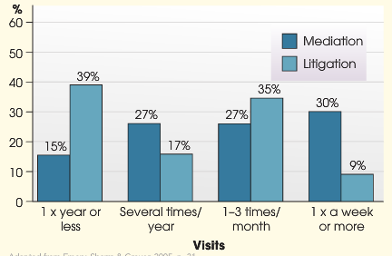Longitudinal research from Robert Emery evaluated the effectiveness of mediation opposed to adversarial settlement in court for parting parents. They followed the progress of parting parents over a 12-year period who had either been randomly assigned to a meditation or a court settlement group
* They found that mediation can:
* Settle a large percent of cases otherwise headed to court
* Speed settlement, save money, increase compliance
* Increase party satisfaction
* Lead to improve relationships between on-residential parents and children
* Lead to improved relationships between divorced parents.
* *negotiation*
* parties who have some shared and some opposing interests coming together to try and reach an agreement
* successful negotiation arrives at an integrative solution, but negotiation may break down due to a failure to understand the positions and goals
* *counselling*
* sought when conflict arises within families
* one or both parties to the conflict may work with a councillor in an effort to develop skills to help them deal with the conflict or to solve the conflict directly
* councillors will be trying to help the clients solve their own problems rather than provide them with solutions
* help improve clients listening skills and help to develop assertiveness
* **socialisation processes observed within families**
* Socialisation – acquiring the beliefs, values and behaviours that are thought to be important and appropriate to function effectively as a member of society**.**  It is a process that is ongoing as we grow older and adjust to changing roles
* 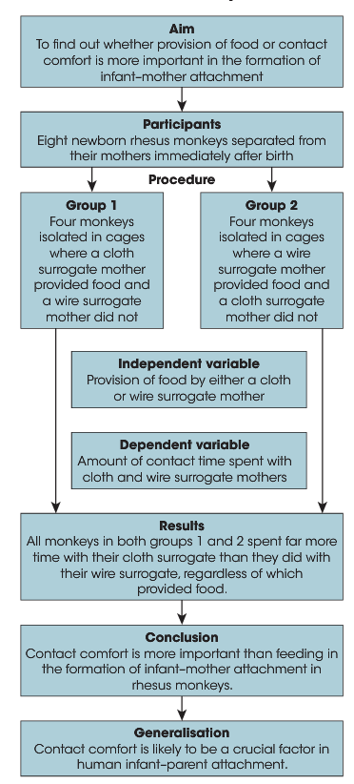The factors that affect our socialisation are known as agents of socialisation.
* *attachment -*
* the formation of a strong emotional tie between a mother and her baby. There is a sensitive period during which such bonding can occur and failure to established can lead to harmful effects later in life.
* *Harlow –*
* used rhesus monkeys to measure the development of attachment
* believed that emotional bonds to mothers were important for subsequent healthy development.
* Regardless of which surrogate was providing food via a bottle, the infant monkeys spent more time clinging to the cloth surrogate than to the wire surrogate
* Harlow conflicted that ‘contact comfort’ as provided by the cloth surrogate was more important in the formation of mother-infant attachment than feeding
* He generalised this conclusion to the mother-infant bond
* *Bowlby*
* ‘attachment’ – the bond that is formed between the mother and child during the ‘sensitive period’
* Mothers have a biological need to be close to their child
* A lack of attachment as an infant can lead to a lack of ability to form attachments as an adult
* ‘monotropy’: the belief that one figure should be the focus of attachment from the infant more than any other figure
* The child behaves in ways that elicit contact or proximity to the caregiver, and care givers respond appropriately to the signal
* ‘maternal deprivation’ – the separation from, or loss of, the mother, as well to the failure to develop an attachment
* Long-term consequences of maternal deprivation: delinquency, reduced intelligence, increased aggression, depression, affectionless psychopathy.
* *Ainsworth*
* Three attachment types identified from the strange situation;
* Type A – anxious-avoidant – insecurity is shown by ignoring their mothers failing to look at her and trying not to be close to her
* Type B – Secure: use their mothers as a secure base to explore their world
* Type C – anxious- resistant: insecurity is shown by resisting their mothers, such as by clinging to her but also kicking and pushing away
* Type B is more common type in all countries, Type A is relatively common in Western Europe, Type C us more common in Japan and Israel
* Some critics have argued whether the strange situation actually measures attachment or just the strangeness of the situation

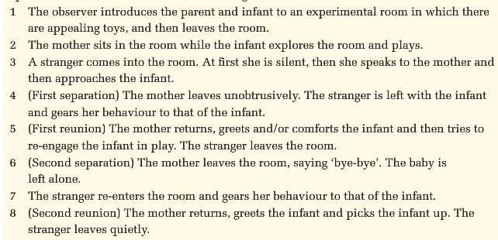

*features of different parenting styles – Diana Baumrind*

* parenting styles can be characterised by two factors. These factors are important in determining the development of children and adolescents as individuals and members of society
* responsiveness: the level of support and affection shown by a parent
* Control: the extent that parents supervise and regulate their children’s behaviour.
* *authoritative* – high in control and responsiveness, Set limits for children. Parents demands are reasonable, and they make sure children understand the reasons for the rules being set. Are more responsive to their children’s viewpoints and, as they get older, involved them in the decision-making process. They are warm and responsive to their children, yet expect rules to be followed as well as mature, independent and age-appropriate behaviours.
* *Authoritarian* - high in control and low in responsiveness, Demands obedience from the children. Many rules are set with few explanations, alternate viewpoints of the child are not considered. Parents are demanding and strict with high expectations of compliance to parental rules and demands.
* *Permissive* – high in responsiveness and low in control. Provides parental acceptance of children but there are few rules or guideline for the children to follow.

Communication

* **communication styles**
* examining the cultural and social aspects of language
* the styles in which we learn to speak depends on the culture in which we were raised, our socioeconomic background and our gender
* style involves not only our accents but also our vocabulary, grammar and the type of ideas we try to express
* *impact of social background –*
* Bernstein – relationship between language style and social class
* Working class used a restricted code – it relied on preserving traditional roles and ways of interacting
* Middle class used both restrictive and an elaborative code – develop ideas in relation to their person experiences
* 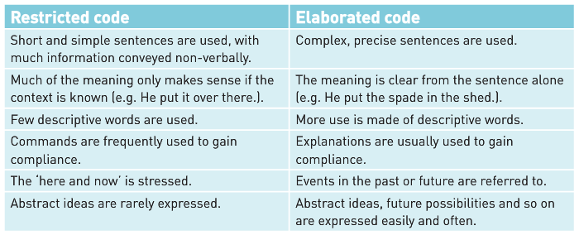Bernstein considered that children in working-class families has a language deficit because they could only use restricted code which limited their ability to benefit from education.
* Labov – ideas were based on his work with black children from New York who spoke Black English Vernacular
* Labov considered that BEV was just as complex, and rule governed as standard English and that it should be considered different not deficient.
* Nothing inherently more complex of ‘he doesn’t know anything’ than in ‘he don’t know nothing’
* European languages used double negative in the same way as BEV
* Labov was particularly concerned that teachers were being told to not accept BEV as it was useless for learning.
* *examples of gender differences – Tannen*
* Men tend to use Report talk which is the type of talk used in public speaking, when telling jokes or stories or imparting information they are comfortable with holding centre stage. They use talk as a way of gaining and holding the attention of their audience and to negotiate and maintain status.
* Women use rapport talk, this is the style of interaction that is based on establishing relationships, developing understanding and negotiating differences. Tannen considered that women enjoyed private conversation more than men
* Friction between men and women can occur because of a lack of understanding of differences in communication styles.
* Women use more confirmatory noises like ‘mmm’ and ‘yeah’ to indicate that they are listening and use more indirect requests.
* **features of persuasive communication**
* persuasion involved trying to change the beliefs, feelings and behaviours of another
* considering what factors affect the listening reactions is critical to successful persuasion
* Petty and Cacioppo 1986 – two routes to persuasion
* Central route – consists of thoughtful consideration of the content of the message by the receiver as an active participant in the persuasion process
* Peripheral route – occurs when the listener decides whether to agree with a message based on cues other than the messages content
* *source of the message*
* research suggests that a person is more likely to accept the word of people with expertise in an area, even without assessing the validity of the persons claim
* research has also shown that audiences attribute expertise to fast talkers, as long as the gist of the message can be understood, listeners assume a fast speaker is more intelligent and knowledgeable.
* Speaking fast also makes it difficult for the audience to fully evaluate the context
* Trustworthiness also persuades audiences
* *nature of the communication*
* when people understand a message and respond favourably to it, they are likely to be persuaded
* research indicates much persuasive information is misunderstood, although comprehension of printed information is higher than for information presented on television
* people do not simply absorb information they react and interact with it
* messages often aim to provoke an emotional response from the audience, both fear and feeling good are emotions that can be manipulated by advertisers to create a response
* *characteristics of the audience*
* the content or presentation style of the message will change depending on a range on audience characteristics; age, relationship to us, personality, level of education, their culture etc.
* high need for cognition: these people enjoys examining issues, checking for inconsistencies and weighing up the pros and cons in a debate
* low need for cognition: these people are more likely to be swayed by the expertise or trustworthiness of the source than the message
* culture also influences persuasion.
* **features and limitations of theories of language development**
* *innate and learned behaviours –*
* *Chomsky – Innate* – based on the assumption that language develops naturally as everyone learns how to speak their own native language.

Feature of the Language Acquisition Device (LAD);

* Hard-wired for language
* Works by receiving as input, the native language around the child and generates sentences in that same language as output

Rules of language;

* Universal rules – convers the deep or grammatical structural of language. These are applicable to all languages
* Surface structure rules: describe the grammatical structure of each spoken language
* People are genetically predisposed to learn this universal grammar.

Criticism to the LAD theory

* Being a nativist theory, it pays little attention to the social environment in which the child was developing, except to acknowledge that the primary linguistic input came from the language used by the family and community.
* *Bruner – Learned* – believes that children’s language development takes place through parents talking to their children
* Bruner’s findings are based on his two-year longitudinal study of two boys from 3 months to approximately 24 months.
* Proposed a Language Acquisition Support System (LASS). This essentially described how parents guided and supported their children’s emerging language through communication
* Not only do children learn to talk, they learn the language of their particular social, cultural and historical group.
* 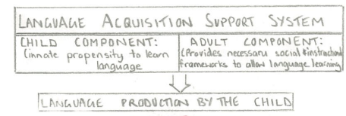scaffolding – interactional frameworks that allow the child to learn language
* Mother stays one step ahead
* Formats- using familiar routines to ‘push’ the child to learn new words
* Reference – Joint attention – establish through eye contact, leads to infants associating names of objects with terms to describe their place in time and space
* Booking reading - a routine structure