### Self

Developmental psychology

* **stages and characteristics of developmental theories**
* *Piaget’s theory of cognitive development*
  + a schema is an idea about what something is and how to deal with it. By adulthood we have a vast number of schemas ranging from those for chairs and tables to those of love and democracy
  + in assimilation we interpret new experiences and information in terms of our current understanding.
  + In accommodation we adjust a schema to include new information as a person encounters it

*Four stages of cognitive development*

* + *Sensori-motor* (0-2) – babies develop their understanding of the world through their sensory and motor interactions, children have been seen to live in the present and have little understanding that things continue to exist if they are not within sight (object permanence), this is gained at 8 months.
  + *Pre-operational* (2-7) - children are egocentric and can only view the world from their own viewpoint until about age 6. This can be shown through the three-mountain task. Children cannot think logically and are unable to conserve, classify or seriate.
  + *Concrete Operational* (7-11) – are able to think logically and carry out mental operations provided they are working with concrete materials. They can conserve (understand that an object does not change mass, volume or area simply because it changed shape). They are able to classify and seriate and towards the end are able to use mental pictures of objects and events rather than having to use concrete objects
  + *Formal Operation* (7+) – at this stage children become capable of abstract thinking – thinking that does not rely on being able to see or handle materials in order to reason about them. Can talk about concepts such as honesty and morality and can discuss possible outcomes to actions. Can look at shades of grey and things in the ‘middle’
* *Kohlberg’s theory of moral development*
  + There is a universal sequence to the development of morality and the stages begin in early childhood.
  + His six stages of moral development were based on children’s responses to various moral dilemmas which focused on the value of human life and property, the meaning of social rules and law, the value of honesty, and the important of upholding contractual agreements with others

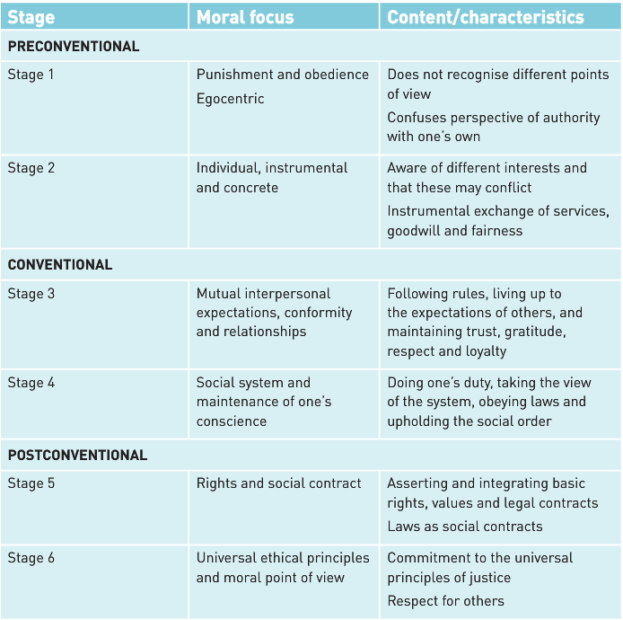

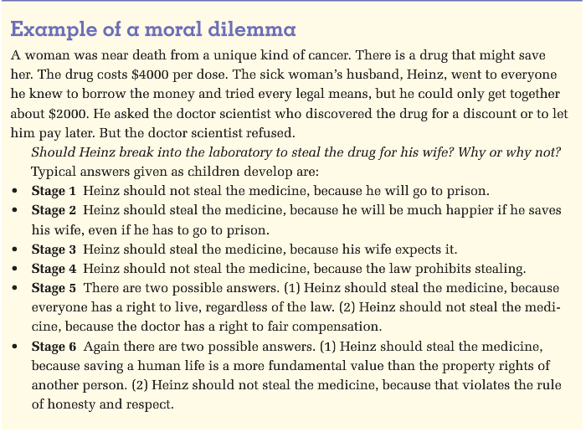

* *Erikson’s stage theory of identity*
  + *Sense of identity* – children develop this and describes the enduring personality characteristics of each and every person. This sense of identity is developed not just through childhood and adolescence but across the entire lifespan
  + The development of identity is a series of continual challenges that have to be met by the individual to move successfully to the next stage of life, is a lifelong process.
  + *Identity formation* – is a continuous challenge with dominant crises characterising various phases of life, starting from infancy to old age.
  + Unsuccessful resolution of crises can lead to children, adolescents and adults becoming ‘stuck’ at a particular stage and not developing normally
  + 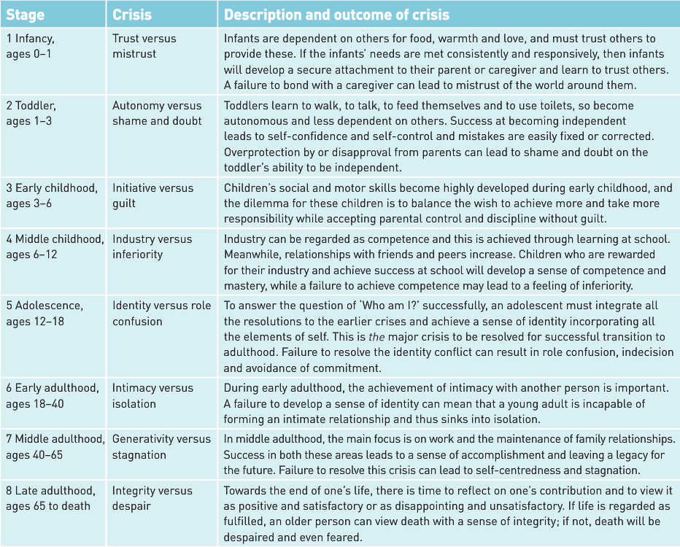Abnormal personality development can be traced to failure to resolve a particular identity crisis.
* **features of Bandura’s Social Learning Theory**
* *the role of observational learning and modelling*
  + Bandura originally proposed that children passively took in information from watching the behaviour of others (or the consequences of behaviour) and then simply copied it
  + Children learn complex social behaviours in this way, ranging from aggression and altruism, to sex roles
  + In later version of the theory, Bandura acknowledges that learners play an active role in the modelling process, choosing which models they attend to and deciding whether the behaviour they are observing is consistent with their beliefs and values and produced wanted outcomes
  + Bandura called this active role Mediational process

*Mediational Processes*

* + These are cognitive processes that mediate (intervene) in the learning process to determine whether a new response is acquired
  + Attention: the extent to which the person notices the behaviour. For a behaviour to be imitated it must be attended too
  + Retention: how well the behaviour is remembered. A memory of the behaviour is formed to be performed later by the observer
  + Reproduction: the ability to perform the behaviour that the model has demonstrated. Must have the physical ability to reproduce it
  + Motivation: the will to perform the behaviour. The rewards and punishments that follow a behaviour will be considered

*Bobo doll Experiment*

* + Bobo doll is a large inflatable balloon-shaped object with a weight at the bottom. It bobs back up when pushed over
  + This doll was repeatedly knocked over by a female student, she bashed it and shouted aggressive words and phrases
  + This was taped and shown to groups of young people
  + The children were later allowed to play with the doll, and they imitated the female students’ actions
  + This demonstrated that children change their behaviour without reinforcement or punishment

Personality

* + Personality is the characteristic ways in which a person thinks, feels and acts that makes them unique/ an individual
* **features and limitations of contemporary personality theories**
* *trait theories –*
  + personality traits describe the stable forms of behaviour that people display in any and every situation
  + traits are inferred from behaviour and can be used to predict behaviour
  + trait approaches move beyond type theory
  + trait theories categorise people using more than one dimension and therefore more fully capture a person’s individuality
  + issues surround consistency and continuity of traits

*FEATURES OF A TRAIT*

* + are stable and enduring over the person’s life
  + predicts behaviour across situations
  + is genetically predetermined
  + identifies differences between people
  + is identifiable and describable in a person
  + can be measured
  + are cognitive, emotional and behavioural tendencies
  + the types of traits and number of traits required to describe personality are open to debate

*McCrae and Costa*

* + Thought there were five main dimensions of personality which became the ‘Big Five’ - OCEAN
  + Extraversion – is characterised by excitability, sociability and high amounts of emotional expressiveness. These people gain energy in social situations
  + Neuroticism – characterised by sadness, moodiness and emotional instability. Mood swings, irritability, anxiety and sadness are common
  + Openness to Experience – features characteristics such as imagination and insight and a broad range of interests. More adventurous and creative
  + Agreeableness – includes attributes such as trust, kindness and pro-social behaviours. Tend to be cooperative and less competitive.
  + Conscientiousness – features characteristics such as high levels of thoughtfulness, with good impulse control and goal directed behaviours. Tend to be organised

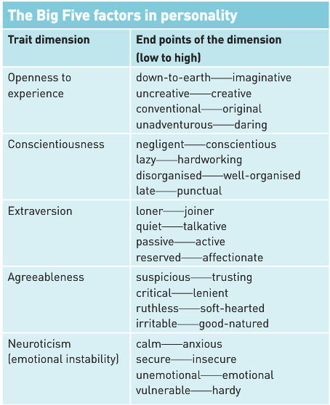

STRENGTHS

* + Contains objectivity that other theories lack
  + There is increasing evidence to support the existence of the Big 5
  + The 5 traits seem to result of approximately equal influence of hereditary and environmental influences
  + Traits seem prevalent in non-western cultures

LIMITATIONS

* + Debate surrounds number of traits required
  + Traits are often poor predictors of behaviour – people do not always behave consistently across situations
  + Does not address how or why differences in personality develop or emerge
  + Relies on self-report (subjective)
* *humanistic theories –*
  + central belief that people are born good
  + people will strive to reach their potential throughout their lives
  + personality results from people striving to reach their potential
  + two biggest contributors are Rogers and Maslow

LIMITATIONS

* + vagueness of some concepts: such as self-actualisation. Vague concepts are difficult to investigate scientifically
  + Maslow’s description of a self-actualised person is possible just a list of values
  + The theory is overly optimistic and fails to take into account the human capacity for evil

*Rogers*

* + believed people are born good
  + have enormous potential for growth like the seed of a big tree
  + this growth requires genuiness, acceptant and empathy like a tree needs nutrients, water and sun
  + Genuiness: a genuine person is open and honest and does not put on a front
  + Acceptant: an accepting person is prepared to take us as we are with all shortcomings (unconditional positive regard)
  + Empathy: when the other person tries to see the world from our perspective and tries to understand how we feel.

Concept of Self: the well-adjusted personality

* + Measure using a Q-sort test
  + 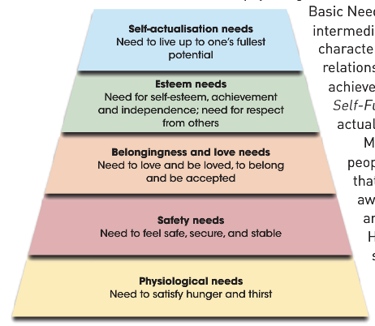Idea of congruence: requires a good match between a person’s ideal self (who they’d like to be), true self (who they wish they were) and their self-image (who they think they are)

*Maslow*

* + Theory surrounds the achievement of self-actualisation (the drive towards growth, self-expression, creativity and the achievement of ones highest unique potential)
  + Lower level needs must be met and gratified before moving on to higher level needs
* *social-cognitive theory –* 
  + believe that personality by itself does not cause behaviour; that even if it relatively stable it only influences behaviour
  + the context of the behaviour should be a focus
  + such contexts include home, work and school and any other social environment.

*Mischel*

* + also took into account social cognitive factors when considering personality and its impact on behaviour
  + tried to reconcile both trait and social cognitive approaches to explain human behaviour
  + considered this was necessary to deal with apparent inconsistencies
  + e.g. mark is yelled at by his wife, so he yells back. Mark is yelled at by his boss, but he sits and takes it.

Situationism

* + people are generally influenced by external situational factors than by internal traits or motivation
  + circumstances are very powerful when predicting the behaviour of a person
  + if A then X; but if B then Y

*Bandura*

*Reciprocal Determinism*

* + Human behaviour is the result of interaction between behaviours, cognitive factors and environmental factors
  + 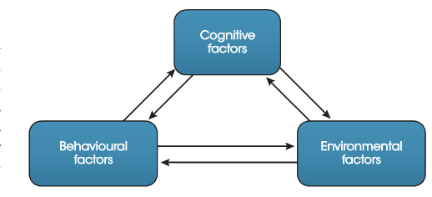Environmental influences are important but so are conscious, self-generated goals and standards that influence our thoughts, feelings and actions. Each factor influences the other factors and is influences by the other factors

*Self-efficacy*

* + The degree to which you are sure of your own ability and capability to manage and to be effective in meeting the demands of particular situations.
  + Developing in early childhood, strong self-efficacy is acquired by mastering new skills and meeting challenged in specific situations

### Others

Social psychology

* **the influence of groups on behaviour**
* *group polarisation*
  + the theory explains that when people are in groups with others who hold similar attitudes and beliefs, discussion within the group tends to strengthen opinions
  + Myers and Bishop (1970): found that when students who were low in racial prejudice talked together about racial issues, their attitudes became more accepting. The opposite was also true.
  + Can be used to explain the terrorist mentality
  + Can describe the processes that can lead to actions such as those of suicide bombers
  + Clark McCauley (2002) noted that a terrorist mentality does not come out of thin air; rather it arises when people with a shared grievance get together and talk in a group in which there are no moderating influences
  + Example: Jake Bilardi – a teenager from Melbourne was radicalised by IS over the internet. He made his way to Iraq through Turkey where he joined IS fighters. Bilardi’s life ended in March 2015 when he blew himself and the 4WD he was driving up outside an Iraqi police checkpoint.
* *conformity* 
  + Changing behaviour in response to group pressure

*TYPES*

* + Normative social influence: when a person conforms to group standards in order to be part of a group and accepted by the group
  + Informational Social Influence: when a person conforms in a strange situation to people we do not know well. People take cues on how to behave from people who they consider having more knowledge (information). People conform in this way to ensure they do not cause offence when in strange situations.

*FACTORS AFFECTING CONFORMITY*

* + Group Size – conformity increases up to a group size of 4
  + Unanimity – when others in the group are unanimous, conformity increases

*ASCH’S LINE EXPERIMENT*

* + Consisted of a simple visual task
  + Participants were seated around a table and shown two cards. On one there was a set of three lines, on the other a single line
  + All participants except one were confederates
  + Participants were asked one-by-one which of the three lines was the same as the single line
  + On 12 of the 18 trials the confederates all agreed on the incorrect answer, some obviously so
  + Asch found that 75% of participants agreed on at least on trial, 50% echoed the confederates on six or more of the trials
  + Only 25% of participants did not conform at all

*ACROSS CULTURES*

* + Highest levels of conformity are found in collectivist cultures, where achieving group goals is highly values



* *obedience –* 
  + the changing of behaviour in response to instruction in response to instruction or direct request by an authority figure

*MILGRAM*

* + Was to study obedience to authority and was partly derived from interest as to why Nazi SS officers obeyed orders from their superiors to gas millions of Jews during WW2
  + Involved and experimenter (scientist) who would be the authority figure instructing the teacher to continue, the teacher who would read the word pairings and administer shocks and a learner who responses and receives increasing levels of shocks
  + Both the experimenter and learner were actors
  + Results: 26 out of the 40 participants administered 450 voltes, even believing they were hurting someone else. All participants accomplished 300 volts
  + The whole experiment was a deception. 40 men were the teachers; the learner (male) was and actor; who had been trained to react to the shocks. No actual shocks were given
  + Participants we debriefed and reassured their behaviour as the teacher was quite normal

*WHAT MILGRAM’S EXPERIMENT TAUGHT US*:

*Factors influencing obedience*

* + Immediacy or proximity to the victim who was not seen. Subsequent studies has situations where the teacher could see the learner, and obedience dropped
  + Immediacy or proximity of the experimenter: removing the experimenter from the same room as the experimenter reduced obedience
  + Authority of the experimenter: conducting the experiment in a non-university setting also reduced the levels of obedience.

Why people obey authority figures

*The belief in legitimate authority*

* + Commitment to successful achievement of the experiment
  + Lack of disobedient role models.
  + Conducting the experiment in social isolation meant that social norms or expected behaviours were not present
  + Lack of personal responsibility. Milgram, as the experimenter assured the teachers that they were not personally responsible for the distress of the learner.

*ZIMBARDO (1973) STANFORD PRISON EXPERIMENT*

* + *Purpose:* to investigate how readily people would conform to the roles of guard and prisoner in a role-playing exercise simulating prison life.
  + *Sample*: 70 young male university students recruited through the newspaper. From this 24 were selected who were judged to be healthy with no psychological problems. 12 assigned to the role of prisoner and 12 to the role of guard
  + *Procedure:* the basement of the Stanford university psychology building was converted into a prison, complete with cells, prison doors. Guards were issued uniforms, prisoners were stripped, de-loused and issued prison overalls
  + *Results*: guards become increasingly brutal in their treatment of the prisoners, and the prisoners became dejected and dehumanized. Six days in to the two-week period and the experiment was halted
  + *Conclusions:* social roles influence behaviour in highly complex ways. The social environment of the prison and the roles of the participants influenced the way both groups behaved.
* *impact of the presence of others on individual behaviour –*

*Social facilitation*

* Norman Triplett (1898) noticed cyclists rode faster when they raced again each other than when they raced against the clock
* He hypothesised the presence of others boosted performance
* He tested this idea by asking adolescents to wind in a fishing reel as quickly as they could
* Performance was better when doing this against another person than against the clock
* He referred to this boost in performance due to the presence of others as Social facilitation

*Social inhibition*

* The presence of others does not always boost performance
* With complex tasks the presence of others either as observers or as people doing the same task led to worse performance
* 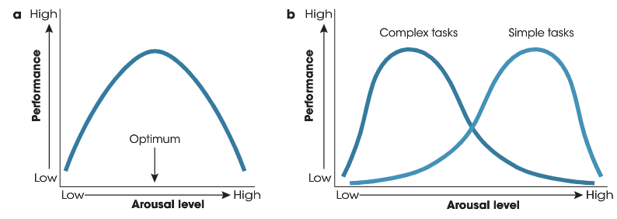Called this social inhibition,
* Diagram A: illustrates the relationship between arousal level and performance (Yerkes and Dodson) (1908)
* Diagram B: performance perks at lower levels of arousal for complex tasks and higher levels for simple or well-learned tasks
* **theories of social psychology**
* *attribution theory –* 
  + attribution is concerned with how and why people explain events as they do

Heider

* + believed that people are naïve psychologists trying to make sense of the social world
  + internal or dispositional attribution: the process of assigning the cause of behaviour to some internal characteristic than to the outside forces. When we explain the behaviour, we look for enduring internal attributions, such as personality traits
  + External or situational Attributions: the process of assigning the cause of behaviour to some situation or event outside a person’s control rather than some internal characteristic.
  + Fundamental Attribution Error – we usually take an individual’s behaviour at face value and do not sufficiently consider the surrounding circumstances. We favour a dispositional attribution for the behaviour
  + Self-serving bias – we distort the facts and make situational attributions in order to maintain self-esteem.

Kelley

* + Explains how people make causal explanations and answer further questions about ‘why’ something happened
  + Considered that people make attributions use three types of information: consensus, distinctiveness and consistency.
  + Consensus – the extent to which other people behave in the same way in a similar situation
  + Distinctiveness: the extent to which the person behaves in the same way in similar situations
  + 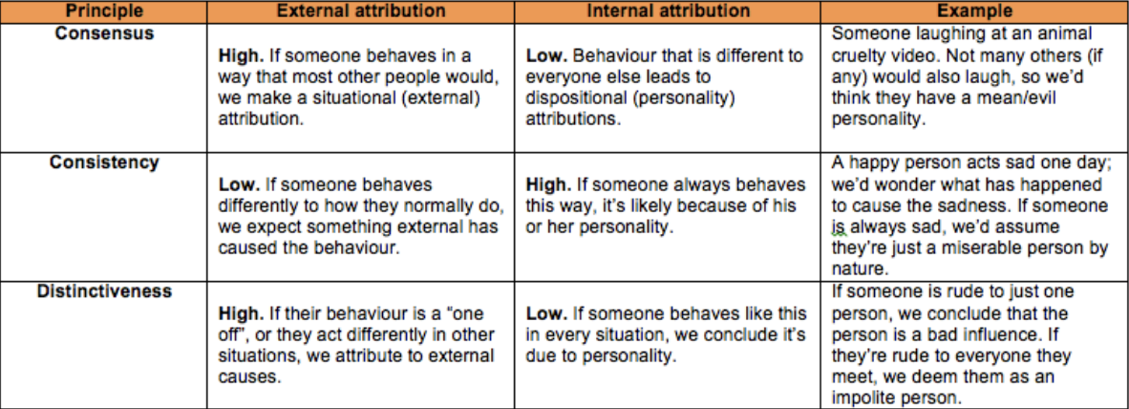Consistency: the extent to which the person behaves like this every time the situation occurs
* *cognitive dissonance* *theory –*

Festinger

* + refers to a situation involving conflicting attitudes, beliefs or behaviours. This produces feeling of discomfort leading to an alteration in one of the attitudes, beliefs or behaviours to reduce the discomfort and restore balance.
  + people attempt to reduce this dissonance either by changing the belief or attitude or changing the behaviour
  + e.g. a smoker who believed smoking is bad for his health may decide that the evidence against smoking being a health hazard is flawed or inconsistent (change in belief) or may join a quit program (change in behaviour)
  + 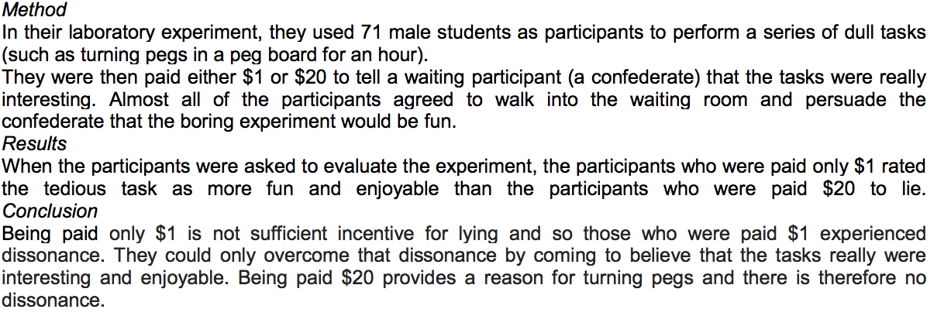Festinger experiment:

Culture and values

* **sense of community as defined by McMillan and Chavis**
  + Community is a geographical notion such as a neighbourhood or town and the quality of relationships (between people) without any reference to location
  + Sense of community – the feeling members have of belonging, a feeling that members matter to one another and the group, and a shared faith that members needs will be met through their commitment to be together
* *Membership*
  + the sense of belonging to a community that an individual develops. There are five attributes to membership:
  + *boundarie*s: marked by such things as language, dress and ritual as well as physical boundaries indicating who belongs and who does not
  + *emotional stability*: is the part of the broader notion of security. Boundaries established by membership criteria provide the structure and security that protect group intimacy. Such security may be more than emotional; gangs provide physical security and collectives emotional security.
  + *A sense of belonging and identification*: involves the feeling, belief and expectation that one fits in the group and has a place there, a feeling of acceptance by the group and a willingness to sacrifice for the group
  + *Personal investment*: having to work for membership to the community, or have to make sacrifices for the community, then membership will be more meaningful and valuable
  + *A common symbol system:* sharing a symbol like a sports team jersey, gang colours or a school uniform creates a sense of community., these symbols are used to create a social distance between members and non-members
* *Influence*
  + Is a bi-directional concept. In one direction, there is the notion that for a member to be attracted to a group, he or she must have some influence over what the group does. Conversely, group/community cohesiveness is contingent on a group’s ability to influence its members
  + People who acknowledge that others’ needs values and opinions matter to them are often the most influential group members.
  + Those who always push to influence, try to dominate others and ignore the wishes and opinions of others are often the least powerful
* *integration and the fulfilment of needs*
  + this helps bind people together and increase group cohesiveness. ‘needs’ is more than the basic ones needed for survival and are valued and desired by the community. Needs include status, a sense of belonging, a support network or thoughtful conversations.
* *shared emotional connection*
  + this occurs when members of the community share various types of experiences that bring them together.
  + this increases the sense of community and cohesion
  + the shared experience might be due to good/positive events such as when a local sporting team wins a championship or to bad/negative events such as some natural disaster or crisis where everyone pitches in to help
* **impact of significant events on individuals and communities**
* *positive responses – resilience and post traumatic growth*

*Kobasa (1979)*

* + thought that personality differences could account for different Reponses to stress. She carried out a study on 600 executives who filled out two questionnaires – personality and stressful events/illness
  + She divided the respondents into two groups: one that had scored above average for illness, and the other that has scored below. The number of stressful events experienced by both groups was high.
  + When the high stress/high illness group was compared to the high stress/low illness, she found that the latter: saw change as a challenge, felt more in control of their lives, had a sense of direction in both their work and personal lives.
  + She described the group as having a hardy personality
  + The qualities Kobasa saw in her hardy types are some of the characteristics that have, in more recent years been identified with the concept of resilience.

Other qualities seen in the resilient person are:

* + The capacity for making the most out of small windows of opportunity
  + Having a deep-rooted faith in the system of meaning
  + Having a healthy social support network
  + Having a wide comfort zone.

*Post Traumatic Growth*

* + Tedeschi and Calhoun
  + After experiencing a traumatic event, people often report three ways in which their psychological functioning increases:
  + Relationships are enhanced in some way
  + People change their views of themselves in some way – developing wisdom, personal strength and gratitude
  + People describe changes in their life philosophy – finding a fresh appreciation for each new day and re-evaluating their understanding of what really matters in life
* *negative responses – post traumatic stress disorder*
  + PTSD is an anxiety disorder that can appear some weeks or months after a person lives through an experience so threatening and uncontrollable, that they are left with feelings of terror and helplessness
  + PTSD affects people who have experiences or witnessed a traumatic or life-threatening event
  + After such an experience, a person suffering from PTSF develops anxieties and fears even when he or she is not directly in danger. These anxieties then manifest themselves in everyday life, making certain situations more difficult for the PTSDO sufferer than normal.
  + *Physical symptoms* – disturbed sleep, nightmares, exhaustion, restlessness and headaches
  + *Cognitive symptoms* – poor concentration, disturbances to attention and memory, flashbacks, intrusive thoughts, disorientation
  + Emotional symptoms – fear, avoidance, panic, anxiety, depression guilt, withdrawal.

*DIAGNOSIS*

* + Past experience of actual or perceived threats to life
  + Violence or serious injury
  + Presence of distressing symptoms such as recurring memories
  + Dreams or flashbacks
  + Problems with concentration
  + Angry outbursts
  + Avoidance
  + Hyper arousal
  + Emotional numbness
* *event characteristics contributing to stress –* 
  + a significant event (sometimes referred to as a ‘world event’) is a large-scale event that affects more than just the individual
  + significant events can either be positive such as the Olympic games or negative such as a terror attack or natural disaster.
  + Whether positive or negative, significant events are often sources of stress for individuals and communities.
  + Three characteristics of the event itself influence whether it is experienced as stressful

*predictability;*

* + While some predictable events can still be stressful, generally the more unpredictable events are, the more stressful they are and the longer the events impact is felt.

*controllability;*

* + Generally, the less control a person feel/perceives they have during an event the more stress will be experiences by the person

*experience of threat or loss*

* + Generally, the more directly a person is impacted by an event, the more stressful it will be. Threats to life, wellbeing or property or loss of family, friends, property or security, will lead to higher stress being felt.