

Yenepoya Institute of Arts, Science, Commerce, and Management
Department of Computer Applications

Low Level Design Document
on
Cloud Forensics Automation for Energy Breaches
Project ID: PRJN26-141

Student Name: Muhammed Rinshad PP

Industry Mentor: |  | Guided by:

Table of Contents
Table of Contents 1
1. Introduction 1
1.1 Purpose 1
1.2 Scope 1
1.3 Intended Audience 1
1.4 References 1
2. Detailed Module Design 1
2.1 forensic_tool.py — Main Controller 1
2.1.1 CLI Argument Structure 1
2.1.2 Function: main() 1
2.1.3 Function: cmd_baseline(args, logger) 1
2.1.4 Function: cmd_scan(args, logger) 1
2.1.5 Function: cmd_compare(args, logger) 1
2.2 scanner.py — Directory Scanner Module 1
2.2.1 Function: scan_directory(path, logger) 1
2.2.2 Function: format_timestamp(epoch) 1
2.2.3 Output Data Structure 1
2.3 hasher.py — File Hashing Module 1
2.3.1 Function: compute_hash(filepath) 1
2.3.2 Function: hash_records(records, logger) 1
2.3.3 Hashed Record Structure 1
2.4 comparator.py — Baseline Comparison Module 1
2.4.1 Function: create_baseline(records, target_path, output_dir) 1
2.4.2 Baseline JSON File Format 1
2.4.3 Function: load_baseline(baseline_path) 1
2.4.4 Function: find_baseline(target_path, baselines_dir) 1
2.4.5 Function: compare_with_baseline(current_records, baseline_data) 1
2.5 report_generator.py — Report Generation Module 1
2.5.1 Function: generate_csv_report(records, output_dir) 1
2.5.2 CSV Column Specification 1
2.5.3 Function: generate_html_dashboard(records, scan_stats, output_dir) 1
2.5.4 Stats Dictionary Structure 1
2.6 logger_config.py — Logging Configuration Module 1
2.6.1 Function: setup_logger(name, log_file) 1
2.6.2 Log File Format 1
3. Data Flow Design 1
3.1 End-to-End Data Pipeline 1
3.2 Record Transformation Stages 1
3.3 Module Dependency Graph 1
4. Error Handling Design 1
4.1 Error Classification 1
4.2 Error Propagation Strategy 1
5. File and Directory Structure 1
6. Sample Data Design 1
7. Testing Strategy 1
7.1 Unit Testing Approach 1
7.2 Integration Testing Approach 1
8. Glossary 1

1. Introduction

1.1 Purpose
This Low Level Design (LLD) document provides a detailed, implementation-level specification of the Cloud Forensics Automation for Energy Breaches project (PRJN26-141). While the High Level Design (HLD) described the overall architecture and module relationships, this document drills down into function signatures, algorithm pseudocode, data structures, file formats, error handling strategies, and the internal logic of each module. A developer should be able to implement the entire system using only this document as a reference.

1.2 Scope
This document covers the detailed design of five core modules: scanner.py (directory traversal and metadata extraction), hasher.py (cryptographic hash computation), comparator.py (baseline management and tamper detection), report_generator.py (CSV and HTML report creation), and logger_config.py (centralized logging configuration). It also covers the main controller forensic_tool.py which dispatches CLI commands to the appropriate modules. The document specifies all function signatures, input/output data formats, algorithms, and error handling for each module.

1.3 Intended Audience
This document targets developers responsible for implementing or extending the forensic tool, project evaluators reviewing the code design quality, and academic mentors assessing the depth of the technical approach. Readers are expected to be familiar with Python 3.10+ syntax, file system APIs (os, pathlib), cryptographic hashing concepts, and standard data formats (JSON, CSV).

1.4 References
This LLD is based on and should be read in conjunction with the High Level Design (HLD) document for project PRJN26-141, which describes the system architecture, component overview, and non-functional requirements. The HLD provides the context within which this detailed design operates.

2. Detailed Module Design

2.1 forensic_tool.py — Main Controller
This is the main entry point of the application. It is responsible for parsing command-line arguments, initializing the logger, dispatching the appropriate workflow function, and handling top-level exceptions gracefully.

2.1.1 CLI Argument Structure
Argument | Type | Required | Description
subcommand | positional | Yes | One of: scan, baseline, compare
--path | string | Yes | Target directory path to scan or compare
--output | string | No | Output directory for reports (default: ./reports)
--report | flag | No | Generate CSV + HTML reports on compare

2.1.2 Function: main()
Attribute | Detail
Signature | main() -> None
Purpose | Application entry point; parses CLI args and dispatches to command handlers
Input | sys.argv (command-line arguments)
Output | None (side effects: calls sub-functions, prints results)
Exceptions | Catches all exceptions at top level, logs and prints user-friendly error

Pseudocode:
1. parser = argparse.ArgumentParser()
2. Add subcommand: scan, baseline, compare
3. Add arguments: --path (required), --output, --report
4. args = parser.parse_args()
5. logger = setup_logger('forensic_tool', 'forensic_log.txt')
6. logger.info(f'Forensic Tool Started | Command: {args.command}')
7. IF args.command == 'baseline': cmd_baseline(args, logger)
8. ELIF args.command == 'scan': cmd_scan(args, logger)
9. ELIF args.command == 'compare': cmd_compare(args, logger)
10. logger.info('Forensic Tool Finished')

2.1.3 Function: cmd_baseline(args, logger)
Attribute | Detail
Signature | cmd_baseline(args: Namespace, logger: Logger) -> None
Purpose | Scans target directory, computes hashes, saves baseline JSON snapshot
Input | args.path (target directory path)
Output | Baseline JSON file in baselines/ directory
Algorithm | 1. Validate directory exists 2. Call scan_directory() 3. Call hash_records() 4. Call create_baseline() 5. Print confirmation with file count and path

2.1.4 Function: cmd_scan(args, logger)
Attribute | Detail
Signature | cmd_scan(args: Namespace, logger: Logger) -> None
Purpose | Full directory audit with metadata collection, hashing, and report generation
Input | args.path, args.output (optional)
Output | CSV report + HTML dashboard in output directory
Algorithm | 1. Validate directory 2. scan_directory() 3. hash_records() 4. Load baseline if exists, compare 5. generate_csv_report() 6. generate_html_dashboard() 7. Print summary

2.1.5 Function: cmd_compare(args, logger)
Attribute | Detail
Signature | cmd_compare(args: Namespace, logger: Logger) -> None
Purpose | Compares current directory state against stored baseline, flags tampered files
Input | args.path, args.report (flag)
Output | Console output with status; optional CSV + HTML reports
Algorithm | 1. Validate directory 2. Load baseline JSON 3. scan_directory() 4. hash_records() 5. compare_with_baseline() 6. Print flagged counts 7. If --report: generate reports

The following screenshots demonstrate the three CLI commands in action:

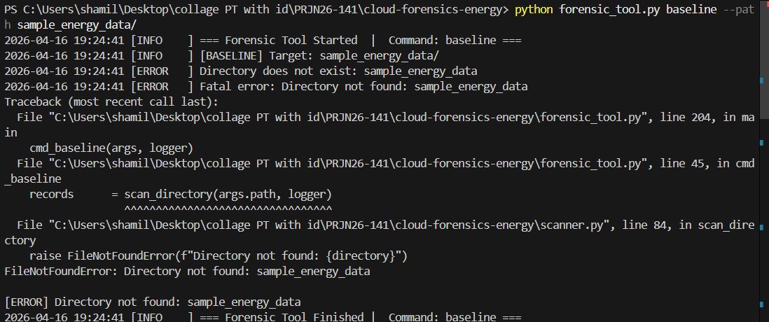
Figure 2.1: CLI — Baseline Command with Error Handling for Invalid Path

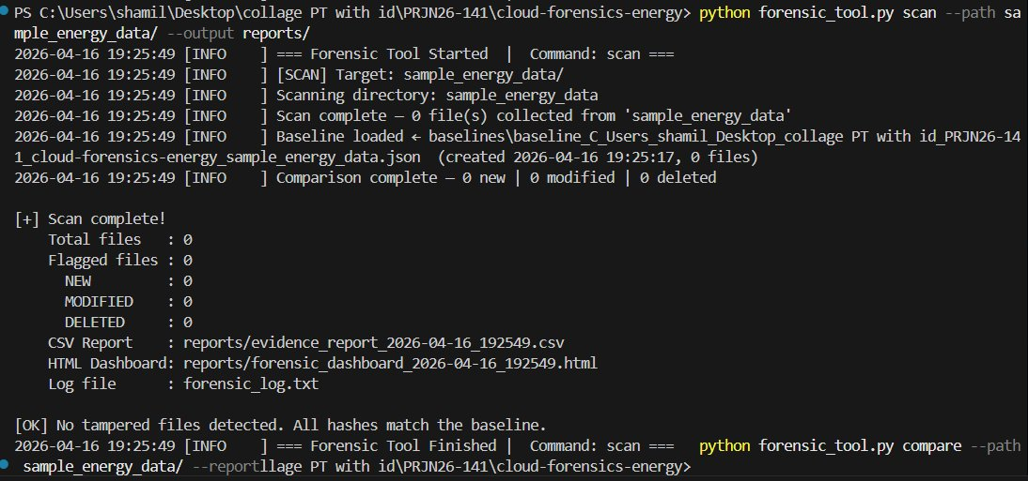
Figure 2.2: CLI — Scan Command Output with Report Generation

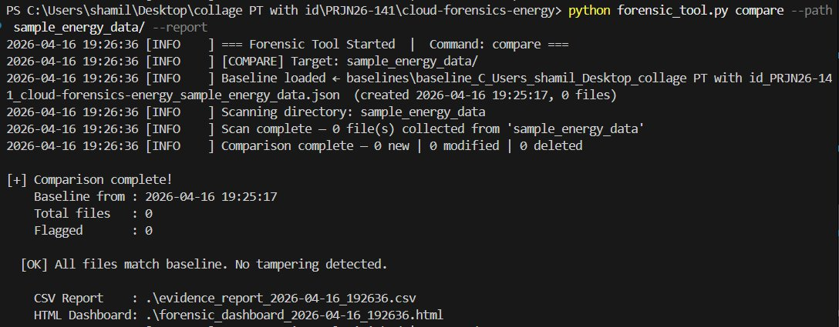
Figure 2.3: CLI — Compare Command Showing No Tampering Detected

2.2 scanner.py — Directory Scanner Module
This module handles recursive directory traversal and file metadata extraction. It walks through every file in the target directory tree and collects forensic-relevant attributes without modifying any files.

2.2.1 Function: scan_directory(path, logger)
Attribute | Detail
Signature | scan_directory(path: str, logger: Logger) -> list[dict]
Purpose | Recursively traverses a directory and collects file metadata for every file
Input | path — absolute or relative path to target directory; logger — Logger instance
Output | List of dictionaries, each representing one file's metadata
Exceptions | Raises FileNotFoundError if path does not exist; PermissionError logged and skipped

Pseudocode:
1. directory = Path(path).resolve()
2. IF NOT directory.exists(): RAISE FileNotFoundError
3. IF NOT directory.is_dir(): RAISE NotADirectoryError
4. records = []
5. FOR root, dirs, files IN os.walk(directory):
6. FOR filename IN files:
7. filepath = Path(root) / filename
8. TRY:
9. stat_info = filepath.stat()
10. record = {
11. 'filename': filename,
12. 'filepath': str(filepath),
13. 'file_size': stat_info.st_size,
14. 'file_type': filepath.suffix or '(none)',
15. 'created': format_timestamp(stat_info.st_ctime),
16. 'modified': format_timestamp(stat_info.st_mtime),
17. 'accessed': format_timestamp(stat_info.st_atime),
18. }
19. records.append(record)
20. EXCEPT PermissionError:
21. logger.warning(f'Permission denied: {filepath}')
22. logger.info(f'Scan complete — {len(records)} file(s)')
23. RETURN records

2.2.2 Function: format_timestamp(epoch)
Attribute | Detail
Signature | format_timestamp(epoch: float) -> str
Purpose | Converts Unix epoch timestamp to ISO-format human-readable string
Input | epoch — float timestamp from os.stat()
Output | String in format 'YYYY-MM-DD HH:MM:SS'
Algorithm | datetime.fromtimestamp(epoch).strftime('%Y-%m-%d %H:%M:%S')

2.2.3 Output Data Structure
Each record returned by scan_directory() is a Python dictionary with the following fields:
Field | Type | Example Value
filename | str | meter_readings_jan.csv
filepath | str | C:\Users\shamil\...\meter_readings_jan.csv
file_size | int | 4096
file_type | str | .csv
created | str | 2026-01-09 21:35:30
modified | str | 2026-01-09 04:05:41
accessed | str | 2026-03-10 21:44:22

2.3 hasher.py — File Hashing Module
This module provides cryptographic hash computation using dual algorithms (MD5 and SHA-256) for file integrity verification. MD5 provides fast comparison while SHA-256 provides forensic-grade collision resistance suitable for legal evidence standards.

2.3.1 Function: compute_hash(filepath)
Attribute | Detail
Signature | compute_hash(filepath: str) -> dict
Purpose | Computes MD5 and SHA-256 cryptographic hashes for a single file
Input | filepath — string path to the file to hash
Output | Dictionary with keys 'md5_hash' and 'sha256_hash', values as hex strings
Buffer Size | 8192 bytes (8 KB) — reads file in chunks to handle large files
Exceptions | Returns {'md5_hash': '', 'sha256_hash': ''} on IOError or PermissionError

Pseudocode:
1. md5 = hashlib.md5()
2. sha256 = hashlib.sha256()
3. TRY:
4. WITH open(filepath, 'rb') AS f:
5. WHILE chunk = f.read(8192):
6. md5.update(chunk)
7. sha256.update(chunk)
8. RETURN {'md5_hash': md5.hexdigest(),
9. 'sha256_hash': sha256.hexdigest()}
10. EXCEPT (IOError, PermissionError) AS e:
11. logger.error(f'Hash failed for {filepath}: {e}')
12. RETURN {'md5_hash': '', 'sha256_hash': ''}

Design Decision — Dual Hashing:
Both MD5 and SHA-256 are computed simultaneously in a single file read pass to minimize I/O overhead. While MD5 is considered cryptographically broken for security purposes, it remains useful for quick deduplication and comparison. SHA-256 provides the forensic-grade integrity guarantee. Computing both in one pass costs negligible additional CPU time since the I/O bottleneck dominates.

2.3.2 Function: hash_records(records, logger)
Attribute | Detail
Signature | hash_records(records: list[dict], logger: Logger) -> list[dict]
Purpose | Batch operation — computes hashes for all file records from scanner output
Input | records — list of dicts from scan_directory(); logger instance
Output | Same list with 'md5_hash' and 'sha256_hash' fields appended to each dict
Algorithm | Iterates records, calls compute_hash(record['filepath']) for each, merges result into record dict

2.3.3 Hashed Record Structure
After hashing, each record dictionary is enriched with two additional fields:
Field | Type | Example Value
md5_hash | str (32 hex chars) | a03b31e6ca1ed55c4f7b701f883c77...
sha256_hash | str (64 hex chars) | e3b0c44298fc1c149afbf4c8996fb924...

2.4 comparator.py — Baseline Comparison Module
This module manages baseline creation, storage, loading, and comparison logic. It is the core of the tamper detection system, responsible for identifying files that have been added, modified, or deleted since the last known-good baseline was recorded.

2.4.1 Function: create_baseline(records, target_path, output_dir)
Attribute | Detail
Signature | create_baseline(records: list[dict], target_path: str, output_dir: str) -> str
Purpose | Saves current hashed file records as a JSON baseline snapshot
Input | records — hashed file records; target_path — scanned directory; output_dir — baselines/ directory
Output | Returns the filepath of the saved baseline JSON file
Filename | baseline_{sanitized_path}.json where path separators are replaced with underscores

Pseudocode:
1. sanitized = target_path.replace('/', '_').replace('\\', '_')
2. sanitized = sanitized.replace(':', '').replace(' ', '_')
3. filename = f'baseline_{sanitized}.json'
4. baseline_path = Path(output_dir) / filename
5. baseline_data = {
6. 'metadata': {
7. 'created': datetime.now().isoformat(),
8. 'target_path': target_path,
9. 'project_id': 'PRJN26-141',
10. 'file_count': len(records)
11. },
12. 'files': { r['filepath']: {
13. 'md5_hash': r['md5_hash'],
14. 'sha256_hash': r['sha256_hash'],
15. 'file_size': r['file_size'],
16. 'modified': r['modified']
17. } FOR r IN records }
18. }
19. WITH open(baseline_path, 'w') AS f:
20. json.dump(baseline_data, f, indent=2)
21. RETURN str(baseline_path)

2.4.2 Baseline JSON File Format
The baseline JSON file has the following structure:
JSON Path | Type | Description
metadata.created | string (ISO) | Timestamp when baseline was created
metadata.target_path | string | Absolute path of the scanned directory
metadata.project_id | string | Project identifier (PRJN26-141)
metadata.file_count | integer | Number of files in the baseline
files.<filepath>.md5_hash | string | MD5 hex digest of the file
files.<filepath>.sha256_hash | string | SHA-256 hex digest of the file
files.<filepath>.file_size | integer | File size in bytes at baseline time
files.<filepath>.modified | string | Last modified timestamp at baseline time

2.4.3 Function: load_baseline(baseline_path)
Attribute | Detail
Signature | load_baseline(baseline_path: str) -> dict
Purpose | Loads and parses a previously saved baseline JSON file
Input | baseline_path — path to the baseline JSON file
Output | Parsed dictionary containing metadata and files sections
Exceptions | Raises FileNotFoundError if baseline not found; json.JSONDecodeError on corruption

2.4.4 Function: find_baseline(target_path, baselines_dir)
Attribute | Detail
Signature | find_baseline(target_path: str, baselines_dir: str) -> str | None
Purpose | Locates the baseline file corresponding to a given target directory path
Input | target_path — directory being compared; baselines_dir — folder with baseline JSONs
Output | Path to matching baseline file, or None if not found
Algorithm | Sanitize target_path to derive expected filename, check if file exists in baselines_dir

2.4.5 Function: compare_with_baseline(current_records, baseline_data)
Attribute | Detail
Signature | compare_with_baseline(current: list[dict], baseline: dict) -> list[dict]
Purpose | Compares current scan records against baseline, assigns tamper status to each file
Input | current — list of hashed file records; baseline — parsed baseline dict
Output | List of records with 'status' field added (UNCHANGED / NEW / MODIFIED / DELETED)

Pseudocode:
1. baseline_files = baseline_data['files']
2. current_paths = set()
3. results = []
4. FOR record IN current_records:
5. path = record['filepath']
6. current_paths.add(path)
7. IF path NOT IN baseline_files:
8. record['status'] = 'NEW'
9. ELIF record['sha256_hash'] != baseline_files[path]['sha256_hash']:
10. record['status'] = 'MODIFIED'
11. ELSE:
12. record['status'] = 'UNCHANGED'
13. results.append(record)
14. FOR path, data IN baseline_files.items():
15. IF path NOT IN current_paths:
16. deleted_record = {
17. 'filepath': path, 'filename': Path(path).name,
18. 'status': 'DELETED', 'file_size': data['file_size'],
19. 'md5_hash': data['md5_hash'], ...
20. }
21. results.append(deleted_record)
22. RETURN results

Tamper Detection Logic:
Status | Condition | Meaning
UNCHANGED | File exists in both current and baseline, SHA-256 hashes match | File has not been tampered with since baseline
NEW | File exists in current scan but not in baseline | File was added after baseline was created
MODIFIED | File exists in both but SHA-256 hashes differ | File content was changed since baseline
DELETED | File exists in baseline but not in current scan | File was removed after baseline was created

2.5 report_generator.py — Report Generation Module
This module produces two output formats from the enriched file records: a CSV evidence file for data analysis and archival, and a standalone HTML dashboard for visual investigation.

2.5.1 Function: generate_csv_report(records, output_dir)
Attribute | Detail
Signature | generate_csv_report(records: list[dict], output_dir: str) -> str
Purpose | Writes all file evidence records to a timestamped CSV file
Input | records — list of annotated file records; output_dir — directory for output
Output | Returns filepath of generated CSV; e.g., evidence_report_2026-04-16_192549.csv
Encoding | UTF-8 with BOM for Excel compatibility

2.5.2 CSV Column Specification
Column Name | Source Field | Description
Status | status | Tamper flag (UNCHANGED/NEW/MODIFIED/DELETED)
Filename | filename | File name without path
File Path | filepath | Full path to the file
Type | file_type | File extension
Size (B) | file_size | File size in bytes
Created | created | Creation timestamp
Last Modified | modified | Last modification timestamp
Last Accessed | accessed | Last access timestamp
MD5 Hash | md5_hash | Full MD5 hex digest (32 characters)
SHA-256 Hash | sha256_hash | Full SHA-256 hex digest (64 characters)

2.5.3 Function: generate_html_dashboard(records, scan_stats, output_dir)
Attribute | Detail
Signature | generate_html_dashboard(records: list[dict], stats: dict, output_dir: str) -> str
Purpose | Generates a standalone HTML file with forensic dashboard including summary cards, sortable table, and highlighted tampered files
Input | records — annotated file records; stats — summary counts dict; output_dir — output path
Output | Returns filepath; e.g., forensic_dashboard_2026-04-16_192549.html
Styling | Embedded CSS with dark theme; no external dependencies; fully self-contained

HTML Dashboard Structure:
Section | Content
Header | Project title (PRJN26-141), scan timestamp, target directory path
Summary Cards | 5 color-coded cards: Total Files (blue), New (green), Modified (yellow), Deleted (red), Clean (white)
Evidence Table | Sortable table with all columns from CSV specification; rows color-coded by status
Color Coding | NEW = green row, MODIFIED = yellow row, DELETED = red row, UNCHANGED = default
Footer | Scan metadata: timestamp, total count, tool version

2.5.4 Stats Dictionary Structure
Key | Type | Description
total_files | int | Total number of files in scan
new_count | int | Files flagged as NEW
modified_count | int | Files flagged as MODIFIED
deleted_count | int | Files flagged as DELETED
clean_count | int | Files flagged as UNCHANGED
scan_time | str | ISO timestamp of when scan was performed
target_path | str | Directory that was scanned

2.6 logger_config.py — Logging Configuration Module

2.6.1 Function: setup_logger(name, log_file)
Attribute | Detail
Signature | setup_logger(name: str, log_file: str = 'forensic_log.txt') -> Logger
Purpose | Creates and configures a Python Logger with both file and console handlers
Input | name — logger name (typically module name); log_file — path to log file
Output | Configured logging.Logger instance
Log Level | INFO for file handler; INFO for console handler
Format | '%(asctime)s [%(levelname)-7s] %(message)s' with datetime format '%Y-%m-%d %H:%M:%S'

Pseudocode:
1. logger = logging.getLogger(name)
2. logger.setLevel(logging.DEBUG)
3. formatter = Formatter('%(asctime)s [%(levelname)-7s] %(message)s')
4. file_handler = FileHandler(log_file, mode='a')
5. file_handler.setLevel(logging.INFO)
6. file_handler.setFormatter(formatter)
7. console_handler = StreamHandler(sys.stdout)
8. console_handler.setLevel(logging.INFO)
9. console_handler.setFormatter(formatter)
10. logger.addHandler(file_handler)
11. logger.addHandler(console_handler)
12. RETURN logger

2.6.2 Log File Format
The forensic_log.txt file contains timestamped entries in the following format:
2026-04-16 19:25:49 [INFO ] === Forensic Tool Started | Command: scan ===
2026-04-16 19:25:49 [INFO ] [SCAN] Target: sample_energy_data/
2026-04-16 19:25:49 [INFO ] Scanning directory: sample_energy_data
2026-04-16 19:25:49 [INFO ] Scan complete — 0 file(s) collected
2026-04-16 19:25:49 [WARNING] Permission denied: /protected/file.dat
2026-04-16 19:25:49 [ERROR ] Fatal error: Directory not found

3. Data Flow Design

3.1 End-to-End Data Pipeline
Data flows through the system in a linear enrichment pipeline. At each stage, the file record dictionary is augmented with additional fields. The pipeline stages are: directory traversal (scanner) produces base metadata, hashing (hasher) appends cryptographic fingerprints, comparison (comparator) adds tamper status flags, and reporting (report_generator) formats the enriched records for output.

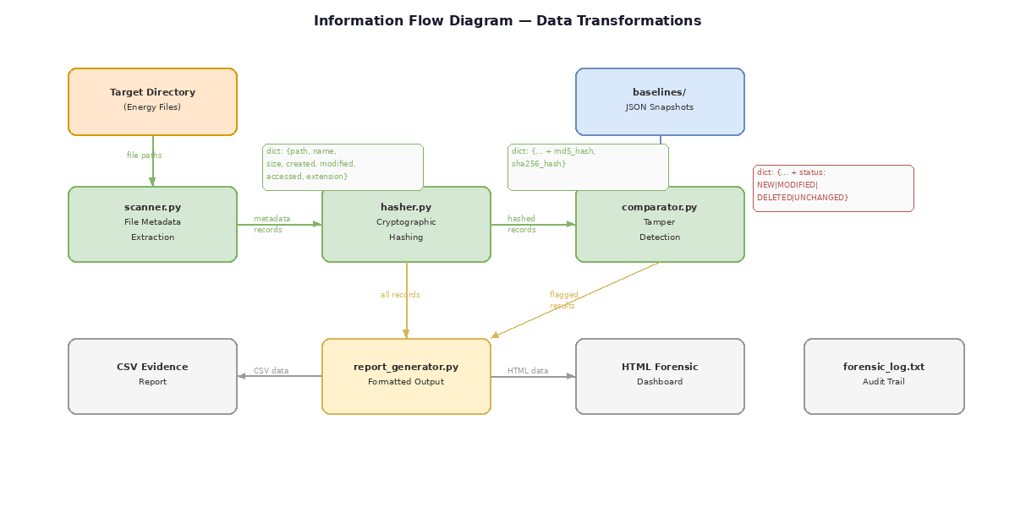
Figure 3.1: Information Flow — Data Enrichment Pipeline

3.2 Record Transformation Stages
Stage | Module | Fields Added | Record Size
1. Scan | scanner.py | filename, filepath, file_size, file_type, created, modified, accessed | 7 fields
2. Hash | hasher.py | md5_hash, sha256_hash | 9 fields
3. Compare | comparator.py | status | 10 fields
4. Report | report_generator.py | (consumes all 10 fields for output) | 10 fields

3.3 Module Dependency Graph
The following diagram shows the complete system architecture with all module dependencies and data flow paths:

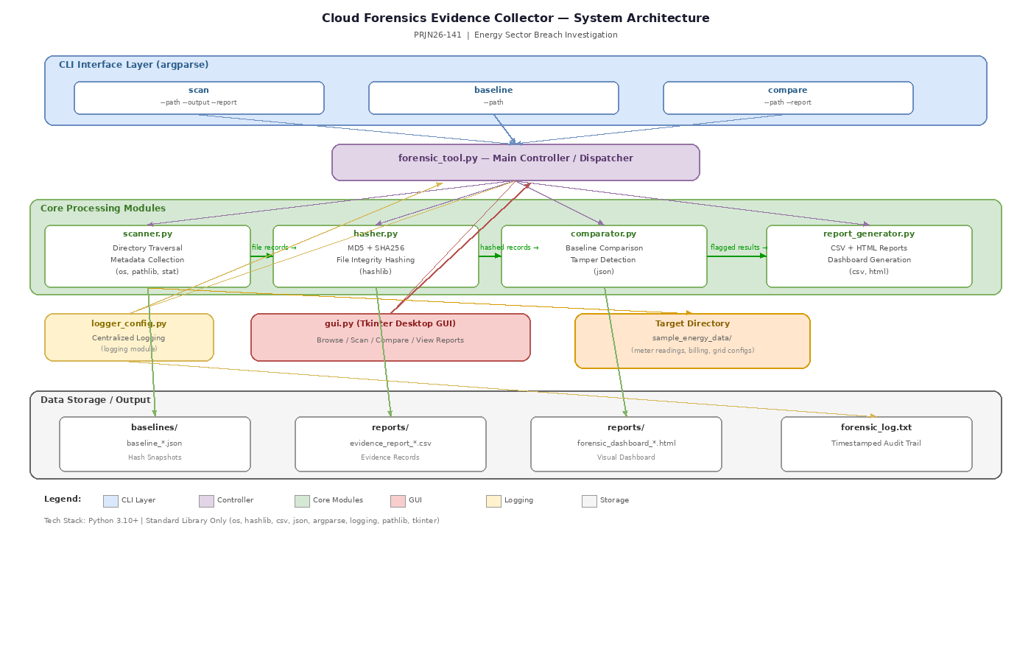
Figure 3.2: System Architecture — Module Dependencies and Data Flow

4. Error Handling Design

4.1 Error Classification
Error Type | Source | Handling Strategy | User Impact
FileNotFoundError | scanner.py, comparator.py | Raised to caller with descriptive message; logged as ERROR | Tool exits with clear error message explaining which path was not found
PermissionError | scanner.py, hasher.py | Caught at file level; skipped with WARNING log; processing continues | File skipped; warning printed; rest of scan proceeds normally
json.JSONDecodeError | comparator.py | Caught when loading corrupted baseline; logged as ERROR | Tool informs user baseline is corrupted; suggests recreating baseline
IOError | report_generator.py | Caught during report write; logged as ERROR | Tool reports failure to write output; suggests checking disk space/permissions
KeyboardInterrupt | forensic_tool.py | Caught at top level; cleanup and graceful exit | Clean termination with partial results preserved
Exception (generic) | forensic_tool.py | Caught at top level as safety net; full traceback logged | User-friendly error message printed; full details in log file

4.2 Error Propagation Strategy
The system uses a layered error handling approach. At the lowest level (scanner, hasher), recoverable errors like PermissionError are caught and logged, allowing the scan to continue processing remaining files. Critical errors like FileNotFoundError are propagated upward to the main controller (forensic_tool.py), which catches them at the top level and provides user-friendly error messages. The logging module ensures every error is recorded in forensic_log.txt regardless of how it is handled, maintaining a complete audit trail for forensic review.

5. File and Directory Structure
Path | Type | Description
cloud-forensics-energy/ | directory | Project root directory
forensic_tool.py | file | Main CLI entry point and command dispatcher
scanner.py | file | Directory traversal and metadata extraction module
hasher.py | file | Cryptographic file hashing module (MD5 + SHA-256)
comparator.py | file | Baseline management and tamper detection module
report_generator.py | file | CSV and HTML report generation module
logger_config.py | file | Centralized logging configuration module
requirements.txt | file | Python dependencies (standard library only — empty/minimal)
README.md | file | Project overview, setup instructions, usage guide
baselines/ | directory | Stored baseline JSON snapshots
reports/ | directory | Generated CSV evidence reports and HTML dashboards
forensic_log.txt | file | Timestamped audit trail of all forensic actions
sample_energy_data/ | directory | Demo directory with simulated energy sector files

6. Sample Data Design
The sample_energy_data/ directory contains 10-15 dummy files simulating an energy company data environment. These files serve as demonstration targets for the forensic tool.
Filename | Type | Content Description
meter_readings_jan.csv | .csv | Monthly smart meter readings with timestamps and kWh values
meter_readings_feb.csv | .csv | February meter data for comparison testing
billing_summary_q1.csv | .csv | Quarterly billing aggregates with customer IDs
grid_config.json | .json | Power grid topology configuration parameters
substation_params.json | .json | Substation voltage and transformer settings
system_access.log | .log | SCADA system access log entries with user IDs and timestamps
maintenance_schedule.txt | .txt | Planned maintenance windows for grid equipment
energy_forecast.csv | .csv | Demand forecast data with hourly predictions
alert_thresholds.json | .json | Alarm threshold configurations for grid monitoring
audit_trail_2025.log | .log | Previous year audit records for compliance
transformer_specs.txt | .txt | Technical specifications for distribution transformers
outage_report.csv | .csv | Historical power outage records with duration and cause

7. Testing Strategy

7.1 Unit Testing Approach
Module | Test Case | Expected Result
scanner.py | Scan a directory with 5 files | Returns list of 5 dicts with all 7 metadata fields
scanner.py | Scan a non-existent directory | Raises FileNotFoundError with descriptive message
scanner.py | Scan directory with permission-denied files | Returns accessible files; logs warning for denied files
hasher.py | Hash a known-content file | Returns expected MD5 and SHA-256 hex digests
hasher.py | Hash a zero-byte empty file | Returns valid hash of empty content (e3b0c44... for SHA-256)
hasher.py | Hash a non-readable file | Returns empty strings for both hash fields
comparator.py | Compare unchanged directory against baseline | All records marked UNCHANGED; flagged count = 0
comparator.py | Compare after adding a new file | New file marked NEW; others UNCHANGED
comparator.py | Compare after modifying a file | Modified file marked MODIFIED; others UNCHANGED
comparator.py | Compare after deleting a file | Deleted file appears with DELETED status
report_generator.py | Generate CSV from 10 records | Valid CSV file with 10 data rows + header; UTF-8 BOM present
report_generator.py | Generate HTML from 10 records | Valid HTML file; opens in browser; summary cards correct

7.2 Integration Testing Approach
Test Scenario | Steps | Expected Outcome
Full Scan Workflow | 1. Run scan on sample_energy_data 2. Check CSV 3. Check HTML | Both reports generated with correct data; all files present
Baseline + Compare (No Change) | 1. Create baseline 2. Compare immediately | 0 new, 0 modified, 0 deleted; all UNCHANGED
Tamper Detection | 1. Create baseline 2. Modify a file 3. Add a file 4. Delete a file 5. Compare | 1 MODIFIED, 1 NEW, 1 DELETED correctly flagged
Error Recovery | 1. Scan non-existent path 2. Verify error message 3. Check log file | Clean error message to user; full traceback in log

8. Glossary
Term | Definition
Baseline | A JSON snapshot of file hashes representing the known-good state of a directory at a specific point in time
CLI | Command-Line Interface — text-based interaction through terminal/PowerShell commands
CSV | Comma-Separated Values — tabular data format used for evidence reports
Digital Forensics | The process of collecting, preserving, and analyzing electronic evidence
Hash (Cryptographic) | A fixed-length string computed from file contents that changes if even one byte is modified
MD5 | Message Digest Algorithm 5 — produces a 128-bit (32 hex character) hash; fast but not collision-resistant
SHA-256 | Secure Hash Algorithm 256-bit — produces a 256-bit (64 hex character) hash; forensic-grade integrity
Tamper Detection | The process of identifying unauthorized modifications to files by comparing current and baseline hashes
Chain of Custody | Documentation tracking evidence from collection to presentation, maintaining integrity at every step
SCADA | Supervisory Control and Data Acquisition — industrial control systems used in energy sector

