##### MCSP - 060

##### FARM TO HOME

**by**

**Rinson George**

**Enrolment No: 135432031**

**Under Guidance of**

**Naveen Menzil**

**Submitted to the School of Computer and Information Sciences, IGNOU**

**in partial fulfillment of the requirements**

**for the award of the degree of**

**Master of Computer Applications (MCA)**

**2016**



**Indira Gandhi National Open University**

**MaidanGarhi, New Delhi – 110068**

**SCHOOL OF COMPUTER AND INFORMATION SCIENCES**

**IGNOU, MAIDAN GARHI, NEW DELHI – 110 068**

II. PROFORMA FOR THE APPROVAL OF MCA PROJECT PROPOSAL (MCSP-060)

##### 

***(Note:* *All entries of the proforma of approval should be filled up with appropriate and complete information.***

***Incomplete proforma of approval in any respect will be summarily rejected.)***

**Enrolment No.: ………………………**

**Project Proposal No :…………………..**

***(for office use only)***

**Study Centre: ……………….……….**

Regional Centre:……..RC Code:…

**E-mail: ………….………..…………...**

**Mobile/Tel No.: …..………………….**

1. Name and Address of the Student ………………………..…………………………………….

………………………………………………………………

2. Title of the Project .………..…………………………………………………….

3. Name and Address of the Guide …..………………………………………………………….

………………………………………………………………

Ph.D**\***  M.Tech.**\*** B.E\***/**B.Tech.**\***  MCA M.Sc.**\***

4. Educational Qualification of the Guide

(Attach bio-data also)

**(\*in Computer Science / IT only)**

5. Working / Teaching experience of the Guide**\*\*** ……………………………………………………………

……………………………………………………………………………………………………………….

**(\*\**Note: At any given point of time, a guide should not provide guidance for more than 5 MCA students of IGNOU*)**

6. Software used in the Project ……………………………………………………………..

7. If already pursued BCA/BIT from IGNOU,

mention the title of the project (CS-76) and the s/w used……………………………………………………

8. Project title of the Mini Project (MCS-044) and the s/w used………………………………………………

9. Is this your first submission? Yes No

Signature of the Student Signature of the Guide

Date: ………………… Date: …………………….

**For Office Use Only** Name:……………………………..............

…………………………………………….

Signature, Designation, Stamp of the Project Proposal Evaluator

Approved Not Approved Date: …………………….

**Suggestions for reformulating the Project:**

**BIO-DATA**  
OF THE GUIDE

Naveen Menzil

Phone : 9747627885

Email ID: naveenmenzil7@gmail.com

# Summary of Experience:

* Having 5.10yrs of experience in developing applications using Java frameworks.
* Possesses a strong knowledge in Java, J2EE technologies.
* Competent in frameworks such as Spring, Struts, Hibernate, JPA.
* Worked mainly on Spring MVC and JAX-WS.
* Excellent inter-personnel, communication and analytical skills.
* Possesses a good knowledge in Quality Management system and developing applications which adhere to quality processes.

# Certifications:

**Oracle Certification in Java (OCJP)5.0**

Work Experience:

|  |  |  |
| --- | --- | --- |
| **Organization** | **Designation** | **Period** |
| **Cognizant Technology Solutions** | Programmer Analyst | Jan’11 – Feb’14 |
| **IBS** | Software Engineer | Feb’14 – Jan’15 |
| **TCS** | ITA | Jan’15 – Till date |

# Technical Skills:

# Operating Systems : Windows 98/XP, Linux

# Languages/ Frameworks : Java/J2EE, Spring, JSP, JavaScript, JAX-WS, Hibernate, JPA

# Databases : Oracle10g

# Servers: : JBoss, Tomcat, WebSphere

Scripting Languages : JavaScript, HTML, XML

# Version control : Git Stash, svn

ProjectExperience*:*

**Project#1: Jan 2015 -Till date**

**Title : Singapore Air**

**Team size : 50**

**Organization : TCS**

**Role:** Developer, Team Lead

**Technical Environment**

Java/J2ee, Spring Framework, Hibernate, svn.

**Project#2: May 2014-Till date**

**Title : Orbitz OFB**

**Team size : 20**

**Organization : IBS**

**Role:** Developer

**Technical Environment :**

Java/J2ee, Spring Framework, Hibernate, Intellij, Git Stash.

**Project#3: Feb 2014-May 2014**

**Title : H.I.S**

**Team size : 15**

**Organization : IBS**

**Role:** Developer

**Technical Environment :**

Java/J2ee, Spring Framework, REST-WS, JPA.

**Project4#: October 2012 – Feb 2014**

**Title : Marsh Endeavour**

**Team size : 6**

**Organization : Cognizant Technology Solutions**

**Role:** Developer

**Technical Environment :**

Java/J2ee, Spring Framework, Struts, JAX-WS, Hibernate, JPA.

**Project#5: February 2012 - October 2012**

**Title : Mapfre AFE UI**

**Team size : 20**

**Organization : Cognizant Technology Solutions**

**Role:** Developer

**Technical Environment :**

Java/J2ee, Spring MVC, webflow, Eclipse.

**Project#6: Jan 2011 – Feb 2012**

**Title : METLIFE MyBenefits**

**Team size : 6**

**Organization : Cognizant Technology Solutions**

**Role:** Developer

**Technical Environment :**

Java, J2EE, JavaScript, Struts, RAD

**EDUCATIONAL QUALIFICATIONS**

|  |  |  |  |
| --- | --- | --- | --- |
| **Qualification** | **Institution**/**Board** | **Year** **of** **Passing** | **Percentage** |
| MCA | Karunya University | 2010 | 74% |

I hereby vouchsafe the authenticity of the above provided information

Place: Kochi

Date: (Naveen Menzil)

Farm TO Home

Organic Online Shop

Table of Contents

[SYSTEM INTRODUCTION & OBJECTIVES](#_Toc454837747) 10

[PROJECT PROFILE](#_Toc454837748) 10

[SYSTEM ANALYSIS](#_Toc454837749) 11

[THE EXISTING SYSTEM](#_Toc454837750) 11

[REQUIREMETS GATHERING](#_Toc454837751) 12

[FEASIBILITY STUDY](#_Toc454837752) 14

[Technical Feasibility](#_Toc454837753) 14

[Economic Feasibility](#_Toc454837755) 14

[Operational feasibility](#_Toc454837757) 14

[Behavioral feasibility](#_Toc454837759) 14

[PROPOSED SYSTEM](#_Toc454837761) 15

[SYSTEM REQUIREMENTS SPECIFICATIONS](#_Toc454837762) 15

[Software Specifications](#_Toc454837763) 15

[Hardware Specifications](#_Toc454837764) 15

[PROJECT PLANNING AND SCHEDULING](#_Toc454837765) 16

[Pert chart](#_Toc454837764) 16

[Gantt chart](#_Toc454837764) 17

[SYSTEM DESIGN](#_Toc454837765) 19

[OUTPUT DESIGN](#_Toc454837766) 19

[INPUT DESIGN](#_Toc454837767) 19

[DATABASE DESIGN](#_Toc454837768) 20

[MODULARIZATION & SYSTEM MODULES](#_Toc454837769) 20

[Admin Module](#_Toc454837770) 21

[Customer Module](#_Toc454837771) 21

[Seller Module](#_Toc454837772) 21

[Purchase Module](#_Toc454837773) 21

[DATA FLOW DIAGRAMS](#_Toc454837777) 21

[PROPOSED SYSTEM DFDs](#_Toc454837778) 22

[Zero Level DFD](#_Toc454837779) 22

[Customer Module 1st Level DFD](#_Toc454837780) 23

[Customer Module 2nd Level DFD 4.0](#_Toc454837781) 24

[Customer Module 2nd Level DFD 5.0](#_Toc454837782) 25

[Seller Module 1st Level DFD](#_Toc454837783) 26

[Seller Module 2nd Level DFD 2.0](#_Toc454837784) 27

[Seller Module 2nd Level DFD 3](#_Toc454837785) 28

[Admin Module 1st Level DFD](#_Toc454837786) 29

[Admin Module 2nd Level DFD 3.0](#_Toc454837787) 30

Admin Module 2nd Level DFD 4.0 ………………………………………………………………………………………………………………31

Admin Module 2nd Level DFD 5.0 ………………………………………………………………………………………………………………32

[ER DIAGRAM](#_Toc454837788) 33

ERD FOR FARM TO HOME………….. ………………………………………………………………………………………………………………34

[DATABASE TABLES DESIGN](#_Toc454837788) 35

[TABLE: PRODUCT](#_Toc454837790) 35

[TABLE: CATEGORY](#_Toc454837792) 35

[TABLE: SELLERSPRODUCT](#_Toc454837793) 35

[TABLE: SELLER](#_Toc454837794) 36

[TABLE: ORDER](#_Toc454837795) 36

[TABLE: ORDERDETAILS](#_Toc454837796) 37

[TABLE: CART](#_Toc454837797) 37

[TABLE: PAYMENTDETAILS](#_Toc454837798) 37

[TABLE: REVIEW](#_Toc454837799) 38

[TABLE: USER](#_Toc454837800) 38

[FUTURE SCOPE](#_Toc454837810) 39

[FURTHER ENHANCEMENTS](#_Toc454837811) 39

[APPENDIX](#_Toc454837812) 40

[Acronyms](#_Toc454837813) 40

[Bibliography](#_Toc454837814) 40

# SYSTEM INTRODUCTION & OBJECTIVES

## PROJECT PROFILE

E-commerce is fast gaining ground as an accepted and used business paradigm. More and more business houses are implementing web sites providing functionality for performing commercial transactions over the web. It is reasonable to say that the process of shopping on the web is becoming commonplace .

The objective of this project is to develop a general purpose e-commerce store where any product (such as books, CDs, computers, mobile phones, electronic items, and home appliances) can be bought from the comfort of home through the Internet. However, for implementation purposes, this paper will deal with an online organic vegetables and fruits store.

This project named ***Farm To Home Organic Online Shop*** isan online e-commerce website developed for selling organic vegetables and fruits. It is a virtual store on the Internet where customers can browse the catalog and select products of interest. The selected items may be collected in a shopping cart. At checkout time, the items in the shopping cart will be presented as an order. At that time, more information will be needed to complete the transaction. Usually, the customer will be asked to fill or select a billing address, a shipping address, a shipping option, and payment information such as credit card number. An e- mail notification is sent to the customer as soon as the order is placed.

In recent times, government agencies, social organizations, political parties, women's organizations and farmers' self-help groups are all participating in what is becoming an organic farming revolution in the state of Kerala. For all above, they need a open market to sell their organic vegetables to the customer. By shops, organic farmers will not get their decent money due to middle men. Here our ***Farm To Home Organic Online Shop*** will open up a wide market of organic vegetables and fruits via internet. This will help the farmers to get their deserved money for their product. It can enhance the growth of organic farming and ensure the good health of people.

For ***Farm To Home Organic Online Shop***, we have 3 perspective in our application.

1. Customer : who can buy.
2. Seller : who can sell.
3. Admin : Administrate everything such as Product, Purchase ,Order, refund etc..

# SYSTEM ANALYSIS

System analysis is a general term that refers to an orderly structured process for identifying and solving problems. System analysis involves the study of an application area to fully understand the problem being posed. Activities are focused on developing a comprehensive knowledge of the existing system, its strength and weakness and the reasons for the need to restructure, replace or automate the existing system.

Such a study was performed on the existing system using techniques like interviewing and questionnaires. The data collected was collated and scrutinized to arrive to a conclusion. The conclusion is an understanding of how the system functions at present. Problems were identified with its current working.

The objectives of the system analysis were:

* Identifying the need
* Analyzing the existing and proposed systems
* Evaluating the feasibility study
* Performing economical and technical analysis
* Identifying the hardware and software requirements
* Create a system definition

## THE EXISTING SYSTEM

There are many small scale organic vegetable/fruits supplies organizations that still rely upon the traditional techniques of the market, where customers either directly walk-in to the store, or place an order through a telephone call or a written letter. The customers in this case are retained solely on the basis of trust. This trust is largely vulnerable. A simple error – with either party – could lead to loss of the customer, and more than that, the trust vested upon the organization. These organizations might not be able to invest a huge amount of money on developing an e-commerce web site for itself. Instead, they still follow the traditional error-prone methods of receiving orders and selling a product, and handles cash in currency instead of electronic funds. Higher chances are that the customers or clients in this case, which could be high profile organizations, could turn to other vendors and suppliers who provide hassle free and easier trade platforms. A few important **limitations of the existing system** identified were:

**On a customer’s perspective**

* To know more about a specific product, the customers have to either walk-in to the store, or enquire over a telephone call or written letter.
* Little or limited information available. Probing for more information would be time consuming and difficult.
* Order placement through direct walk-in, or telephone call, or written letter
* No efficient feedback mechanisms. Lack of query / complaints addressing procedures

**On a organization’s perspective**

* Use of traditional way of record keeping – on papers and files
* Time consuming procedures
* Data redundancy
* Lack of security
* Lack of automated reports to understand trend and make decisions

Next step would be to gather customer’s and organization’s requirements, and propose solutions to the problems identified. Different proposals are then weighted, conducted a feasibility study upon, and the best one is selected. The proposal would be reviewed on user request and suitable changes made. For the problems as identified with the existing system above, a solution is to create easy-to-use web based software to maintain better relationship with customers, by adhering to all their needs and providing an easy, hassle free, error free and interactive market experience.

REQUIREMETS GATHERING – **FOR A SOLUTION SYSTEM**

Requirements’ gathering is a way to identify what the organization and customer expects from a solution system – or in better words, what they require the new system to perform. When a organization is ready to invest money into development of software to help perform their daily business better, they would definitely want more than expected out of the system. A few requirements stated might sound unrealistic and impossible to implement, as the organization officials might not have an idea on what can be achieved technically and what cannot. It is the job of a systems analyst to collate and group the requirements into different categories – functional, non-functional – of requirements and work on them separately.

Different methods as used for data collection on the existing system were used during requirements gathering – like interviews, discussions, questionnaires and brain-storming. What customers and organization expects out of the ***Farm To Home Organic Online Shop*** can be summarized as below. These are the high-level requirements for a new system:

1. What required is a web based application to display and sell a organization’s products online.
   1. The software should be able to handle the following modules for a organization
      1. Administration
      2. Consumer Accounts
      3. Products
      4. Consumer Complaints
      5. Consumer Feedback
      6. Discussion Forum
      7. Product Optimization
2. The system should enable potential customers to view products and product related information.
   1. A customer must be able to log in to the system with a user name and password. If not available, an option to be provided to create a sign-in to obtain user credentials. Appropriate validation mechanisms to be performed while accepting user’s input for username-password data.
   2. The website should display relevant information about the available products.
      1. Any product that is out-of-stock shall be marked grey, with appropriate label displayed on them.
   3. A customer must be able to place an order online.
      1. If an item is available and customer wishes to purchase it, he/she should be able to add it to his/her cart, check-out to payment and purchase the product.
      2. Hassle free and easy payment option to be made available.
      3. Necessary data validation at each stage of purchase/payment.
   4. The system should keep a record of sales to be reported when necessary.
   5. The customer should be able to enquire about an available product, raise a complaint about a product bought through forums.
3. A systems administrator should be able to completely manage the system.
   1. Necessary reports should be created for the following;
      1. Online Sales
      2. Complaint
      3. Product
      4. Feed Back
      5. Invoice
4. System security being the most important aspect, should not be compromised.
   1. Any user login should be only through appropriate account log-in mechanism, to decide the role of the user, and access controls.
   2. Payment should only be through any https certified payment gateway with a minimum of 128 bit encryption mechanism.

## FEASIBILITY STUDY

A feasibility study is an evaluation and analysis of the potential of the proposed project which is based on extensive investigation and research to give full comfort to the decisions makers. Feasibility studies aim to objectively and rationally uncover the strengths and weaknesses of an existing business or proposed venture, opportunities and threats as presented by the [environment](http://en.wikipedia.org/wiki/Natural_environment), the [resources](http://en.wikipedia.org/wiki/Resources) required to carry through, and ultimately the prospects for success. In its simplest terms, the two criteria to judge feasibility are [cost](http://en.wikipedia.org/wiki/Cost) required and [value](http://en.wikipedia.org/wiki/Value_%28economics%29) to be attained.

Feasibility analysis involves a few steps.

* Enumerate a potential candidate systems
* Identify and describe characteristics of candidate systems
* Prepare system flow charts
* Determine and evaluate performance and cost effectiveness of each candidate system
* Weigh system performance and cost data
* Select the best candidate system
* Repair and report final project directive

The four aspects in the feasibility study are:

* **Technical Feasibility**

Focused on gaining an understanding of the present technical resources of the organization and their applicability to the expected needs of the proposed system.

* **Economic Feasibility**

Known as cost benefit analysis, this is to determine the benefits expected from a candidate system as compare to cost. Only if the benefits outweigh costs then the system is implemented, else the system is altered.

* **Operational feasibility**

It is a measure of how well a proposed system solves the problems, and takes advantage of the opportunities identified during scope definition.

* **Behavioral feasibility**

This is a survey of the acceptability of the software within the organization, and

the attitude of people towards it.

## PROPOSED SYSTEM

In our proposed system, Customer can buy the vegetables and fruits by their computer or smart phone. Customer can avoid lot of effort of buying a product. Customer can get detailed time to purchase the product also can maintain a virtual shopping cart. Our system proposed provides user friendly interface, and a hassle free shopping experience. Customer can able to place the order as well as cancel the order. The system also recommends a home delivery system for the purchased products.

As seller, our proposed system allows to market their product though our proposed system. It makes wide visibility of seller’s product. Seller can update their product details such as product quantity and stock details. Seller can track down their sales by our proposed system. Our proposed system provides faster processing and ability to manage multiple customer order.

# SYSTEM REQUIREMENTS SPECIFICATIONS

## Software Specifications

Operating System : Windows 7 and above  
Web Server : Apache Tomcat 8.0  
Environment : Java Enterprise Edition  
Front End (User Interface) : HTML5,CSS3  
Back End (Database interface) : MySQL 5.6  
Server side scripting : JavaEE  
Internet Browsers : Google Chrome/ Mozilla Firefox

## Hardware Specifications

When it comes to software development, careful selection of hardware configuration is very important. Insufficient memory may have adverse effect on speed and efficiency of the software. The processor should be powerful to handle all operations. The disk space should be large and sufficient enough to store large volumes of data once the software is operational.

Processor : Min. 1.6 GHz  
RAM (Random Access memory) : Min. 1 GB  
Disk Storage : Min. 40 GB  
Display : SVGA COLOR  
Keyboard : Standard Keyboard  
Pointing Device : Any compatible mouse or pointing device  
Printer : Inkjet (as required)

# PROJECT PLANNING AND SCHEDULING

# Project management is not an easy job, there are so many contributing factors which need to be carefully monitored. Without proper tracking it would be very hard to successfully complete the project, especially if it involved many teams. There may be several different companies and teams involved at various times throughout the project so it is important that all of them are aware of the project plan, dependencies with each other and how to communicate with each teams.

# With so many different people and tasks which need to be managed it can be useful to use Pert chart or a Gantt chart to make sure everything progresses as it should.

# PERT CHART

# A PERT chart is a project management tool used to schedule, organize, and coordinate tasks within a project. PERT stands for Program Evaluation Review Technique. A PERT chart presents a graphic illustration of a project, consisting of numbered nodes representing events or milestones in the project linked by directional lines. The direction of the arrows on the lines indicates the sequence of tasks.

# The PERT chart is sometimes preferred over the Gantt chart, another popular scheduling technique, because it clearly illustrates task dependencies. Using the PERT chart we were able to plan the execution of the project Farm to Home.

Consulting people

Identification of Needs people

Study the current system

New System Proposal

H/w &S/w requirements

Estab. Of project structure

System Design

Coding

Testing

Deliver New System

# GANT CHART

# A Gantt chart is a project technique that can be used for several purposes, including scheduling and resource planning. A Gantt chart is a bar chart, with each bar representing an activity. A Gantt chart provides a graphical illustration of a schedule that helps to plan, coordinate, and track specific tasks in project.

A Gantt chart is constructed with a horizontal axis representing the total time span of the project, broken down into increments (for example, days, weeks or months) and a vertical axis representing the tasks that make up the project. Horizontal bars of varying lengths represent the sequences, timing, and time span for each task. The Gantt chart for **Farm to Home** is given below.

2

3

4

5

6

7

8

9

10

11

12

Jan 07 14 28 Feb 8 16 24 27 Mar 5 15 19 Apr 9 21 25 May 12 18 26 Jun 7 20

1. User Request and approval 7. Selection of a prototype

2. Requirement study 8. Physical Design

3. Initial Investigation 9. Logical Design (coding)

4. Feasibility Study 10. Testing

5. Requirement specification and approval 11. Implementation

6. Detailed investigation 12. User Training

# SYSTEM DESIGN

This is the most creative and challenging face of the system development. It provides the understanding and procedural details necessary for implementing the system recommended in the feasibility study. Design goes through the logical and physical stages of development. When designing a new system, the system analyst must have a clear understanding of the objectives of it. The first step is to determine how the output is to be produced and in what format. Second, input data and master files have to be designed to meet the requirements of the proposed output. The operational phases are handled through program construction and testing.

For the development of this ***Farm To Home Organic Online Shop***, modular approach would be used. Modularization is the process of partitioning the system into modular units of limited size to simplify enhancement and maintenance when necessary. Each and every module is selected according to the function it is expected to perform. Modularization makes system development simpler.

## OUTPUT DESIGN

One of the most important features of the system for users is the output it produces. Output design should aim at producing quality products out of the system. System output could be displayed on the monitor for immediate need, or be created as a hard copy report or summary. The objective of output design is to define the formats of all documents and other displays that will be produced by the system. System output is the most important and direct source of information to the user. For many end users output is the main reason for developing the system and the basis on which they will evaluate the usefulness of the application.

## INPUT DESIGN

In the input design, user oriented inputs are converted into a computer based system format. It also includes determining the record media, method of input, speed of capture and entry on to the screen. The major approach to input design is the menu and prompts design. The quality of system inputs determines the quality of system outputs. All data entry screens should be of interactive and user friendly. The input design determines how the user interacts with the system. Interactive input screens ensure the reliability and accuracy of the system. Input data is collected, and similar kind of data is grouped. Data can either be entered through the keyboard or pointed or selected with a mouse. Input design also aims to minimize the data entry errors for efficient system performance. The goal of designing input data is to make it free from logical errors.

In this proposed system, all inputs would be validated for integrity and correctness. In case of any deviation from the expected format, the user would be warned by a message and asked to retry. Data that passes all checks are transferred to the system for processing. Forms and UI design comprise another aspect of inputs design. Forms control information that is entered into the system by the user.

## DATABASE DESIGN

A database is similar to a data file, which is the storage place for data Database systems are more powerful than data files and are highly organized. In a well-developed database, there are no duplicate pieces of data that the user or application must update at the same time. Related pieces of data are grouped together in a single structure or record and relationships can be defined between these structures and records. The database design is made-up of two levels.

1. Conceptual Level 2. Normalization

This level represents the major data objects and relationship between them. Conceptual level describes the essential feature of the system data.

After the conceptual level, the next level of process of database design to organize the data structure into a good shape is called Normalization. The normalization simplifies the entries, removing the redundancies from the system data and finally builds a data structure, which is both flexible and adaptable to the system. The set of tables planned for the new proposed system are mentioned later in this report.

## MODULARIZATION & SYSTEM MODULES

## Modularization is the process of partitioning the system into modules or units of limited size to simplify maintenance when necessary. Each and every module is selected according to the function. Modularization makes system development simpler. It is an attempt to minimize the complexity of the problem. Modular design increases the flexibility of the system.

## The modules included the system are follows,

## Admin Module

## Customer Module

## Seller Module

## Purchase Module.

## Admin Module : In this module, Admin is a high privileged user who can add products, update product and delete product. Also Admin who deals with Order details, seller details and report generation. This module comprehends every activities by Admin.

## Customer Module : In this module, Customer is an end user who can register in our system and update his/her information such as delivery address, user details and so on.

## Seller Module : Seller is a kind of user, who can sell their product through our system. In this module seller can login, update their information, update product price, generate report etc.

## Purchase Module : Purchase module is intended for purchase related activities includes product listing, shopping cart updating, placing an order and payment.

# DATA FLOW DIAGRAMS

Data flow diagrams (DFD) are graphical representation of the flow of data through an information system. The Data Flow Diagram shows the logical flow of a system and defines the boundaries of the system. For a candidate system it describes the inputs, outputs, databases and procedures. A Data Flow Diagram, also known as Bubble Chart is the best and easiest tool to represent the flow of the data in the project. It has the purpose of clarifying system requirements and identifying major transformations that will become programs during actual system design. It is the major starting point in the design phase that functionally decomposes the requirements specifications down to the lowest level of detail. A DFD consists of a series of bubbles joined by lines. The bubble represents data transformation and lines represent data flow in the system.

To better understand a DFD, a legend of symbols used in its construction is given below:



A **rectangle or square** is used to represent source or destination of data.

An **arrow** represents flow of data.



A **circle or ellipse** represents a process that transforms data.



An **open rectangle** represents a data store.

The DFD at the simplest level is referred to as the zero level DFD or in simple words a Context Analysis Diagram, These are expanded level by level each explaining its process in detail. Processes are numbered for easy identification and are normally labelled in block letters. Each data flow is labelled for easy understanding..

## PROPOSED SYSTEM DFDs

The DFDs for the proposed system are depicted as various levels to show the functionalities in detail. Please note that only the most important modules have been represented below as of now.

### Zero Level DFD

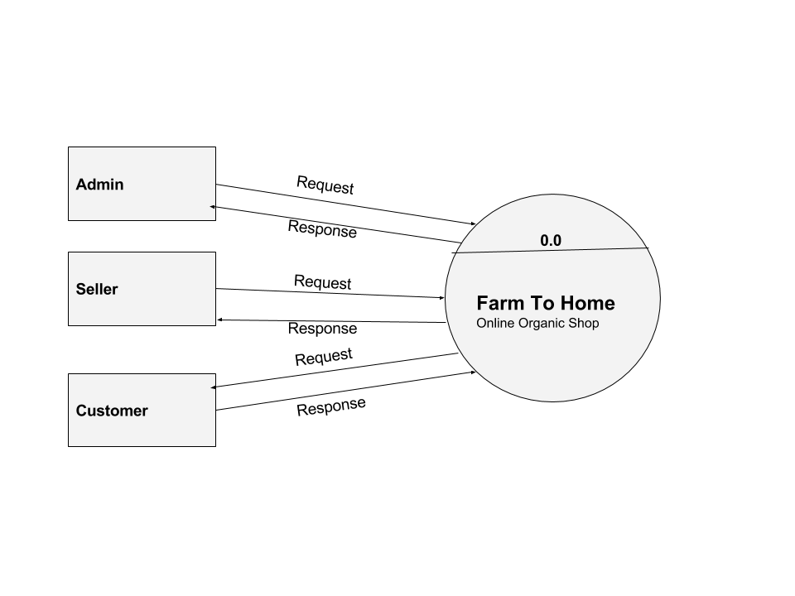

### Customer Module 1st Level DFD

### C:\Users\rinson\Desktop\PIC\customer\Customer_Module_1stLevel_DFD.png

**Customer Module 2nd Level DFD 4**

**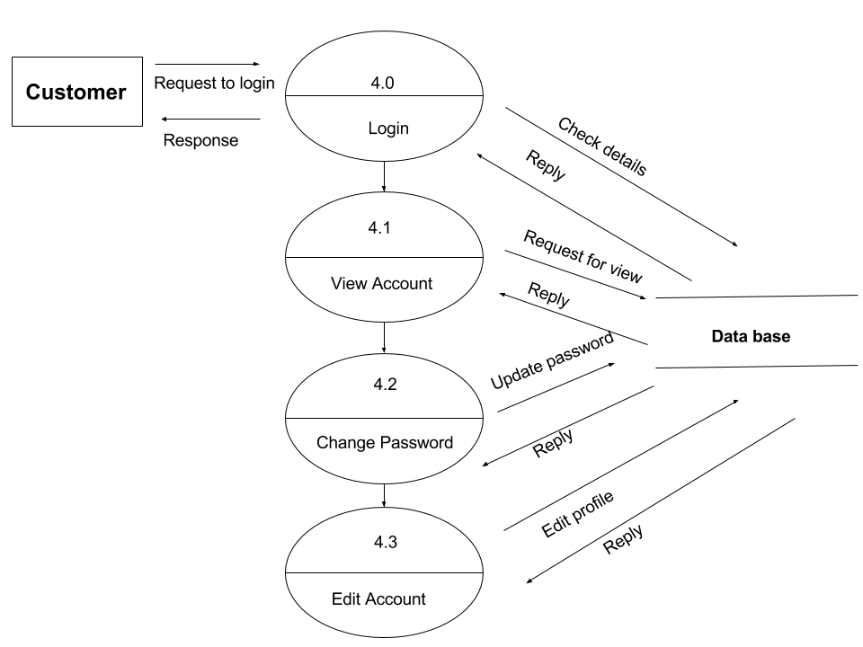**

**Customer Module 2nd Level DFD 5**

**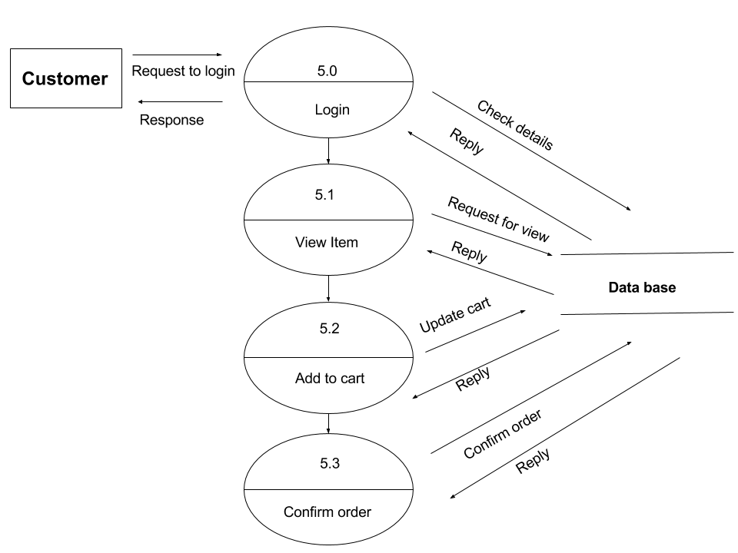**

**Seller Module 1st Level DFD**

**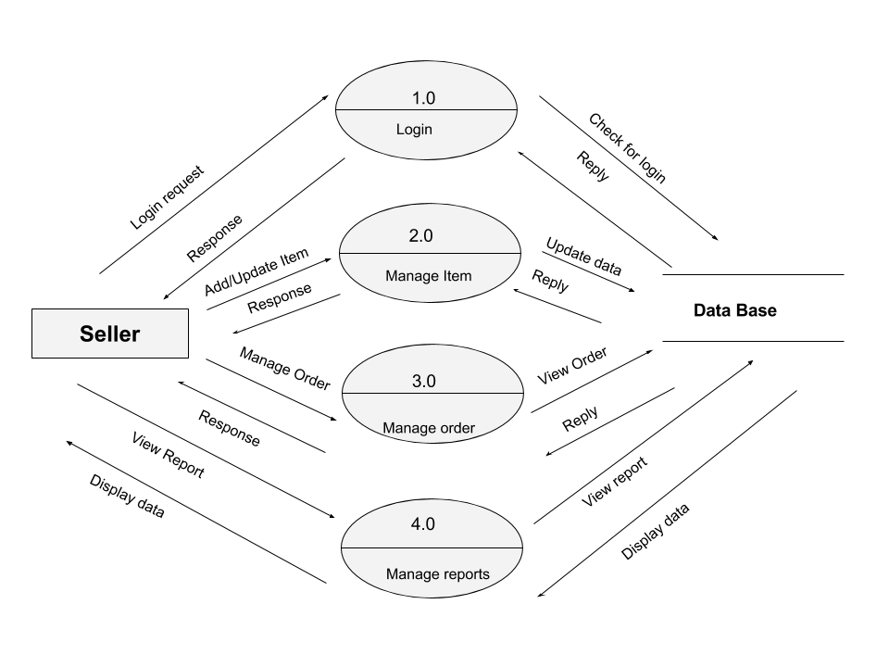**

**Seller Module 2nd Level DFD 2**

**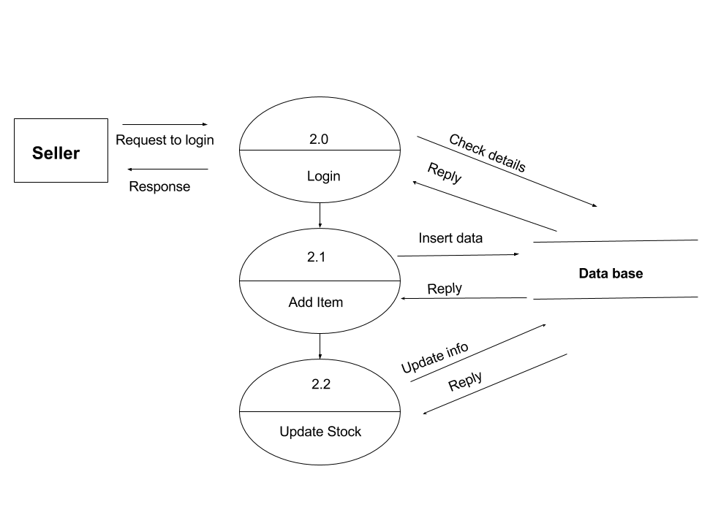**

**Seller Module 2nd Level DFD 3**

**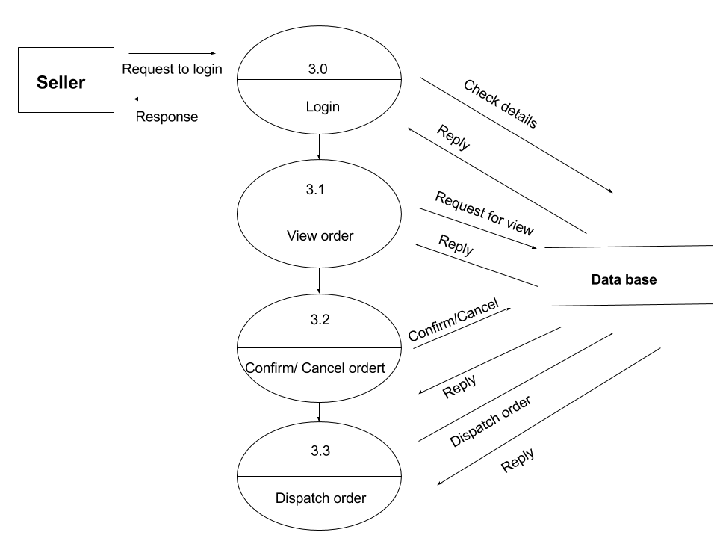**

**Admin Module 1st Level DFD**

**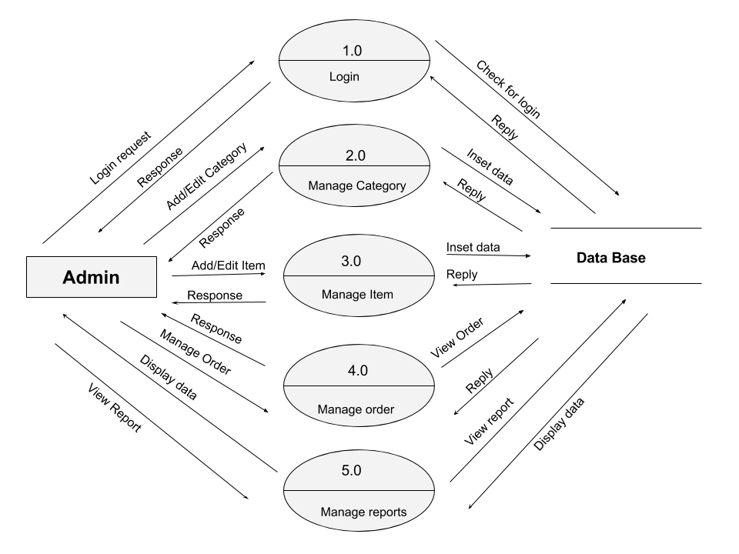**

**Admin Module 2nd Level DFD 3**

**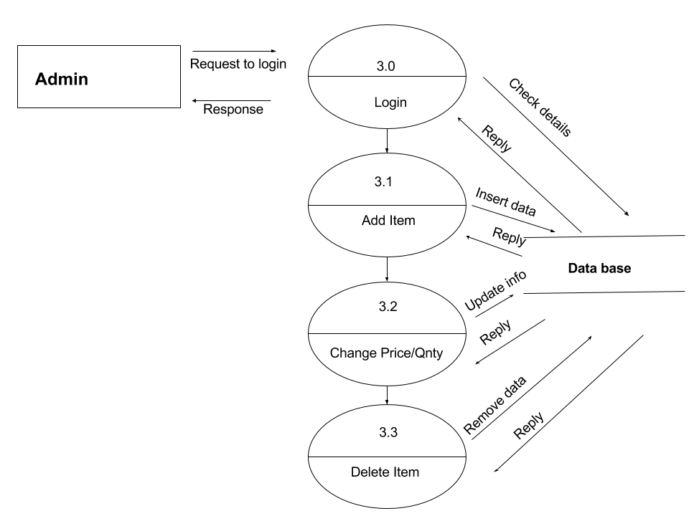**

**Admin Module 2nd Level DFD 4**

**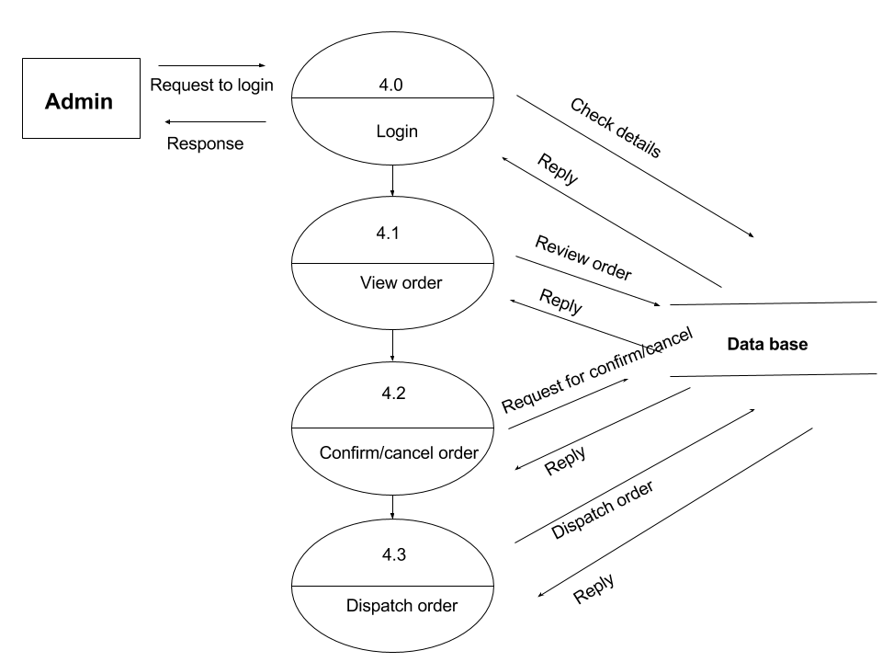**

**Admin Module 2nd Level DFD 5**

**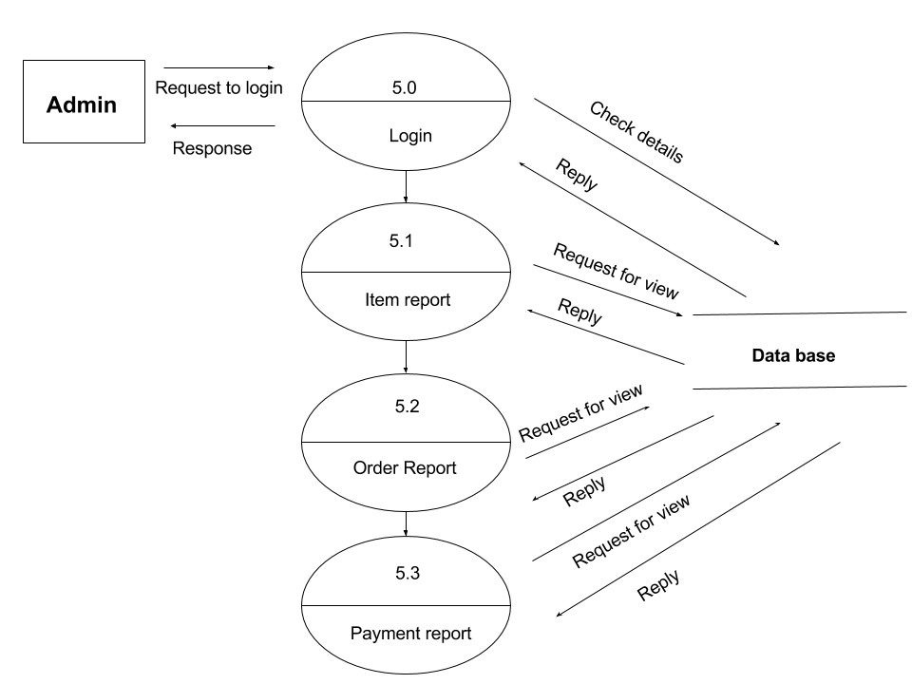**

# ENTITY RELATIONSHIP DIAGRAM

# An entity relationship diagram (ERD) shows the relationships of entity sets stored in a database. It works around real-world entities and the associations among them. In other words, ER diagrams illustrate the logical structure of databases. Some of the symbols and notations to representing ERD shown below,

# C:\Users\871635\Desktop\er-diagram-symbol.png

# ERD for FARM TO HOME

# C:\Users\871635\Desktop\rinson\ER-Diagram.png

# DATABASE TABLES DESIGN

# Table : PRODUCT

|  |  |  |
| --- | --- | --- |
| NAME | DATATYPE | CONSTRAINT |
| ProductID | INT | Primary Key |
| ProductName | VARCHAR(25) | Not Null |
| ProductUnitPrice | DECIMAL(4,2) | Not Null |
| ProductUnitWeight | INT | Not Null |
| ProductDescription | VARCHAR(50) | Not Null |
| ProductImage | VARCHAR(50) | Not Null |
| ProductThumbImage | VARCHAR(50) | Not Null |
| ProductUpdateDate | DATETIME | Not Null |
| Active | BOOLEAN | Not Null |
| CategoryID | INT | Foreign Key |

Table **: CATEGORY**

|  |  |  |
| --- | --- | --- |
| NAME | DATATYPE | CONSTRAINT |
| CategoryID | INT | Primary Key |
| CategoryName | VARCHAR(25) | Not Null |
| Description | VARCHAR(50) | Not Null |
| CategoryImage | VARCHAR(50) | Not Null |
| Active | BOOLEAN | Not Null |

Table **: SELLERSPRODUCT**

|  |  |  |
| --- | --- | --- |
| NAME | DATATYPE | CONSTRAINT |
| SellersProductID | INT | Primary Key |
| SellersStock | INT | Not Null |
| StockStatus | VARCHAR(10) | Not Null |
| SellersDiscount | DECIMAL(2,2) | Not Null |
| ProductID | INT | Foreign Key |
| SellerID | INT | Foreign Key |

Table **: SELLER**

|  |  |  |
| --- | --- | --- |
| NAME | DATATYPE | CONSTRAINT |
| SellerID | INT | Primary Key |
| About | VARCHAR(50) | Not Null |
| LogoImage | VARCHAR(50) | Not Null |
| RegistrationNumber | VARCHAR(25) | Not Null |
| CompanyName | VARCHAR(25) | Not Null |
| URL | VARCHAR(50) | Not Null |
| PaymentMethods | VARCHAR(50) | Not Null |
| ContactTitle | VARCHAR(50) | Not Null |
| UserID | INT | Foreign Key |

Table **: ORDER**

|  |  |  |
| --- | --- | --- |
| NAME | DATATYPE | CONSTRAINT |
| OrderID | INT | Primary Key |
| OrderDate | DATE | Not Null |
| OrderAmount | DECIMAL(6,2) | Not Null |
| Freight | DECIMAL(2,2) | Not Null |
| Tax | DECIMAL(2,2) | Not Null |
| OrderShipName | VARCHAR(50) | Not Null |
| OrderShipAddress1 | VARCHAR(50) | Not Null |
| OrderShipAddress2 | VARCHAR(50) | Not Null |
| OrderCity | VARCHAR(50) | Not Null |
| OrderState | VARCHAR(25) | Not Null |
| OrderPinCode | VARCHAR(6) | Not Null |
| OrderCountry | VARCHAR(25) | Not Null |
| OrderPhone | VARCHAR(10) | Not Null |
| OrderMobile | VARCHAR(10) | Not Null |
| OrderEmail | VARCHAR(25) | Not Null |
| Deleted | BOOLEAN | Not Null |
| TransactionStatus | VARCHAR(25) | Not Null |
| Paid | BOOLEAN | Not Null |
| ErrMsg | VARCHAR(50) | Not Null |
| ErrLoc | VARCHAR(50) | Not Null |
| Refund | BOOLEAN | Not Null |
| PaymentID | INT | Foreign Key |
| OrderUserID | INT | Foreign Key |

Table **: ORDERDETAILS**

|  |  |  |
| --- | --- | --- |
| NAME | DATATYPE | CONSTRAINT |
| DetailIOrderID | INT | Primary Key |
| DetailPrice | DECIMAL(6,2) | Not Null |
| DetailQuantity | INT | Not Null |
| Total | DECIMAL(6,2) | Not Null |
| ProductID | INT | Foreign Key |
| SellerID | INT | Foreign Key |
| OrderID | INT | Foreign Key |
| ReviewID | INT | Foreign Key |

Table **: CART**

|  |  |  |
| --- | --- | --- |
| NAME | DATATYPE | CONSTRAINT |
| CartID | INT | Primary Key |
| DateCreated | BOOLEAN | Not Null |
| Deleted | BOOLEAN | Not Null |
| ProductID | INT | Foreign Key |
| SellerID | INT | Foreign Key |
| UserID | INT | Foreign Key |

Table **: PAYMENTDETAILS**

|  |  |  |
| --- | --- | --- |
| NAME | DATATYPE | CONSTRAINT |
| PaymentID | INT | Primary Key |
| PaymentMode | VARCHAR(20) | Not Null |
| CreditCardTypeID | VARCHAR(50) | Foreign Key |
| CreditCardExpMonth | INT | Not Null |
| CreditCardExpYear | INT | Not Null |
| CreditCardNumber | VARCHAR(25) | Not Null |
| OrderID | INT | Foreign Key |

Table **: REVIEW**

|  |  |  |
| --- | --- | --- |
| NAME | DATATYPE | CONSTRAINT |
| ReviewID | INT | Primary Key |
| ReviewDescription | VARCHAR(100) | Not Null |
| Rating | INT | Not Null |
| TimeStamp | DATETIME | Not Null |

Table **: USER**

|  |  |  |
| --- | --- | --- |
| NAME | DATATYPE | CONSTRAINT |
| UserID | INT | Primary Key |
| FirstName | VARCHAR(50) | Not Null |
| LastName | VARCHAR(50) | Not Null |
| Address1 | VARCHAR(50) | Not Null |
| Address2 | VARCHAR(50) | Not Null |
| City | VARCHAR(25) | Not Null |
| State | VARCHAR(25) | Not Null |
| Country | VARCHAR(25) | Not Null |
| PinCode | VARCHAR(6) | Not Null |
| Phone | VARCHAR(10) | Not Null |
| Mobile | VARCHAR(10) | Not Null |
| Email | VARCHAR(25) | Not Null |
| Password | VARCHAR(16) | Not Null |
| UserIP | VARCHAR(15) | Foreign Key |
| DateCreated | DATETIME | Not Null |
| Role | VARCHAR(10) | Not Null |

## FUTURE SCOPE

## Quality of software revolves around 3 factors – Operational, Transition, and Revision characteristics. Operational characteristics are related to exterior quality of software – like correctness, usability, integrity, reliability, efficiency, and security. Transition characteristics mainly deal with the interoperability, reusability, and portability of the system. Revision characteristics are engineering based factors that relate to interior quality of the software – maintainability, flexibility, scalability, extensibility, modularity, and testability to quote a few.

## FURTHER ENHANCEMENTS

## As and when this software is asked for by an organization, it can be customized based on their preferences. For this, another round of SDLC process has to be initiated to understand user requirements and feasibility of changes. However, as the system is built on a basic framework and a set of functionalities, changes are expected to be minimal and with very less or no impact on the existing coverage

## Our future enhancement will be:

## As the technology emerges, it is possible to upgrade the system and be adaptable to desired environment.

## Because it is based on object-oriented design, any future changes can be easily adaptable.

## Based on the future security issues, security can be improved using emerging technologies.

## Sub admin module can be added.

## Besides, we will include more functions and introduce more widgets to the system. Like

## Mobile apps

## Mobile version

## Home Delivery

## Call Center Support

## We also plan to enhance the interface so that it looks more attractive and interactive.

# APPENDIX

## Acronyms

## JSP – Java Server Pages

## JAVAEE – Java Enterprise Edition

## HTML – Hyper Text Markup Language

## CSS – Cascading Style Sheet

Bibliography

1. SYSTEM ANALYSIS AND DESIGN, Award E.M.
2. SOFTWARE ENGINEERING, K.K. Aggarwal and Yogesh Singh.
3. OCP/OCA , Cathy Sierra