AMAL JYOTHI COLLEGE OF ENGINEERING
AUTONOMOUS, KANJIRAPALLY



DEPARTMENT OF COMPUTER APPLICATIONS
MCA: 2025-27 (REGULAR)
Semester :2

Rinta Thomas
Roll.No:53
Reg.No:17252

UNDERSTANDING CAP THEOREM

The CAP Theorem is a key idea in distributed systems that explains why building a perfectly reliable, networked data system is impossible. Proposed by Eric Brewer and proven later by Seth Gilbert and Nancy Lynch, it states that a distributed system cannot guarantee Consistency, Availability, and Partition Tolerance all at the same time—at most, it can fully achieve any two. This means designers must make conscious trade-offs based on what their application needs most: strict accuracy of data, continuous system responsiveness, or the ability to function even when parts of the network fail. Understanding this balance helps developers choose the right priorities to create systems that perform reliably in real-world distributed environments.

Consistency – every read returns the most recent write. Example: banking ledger that always shows the exact balance after a deposit.
Availability – every request receives a response (success or failure) without waiting for other nodes. Example: A public website that always serves a page, even if some replicas are out-of-date
Partition Tolerance – the system continues to operate despite lost or delayed messages between nodes. Example: Two data centers that lose their network link but still accept reads/writes locally.
) Consistency (C)
Consistency ensures that all nodes in the system return the same, most recent data at any given time. After a write operation, every read should reflect that update immediately.
Explanation:
If data is updated in one part of the system, that update must be visible everywhere without delay. No user should ever see outdated or conflicting information.
Example:
In a banking application:
- If ₹1000 is transferred from Account A to Account B
- The updated balance must be reflected instantly
- No system should show the old balance after the transaction
Key Point:
Consistency prioritizes data accuracy and correctness over system responsiveness.

b) Availability (A)
Availability ensures that every request to the system receives a response, regardless of whether the data is the most recent.
Explanation:
Even if some parts of the system are down or out of sync, the system continues to function and respond to users.
Example:
In a social media platform:
- You can still view posts and profiles even during server issues
- Some data (likes, comments) might not be fully updated
Key Point:
Availability prioritizes system responsiveness and user access over strict accuracy.

c) Partition Tolerance (P)
Partition Tolerance means the system continues to operate even when there is a communication breakdown (network partition) between nodes.
Explanation:
In distributed systems, servers are often spread across different regions. Network failures can split the system into parts that cannot communicate with each other.
Example:
Consider servers located in India and the US:
- If the connection between them fails
- Each side should still continue working independently
Key Point:
Partition tolerance is essential and unavoidable in distributed systems.

3. Relationship Between C, A, and P
- In the presence of a network partition, a system must choose:
  - Consistency (CP) → correct data but may deny requests
  - Availability (AP) → always responds but may return outdated data
- Partition Tolerance cannot be ignored because network failures are inevitable.

4. Simple Real-Life Analogy
Think of a group of students sharing notes:
- Consistency: Everyone always has the latest version of notes
- Availability: Anyone can access notes anytime
- Partition: Some students lose internet connection
Now, if the group splits (partition happens):
- Either you wait to get the latest notes (Consistency)
- Or you use whatever version you have (Availability)

Conclusion
The CAP Theorem highlights a fundamental trade-off in distributed systems:
- You cannot have perfect consistency, full availability, and partition tolerance all at once
- System designers must choose the right balance based on application needs

Part B – Scenario Classification
Scenario | CAP classification | Why
Banking transaction system that never allows inconsistent balances | CP | It must keep balances consistent (C). When a partition happens it will reject or delay operations, sacrificing availability (A).
Messaging app where messages may be delayed but the system is always accessible | AP | It stays available (A) even during partitions, letting users send/receive locally. Consistency (C) is relaxed because messages can arrive out-of-order or later.
Single-server library database with no distributed nodes | CA (trivially) | With only one node there are no partitions, so the system can be both consistent and available. In practice this is a non-distributed case, so P is irrelevant.

1. Banking Transaction System
Type: CP (Consistency + Partition Tolerance)
Explanation:
A banking system deals with financial data, where correctness is extremely critical. Even a small inconsistency (like showing the wrong balance) can lead to serious financial and legal issues.
- The system must always ensure that:
  - Account balances are accurate
  - Transactions are not duplicated or lost
  - All users see the same updated data
Behavior during Partition:
If a network failure occurs:
- The system may deny or delay some requests
- But it will never return incorrect data
Why not AP?
If availability were prioritized:
- Users might see outdated balances
- This could allow incorrect withdrawals or transactions
Conclusion:
The system sacrifices Availability to guarantee Consistency, making it a CP system.

2. Messaging App
Type: AP (Availability + Partition Tolerance)
Explanation:
Messaging apps prioritize continuous user access. Users expect the system to work at all times, even if there are network issues.
- The system ensures:
  - Messages can still be sent
  - The app remains usable
  - No request is rejected
Behavior during Partition:
If network issues occur:
- Messages may be delayed
- Messages may arrive out of order temporarily
- Some devices may not immediately reflect updates
Why not CP?
If consistency were prioritized:
- The app might block sending messages until all nodes sync
- This would reduce usability and frustrate users
Conclusion:
The system sacrifices strict Consistency for Availability, making it an AP system.

3. Single-Server Library Database
Type: CA (Consistency + Availability)
Explanation:
This system is not distributed (only one server), so network partition does not occur.
- The system can:
  - Provide accurate data (Consistency)
  - Always respond to queries (Availability)
Why no Partition Tolerance?
- Partition tolerance is only relevant in distributed systems
- Since there is only one node, there is no risk of network partition
Example:
- A local library system showing available books
- Updates and queries happen on the same server
Limitation:
- If the server fails, the system becomes unavailable
Conclusion:
Since partitioning is not a concern, the system achieves both Consistency and Availability, making it a CA system.

Final Summary Table
System | Type | Priority
Banking Transaction System | CP | Accuracy over availability
Messaging App | AP | Availability over consistency
Single-Server Library Database | CA | No partition, so both possible
Part C – E commerce Component Choices
- *Shopping-cart service – AP
A cart must stay usable even if a network partition occurs (e.g., a user adds items while their connection is spotty).
  - Prioritizes availability so the user can keep browsing and updating the cart.
  - Accepts that the cart’s state may temporarily diverge across replicas; eventual reconciliation resolves conflicts when the partition heals.
- **Payment-processing system – CP
Financial transactions demand strong consistency to avoid double-charging or lost payments.
  - Chooses consistency over availability: if a partition prevents consensus on a payment, the system will reject or pause the request rather than risk an inconsistent ledger.
  - Partition tolerance is still required, but the service prefers to fail fast rather than give a possibly incorrect result.
- **Product-catalog service – AP (or CP depending on business needs, but most e-commerces pick AP)
Product listings are read-heavy and can tolerate brief staleness.
  - Emphasizes availability so shoppers see catalog data even during outages.
  - Inconsistent replicas (e.g., a newly added item not instantly visible everywhere) are acceptable because they can be reconciled later without harming core transactions.
Key takeaway: AP services keep the user experience smooth under network issues, while CP services protect critical invariants like money movement.
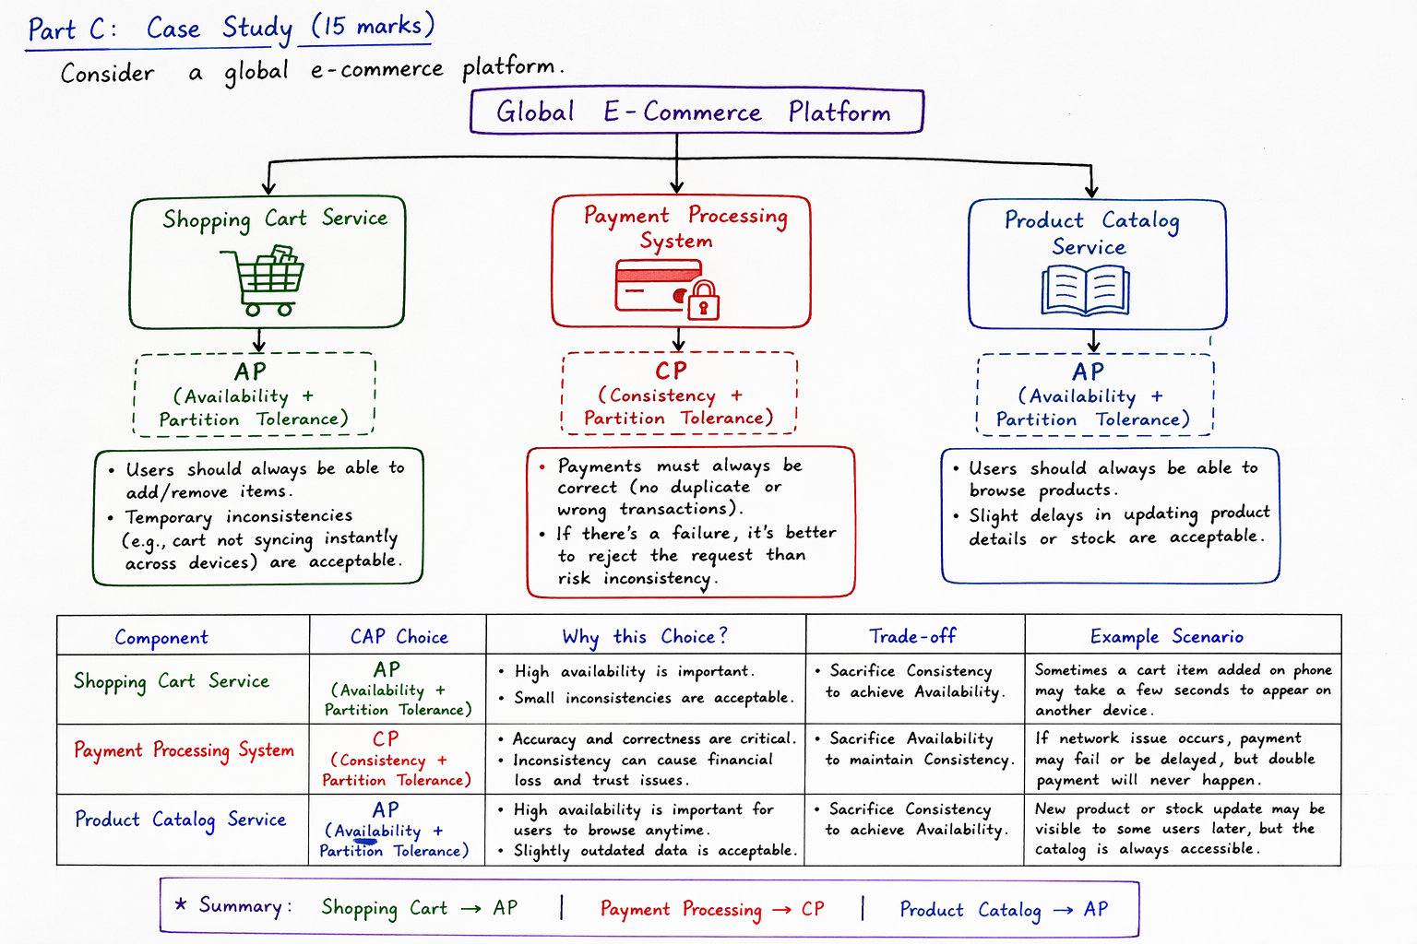

Component | Preferred CAP stance | Rationale
Shopping cart service | AP | Users expect the cart to be reachable at all times; a brief inconsistency (e.g., a duplicate item) is tolerable, while partitions should not block the UI.
Payment processing system | CP | Financial correctness is critical; any partition must halt processing to avoid double-charging or lost payments, preserving consistency over availability.
Product catalog service | AP (or CP for certain read-heavy parts) | Catalog data can tolerate slight staleness (e.g., a newly added product appearing a few seconds later) to keep the site highly available globally. Critical inventory counts, however, may be handled by a CP sub-service.

Part D – Critical & Dynamic Considerations
- Why partition tolerance is unavoidable: In any system that spans multiple machines or data centers, network links can fail, latency can spike, or packets can be dropped. The CAP theorem assumes such partitions will occur; designing without P would mean the system cannot function under realistic network conditions.
Partition tolerance is unavoidable because:
- Networks can fail at any time (hardware issues, outages, etc.)
- Distributed systems operate across multiple locations
- Communication between nodes is never 100% reliable
So, systems must be designed assuming partitions will happen.

- Dynamic switching between CP and AP: Some modern databases (e.g., Cassandra, DynamoDB, CockroachDB) let you tune consistency per operation. A read can be served with strong consistency (CP mode) or eventual consistency (AP mode) depending on the client’s latency requirements. However, the underlying system still remains partition-tolerant; it merely adjusts the trade-off between C and A on the fly.
During normal operation, a system might behave like AP (favor availability).
During network failures, it may switch to CP (favor consistency).
Example:
Distributed databases like MongoDB or Cassandra allow tuning:
You can choose stronger consistency (CP-like behavior)
Or higher availability (AP-like behavior)
This is often controlled through configuration settings like read/write consistency levels.

