Cycle-1
Experiment-3:

1. echo

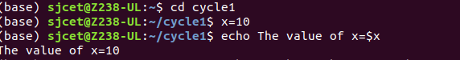

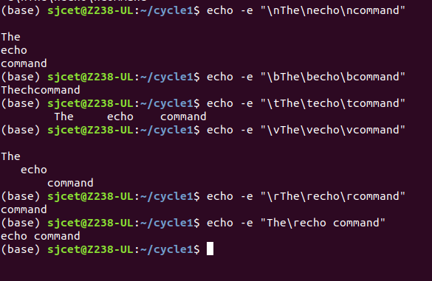
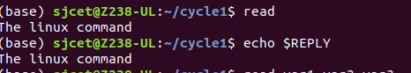

2.read

