Mainactivity

package com.example.sjcet.exam01;
import android.content.Intent;
import android.support.v7.app.AppCompatActivity;
import android.os.Bundle;
import android.view.View;
import android.widget.EditText;
import android.widget.TextView;
public class MainActivity extends AppCompatActivity {
EditText ed1,ed2,ed3,ed4,ed5;
TextView tv1;
protected void onCreate(Bundle savedInstanceState) {
super.onCreate(savedInstanceState);
setContentView(R.layout.activity_main);
}
public void SignUp(View view) {
ed1=(EditText)findViewById(R.id.e1);
ed2=(EditText)findViewById(R.id.e2);
ed3=(EditText)findViewById(R.id.e3);
ed4=(EditText)findViewById(R.id.e4);
ed5=(EditText)findViewById(R.id.e5);
tv1=(TextView)findViewById(R.id.t1);
String Username=ed3.getText().toString();
String Password=ed2.getText().toString();
if (AllCheck())
{
Intent intent=new Intent(getApplicationContext(),Main2Activity.class);
intent.putExtra("name",Username);
intent.putExtra("pass",Password);
startActivity(intent);
}
}
private boolean AllCheck(){
if (ed1.length()==0)
{
ed1.setError("This fiels is required");
}
if (ed2.length()==0)
{
ed2.setError("This fiels is required");
}
if (ed3.length()==0)
{
ed3.setError("This fiels is required");
}
if (ed4.length()==0)
{
ed4.setError("This fiels is required");
}
if (ed5.length()==0)
{
ed5.setError("This fiels is required");
}
return true;
}
public void Sign(View view) {
ed1=(EditText)findViewById(R.id.e1);
ed2=(EditText)findViewById(R.id.e2);
ed3=(EditText)findViewById(R.id.e3);
ed4=(EditText)findViewById(R.id.e4);
ed5=(EditText)findViewById(R.id.e5);
tv1=(TextView)findViewById(R.id.t1);
String Username=ed3.getText().toString();
String Password=ed2.getText().toString();
if (AllCheck())
{
Intent intent=new Intent(getApplicationContext(),Main3Activity.class);
startActivity(intent);
}
}
}

main2activity

package com.example.sjcet.exam01;
import android.content.Intent;
import android.support.v7.app.AppCompatActivity;
import android.os.Bundle;
import android.widget.TextView;
public class Main2Activity extends AppCompatActivity {
TextView tv2;
TextView tv3;
Intent intent;
protected void onCreate(Bundle savedInstanceState) {
super.onCreate(savedInstanceState);
setContentView(R.layout.activity_main2);
tv2=(TextView)findViewById(R.id.tv2);
tv3=(TextView)findViewById(R.id.tv3);
intent=getIntent();
String result=intent.getStringExtra("name");
String result1=intent.getStringExtra("pass");
tv2.setText(result);
tv3.setText(result1);
}
}

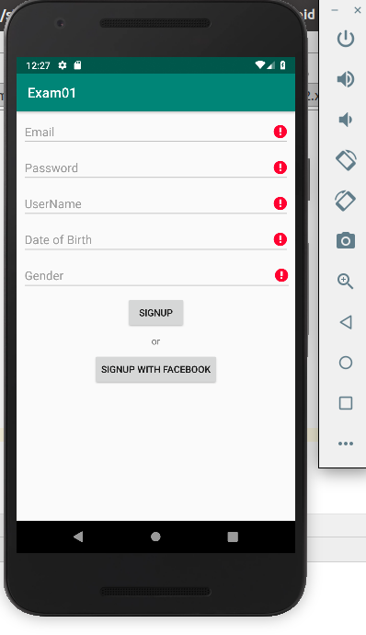
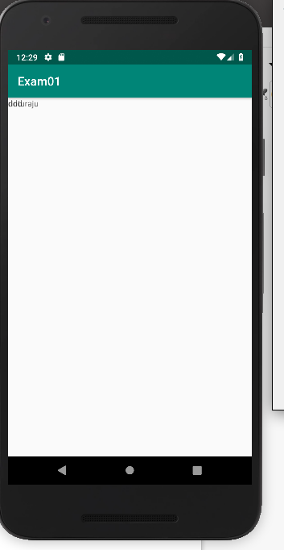

2.mainactivity
package com.example.sjcet.exam02;
import android.support.v7.app.AppCompatActivity;
import android.os.Bundle;
import android.view.View;
import android.widget.EditText;
import android.widget.TextView;
import android.widget.Toast;
public class MainActivity extends AppCompatActivity {
EditText ed1,ed2;
TextView Dv;
Database database;
public MainActivity() {
database = new Database(this);
}
protected void onCreate(Bundle savedInstanceState) {
super.onCreate(savedInstanceState);
setContentView(R.layout.activity_main);
ed1=(EditText)findViewById(R.id.e1);
ed2=(EditText)findViewById(R.id.e2);
Dv=(TextView)findViewById(R.id.Dv);
}
public void SaveData(View view) {
String Userval=ed1.getText().toString();
String Passval=ed2.getText().toString();
long boolean result=database.insertdata(Userval,Passval);
if(result == true)
{
Toast.makeText(this, "Data inserted Successfully", Toast.LENGTH_SHORT).show();
}
else
{
Toast.makeText(this, "Data Insertion Failed", Toast.LENGTH_SHORT).show();
}
}
}

main2activity

package com.example.sjcet.exam02;
import android.content.ContentValues;
import android.database.Cursor;
import android.database.sqlite.SQLiteDatabase;
import android.support.v7.app.AppCompatActivity;
import android.os.Bundle;
public class database extends AppCompatActivity {
@Override
protected void onCreate(Bundle savedInstanceState) {
super.onCreate(savedInstanceState);
setContentView(R.layout.activity_database2);
}
public void onCreate(SQLiteDatabase db)
{
db.execSQL("create table user(id integer primary key,Userval text,Passval text),null");
}
public void onUpgrade(SQLiteDatabase db, int oldVersion ,int newVersion,){
db.execSQL("Drop table if exists user");
}
public Cursor getAllData(){
SQLiteDatabase db = this.getWritableDatabase();
Cursor res = db.rawQuery("Select * from user",null);
return res;
}
private SQLiteDatabase getWritableDatabase() {
return null;
}
public boolean insertdata(String Userval,String Passval){
SQLiteDatabase db = this.getWritableDatabase();
ContentValues contentvalues=new ContentValues();
contentvalues.put("name",Userval);
contentvalues.put("password",Passval);
long result = db.insert("user",null,contentvalues);
db.close();
if(result<-1)
{
return false;
}
else {
return true;
}
}
}

