**MOBILE APPLICTION DEVELOPMENT LAB**

CYCLE 2

# Create two activities. From the first activity on a button click move to the next activity.(Using intent)

**activity_main.xml**

<LinearLayout

android:layout_width="match_parent" android:layout_height="match_parent" android:orientation="vertical" android:gravity="center"

xmlns:android="<http://schemas.android.com/apk/res/android>">

<Button

android:layout_width="wrap_content" android:layout_height="wrap_content" android:text="MOVE TO NEXT ACTIVITY" android:id="@+id/bt" android:onClick="click" android:gravity="center"/>

</LinearLayout>

# MainActivity.java

**package** com.example.sjcet.a1_activity;

**import** android.content.Intent;

**import** android.support.v7.app.AppCompatActivity;

**import** android.os.Bundle; **import** android.view.View; **import** android.widget.Button;

**public class** MainActivity **extends** AppCompatActivity { Button **bt**;

@Override

**protected void** onCreate(Bundle savedInstanceState) { **super**.onCreate(savedInstanceState); setContentView(R.layout.***activity_main***);

**bt** = findViewById(R.id.***bt***);

}

**public void** click(View view) { OpenNewActivity();

}

**public void** OpenNewActivity()

{

Intent intent = **new** Intent(**this**, Main3Activity.**class**); startActivity(intent);

}

}

# activity_main3.xml

<LinearLayout android:layout_width="match_parent"android:layout_height="match_parent"

android:orientation="vertical" android:gravity="center" android:background="@android:color/holo_blue_light"

xmlns:android="<http://schemas.android.com/apk/res/android>">

<TextView

android:layout_width="wrap_content" android:layout_height="wrap_content" android:text="WELCOME TO THE SECOND ACTIVITY"

android:id="@+id/tv" />

</LinearLayout>

# Main3Activity.java

**package** com.example.sjcet.a1_activity;

**import** android.support.v7.app.AppCompatActivity;

**import** android.os.Bundle;

**public class** Main3Activity **extends** AppCompatActivity { @Override

**protected void** onCreate(Bundle savedInstanceState) { **super**.onCreate(savedInstanceState); setContentView(R.layout.***activity_main3***);

}

}

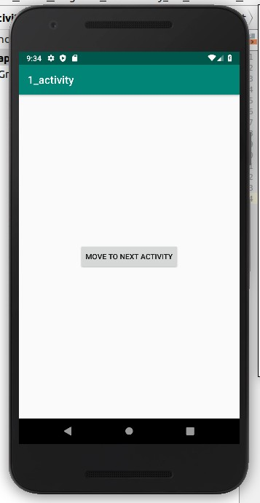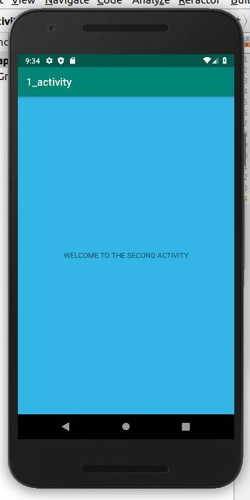

# Create an activity and move to the Facebook login page on a button click.(making use of intent)

**activity_main.xml**

<LinearLayout android:layout_width="match_parent" android:layout_height="match_parent" android:orientation="vertical" android:gravity="center"

xmlns:android="<http://schemas.android.com/apk/res/android>">

<Button

android:layout_width="wrap_content" android:layout_height="wrap_content" android:text="MOVE TO FACEBOOK PAGE" android:id="@+id/bt" android:onClick="click" android:gravity="center"/>

</LinearLayout>

# MainActivity.java

package com.example.sjcet.a2_moveto_fb;

**import** android.content.Intent;

**import** android.net.Uri;

**import** android.support.v7.app.AppCompatActivity;

**import** android.os.Bundle; **import** android.view.View; **import** android.widget.Button;

**public class** MainActivity **extends** AppCompatActivity { @Override

**protected void** onCreate(Bundle savedInstanceState) { **super**.onCreate(savedInstanceState); setContentView(R.layout.***activity_main***);

Button btn_Explicit = (Button)findViewById(R.id.***bt***); btn_Explicit.setOnClickListener(**new** View.OnClickListener() {

@Override

**public void** onClick(View v) { Intent intent = **new**

Intent(Intent.***ACTION_VIEW***,Uri.*parse*(**"https://**[**www.facebook.com/"**](http://www.facebook.com/))); startActivity(intent);

}

});

}

}

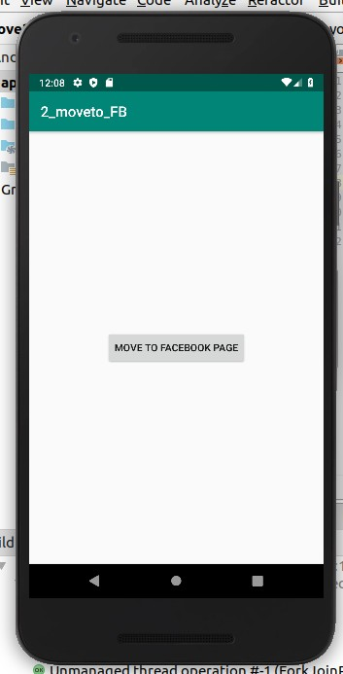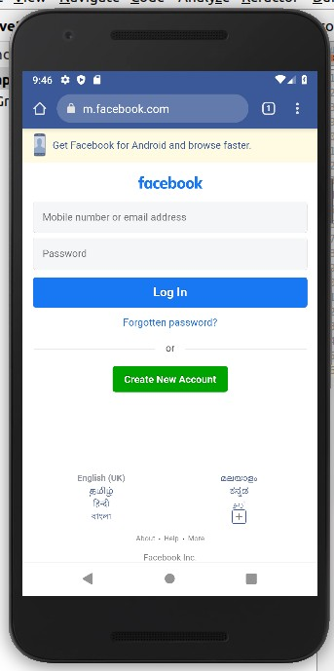

# Read a message in the first activity and pass it to the second activity on a button click. activity_main.xml

<LinearLayout

android:layout_height="match_parent" android:layout_width="match_parent" android:orientation="vertical" android:layout_gravity="center" xmlns:android="<http://schemas.android.com/apk/res/android>">

<EditText

android:layout_width="match_parent" android:layout_height="wrap_content" android:id="@+id/msg" android:hint="Enter Message"/>

<Button

android:layout_width="wrap_content" android:layout_height="wrap_content" android:id="@+id/snd"

android:text="Send" android:layout_gravity="center" android:onClick="click"/>

</LinearLayout>

# MainActivity.java

**package** com.example.sjcet.a3_pass_msg;

**import** android.content.Intent;

**import** android.support.v7.app.AppCompatActivity;

**import** android.os.Bundle; **import** android.view.View; **import** android.widget.Button; **import** android.widget.TextView;

**public class** MainActivity **extends** AppCompatActivity { TextView **msg**;

Button **snd**; @Override

**protected void** onCreate(Bundle savedInstanceState) { **super**.onCreate(savedInstanceState); setContentView(R.layout.***activity_main***); **msg**=findViewById(R.id.***msg***); **snd**=findViewById(R.id.***snd***);

}

**public void** click(View view) {

String str = **msg**.getText().toString();

Intent intent=**new** Intent(getApplicationContext(),Main2Activity.**class**); intent.putExtra(**"Message_Key"**,str);

startActivity(intent);

}

}

# activity_main2.xml

<LinearLayout

android:layout_height="match_parent” android:layout_width="match_parent" android:orientation="vertical" xmlns:android="<http://schemas.android.com/apk/res/android>" >

<TextView

android:id="@+id/rcv"

android:layout_width="match_parent" android:layout_height="wrap_content" android:gravity="center"/>

</LinearLayout>

# Main2Activity.java

**package** com.example.sjcet.a3_pass_msg;

**import** android.content.Intent;

**import** android.support.v7.app.AppCompatActivity;

**import** android.os.Bundle;

**import** android.widget.TextView;

**public class** Main2Activity **extends** AppCompatActivity { TextView **rcv**;

@Override

**protected void** onCreate(Bundle savedInstanceState) { **super**.onCreate(savedInstanceState); setContentView(R.layout.***activity_main2***); **rcv**=findViewById(R.id.***rcv***);

Intent intent=getIntent();

String str = intent.getStringExtra(**"Message_Key"**);

**rcv**.setText(str);

}

}

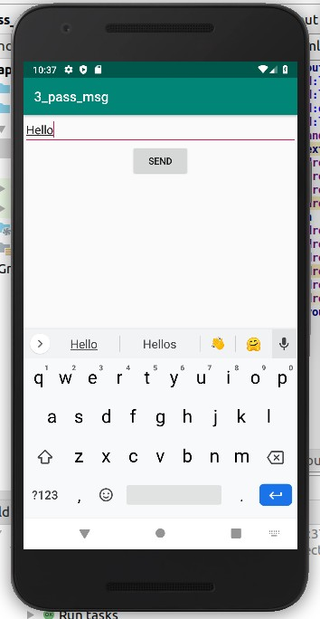 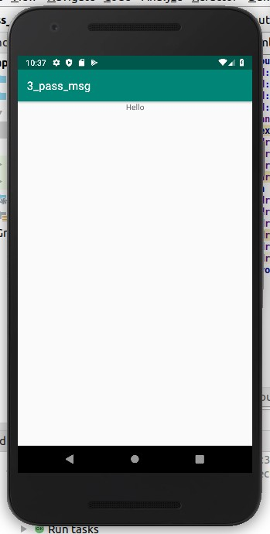

# Create a registration page with full validation and pass the information to the second activity (using shared preference)

**Mandatory fields : fname,lname,gender,email,phone number,password,dob(date picker)**

# activity_main.xml

<LinearLayout android:layout_height="match_parent" android:layout_width="match_parent"

android:orientation="vertical" android:layout_gravity="left"

xmlns:android="<http://schemas.android.com/apk/res/android>">

<TextView

android:layout_width="match_parent" android:layout_height="wrap_content" android:layout_centerHorizontal="true" android:layout_marginTop="32dp" android:gravity="center" android:text="Registration Form" android:textColor="@android:color/black" android:textSize="24sp" />

<EditText

android:layout_width="match_parent" android:layout_height="wrap_content" android:id="@+id/fname" android:padding="10dp" android:hint="First Name"/>

<EditText

android:layout_width="match_parent" android:layout_height="wrap_content" android:id="@+id/lname" android:padding="10dp" android:hint="Last Name"/>

<EditText

android:layout_width="match_parent" android:layout_height="wrap_content" android:id="@+id/gen" android:padding="10dp" android:hint="Gender"/>

<EditText

android:layout_width="match_parent" android:layout_height="wrap_content" android:id="@+id/email" android:padding="10dp" android:hint="Email Id"/>

<EditText

android:layout_width="match_parent" android:layout_height="wrap_content" android:id="@+id/phno" android:padding="10dp" android:hint="Contact"/>

<EditText

android:layout_width="match_parent" android:layout_height="wrap_content" android:id="@+id/pswd" android:padding="10dp" android:hint="Password"/>

<EditText

android:layout_width="match_parent" android:layout_height="wrap_content" android:id="@+id/dob" android:padding="10dp" android:hint="Date Of Birth"/>

<Button

android:layout_width="wrap_content" android:layout_height="wrap_content" android:id="@+id/btn" android:text="Submit" android:onClick="Save"/>

</LinearLayout>

# MainActivity.java

**package** com.example.sjcet.a4_registration;

**import** android.content.Context;

**import** android.content.Intent;

**import** android.content.SharedPreferences;

**import** android.support.v7.app.AppCompatActivity;

**import** android.os.Bundle; **import** android.text.TextUtils; **import** android.util.Patterns; **import** android.view.View; **import** android.widget.Button; **import** android.widget.EditText; **import** android.widget.Toast;

**public class** MainActivity **extends** AppCompatActivity { EditText **fname**,**lname**,**gen**,**phno**,**email**,**pswd**,**dob**; Button **btn**;

SharedPreferences **sharedpreferences**;

**public static final** String ***MyPREFERENCES*** = **"MyPrefs"** ; @Override

**protected void** onCreate(Bundle savedInstanceState) { **super**.onCreate(savedInstanceState); setContentView(R.layout.***activity_main***); **fname** = findViewById(R.id.***fname***);

**lname** = findViewById(R.id.***lname***); **gen** = findViewById(R.id.***gen***); **email** = findViewById(R.id.***email***); **phno** = findViewById(R.id.***phno***); **pswd** = findViewById(R.id.***pswd***); **dob** = findViewById(R.id.***dob***);

**btn** = findViewById(R.id.***btn***);

**sharedpreferences** = getSharedPreferences(***MyPREFERENCES***, Context.***MODE_PRIVATE***);

**btn**.setOnClickListener(**new** View.OnClickListener() { @Override

**public void** onClick(View v) { checkDataEntered();

SharedPreferences MyPrefs = getSharedPreferences(**"activity_main2.xml"**,0); SharedPreferences.Editor editor=MyPrefs.edit(); editor.putString(**"fname"**,**fname**.getText().toString()); editor.putString(**"lname"**,**lname**.getText().toString());

editor.putString(**"phno"**, **phno**.getText().toString()); editor.putString(**"gen"**, **gen**.getText().toString()); editor.putString(**"mail"**, **email**.getText().toString()); editor.putString(**"dob"**, **dob**.getText().toString()); editor.putString(**"pswd"**,**pswd**.getText().toString()); editor.commit();

Intent intent = **new** Intent(getApplicationContext(), Main2Activity.**class**); intent.putExtra(**"fname"**,**fname**.getText().toString()); intent.putExtra(**"lname"**,**lname**.getText().toString()); intent.putExtra(**"phno"**, **phno**.getText().toString()); intent.putExtra(**"gen"**, **gen**.getText().toString());

intent.putExtra(**"mail"**, **email**.getText().toString()); intent.putExtra(**"dob"**, **dob**.getText().toString()); intent.putExtra(**"pswd"**,**pswd**.getText().toString()); startActivity(intent);

Toast.*makeText*(MainActivity.**this**,**"Thanks"**,Toast.***LENGTH_LONG***).show();

}

});

}

**boolean** isEmail(EditText text) {

CharSequence email = text.getText().toString();

**return** (!TextUtils.*isEmpty*(email) && Patterns.***EMAIL_ADDRESS***.matcher(email).matches());

}

**boolean** isEmpty(EditText text) {

CharSequence str = text.getText().toString();

**return** TextUtils.*isEmpty*(str);

}

**void** checkDataEntered(){

**if** (isEmpty(**fname**)) {

Toast t = Toast.*makeText*(**this**, **"You must enter first name to register!"**,

Toast.***LENGTH_SHORT***);

}

t.show();

**if** (isEmpty(**lname**)) {

**lname**.setError(**"Last name is required!"**);

}

**if** (isEmpty(**phno**)) {

**phno**.setError(**"mobile number is required!"**);

}

**if** (isEmpty(**gen**)) {

**gen**.setError(**"Gender is required!"**);

}

**if** (isEmpty(**pswd**)) {

**pswd**.setError(**"Password is required!"**);

}

**if** (isEmpty(**dob**)) {

**dob**.setError(**"DOB is required!"**);

}

**if** (isEmail(**email**) == **false**) {

**email**.setError(**"Enter valid email!"**);

}

}

}

# activity_main2.xml

<LinearLayout android:layout_width="match_parent" android:layout_height="match_parent" android:orientation="vertical" android:gravity="center"

xmlns:android="<http://schemas.android.com/apk/res/android>">

<TextView

android:layout_width="wrap_content" android:layout_height="wrap_content" android:text="WELCOME " android:textColor="@color/colorPrimaryDark" android:textSize="32dp"/>

<TextView

android:layout_width="match_parent" android:layout_height="wrap_content" android:gravity="center" android:id="@+id/tv" android:textColor="@color/colorPrimaryDark"

/>

<TextView

android:id="@+id/tv1" android:layout_width="match_parent" android:layout_height="wrap_content" android:gravity="center" android:textColor="@color/colorPrimaryDark" />

<TextView

android:layout_width="match_parent" android:layout_height="wrap_content" android:id="@+id/tv2" android:gravity="center" android:textColor="@color/colorPrimaryDark"

/>

<TextView

android:layout_width="match_parent" android:layout_height="wrap_content" android:id="@+id/tv3" android:gravity="center" android:textColor="@color/colorPrimaryDark"

/>

<TextView

android:layout_width="match_parent" android:layout_height="wrap_content" android:id="@+id/tv4" android:gravity="center" android:textColor="@color/colorPrimaryDark"

/>

<TextView

android:layout_width="match_parent" android:layout_height="wrap_content" android:id="@+id/tv5" android:gravity="center" android:textColor="@color/colorPrimaryDark"

/>

<TextView

android:layout_width="match_parent" android:layout_height="wrap_content" android:id="@+id/tv6" android:gravity="center" android:textColor="@color/colorPrimaryDark"

/>

</LinearLayout>

# Main2Activity.java

**package** com.example.sjcet.a4_registration;

**import** android.content.Intent;

**import** android.content.SharedPreferences;

**import** android.support.v7.app.AppCompatActivity;

**import** android.os.Bundle;

**import** android.widget.TextView;

**public class** Main2Activity **extends** AppCompatActivity { TextView **tv**,**tv1**,**tv2**,**tv3**,**tv4**,**tv5**,**tv6**;

@Override

**protected void** onCreate(Bundle savedInstanceState) {

**super**.onCreate(savedInstanceState);

setContentView(R.layout.***activity_main2***);

**tv** = findViewById(R.id.***tv***); **tv1** =findViewById(R.id.***tv1***); **tv2** =findViewById(R.id.***tv2***); **tv3** =findViewById(R.id.***tv3***); **tv4** =findViewById(R.id.***tv4***); **tv5** =findViewById(R.id.***tv5***); **tv6** =findViewById(R.id.***tv6***); Intent intent = getIntent();

SharedPreferences mypref=getSharedPreferences(**"activity_main2.xml"**,0); String str = mypref.getString(**"fname"**,**null**);

String str1 = mypref.getString(**"lname"**,**null**); String str2 = mypref.getString(**"gen"**,**null**); String str3 = mypref.getString(**"phno"**,**null**); String str4 = mypref.getString(**"pwd"**,**null**); String str5 = mypref.getString(**"email"**,**null**); String str6 = mypref.getString(**"dob"**,**null**); **tv**.setText(str);

**tv1**.setText(str1); **tv2**.setText(str2); **tv3**.setText(str3); **tv4**.setText(str4); **tv5**.setText(str5); **tv6**.setText(str6);

}

}

