**Twitter API**

1. **Importing required Libraries**

It includes installation of Tweepy, Time, DateTime, os libraries.

Tweepy provides access to well designed document called Twitter API, with tweepy we can get any object and use any method for example, by following this website “[https://dev.twitter.com/docs/platform-objects/users](https://dev.twitter.com/docs/platform-objects/users" \o "Twitter Users API Documentation" \t "https://www.pythoncentral.io/introduction-to-tweepy-twitter-for-python/_blank)” we can get relevant and appropriate information.

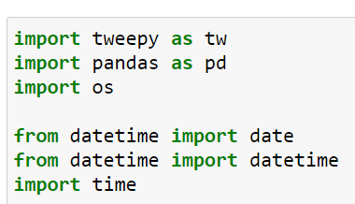

1. **Getting Access and Consumer keys/tokens**

To get access keys and tokens, enrolling into a twitter developer account is necessary. Steps to sign up with a developer account is explained in here “[How to create a Twitter application - Inbound Now Documentation](https://docs.inboundnow.com/guide/create-twitter-application/)”.

1. **Fetching tweets using authentication object**

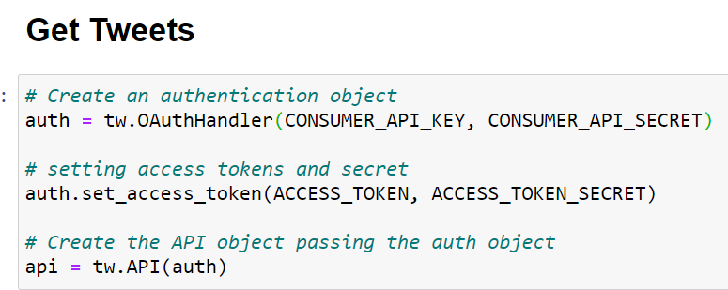

1. **Display all tweets in friendly format**

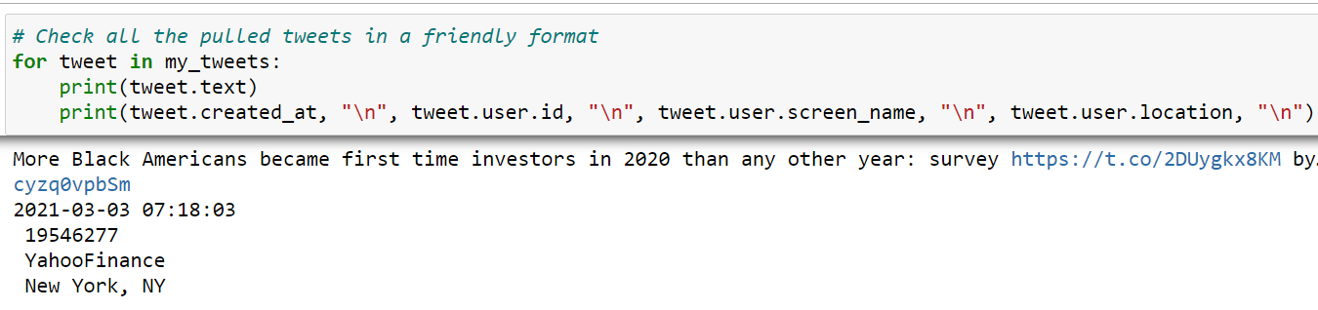

1. **Fetching particular ‘#’ hashtags**

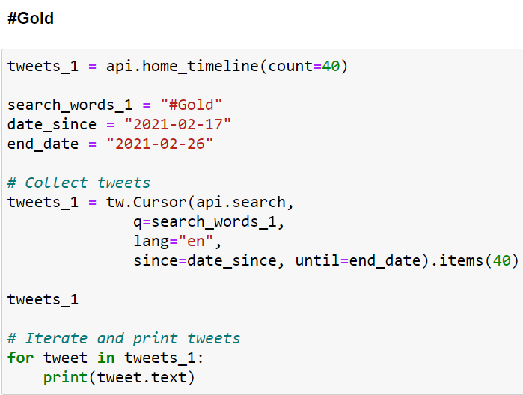

1. **Convert individual tags tweet into a dataframe**

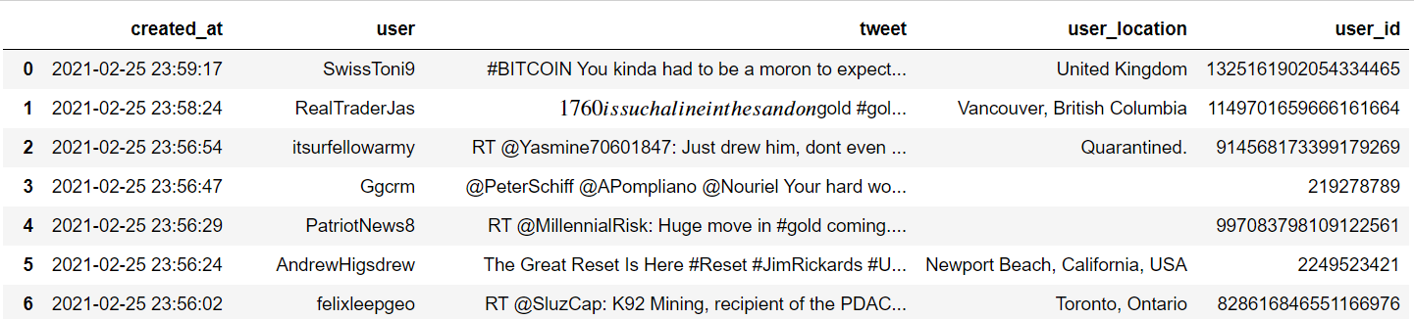

1. **Save dataframe to csv**

