**118**: Bricks II - West End

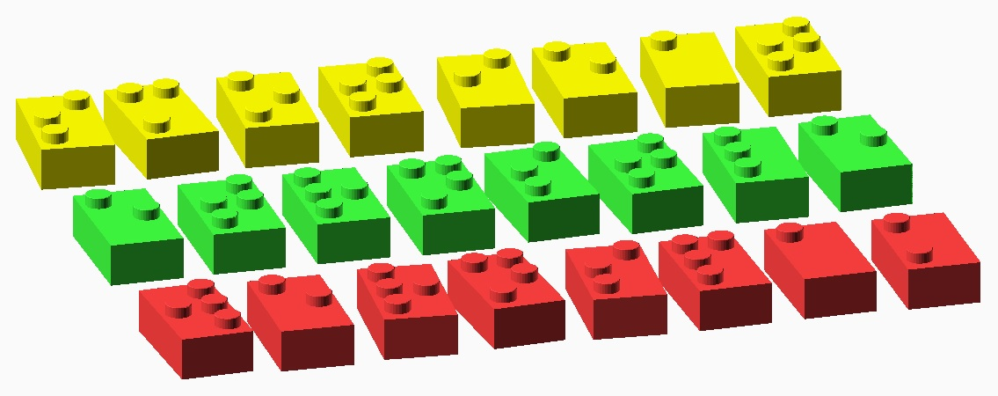

These may look like damaged bricks from a popular toy company, but they actually encode a message! Each brick represents a letter. But which letter? Hmm…, check the reference charts for inspiration.

Fill in the message below. Wondering which letters should go where? Think of the most intuitive order.



The message should lead you to the final answer, which is the name of a place. You may also want to consult the “Seattle and Surroundings” reference map if you are unsure of your local geography.