**240**: Bricks IV - Animal Analogy

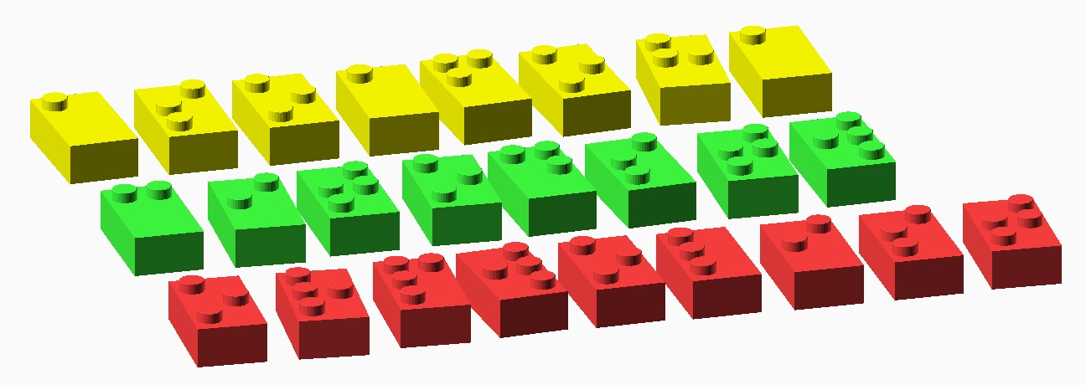

These may look like damaged bricks from a popular toy company, but they actually encode a message! Each brick represents a letter. But which letter? Hmm…, check the reference charts for inspiration.

Fill in the message below. Wondering which letters should go where? Think of the most intuitive order.

C:\Users\josephj\Documents\git\puzzle-circle\EAS2015\puzzles\Bricks\Bricks-IV-panel.png

The message should lead you to the final answer, which is a single word.