803: Bricks I - Free to be US

By: Joseph Joy

Answer: JEFFERSON

Each brick represents a Braille character. Once you have decoded each brick you can fill in the clue by starting from the left and moving from left to right, picking successive letters from the row that matches the color of the next empty letter box in the clue. The filling-in of the first three letters as well as the completed clue are shown below.

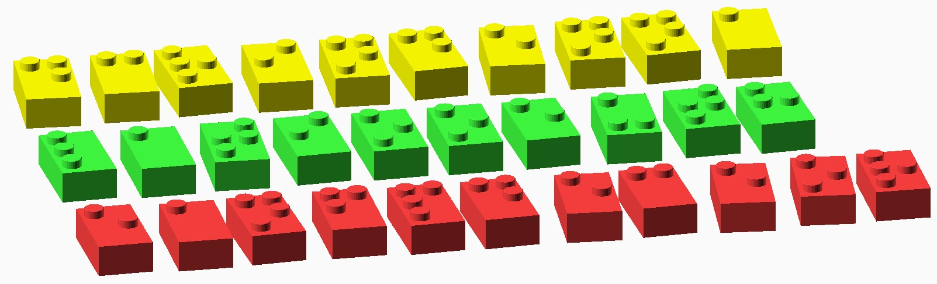

The final answer is JEFFERSON, which is the last name of Thomas Jefferson, primary author of the US Declaration of Independence.