**350**: Bricks VI - North of the Lake

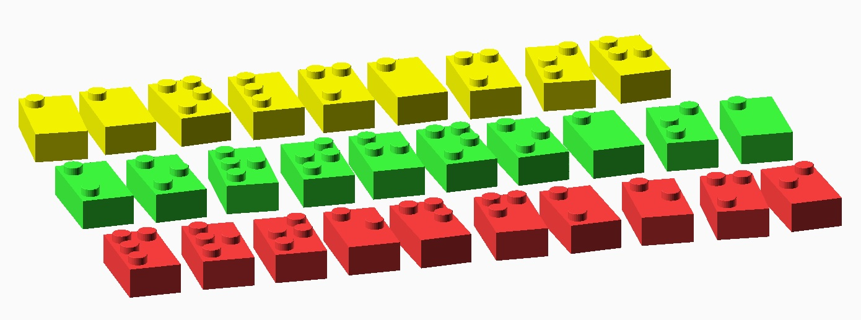

These may look like damaged bricks from a popular toy company, but they actually encode a message! Each brick represents a letter. But which letter? Hmm…, check the reference charts for inspiration.

Fill in the message below. Wondering which letters should go where? Think of the most intuitive order.

C:\Users\josephj\Documents\git\puzzle-circle\EAS2015\puzzles\Bricks\Bricks-VI-panel.png

The message should lead you to the final answer, which is the name of a place. You may also want to consult the “Seattle and Surroundings” reference map if you are unsure of your local geography.