**684**: Clocks I - Weekly Pursuits

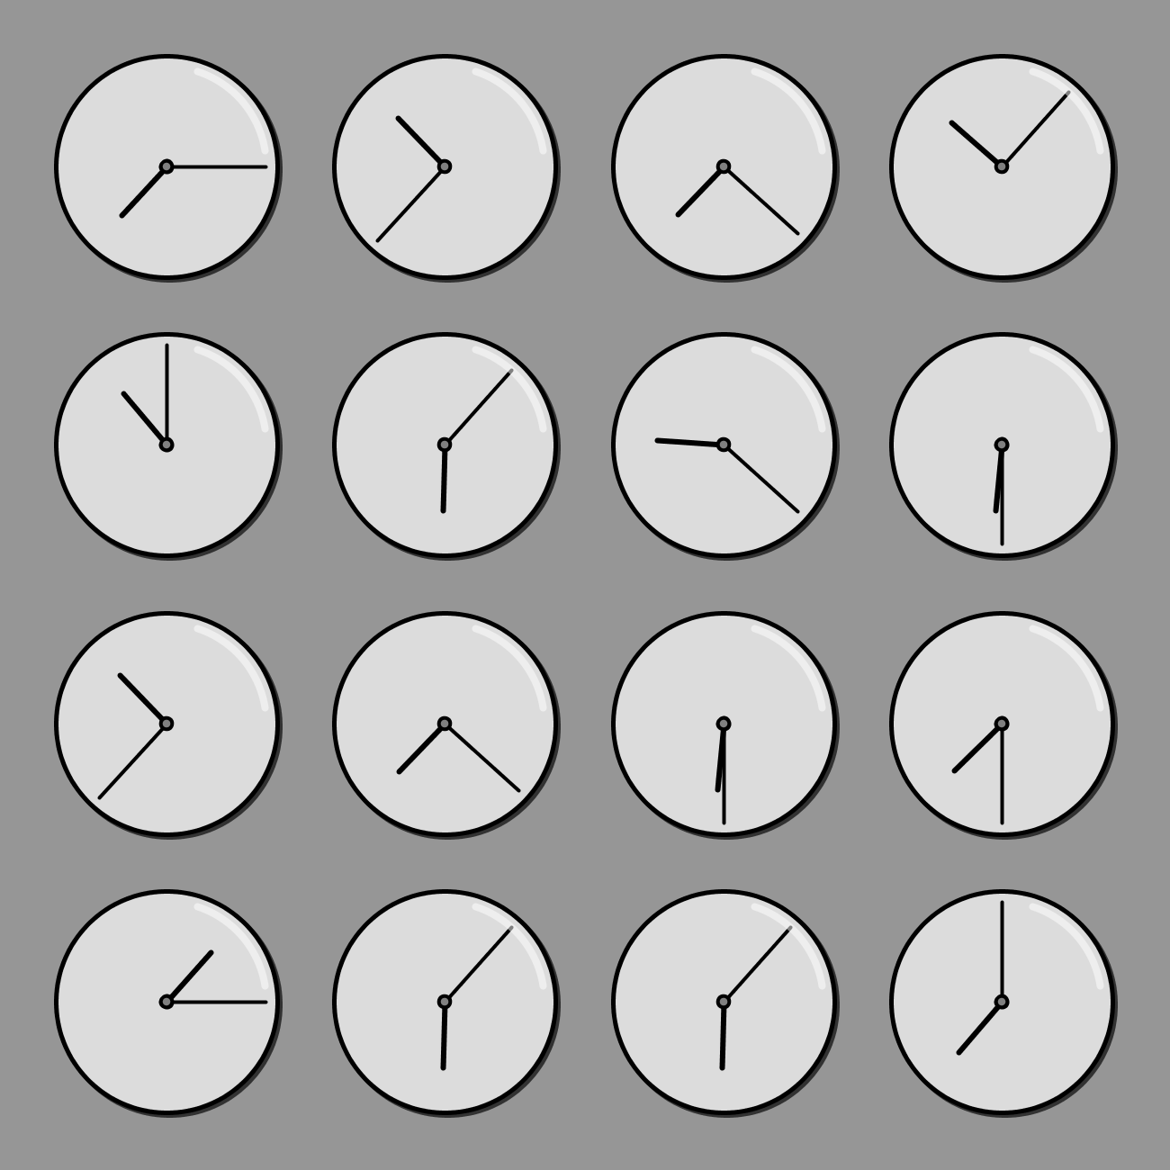

The clocks hide a message. The message is a short phrase that instructs you to compute a number. The 5-digit number is the solution to this puzzle. HINT: Do these clocks resemble *anything* in the provided reference charts?