**765**: Clocks II - Jewel of the Northwest

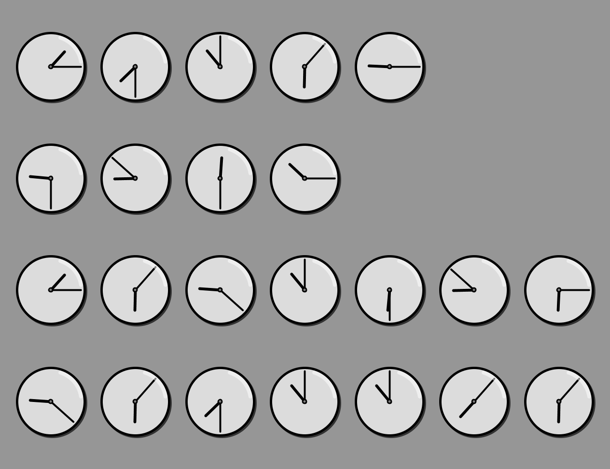

The clocks hide a message. The message is a short phrase that identifies an important landmark. HINT: Do these clocks resemble *anything* in the provided reference charts? Once you have decoded the message, you may also want to consult the “Seattle and Surroundings” reference map of you are unsure of your local geography.