**292**: Clocks III - Starts With...

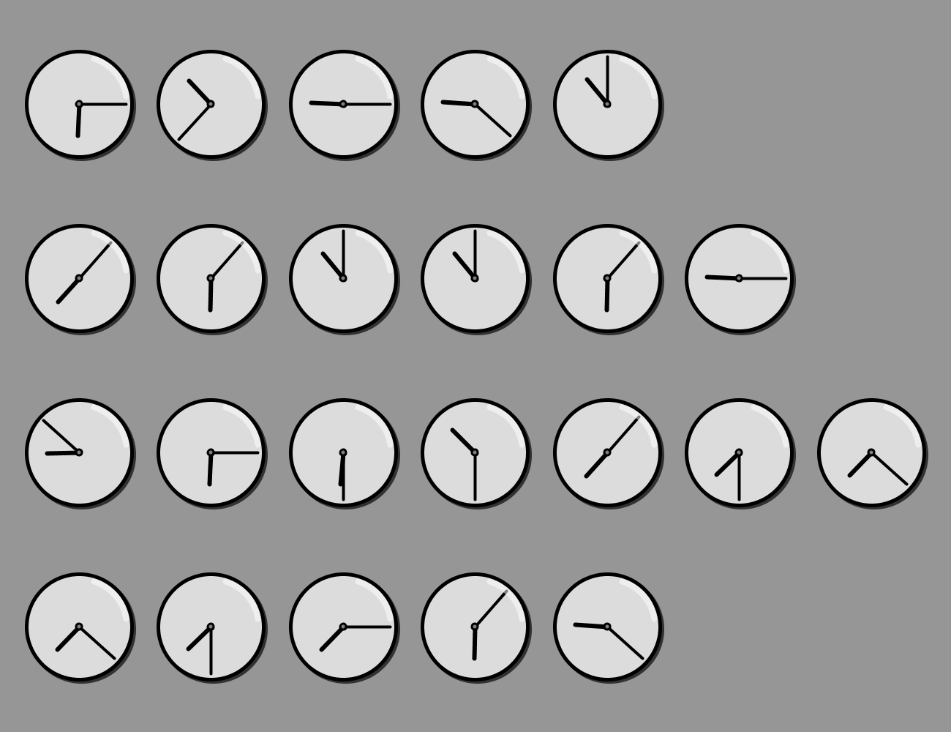

The clocks hide a message. The message is a short phrase that leads to the final answer which is a set of letters that *must be submitted in alphabetical orde*r. HINT: Do these clocks resemble *anything* in the provided reference charts?