**347**: Clocks VI - Verdant Hue

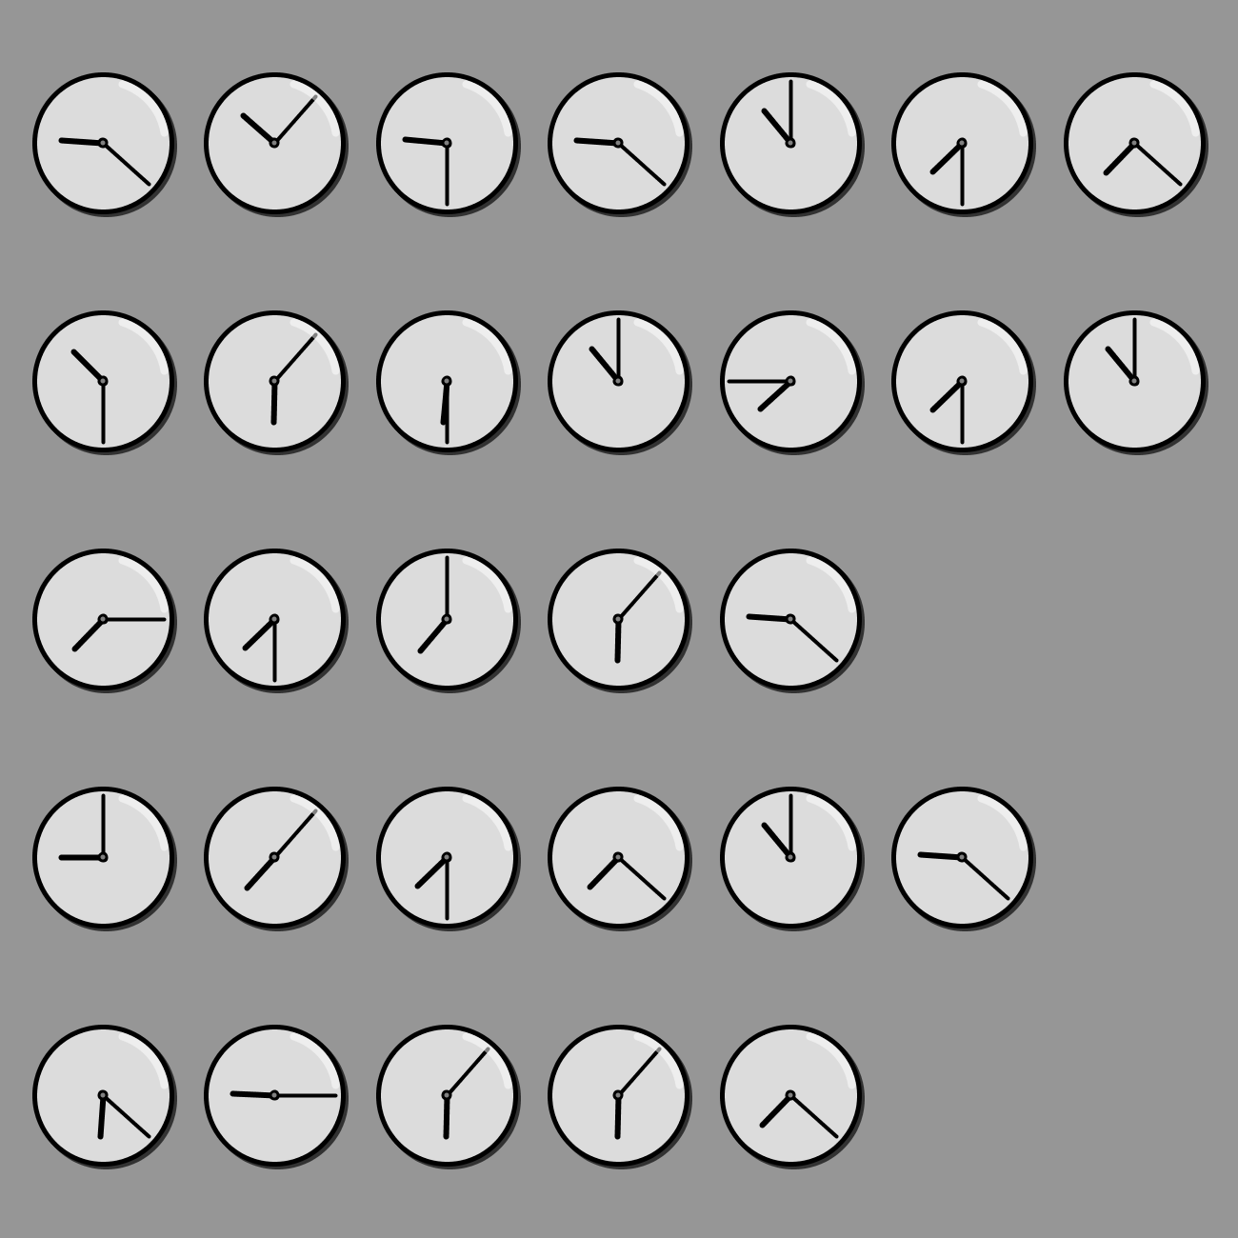

The clocks hide a message. The message is a short phrase that leads to the final answer which is a single word. HINT: Do these clocks resemble *anything* in the provided reference charts?