Map of Seattle and Surroundings

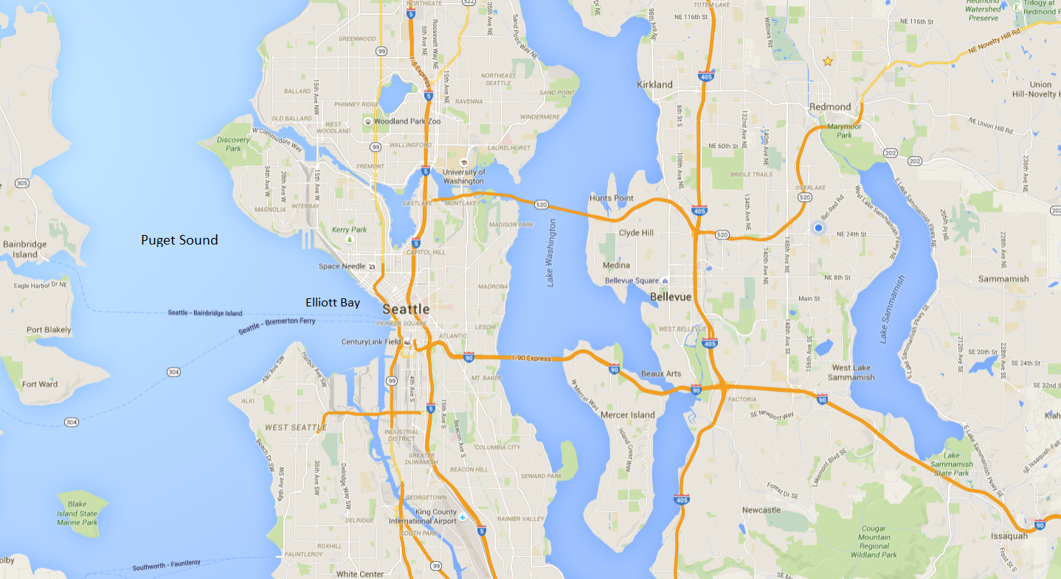

Map source: Google Maps