**394**: Crisscross II

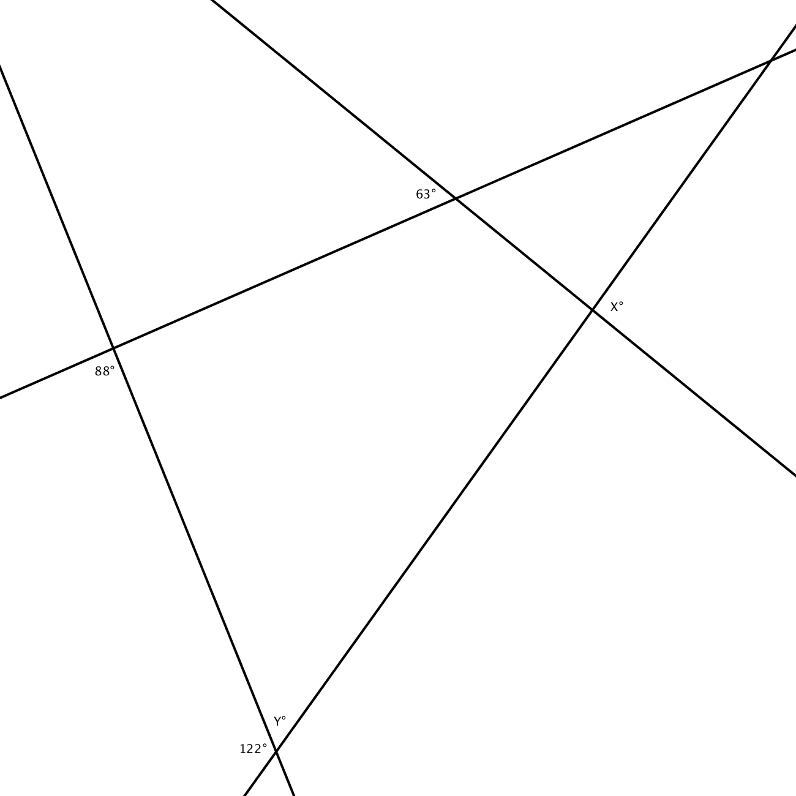

The answer to this puzzle is a 3-digit number, the *sum* of angles X and Y. Unsure how to proceed? Maybe you can start by computing Y. Use the fact that Y and its supplementary angle add up to 180°. Unsure how to compute X? Here’s a big hint: do you spot a quadrilateral anywhere in this pattern of straight lines? Did you know that the sum of interior angles (including Y) of a quadrilateral add up to 360°?