203: Crisscross I

By: Joseph Joy

Answer: 166

The objective is to compute the quantity X+Y. First compute Y by observing that its supplementary angle adds up to 180°. Then compute two other interior angles (A and B) of the shaded quadrilateral from *their* supplementary angles. Compute C from Y, A and B by utilizing the fact that the interior angles of a quadrilateral add up to 360°. Finally realize that X is the same as C because they are opposite angles.

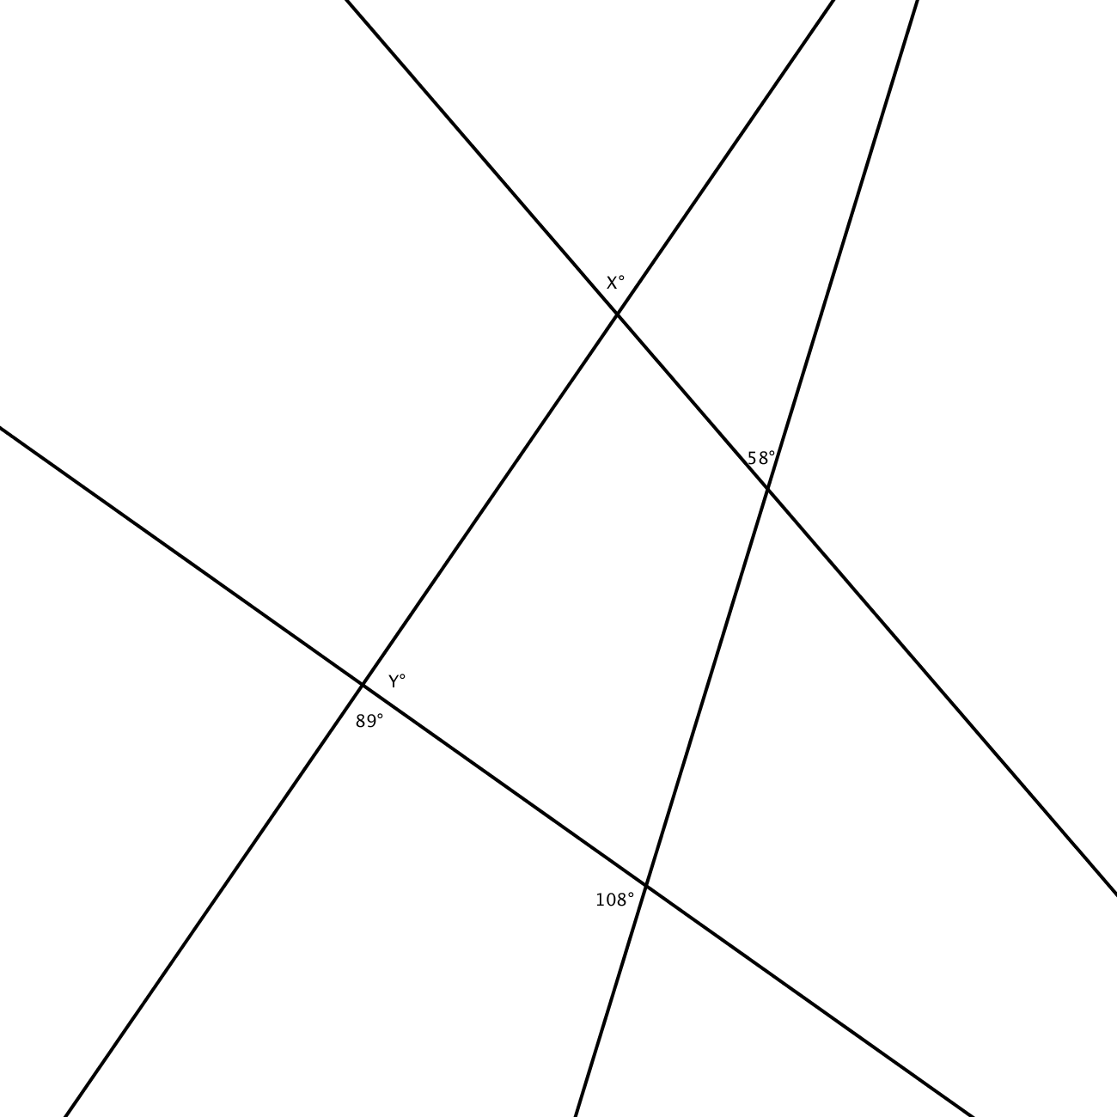

Y°

A°

B°

C°

Y = 180-89 = 91

A = 180-58 = 122

B = 180-108 = 72

C = 360-(Y+A+B) = 75

X = C