**288**: Lasers I - Red and Blue

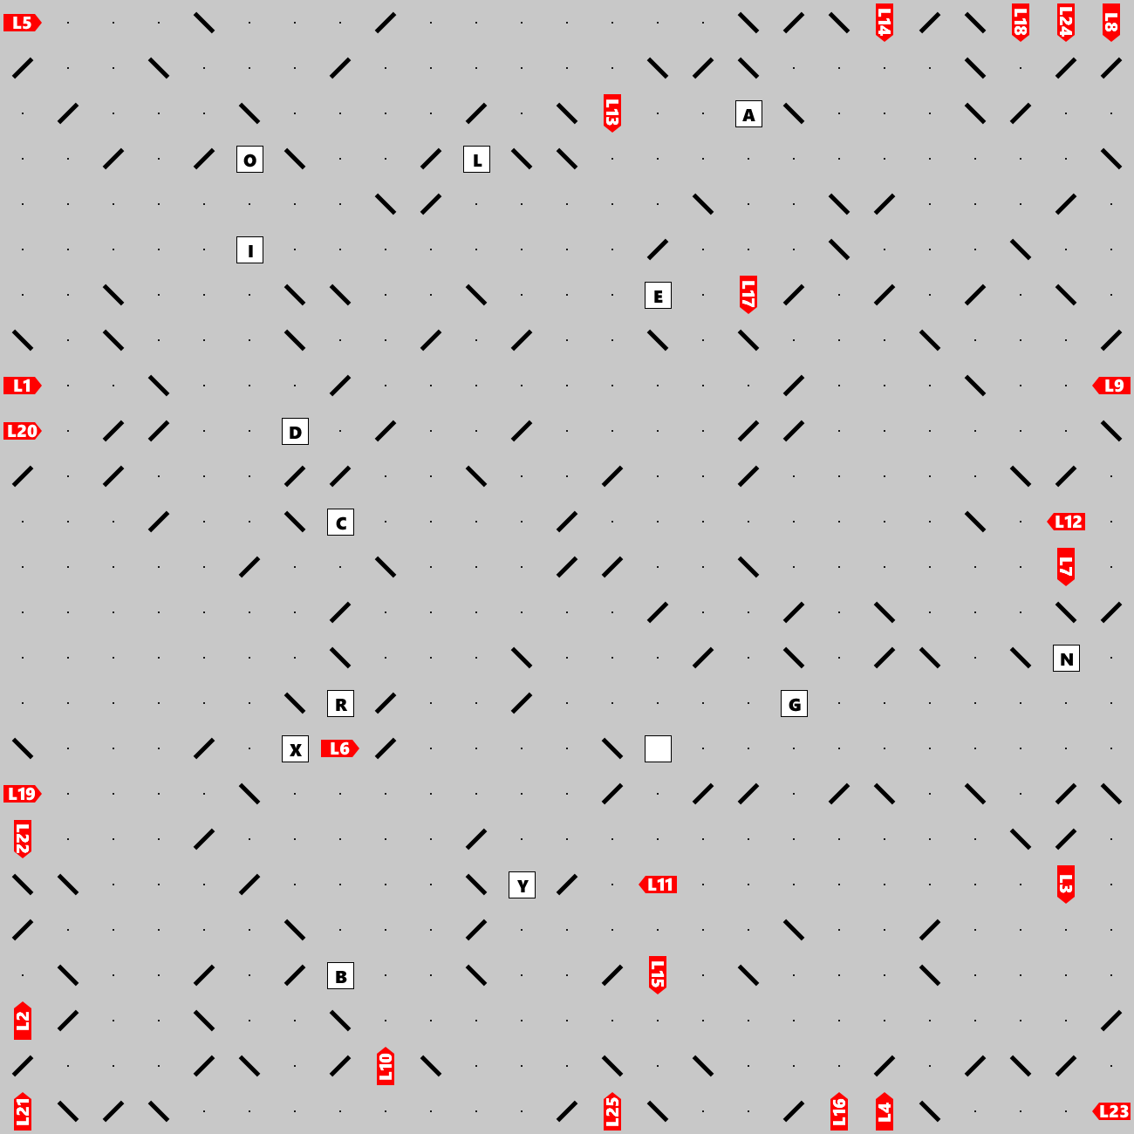

Lasers shoot beams that may bounce off double-sided mirrors and eventually hit a letter, at which point the beams stop. Can you find the hidden clue (a short phrase)? The clue leads to the final answer.