**199**: Lasers III - A Many-sided Personality

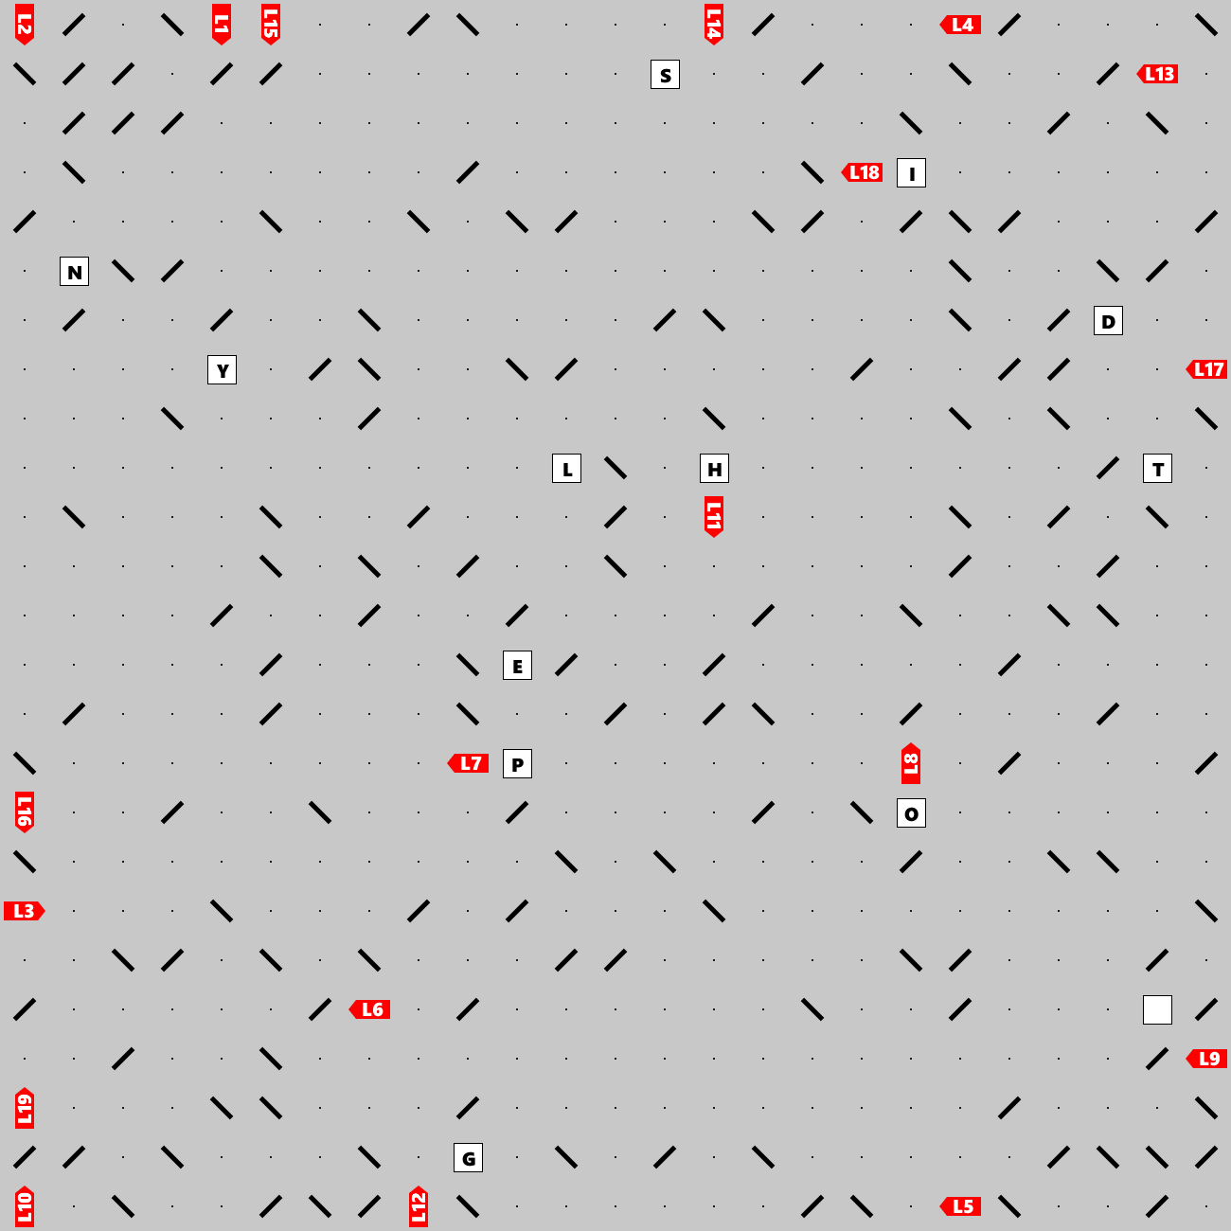

Lasers shoot beams that may bounce off double-sided mirrors and eventually hit a letter, at which point the beams stop. Can you find the hidden clue (a short phrase)? The clue leads to the final one-word answer.