**138**: Lasers IV - Hidden Equation

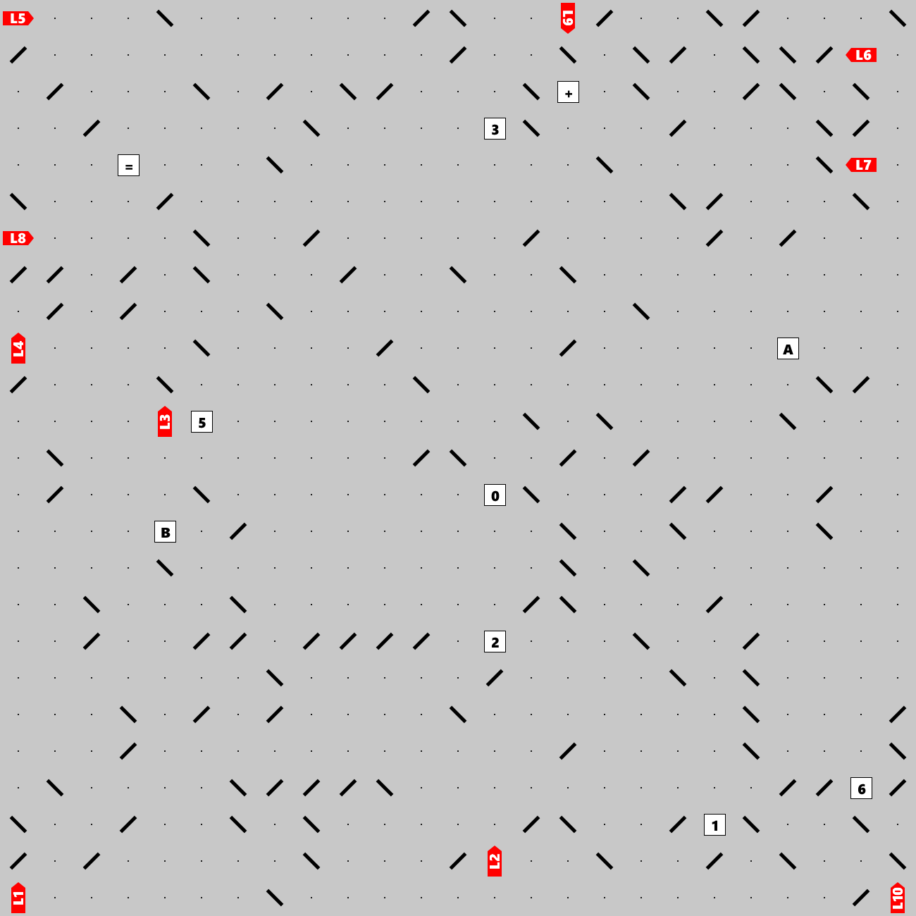

Lasers shoot beams that may bounce off double-sided mirrors and eventually hit a letter, at which point the beams stop. Can you find the hidden clue (an equation)? The clue will help you answer the following question: **If A is 32, what is B?** The final answer is a 3-digit number.