**343**: Lasers V - Green Machine

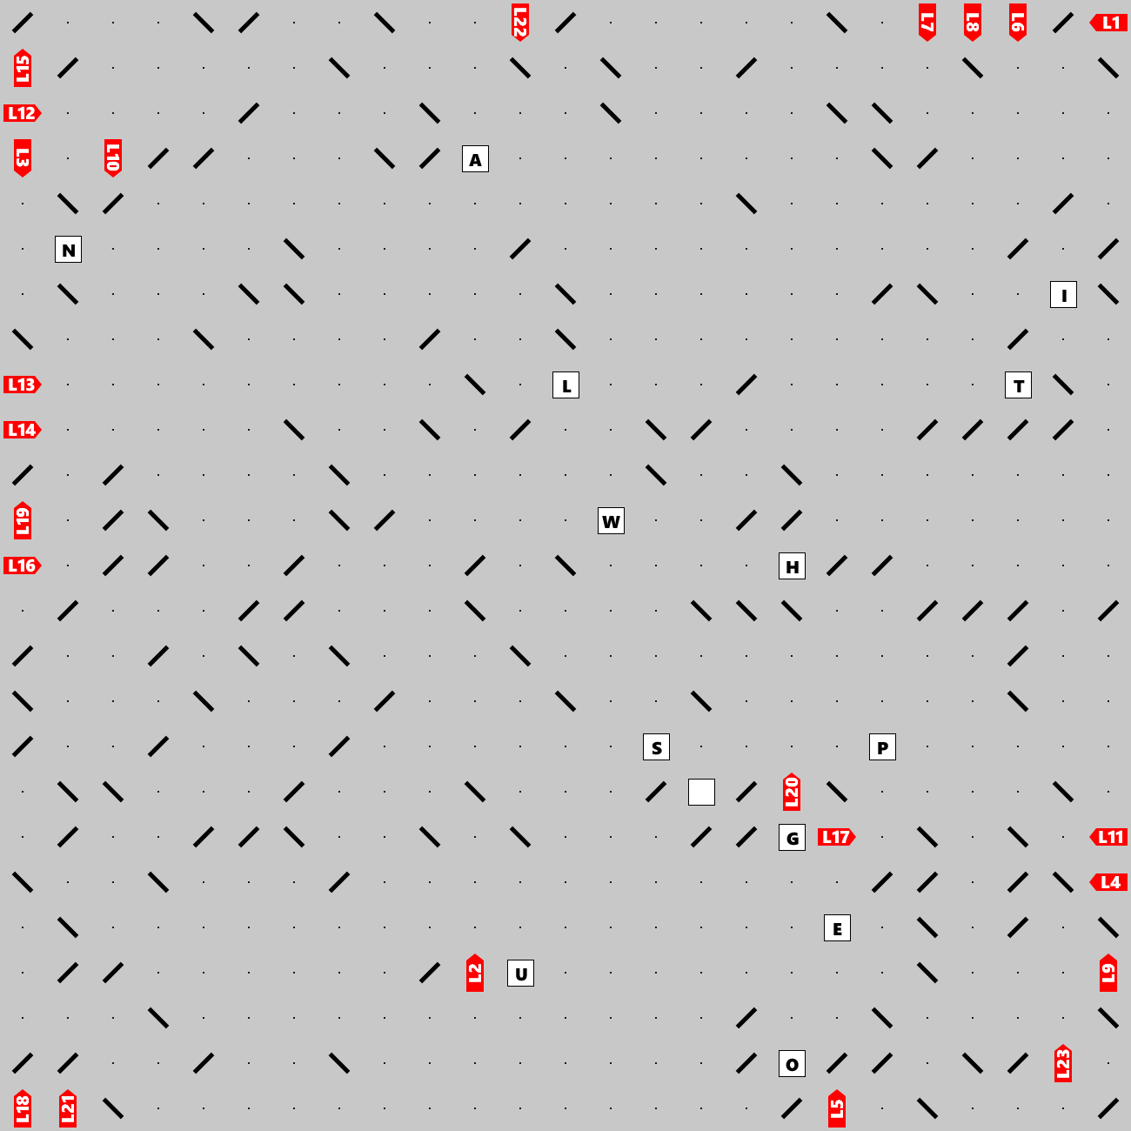

Lasers shoot beams that may bounce off double-sided mirrors and eventually hit a letter, at which point the beams stop. Can you find the hidden clue (a short phrase)? The clue will lead you to the final answer which is a single word defining a biological process.