138: Lasers IV - Hidden Equation

By: Joseph Joy

Answer: 777

Each laser targets a single character in the clue, starting with laser L1, shown below, which identifies the first character as “3”.

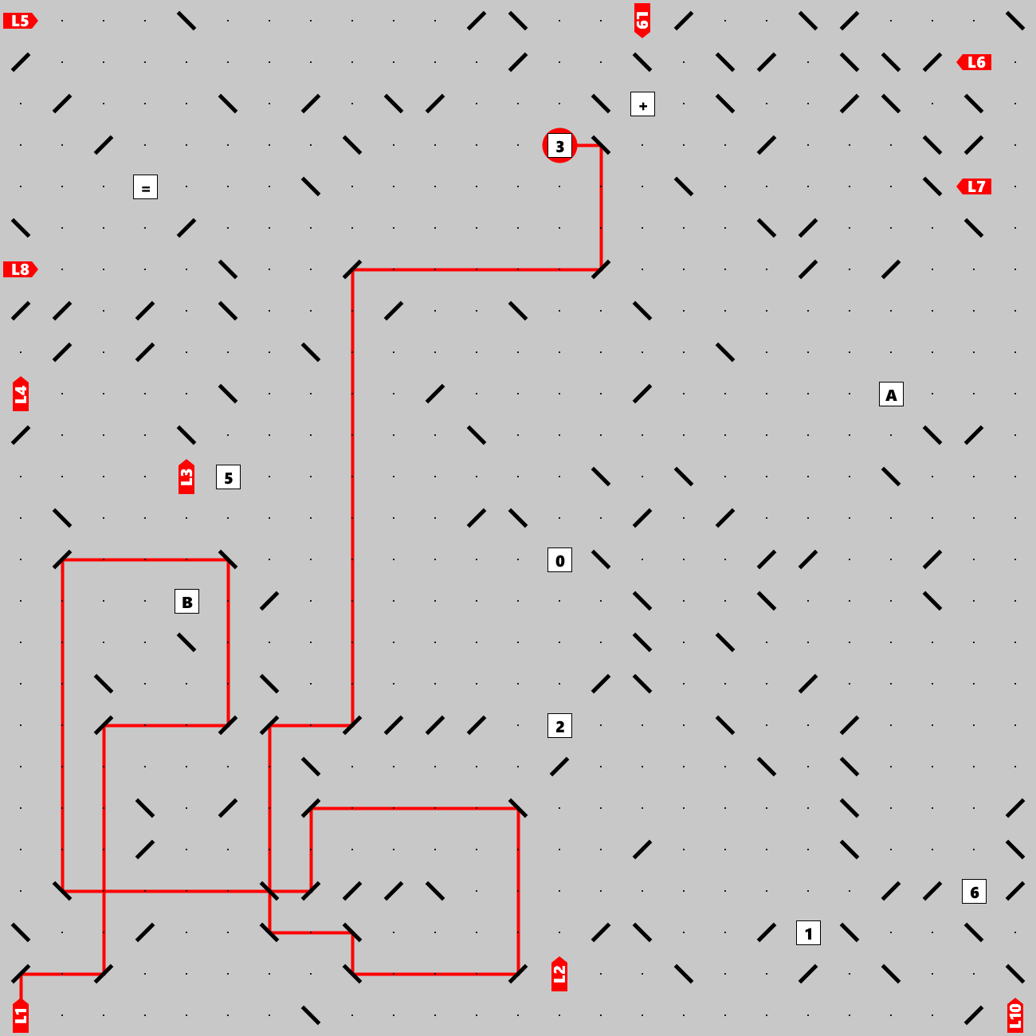

The entire clue is: “**3A+2B=1650**”.This is the hidden equation. The puzzle asked “If A is 32, what is B?” We can answer that question by filling in the value of 32 for A and solving the equation for B:

3x32+2B=1650  
2B = 1554  
B = 777