565: Tile Jumble I - Something Fishy

By:

Answer: REDD

Assemble the 9 tiles in the correct order using the background image as an aid. You get the following.

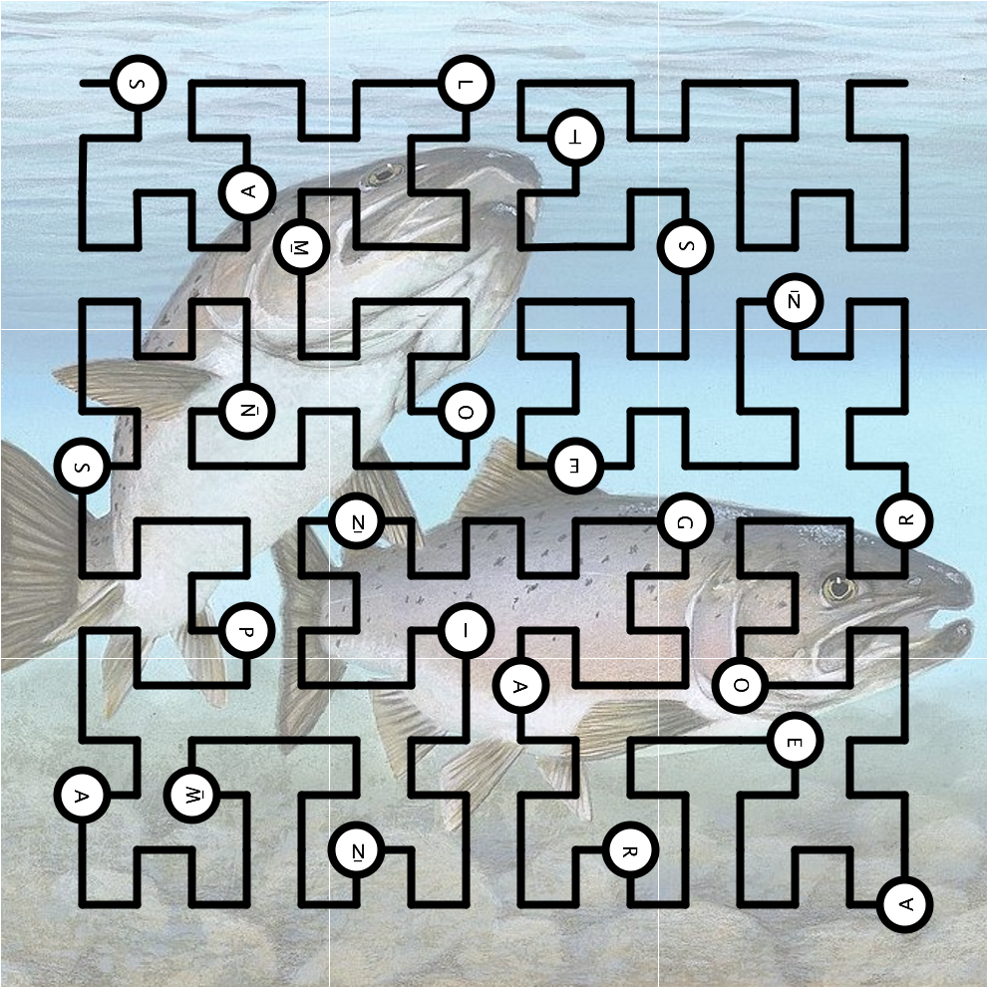

Reading the letters along the black path produces the clue “SALMON SPAWNING AREA OR NEST”, which is known as a REDD. Incidentally, the black path is an instance of a “space-filling curve” known as a Hilbert curve, devised by famous mathematician David Hilbert (1862-1943).

Artwork credit: Timothy Knepp (source: Wikimedia Commons)