ДЗ_1: Написать Dockerfile для frontend, собрать и запустить. [Ссылка на GIT](https://github.com/asilnikov/docker_homework)

My repo

https://github.com/rinxster/docker-homework/tree/main/task1-frontend

0. Dockerfile

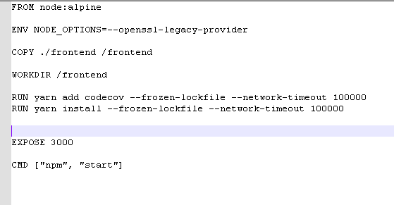

1. Executed followng command to build image

**docker build -t frontend .**



2. started in development mode to see if it starts and if there are any errors

**sudo docker run -it -p 3000:3000 frontend**

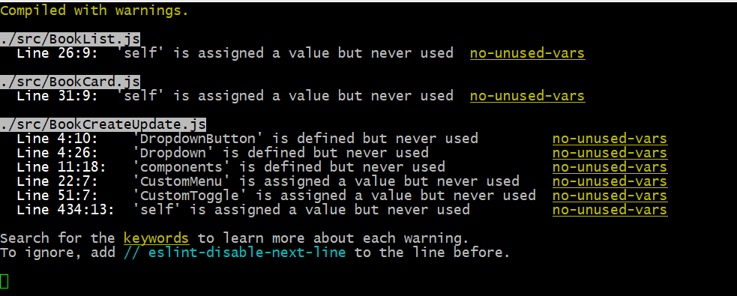

3. After that started again in detached mode

**sudo docker run -it -p 3000:3000 -d frontend**

Here is front end container and web screenshots



