ДЗ_2: Написать Dockerfile для lib_catalog, postgresql, собрать и запустить. [Ссылка на GIT](https://github.com/asilnikov/docker_homework)

**My repo: https://github.com/rinxster/docker-homework/tree/main/task2-backend-and-database**

**docker-compose.yml**

**$ docker-compose up -d**

**$ docker ps**

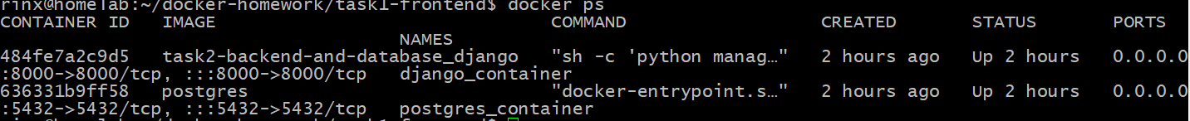

Result

