MOUNT  KENYA
UNIVERSITY
PROJECT PROPOSAL

iSmart: A Seamless Investment Platform for Enhancing Financial Inclusion in Kenya

ADMIN NO. BIT/2025/68548
NAME: MORRIS KARANI MUNG’ATHIA

Submitted in partial fulfillment of the requirements for the Bachelors of Science in Information Technology

May 2026

DECLARATION
I declare that this research project is my original work and has not been presented for a degree in any other university or institution of higher learning. All sources of information used herein have been duly acknowledged.

Signature: ____________________________

Date: ________________________________

Morris Karani Mung'athia
BIT/2025/68548

RECOMMENDATION
This research project has been submitted for examination with my approval as the university supervisor.

Supervisor’s Name: ____________________________

Signature: ____________________________

Date: ________________________________

Department of Information Technology
Mount Kenya University

ACKNOWLEDGEMENT
I wish to express my sincere gratitude to the Almighty God for the grace, strength, and wisdom bestowed upon me throughout this research project. His guidance has been my source of inspiration and perseverance.
I am deeply thankful to my supervisor for the invaluable guidance, constructive criticism, and unwavering support throughout the research process. The mentorship received has been instrumental in shaping the direction and quality of this work.
Special thanks go to my family and friends for their moral support, patience, and understanding during the demanding periods of this research. Their encouragement kept me focused and motivated.
I also acknowledge the faculty and staff of the School of Computing and Informatics at Mount Kenya University for their academic support and for creating an environment conducive to research and learning.
Finally, I acknowledge the aspiring investors and the broader Kenyan community whose financial challenges inspired this research. It is my hope that the iSmart platform will contribute meaningfully to enhancing financial inclusion and economic empowerment in Kenya.

TABLE OF CONTENTS
DECLARATION I
RECOMMENDATION I
ACKNOWLEDGEMENT II
LIST OF FIGURES VI
LIST OF TABLES VI
LIST OF ABBREVIATIONS VII
CHAPTER ONE: INTRODUCTION 1
1.1 Introduction 1
1.2 Background of the Study 1
1.2.1 Global Perspective 2
1.2.2 African Regional Context 2
1.2.3 Kenyan Context 3
1.2.4 Current System 4
1.3 Problem Statement 4
1.4 Problem Solution 5
1.5 Objectives of the System 6
1.5.1 Main Objective 6
1.5.2 Specific Objectives 6
1.6 Research Questions 7
1.7 Scope of the Study 7
1.8 Justification 8
1.9 Risk and Mitigation 9
1.10 System Requirements 9
1.10.1 Functional Requirements 9
1.10.2 Non-Functional Requirements 10
1.11 Budget 11
1.12 Gantt Chart 12
CHAPTER TWO: LITERATURE REVIEW 13
2.1 Introduction 13
2.2 Theoretical Review 13
2.2.1 Technology Acceptance Model (TAM) 13
2.2.2 Financial Intermediation Theory 14
2.3 Conceptual Review 15
2.3.1 Digital Investment Platforms 15
2.3.2 Mobile Money and Financial Inclusion 15
2.3.3 Cybersecurity in Financial Technology 16
2.4 Review of Existing Systems 16
2.5 Research Gaps 17
2.6 Conceptual Framework 18
2.7 Summary of the Chapter 20
CHAPTER THREE: RESEARCH METHODOLOGY 21
3.1 Introduction 21
3.2 Research Design 21
3.3 Study Area 22
3.4 Target Population, Sample Size, and Sampling Procedure 23
3.4.1 Target Population 23
3.4.2 Sample Size 23
3.5 Sampling Procedure 24
3.6 Data Collection 24
3.6.1 Secondary Data Collection 24
3.6.2 Primary Data Collection 25
3.7 Data Analysis 25
3.8 System Design 26
3.8.1 Context Diagram 26
3.8.2 Data Flow Diagram Level 1 27
3.8.3 Development Methodology 28
3.8.3 Technology Stack 29
3.8.4 System Modules 29
3.9 Ethical Considerations 30
3.10 Summary 31
REFERENCES 32

LIST OF FIGURES
Figure 2.1……………………… Conceptual Framework — iSmart Investment Platform
Figure 3.1……………………… Context Diagram of iSmart System
Figure 3.2……………………… Data Flow Diagram Level 1 of iSmart System
Figure 3.3……………………… System Architecture of iSmart Platform

LIST OF TABLES
Table 1.1…………………………………………………… Risk and Mitigation Strategies
Table 1.2…………………………………………………… Project Budget Estimate
Table 1.3…………………………………………………… Project Gantt Chart Timeline
Table 2.1………………………………………… Review of Existing Investment Systems
Table 3.1…………………………………………………… Target Population Segments

LIST OF ABBREVIATIONS
API - Application Programming Interface
B2C - Business to Consumer
C2B - Consumer to Business
CMA - Capital Markets Authority
DB - Database
DFD - Data Flow Diagram
DSRM - Design Science Research Methodology
ER - Entity Relationship
HTTPS - Hypertext Transfer Protocol Secure
JWT - JSON Web Token
KES - Kenyan Shilling
KYC - Know Your Customer
M-PESA - Mobile Money Service by Safaricom
NSE - Nairobi Securities Exchange
OOP - Object-Oriented Programming
PEOU - Perceived Ease of Use
PHP - Hypertext Preprocessor
PU - Perceived Usefulness
SSL - Secure Sockets Layer
STK - SIM Toolkit
TAM - Technology Acceptance Model
TLS - Transport Layer Security
UI - User Interface
URL - Uniform Resource Locator

CHAPTER ONE: INTRODUCTION

1.1 Introduction
The iSmart – Seamless Investment Platform is a proposed web-based system designed to revolutionize the investment landscape in Kenya by addressing key challenges faced by retail investors, small and medium enterprises (SMEs), and aspiring entrepreneurs. This research proposal presents a comprehensive study that outlines the design, development, and evaluation of iSmart, a platform that seeks to democratize access to investment opportunities, promote financial inclusion, and encourage informed investment practices among Kenyan investors through the application of modern information and communication technologies.
The project is undertaken as a partial fulfilment of the requirements for the Bachelor of Information Technology degree at Mount Kenya University, School of Computing and Informatics. The proposal is organized into three chapters: Chapter One introduces the study, outlining the background, problem statement, objectives, research questions, scope, justification, risks, system requirements, budget, and project timeline; Chapter Two provides a critical review of existing literature; and Chapter Three describes the research methodology to be employed in the study.
The significance of this study lies in its potential to bridge the gap between traditional financial services and the growing population of digitally literate Kenyans who seek accessible, secure, and user-friendly investment avenues. By leveraging technologies such as Firebase Authentication for security, the M-PESA Daraja API for seamless payment integration, and a community-driven pooled investment model, iSmart aims to deliver a transformative solution that empowers individuals to grow their wealth sustainably while contributing to broader economic development goals in Kenya.

1.2 Background of the Study
The background of this study contextualizes the challenges within Kenya’s investment landscape by adopting a hierarchical approach, beginning with a global perspective, narrowing to the African regional context, and culminating in a focused analysis of Kenya’s specific challenges and opportunities. This structured approach ensures a comprehensive understanding of the investment ecosystem and the systemic barriers that iSmart seeks to address.

1.2.1 Global Perspective
Globally, investment accessibility remains a significant challenge, particularly in emerging economies. The World Bank’s Global Findex Database indicates that while financial account ownership has grown substantially over the past decade, actual investment participation remains disproportionately low. Barriers to investment include complex regulatory environments that deter new entrants, prohibitively high transaction costs that discourage low-income individuals, widespread financial illiteracy that prevents effective engagement with financial markets, and inadequate financial infrastructure that limits the availability of investment services in underserved regions. These challenges are particularly acute in emerging economies, where the gap between financial access and meaningful investment participation is most pronounced.
The advent of financial technology (fintech) has begun to address some of these barriers by democratizing access to financial services through digital platforms. Robo-advisors, micro-investment platforms, and mobile trading applications have lowered entry thresholds, allowing individuals with modest capital to participate in investment markets. However, the pace of technological adoption varies significantly across regions, and many populations in developing countries continue to face systemic barriers that limit their ability to benefit from these innovations.

1.2.2 African Regional Context
Africa presents a paradox of economic diversity and investment opportunity tempered by significant structural challenges. The continent boasts the world’s youngest population, with approximately 60% of Africans under the age of 25, rapid urbanization rates exceeding 4% annually in some countries, and growing technology adoption driven by mobile phone penetration. These demographic and technological trends create a fertile ground for investment innovation. However, the African investment landscape is simultaneously constrained by underdeveloped financial infrastructure, political instability in certain regions, over-reliance on traditional savings methods rather than formal investment channels, and limited access to diversified financial products.
In response to these challenges, technology-based platforms offering forex trading, cryptocurrency investments, and collective investment schemes have emerged across the continent. These platforms provide easy-to-use interfaces that allow more people to invest with relatively small amounts of capital. The African fintech ecosystem has attracted significant investment, with Kenya securing 82.44 Bilion in startup funding in 2024 alone, the highest on the continent, accounting for 29% of Africa’s total funding. This demonstrates both the market potential and the growing recognition of technology-driven financial solutions in the region.

1.2.3 Kenyan Context
Within Kenya, the investment landscape presents a dichotomy of promise and constraint. As East Africa’s largest economy, Kenya stands out for its rapid adoption of technology and widespread use of digital financial services. Innovations like mobile money platforms, notably M-PESA, have transformed the country’s payment systems and financial transactions, setting a precedent for digital financial inclusion across the region. According to the FinAccess Household Survey 2024, 84.8% of Kenyan adults now have access to formal financial services, marking a significant milestone in financial inclusion.
Despite these advancements, significant challenges persist in the realm of investment accessibility and financial inclusion. Kenya’s investment environment is characterized by a complex interplay of factors that both enable and hinder economic growth. While technological infrastructure continues to expand, offering digital avenues for financial services, gaps remain in providing diverse and accessible investment opportunities to a broader demographic. One of the primary challenges is the limited access to diversified investment options for retail investors, SMEs, and emerging entrepreneurs. Traditional investment avenues often favour larger entities or require significant capital, excluding many potential investors from participating in more lucrative markets such as forex trading, collective investment schemes, or venture capital.
Moreover, the regulatory landscape in Kenya, while evolving, can still be opaque and challenging to navigate for aspiring investors. The Capital Markets Authority (CMA) has recently moved to license digital investment apps and robo-advisors under new Capital Markets (Licensing) requirements, and Kenya’s parliament passed a crypto asset law to boost investments. However, unclear or fluctuating economic policies and regulatory frameworks may still deter potential investors from engaging in long-term investment ventures, impacting overall investment sentiment and economic stability.

1.2.4 Current System
The current investment landscape in Kenya is fragmented and often inaccessible to a broad spectrum of potential investors. Traditional investment avenues predominantly cater to high-net-worth individuals and institutional investors, leaving a significant portion of the population underserved. Existing platforms lack integration, transparency, and user-friendly interfaces, complicating the investment process for novices and seasoned investors alike. The Nairobi Securities Exchange (NSE) and licensed stockbrokers remain the primary formal investment channels, but their accessibility is limited by high minimum investment thresholds, complex account opening procedures, and the requirement for significant financial knowledge.
Digital investment platforms such as Abacus, Hisa, and Ndovu have begun to address some of these gaps by offering fractional investment opportunities and simplified user interfaces. However, these platforms often operate in isolation, lacking integration with popular payment systems like M-PESA, and few offer community-driven or pooled investment models that could reduce individual risk. Furthermore, concerns about security, data privacy, and the legitimacy of online investment platforms continue to undermine public trust, particularly in light of past incidents involving fraudulent investment schemes in Kenya.

1.3 Problem Statement
The problem at hand is the limited accessibility and complexity of investment opportunities in Kenya. Despite significant technological advancements and a high rate of formal financial service access at 84.8%, many potential investors face formidable barriers that prevent meaningful participation in investment markets. These barriers include limited access to diversified investment options, particularly in emerging markets like forex and cryptocurrencies; complicated and opaque regulatory frameworks that deter new investors and small businesses; fluctuating economic policies that create uncertainty and risk for investors; and a persistent financial literacy gap that prevents effective engagement with available investment products.
The magnitude of these issues is significant, affecting a wide range of stakeholders, from individual investors seeking to grow their savings to small and medium enterprises (SMEs) aiming to expand through investment. The lack of accessible and transparent investment platforms restricts financial inclusion and limits opportunities for wealth accumulation across the population. If left unaddressed, these issues could perpetuate income inequality, stifle economic development, and deter foreign investment in Kenya’s growing economy. Without a streamlined and inclusive investment ecosystem, the potential benefits of technological innovation and financial market growth may remain unrealized, leaving many Kenyans without the means to secure their financial futures.
Specifically, current systems fail to integrate secure payment processing with investment management, lack community-driven models that could mitigate individual risk, and do not provide adequate financial education alongside investment opportunities. The iSmart platform is proposed as a comprehensive solution that addresses these interconnected challenges by combining secure technology, seamless M-PESA integration, pooled investment strategies, and financial literacy resources in a single, user-friendly web application.

1.4 Problem Solution
The proposed solution to the identified problems is the iSmart – Seamless Investment Platform, a web-based application designed to address the key challenges in Kenya’s investment landscape through an integrated, community-driven approach. iSmart proposes a novel model where community members pool their funds together, creating a collective investment pool managed by seasoned traders. This collective approach not only mitigates individual risk but also allows for the application of sophisticated trading strategies, including rigorous risk management protocols. By aggregating resources and expertise, iSmart strives to deliver consistent and reliable returns for its users.
The platform will integrate multiple key technologies and features to provide a comprehensive solution. Firebase Authentication will ensure secure and reliable user management, preventing unauthorized access and protecting user accounts. The M-PESA Daraja API will facilitate seamless and secure payment processing for deposits and withdrawals, leveraging Kenya’s most widely used mobile money platform. An automated investment growth module will manage returns and distribute profits from various investment avenues including forex trading, stock market participation, and cryptocurrency trading. A tiered investment plans module will offer four distinct plans – Simba (50,000 KES), Ndovu (30,000 KES), Kifaru (10,000 KES), and Chui (1,000 KES) – catering to investors across different financial capacities. Additionally, a reporting and analytics module will generate investment reports and track user activity to support informed decision-making and platform improvement.
Beyond the technological features, iSmart will embed financial literacy resources directly within the platform, ensuring that users not only invest but also develop the knowledge and skills necessary for long-term financial planning. This dual approach of combining investment access with education is designed to address both the supply-side constraints (limited investment platforms) and demand-side constraints (financial literacy gaps) that currently hinder investment participation in Kenya.

1.5 Objectives of the System

1.5.1 Main Objective
The main objective of this study is to design, develop, and evaluate iSmart, a secure and user-friendly web-based investment platform that simplifies the investment process, enhances financial literacy, and increases investment participation among Kenyans, with particular focus on urban and peri-urban populations with access to digital financial services.

1.5.2 Specific Objectives
The specific objectives of this study are:
- To analyse the current investment barriers and challenges faced by potential investors in Kenya.
- To design and develop a user-friendly and secure online platform for seamless investment management.
- To integrate robust security measures, including Firebase Authentication and data encryption, ensuring the safety and confidentiality of user transactions.
- To evaluate the effectiveness of the iSmart platform in increasing investment participation and enhancing financial literacy among Kenyan users.

1.6 Research Questions
To align with the specific objectives, the following research questions will guide the study:
- How do current investment barriers and challenges impact potential investors in Kenya?
- What design and development strategies will ensure a user-friendly and secure online investment platform?
- How can robust security measures be effectively integrated into the iSmart platform to ensure the safety and confidentiality of user transactions?
- What is the impact of the iSmart platform on increasing investment participation and enhancing financial literacy among Kenyan users?

1.7 Scope of the Study
The study focuses on the investment landscape in Kenya, specifically targeting urban and peri-urban areas where digital financial services are widely accessible. The primary users of the iSmart platform will include individual retail investors, SMEs, and young, tech-savvy individuals who are keen on exploring new investment opportunities. The iSmart platform will be developed as a web-based application, ensuring accessibility and convenience for users across different devices and platforms.
The scope encompasses the full system development lifecycle, from requirements analysis and design through to implementation and evaluation. The platform will integrate with M-PESA through the Daraja API for payment processing, use Firebase for authentication and real-time database management, and implement four tiered investment plans (Simba, Ndovu, Kifaru, and Chui) as the core investment model. The study will also assess the platform’s impact on financial literacy and investment participation among a sample of target users.
However, the study acknowledges certain limitations. Kenya’s regulatory environment may pose challenges to the implementation and operation of the platform, particularly given the evolving nature of CMA regulations regarding digital investment platforms. Varying levels of digital literacy among potential users may limit adoption and effectiveness. Investment returns are subject to market fluctuations, and while risk management strategies will be employed, absolute guarantees cannot be provided. The study will not extend to rural areas with limited internet connectivity, nor will it cover the legal and regulatory compliance process in depth, which would require separate expert analysis.

1.8 Justification
The iSmart – Seamless Investment Platform project is justified on multiple grounds, spanning economic, social, technological, and academic dimensions. The initiative aims to provide a comprehensive solution that caters to the needs of various stakeholders, including individual investors, small and medium enterprises (SMEs), and the broader community.
The primary beneficiaries of the iSmart platform include individual investors, who will gain access to a diverse range of investment opportunities that were previously reserved for high-net-worth individuals and institutional investors. By lowering entry barriers and offering tiered investment plans starting from as little as 1,000 KES, iSmart effectively democratizes the investment sphere, enabling users from different financial backgrounds to participate in profitable ventures. This inclusive approach ensures that a broader range of individuals can benefit from the platform, contributing to the overall growth of the investment sector.
Small and Medium Enterprises (SMEs) will also greatly benefit from the iSmart platform. By offering a secure and user-friendly investment environment, SMEs can access the capital they need to expand and innovate more efficiently. The pooled investment model provides an alternative to traditional bank loans, which often come with stringent lending conditions and high interest rates. This will help foster a thriving SME sector, which plays a crucial role in the development of Kenya’s economy, contributing approximately 33% of GDP according to the Kenya National Bureau of Statistics.
From a technological perspective, the project demonstrates the practical application of modern web technologies, API integration, and secure authentication systems in solving real-world financial challenges. The integration of M-PESA Daraja API for payment processing and Firebase for real-time data management showcases how existing digital infrastructure can be leveraged to create innovative financial solutions. Academically, the study contributes to the body of knowledge on digital investment platforms in emerging economies, providing insights that can inform future research and development in this field.

1.9 Risk and Mitigation
The development and deployment of the iSmart platform involves several risks that must be identified and mitigated to ensure the project’s success. A comprehensive risk assessment has been conducted, and the following table presents the key risks alongside their proposed mitigation strategies.
Risk | Severity | Mitigation Strategy
Regulatory non-compliance | High | Engage legal counsel; monitor CMA guidelines; implement KYC/AML protocols
Cybersecurity breaches | High | Firebase Authentication; SSL/TLS encryption; regular security audits; penetration testing
Low user adoption | Medium | User-centred design; financial literacy integration; targeted marketing campaigns
M-PESA API integration failure | Medium | Sandbox testing; fallback payment methods; Daraja 3.0 documentation review
Market volatility affecting returns | Medium | Diversified investment portfolio; risk management protocols; transparent disclosures
Data loss or corruption | Low | Firebase real-time backups; redundant database architecture; disaster recovery plan
Scope creep | Low | Agile Scrum methodology; defined sprint objectives; regular stakeholder reviews
Insufficient funding | Low | Phased development approach; prioritize core features; seek additional sponsorship

1.10 System Requirements

1.10.1 Functional Requirements
The following functional requirements define the core capabilities that the iSmart platform must deliver:
- User registration and authentication: The system shall provide secure registration and login functionality using Firebase Authentication, including email verification and password recovery.
- Investment plan management: The system shall allow users to select, subscribe to, and manage investment plans (Simba, Ndovu, Kifaru, Chui) with clearly defined return structures.
- Payment processing: The system shall integrate M-PESA Daraja API to facilitate secure deposits and withdrawals, supporting both STK Push and C2B payment flows.
- Automated return calculation: The system shall automatically calculate and credit investment returns based on the selected plan’s return structure on a weekly basis.
- Reporting and analytics: The system shall generate investment reports, transaction histories, and user activity summaries to support informed decision-making.
- Financial literacy resources: The system shall provide educational materials, investment guides, and market insights within the platform interface.
- User profile management: The system shall allow users to view and update their personal information, investment history, and account settings.

1.10.2 Non-Functional Requirements
- Security: All user data shall be encrypted in transit and at rest; authentication shall use industry-standard protocols; the system shall comply with Kenya’s Data Protection Act 2019.
- Performance: The system shall support a minimum of 500 concurrent users with page load times not exceeding 3 seconds under normal operating conditions.
- Reliability: The system shall maintain 99.5% uptime availability, with automated failover mechanisms and regular data backups through Firebase.
- Usability: The system shall feature a responsive, mobile-friendly interface that is accessible to users with basic digital literacy; all critical functions shall be achievable within 3 clicks.
- Scalability: The system architecture shall support horizontal scaling to accommodate future growth in user base and transaction volume.

1.11 Budget
The estimated budget for the development and initial deployment of the iSmart platform is presented below. All figures are in Kenyan Shillings (KES). The budget covers the key cost categories including development tools, hosting and infrastructure, API integration costs, testing, and contingency provisions.
Item | Estimated Cost (KES)
Development Tools and Software Licences | 15,000
Web Hosting and Domain Registration (12 months) | 24,000
Firebase Real-time Database (estimated usage) | 12,000
M-PESA Daraja API Integration and Testing | 10,000
SSL Certificate and Security Tools | 5,000
User Testing and Quality Assurance | 8,000
Documentation and Report Production | 5,000
Contingency (10%) | 7,900
Total | 86,900

1.12 Gantt Chart
The following Gantt chart provides a timeline for the major activities involved in the development of the iSmart platform. The project is planned over a period of approximately 24 weeks, organized into distinct phases aligned with the Agile Scrum methodology. Each sprint is designed to last between two and four weeks, with defined deliverables and review milestones.
Phase / Activity | Timeline | Key Deliverables
Phase 1: Requirements Analysis | Week 1-2 | Literature review; stakeholder analysis; requirements specification
Phase 2: System Design | Week 2 | Architecture design; database schema; UI/UX wireframes; DFD diagrams
Phase 3: Sprint 1 – Core Modules | Week 3-4 | User authentication; registration; profile management; Firebase setup
Phase 4: Sprint 2 – Payment Integration | Week 4 | M-PESA Daraja API integration; deposit/withdrawal workflows; transaction logging
Phase 5: Sprint 3 – Investment Engine | Week 5 | Investment plan logic; return calculations; pooled fund management; reporting module
Phase 6: Sprint 4 – Testing & Refinement | Week 5 | Integration testing; security audits; user acceptance testing; bug fixes
Phase 7: Documentation & Deployment | Week 5-6 | Final documentation; thesis writing; platform deployment; presentation preparation

CHAPTER TWO: LITERATURE REVIEW

2.1 Introduction
This chapter reviews existing literature relevant to the development of the iSmart investment platform. It aims to align with the objectives outlined in Chapter One by providing a structured analysis of key topics. The literature review is organized thematically, beginning with a theoretical framework that underpins the study, followed by a conceptual review of digital investment platforms, a review of existing systems in the Kenyan and international context, an identification of research gaps, and the presentation of a conceptual framework that guides the proposed system design. This approach ensures a comprehensive understanding of the current investment landscape, technological advancements, and potential barriers to investment in Kenya.
The review draws on a range of scholarly sources, including peer-reviewed journal articles, conference proceedings, government reports, and industry publications. Particular attention is given to literature that addresses financial inclusion, digital investment platforms, mobile money integration, and cybersecurity in financial technology, as these areas are directly relevant to the iSmart platform’s objectives and design considerations.

2.2 Theoretical Review
The theoretical foundation of this study is anchored in two complementary theories: the Technology Acceptance Model (TAM) and the Financial Intermediation Theory. These theories provide a robust framework for understanding both the technological and financial dimensions of the iSmart platform.

2.2.1 Technology Acceptance Model (TAM)
The Technology Acceptance Model, originally proposed by Davis (1989), posits that the acceptance and use of a new technology system is primarily determined by two key factors: Perceived Usefulness (PU), defined as the degree to which a person believes that using a particular system would enhance their performance, and Perceived Ease of Use (PEOU), defined as the degree to which a person believes that using a particular system would be free from effort. TAM has been widely applied in information systems research to explain and predict user acceptance of technology, and it is particularly relevant to this study because the success of the iSmart platform fundamentally depends on its acceptance by target users.
In the context of iSmart, TAM suggests that potential investors will adopt the platform if they perceive it as useful for growing their wealth (PU) and easy to navigate without requiring advanced technical skills (PEOU). The platform’s design priorities – including a simplified user interface, M-PESA integration for seamless transactions, and embedded financial literacy resources – are directly informed by TAM’s emphasis on perceived usefulness and ease of use. Furthermore, TAM has been extended in various studies to include additional variables such as trust and social influence, both of which are critical in the context of financial technology adoption in Kenya, where trust in digital financial systems is still developing.

2.2.2 Financial Intermediation Theory
Financial Intermediation Theory, as articulated by Scholtens and van Wensveen (2003), explains the role of financial intermediaries in bridging the gap between savers (surplus units) and borrowers (deficit units). Financial intermediaries reduce transaction costs, mitigate information asymmetry, and provide risk management services that individual market participants cannot efficiently achieve on their own. This theory is directly applicable to the iSmart platform, which functions as a digital financial intermediary by pooling individual investments and managing them through professional traders.
The pooled investment model employed by iSmart embodies the core principles of financial intermediation. By aggregating resources from multiple investors, iSmart achieves economies of scale in investment management, reduces individual risk through diversification, and provides access to sophisticated trading strategies that would be unavailable to individual small-scale investors. The theory also supports the platform’s role in reducing information asymmetry by providing transparent reporting, educational resources, and clear disclosure of investment terms and potential risks.

2.3 Conceptual Review

2.3.1 Digital Investment Platforms
Digital investment platforms represent a transformative shift in the financial services industry, leveraging technology to democratize access to investment opportunities. These platforms have transitioned from traditional brokerage services to digital interfaces offering diverse financial products, including stocks, bonds, mutual funds, exchange-traded funds (ETFs), and increasingly, cryptocurrency and forex trading. Key features of successful digital investment platforms include user-friendly interfaces that simplify the investment process, robust security measures to protect user data and transactions, diverse investment options catering to various risk appetites and financial goals, and educational resources to enhance financial literacy.
The evolution of investment platforms has been particularly impactful in emerging markets, where traditional financial services often exclude large segments of the population. In Kenya, digital investment platforms are playing a crucial role in enhancing financial inclusion by allowing a broader population to participate in investment activities. These platforms offer various services, from basic savings accounts to complex investment products, leveraging technology to provide users with easy access, real-time data, and automated advisory services.

2.3.2 Mobile Money and Financial Inclusion
Mobile money services, particularly M-PESA in Kenya, have revolutionized financial transactions by providing easy and secure ways to transfer money and make payments. Launched by Safaricom in 2007, M-PESA has grown to become the most widely used mobile money platform in East Africa, processing millions of transactions daily. The platform’s success demonstrates the potential for mobile-first financial solutions in markets where traditional banking infrastructure is limited.
The integration of mobile money with investment platforms represents a significant opportunity for enhancing financial inclusion. The M-PESA Daraja API, launched as a developer portal, provides REST APIs for integrating M-PESA into web and mobile applications, enabling seamless payment processing for deposits, withdrawals, and other financial transactions. For the iSmart platform, this integration is critical, as it allows users to fund their investment accounts and receive returns directly through M-PESA, eliminating the need for traditional bank accounts and reducing friction in the investment process.

2.3.3 Cybersecurity in Financial Technology
Security is paramount in financial services to ensure user trust and protect sensitive data. The increasing digitization of financial services has expanded the attack surface for cyber threats, making robust security measures essential for any digital investment platform. Effective security measures include multi-factor authentication protocols to ensure only authorized users access the platform, data encryption (both in transit and at rest) to protect user data from unauthorized access, secure payment processing systems to ensure reliable and safe transactions, and regular security audits and penetration testing to identify and address vulnerabilities.
In the Kenyan context, cybersecurity is particularly critical given the country’s history of fraudulent investment schemes that have undermined public trust. The iSmart platform addresses this by implementing Firebase Authentication for secure user management, which provides built-in protection against common authentication attacks, combined with SSL/TLS encryption for all data in transit. The platform’s security architecture is designed to comply with Kenya’s Data Protection Act 2019 and the regulatory guidelines issued by the Capital Markets Authority for digital investment platforms.

2.4 Review of Existing Systems
A review of existing investment platforms operating in Kenya and internationally provides valuable insights for the design and development of the iSmart platform. This review identifies both the strengths and limitations of current systems, highlighting opportunities for innovation and improvement.
Platform | Market | Key Strengths | Key Limitations
Ndovu | Kenya | Fractional shares; low minimum investment; CMA-licensed; educational content | Limited payment options; no pooled investment model; limited forex/crypto options
Hisa | Kenya | US and Kenyan stock market access; user-friendly mobile app | No M-PESA integration; no community/pooled model; limited local investment options
Abacus | Kenya | NSE access; professional advisory services | High minimum investment; complex interface; not mobile-first; limited digital integration
eToro | International | Social trading; copy trading; diverse asset classes | Not available in Kenya; no M-PESA; regulatory restrictions; complex for beginners
Robinhood | International | Commission-free trading; simple interface; fractional shares | Not available in Kenya; limited customer support; no pooled investment model

The review reveals that while several investment platforms exist in the Kenyan market, none comprehensively combine M-PESA integration, a community-driven pooled investment model, tiered investment plans, and embedded financial literacy resources in a single platform. This gap presents a clear opportunity for the iSmart platform to differentiate itself and deliver unique value to Kenyan investors.

2.5 Research Gaps
Based on the literature review and the analysis of existing systems, several significant research gaps have been identified that the iSmart platform seeks to address. These gaps represent both theoretical and practical deficiencies in the current knowledge and practice of digital investment platforms in Kenya.
First, there is a notable gap in the integration of mobile money services with investment management platforms. While M-PESA has transformed payment systems in Kenya, most existing investment platforms have not leveraged the M-PESA Daraja API to provide seamless, native payment integration. This disconnect creates friction for users who must navigate multiple systems to fund their investment accounts, effectively excluding the large population of Kenyans who rely primarily on mobile money for financial transactions. The iSmart platform addresses this gap by embedding M-PESA as the primary payment channel.
Second, the absence of community-driven or pooled investment models in existing Kenyan platforms represents a significant gap. Current platforms focus primarily on individual investment accounts, which expose users to the full risk of their investment decisions. The pooled investment model, which aggregates resources and employs professional management, has been well-documented in financial intermediation theory as a mechanism for reducing individual risk and improving returns, yet it has not been widely implemented in digital platforms targeting Kenyan retail investors. iSmart’s community-driven approach fills this gap.
Third, there is a persistent gap in the integration of financial literacy within investment platforms. While some platforms offer basic educational content, none comprehensively embed financial education as a core feature alongside investment management. This gap is particularly critical in Kenya, where financial literacy levels remain a significant barrier to investment participation. By integrating educational resources, investment insights, and personalized guidance directly within the investment workflow, iSmart seeks to cultivate a culture of informed investment decision-making among its users.
Fourth, from a theoretical perspective, there is limited empirical research on the application of the Technology Acceptance Model in the context of community-driven investment platforms in East Africa. While TAM has been extensively studied in various technology adoption contexts, its specific application to pooled digital investment platforms in the Kenyan market has not been adequately explored. This study contributes to filling this theoretical gap by evaluating the iSmart platform through the lens of TAM, providing empirical evidence on the factors that influence user acceptance of community-driven investment technology in Kenya.

2.6 Conceptual Framework
The conceptual framework for this study illustrates the relationship between the independent variables (investment barriers, technology integration, and security measures) and the dependent variables (investment participation and financial literacy). The framework is grounded in the Technology Acceptance Model and Financial Intermediation Theory, and it provides a structured basis for understanding how the iSmart platform’s design features influence the desired outcomes.
The framework posits that investment barriers (including regulatory complexity, high transaction costs, limited financial literacy, and inadequate infrastructure) negatively impact investment participation and financial literacy outcomes. The iSmart platform’s intervention – comprising technology integration (M-PESA Daraja API, Firebase, web technologies), security measures (authentication, encryption, secure payment processing), and financial literacy resources (educational materials, investment guides, market insights) – mediates the relationship between these barriers and the desired outcomes. The community-driven pooled investment model serves as the central mechanism through which technology and security features translate into increased participation and improved financial literacy.
The conceptual framework can be represented as follows: Independent Variables (Investment Barriers, Technology Integration, Security Measures) → iSmart Platform (Mediating Variable: Community-Driven Pooled Investment Model) → Dependent Variables (Investment Participation, Financial Literacy). This framework guides the research design, data collection, and analysis, ensuring that the study systematically evaluates the platform’s effectiveness in addressing the identified barriers and achieving its stated objectives.
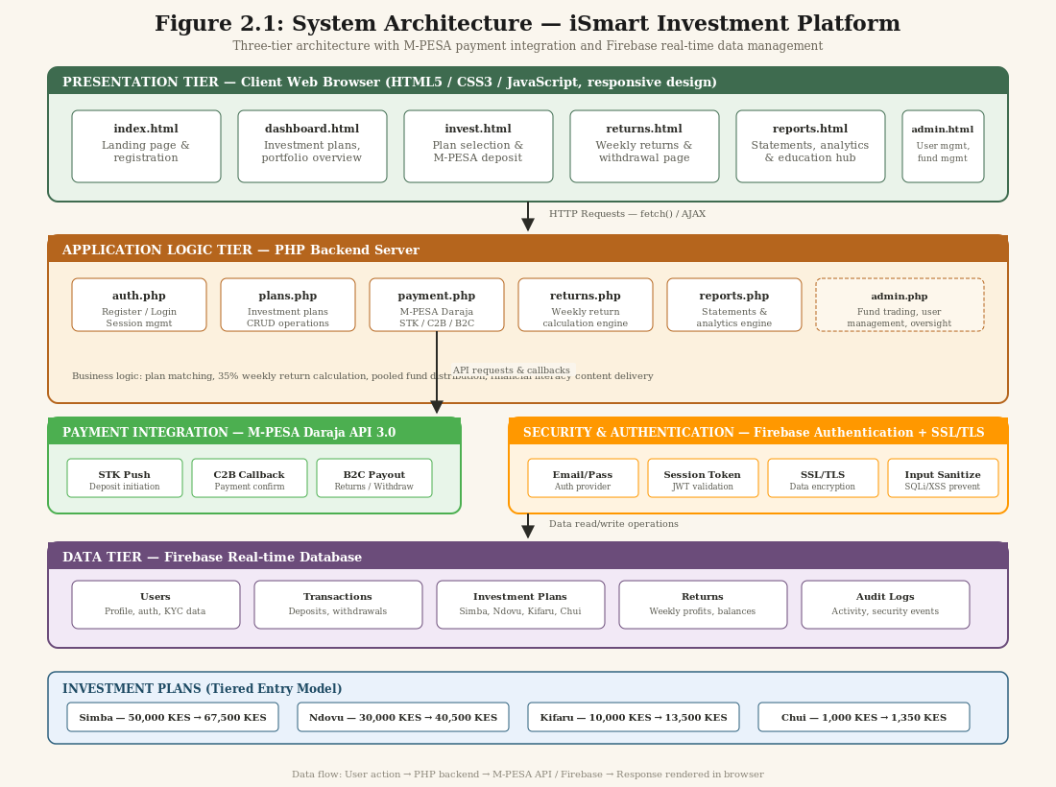Figure 2.1: System Architecture of iSmart Investment Platform

2.7 Summary of the Chapter
This chapter has provided a comprehensive review of the literature relevant to the development of the iSmart investment platform. The theoretical review established the Technology Acceptance Model and Financial Intermediation Theory as the foundational frameworks for the study, providing lenses through which to evaluate the platform’s design and impact. The conceptual review examined key concepts including digital investment platforms, mobile money and financial inclusion, and cybersecurity in financial technology, providing context for the platform’s design decisions.
The review of existing systems identified the strengths and limitations of current investment platforms operating in Kenya and internationally, highlighting the absence of a comprehensive solution that combines M-PESA integration, pooled investment models, and embedded financial literacy. The research gaps analysis revealed four significant gaps: the lack of mobile money integration with investment platforms, the absence of community-driven investment models, the insufficient integration of financial literacy within investment platforms, and the limited empirical research on TAM’s application to pooled digital investment platforms in East Africa. The conceptual framework synthesized these insights into a structured model that guides the research design and evaluation of the iSmart platform.
The findings of this literature review directly inform the research methodology presented in Chapter Three, ensuring that the study is grounded in established theory and addresses clearly identified gaps in both academic knowledge and practical implementation of digital investment platforms in Kenya.

CHAPTER THREE: RESEARCH METHODOLOGY

3.1 Introduction
This chapter presents a detailed account of the research methodology that will be employed in the design, development, and evaluation of the iSmart – Seamless Investment Platform. The methodology encompasses the research design, study area, target population, sample size and sampling procedures, data collection instruments and procedures, data analysis techniques, system design methodology, ethical considerations, and a summary of the chapter. The chosen methodologies are aligned with the study’s objectives and are informed by the theoretical and conceptual frameworks established in Chapter Two.
The research adopts a mixed-method approach that combines qualitative and quantitative techniques to ensure a comprehensive evaluation of the platform’s effectiveness. This approach is consistent with the pragmatic research paradigm, which emphasizes the use of multiple methods to address research questions from different perspectives, thereby enhancing the validity and reliability of the findings.

3.2 Research Design
The research design for this study employs a mixed-method approach combining descriptive survey research and design science research methodology (DSRM). The descriptive survey component enables the systematic collection and analysis of data regarding the current investment landscape, barriers to investment, and user perceptions, providing the empirical foundation for the platform’s design. The design science research component guides the development and evaluation of the iSmart artefact, following the DSRM framework proposed by Hevner et al. (2004) and refined by Peffers et al. (2007).
The descriptive survey design was selected for its ability to access a broad range of information and insights efficiently, allowing for a comprehensive understanding of the investment landscape within Kenya. This component involves an extensive literature review focusing on websites and online platforms that provide investment opportunities, market analysis, and financial services specific to Kenya. A qualitative content analysis will be conducted on these sources to extract relevant information regarding the features, benefits, and challenges of various investment platforms. Additionally, user reviews and testimonials from existing platforms will be scrutinized to gauge customer satisfaction and identify potential areas for improvement.
The design science research component follows the six-step DSRM process: (1) problem identification and motivation, which was addressed in Chapter One; (2) definition of objectives for a solution, also established in Chapter One; (3) design and development of the artefact, which will follow the Agile Scrum methodology described in Section 3.8; (4) demonstration of the artefact through implementation and testing; (5) evaluation of the artefact against the defined objectives using both qualitative and quantitative metrics; and (6) communication of the results through this research report and academic presentations.

3.3 Study Area
The study will be conducted primarily online, focusing on digital investment platforms and financial services available in Kenya. The choice of an online setting is driven by the nature of the proposed system, which is a web-based investment platform, and the need to capture data from a diverse pool of users actively engaged in or interested in digital investment activities. Kenya’s growing digital economy and increasing internet penetration, estimated at approximately 43 million internet users as of 2024, provide a rich backdrop for this research.
The online environment allows for the collection of data from multiple investment platforms and user demographics, offering a comprehensive view of the investment landscape within the country. Key platforms and forums frequented by Kenyan investors will be analysed to understand the trends, preferences, and challenges faced by users. The study will also engage students and staff at Mount Kenya University as a subset of the target population, providing a readily accessible group for primary data collection through surveys and user testing sessions.

3.4 Target Population, Sample Size, and Sampling Procedure

3.4.1 Target Population
The target population for this study consists of individual investors and potential investors who engage with or express interest in digital investment platforms in Kenya. This group includes a diverse range of individuals varying in age, socioeconomic status, investment experience, and technological proficiency. The primary segments of the target population include working professionals between the ages of 25 and 55 who are actively seeking convenient and secure avenues for investing their disposable income; young adults aged 18 to 24 who are beginning their investment journeys and favour platforms that offer educational resources and user-friendly interfaces; and small business owners and entrepreneurs who seek seamless platforms to manage their business-related investments.

3.4.2 Sample Size
The sample size for this study will be determined using both statistical and pragmatic considerations. For the quantitative survey component, the sample size will be calculated using Cochran’s formula for determining sample size for finite populations. Given that the target population is large and potentially unbounded, a confidence level of 95% and a margin of error of 5% will be applied, yielding a minimum sample size of approximately 384 respondents. However, considering practical constraints including time and resource limitations, the study will target a minimum of 50 respondents for the user evaluation survey, which is consistent with similar studies in the field of information systems research.
For the qualitative component, purposive sampling will be used to select 10–15 participants for in-depth interviews and focus group discussions, ensuring representation from different user segments (novice investors, experienced investors, and non-investors with interest). The sample size for qualitative research is guided by the principle of data saturation, where additional participants no longer provide new insights.

3.5 Sampling Procedure
The sampling procedure for this study employs a mixed sampling strategy that combines purposive sampling and convenience sampling to ensure both relevance and feasibility. Purposive sampling will be used to select participants who meet specific criteria relevant to the study’s objectives, including individuals who have experience with digital financial platforms, individuals who have expressed interest in investment opportunities, and individuals who represent the target demographic for the iSmart platform.
The purposive sampling will begin with the identification of experts and stakeholders in the Kenyan investment ecosystem, drawing on sources such as the Kenya Investment Authority, Business Daily Africa, and Nation.africa. This ensures that the study gathers insights from knowledgeable and experienced sources, enhancing the overall relevance and depth of the findings. For the user evaluation component, convenience sampling will be employed among students and staff at Mount Kenya University who meet the target user profile, supplemented by online recruitment through social media channels and investment forums.
In cases where the initial purposive sampling yields larger datasets than anticipated, the study will conduct a population assessment to determine whether random sampling is necessary to ensure statistical representation. This adaptive approach combines the depth of purposive sampling with the rigour of probability sampling, allowing the study to respond effectively to the diverse data requirements of the mixed-method research design.

3.6 Data Collection
Data collection for this study will employ a multifaceted approach combining secondary data collection through online research and primary data collection through surveys, interviews, and system usage analytics. This triangulation of data sources enhances the validity and reliability of the research findings.

3.6.1 Secondary Data Collection
Secondary data will be collected through a systematic review of online sources, including investment platforms, financial news websites, government portals (such as the Kenya Investment Authority and Capital Markets Authority websites), and academic journals. Web scraping techniques will be employed to extract relevant data from various online platforms regarding trending investment opportunities, market statistics, and user feedback. Specific sources include Nation.africa, Business Daily Africa, the Central Bank of Kenya publications, and the FinAccess Household Survey reports. This secondary data provides the contextual foundation for the platform’s design and the baseline for evaluating its impact.

3.6.2 Primary Data Collection
Primary data will be collected through two main instruments: structured questionnaires and semi-structured interviews. The structured questionnaire will be administered online using Google Forms and will target the broader sample of 50+ respondents. The questionnaire will be designed to collect both qualitative and quantitative data, including demographic information, investment experience and behaviour, perceptions of investment barriers, technology acceptance measures (based on TAM constructs), and satisfaction with the iSmart platform after a testing period.
Semi-structured interviews will be conducted with 10–15 purposively selected participants to gather in-depth qualitative data on their investment experiences, perceptions of digital investment platforms, and feedback on the iSmart platform. The interview guide will include open-ended questions that explore participants’ understanding of investment concepts, their experiences with existing platforms, and their evaluation of iSmart’s features, usability, and perceived value.

3.7 Data Analysis
The data analysis strategy follows the mixed-method approach, employing both qualitative and quantitative techniques. Quantitative data from the structured questionnaires will be analysed using descriptive statistics (means, standard deviations, frequencies, and percentages) and inferential statistics (correlation analysis and regression analysis) using statistical software. The descriptive statistics will provide a summary of the data, while the inferential statistics will test the relationships between the independent variables (technology integration, security measures, financial literacy resources) and the dependent variables (investment participation, financial literacy outcomes).
Qualitative data from interviews and open-ended survey questions will be analysed using thematic analysis, following the six-phase approach proposed by Braun and Clarke (2006): familiarization with the data, generation of initial codes, searching for themes, reviewing themes, defining and naming themes, and producing the report. This systematic approach ensures that the qualitative analysis is rigorous, transparent, and grounded in the data rather than imposed from pre-existing theoretical frameworks.
The findings from both quantitative and qualitative analyses will be integrated using a convergent parallel design, where the two data strands are analysed separately and then merged to provide a comprehensive understanding of the research questions. This integration allows for triangulation of findings, where convergence between qualitative and quantitative results strengthens the validity of conclusions, while divergence provides opportunities for deeper exploration and understanding of complex phenomena.

3.8 System Design

3.8.1 Context Diagram
The context diagram, shown in Figure 3.1, provides a high-level view of the iSmart system and its interactions with external entities. The system has four external entities: the Investor (registered user), the Admin/Trader (system manager), M-PESA Daraja API (payment gateway), and Firebase (authentication and database service). The investor interacts with the system through registration, investment plan selection, and withdrawal requests, receiving returns, reports, and statements in response. The admin manages investment plans and trading activities, receiving analytics and user reports. M-PESA handles all payment flows including STK Push deposits and B2C payout withdrawals. Firebase provides authentication services and real-time data storage.
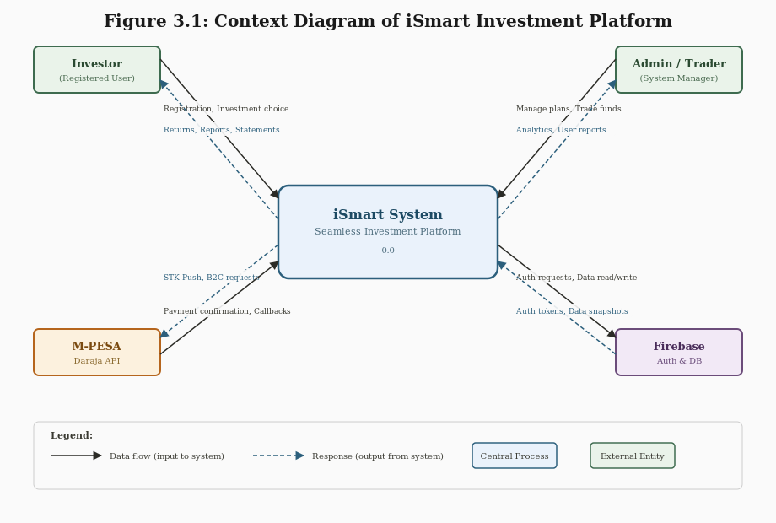
Figure 3.1: Context Diagram of iSmart Investment Platform

3.8.2 Data Flow Diagram Level 1
The Level 1 Data Flow Diagram, shown in Figure 3.2, decomposes the iSmart system into six core processes and three data stores. The processes are: (1) User Authentication and Registration, which handles user onboarding through Firebase; (2) Investment Plan Selection, where users choose from the four tiered plans (Simba, Ndovu, Kifaru, Chui); (3) Payment Processing, which integrates M-PESA Daraja API for STK Push deposits, C2B callbacks, and B2C payouts; (4) Investment Growth and Returns, which manages the weekly return calculations at 35%; (5) Reporting and Analytics, generating investment statements and performance reports; and (6) Pooled Fund Management, where the admin/trader oversees the collective investment pool across forex, stock, and cryptocurrency markets. The three data stores are the Users Database (Firebase), Transactions Database (deposits, withdrawals, returns), and Investment Plans store (plan definitions and subscriptions).
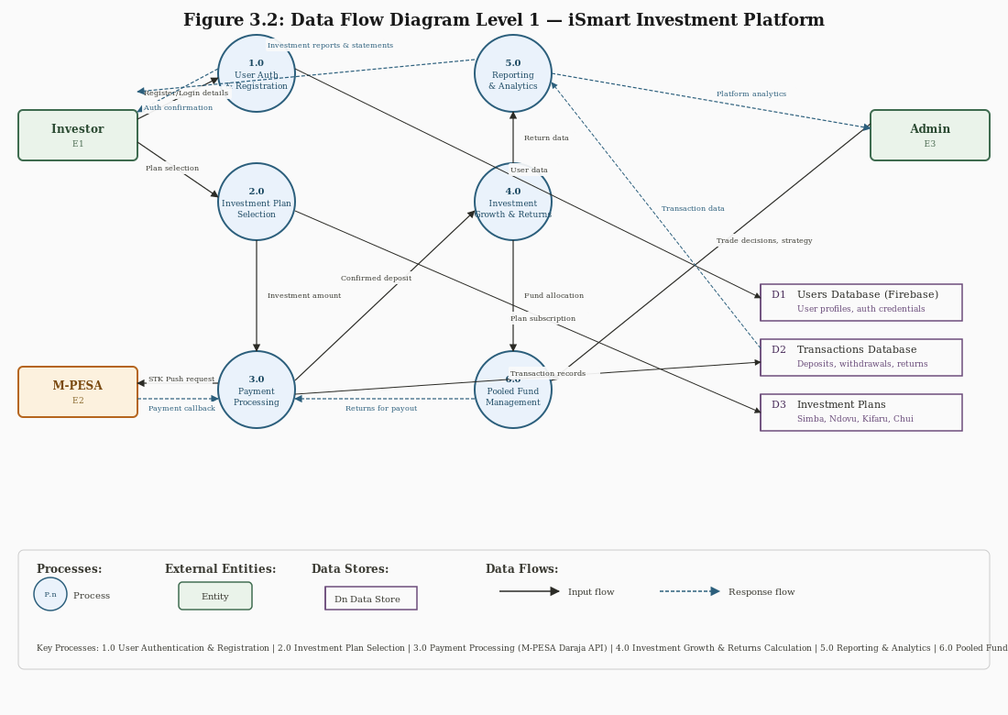
Figure 3.2: Data Flow Diagram Level 1 of iSmart Investment Platform

3.8.3 Development Methodology
The system development methodology for this project will follow the Agile approach, specifically the Scrum framework. This methodology is chosen for its iterative and flexible nature, allowing for incremental development, continuous feedback, and adaptation to changing requirements. The development process will be organized into short, time-boxed iterations called sprints, each lasting two to four weeks, with defined deliverables and review milestones.
The Scrum framework was selected over traditional waterfall methodologies because it accommodates the inherent uncertainty in developing an innovative financial technology product where user requirements may evolve as the platform takes shape. Each sprint will focus on key features and functionalities critical for a successful investment platform, prioritized based on user value and technical dependencies. The team will conduct daily stand-ups, sprint planning sessions, sprint reviews, and retrospectives to ensure continuous improvement and alignment with project objectives.

3.8.3 Technology Stack
The iSmart platform will be developed using a layered architecture that separates the user interface, business logic, and data access layers, facilitating the development of a scalable and flexible system. The technology stack comprises the following components:
• Frontend: HTML5, CSS3, JavaScript (with modern frameworks for responsive design), ensuring a mobile-first, user-friendly interface accessible across devices.
• Backend: PHP with server-side frameworks, leveraging robust libraries to handle complex investment calculations, business rules, and API integration logic.
• Database: Firebase Real-time Database for data integrity, efficient query processing, real-time synchronization, and automated backup capabilities.
• Authentication: Firebase Authentication for secure user management, including email/password authentication, session management, and protection against common security threats.
• Payment Integration: M-PESA Daraja API (version 3.0) for seamless payment processing, supporting STK Push for deposits and C2B/B2C flows for withdrawals and returns distribution.
• Security: SSL/TLS encryption for all data in transit; server-side data encryption; input validation and sanitization; protection against SQL injection and XSS attacks.

3.8.4 System Modules
The iSmart platform will consist of six integrated modules: the User Module (registration, authentication, and profile management); the Payment Integration Module (M-PESA Daraja API integration for deposits and withdrawals); the Investment Growth Module (automated return calculations, profit management and distribution); the Security Module (Firebase Authentication, data encryption, and secure transaction processing); the Investment Plans Module (four tiered plans: Simba at 50,000 KES returning 67,500 KES, Ndovu at 30,000 KES returning 40,500 KES, Kifaru at 10,000 KES returning 13,500 KES, and Chui at 1,000 KES returning 1,350 KES); and the Reporting and Analytics Module (investment reports, transaction histories, and user activity tracking).

3.9 Ethical Considerations
This study will adhere to strict ethical standards in accordance with the research ethics guidelines of Mount Kenya University and the Kenya National Commission for Science, Technology and Innovation (KEMRI/NACOSTI). The following ethical considerations will be observed throughout the research process:
Informed Consent: All participants will be provided with clear and comprehensive information about the study’s purpose, procedures, potential risks, and benefits before providing their consent to participate. Participants will be informed of their right to withdraw from the study at any time without penalty or negative consequences. Consent forms will be administered electronically for online survey participants and in writing for interview participants.
Confidentiality and Data Protection: All participant data will be treated as confidential and stored securely in compliance with the Kenya Data Protection Act 2019. Personal identifiers will be removed from research data, and participants will be assigned anonymous codes to protect their identity. Data will be stored on encrypted servers with access restricted to the research team, and all data will be deleted upon completion of the study or as otherwise required by applicable regulations.
Voluntary Participation: Participation in the study will be entirely voluntary, with no coercion or undue influence applied to potential participants. The study will not collect data from minors (individuals under 18 years of age) without parental or guardian consent. Participants will not be offered financial incentives that could be perceived as coercive, though reasonable compensation for time and travel expenses may be provided for interview participants.
Research Integrity: The study will maintain the highest standards of research integrity, ensuring honest reporting of methods, procedures, and findings. Data will not be fabricated, falsified, or manipulated to support predetermined conclusions. Any conflicts of interest will be disclosed transparently, and the research will be conducted in a manner that respects the dignity and rights of all participants.

3.10 Summary
This chapter has presented a comprehensive description of the research methodology to be employed in the design, development, and evaluation of the iSmart – Seamless Investment Platform. The mixed-method research design, combining descriptive survey research and design science research methodology, provides a robust framework for addressing the study’s objectives from both empirical and practical perspectives. The study area, target population, and sampling procedures have been defined to ensure relevance and feasibility, while the data collection and analysis strategies employ triangulation to enhance the validity and reliability of the findings.
The system design section outlined the Agile Scrum development methodology, the technology stack, and the platform’s modular architecture, providing a clear roadmap for the platform’s implementation. The ethical considerations ensure that the study will be conducted in compliance with institutional and national research ethics standards, protecting the rights and welfare of all participants. Together, these methodological choices ensure that the study is rigorous, systematic, and capable of producing meaningful and actionable insights into the effectiveness of the iSmart platform in enhancing financial inclusion and investment participation in Kenya.

REFERENCES
Braun, V. and Clarke, V. (2006). Using thematic analysis in psychology. Qualitative Research in Psychology, 3(2), pp. 77–101.
Central Bank of Kenya (2024). Kenya National Financial Inclusion Strategy 2025–2028. Nairobi: CBK.
Davis, F.D. (1989). Perceived usefulness, perceived ease of use, and user acceptance of information technology. MIS Quarterly, 13(3), pp. 319–340.
Dewi, R. and Rahadi, R.A. (2015). Capitalizing on Institutional Co-Investment Platforms. Journal of Alternative Investments, 18(2), pp. 45–58.
FinAccess Household Survey (2024). FinAccess 2024 Household Survey Report. Nairobi: KNBS and CBK.
Forslid, R. and Markusen, J.R. (2007). Export-Platform Foreign Direct Investment. Journal of the European Economic Association, 5(4), pp. 776–795.
GeoPoll (2024). Kenya’s Financial Landscape Report. Available at: https://www.geopoll.com/blog/kenyas-financial-landscape-report.
Hevner, A.R., March, S.T., Park, J. and Ram, S. (2004). Design Science in Information Systems Research. MIS Quarterly, 28(1), pp. 75–105.
Kenya National Bureau of Statistics (2024). Economic Survey 2024. Nairobi: KNBS.
Kenya Investment Authority (2024). Investment Opportunities in Kenya: A Comprehensive Guide. Available at: https://kenyainvest.co.ke.
Peffers, K., Tuunanen, T., Rothenberger, M.A. and Chatterjee, S. (2007). A Design Science Research Methodology for Information Systems Research. Journal of Management Information Systems, 24(3), pp. 45–77.
Scholtens, B. and van Wensveen, S. (2003). The Theory of Financial Intermediation: An Essay on What It Does (Not) Explain. SUERF Studies, No. 2003/1.
Safaricom (2024). Daraja Developer Portal: M-PESA API Documentation. Available at: https://developer.safaricom.co.ke.
Capital Markets Authority Kenya (2024). Capital Markets (Licensing) Requirements for Digital Investment Platforms. Nairobi: CMA.

