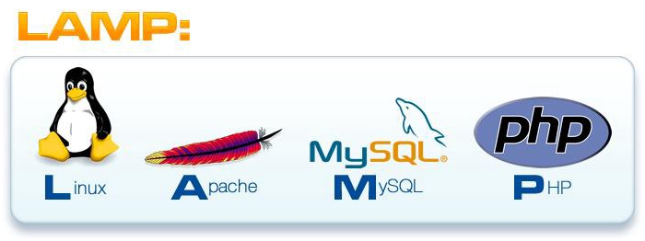

LAMP SETUP:

- Linux : Centos 7.5 (Latest)
- Apache: 2.4 (Latest)
- MySQL : 5.7.22
- PHP: 5.6.36 (latest 7.2)

rsync
Master/Slave

