BDS Backup server in Hydrabad Location

Objective:

Our aim to provide to continue our services without any disturb to all clients.

Main Goals:

1. Web Data Applications
2. Images
3. Database

This thing are keep up to date to backup location is possible to next few minutes to up from backup server to live.

Handle the techniques to All Data to Upto Date:

“Database Replication Techniques”

Replication:

MySQL’s built-in replication is the foundation for building large, high-performance applications on top of MySQL, using the so-called “scale-out” architecture. Replication lets you configure one or more servers as replicas 1 of another server, keeping their data synchronized with the master copy. This is not just useful for high-performance applications—it is also the cornerstone of many strategies for high availability, scala-bility, disaster recovery, backups, analysis, data warehousing, and many other tasks.

How Replication Works:

Before we get into the details of setting up replication, let’s look at how MySQL actually replicates data. At a high level, replication is a simple three-part process:

1. The master records changes to its data in its binary log. (These records are called binary log events.)
2. The replica copies the master’s binary log events to its relay log.
3. The replica replays the events in the relay log, applying the changes to its own data

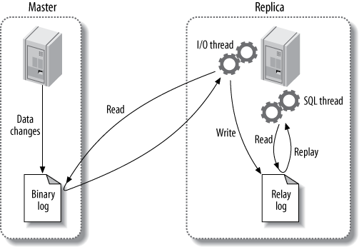

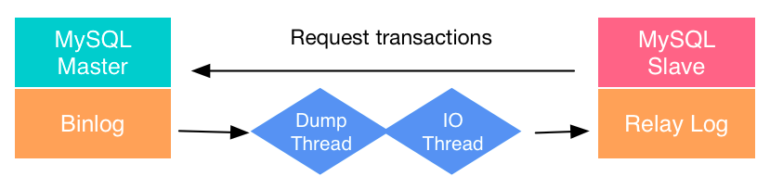

Replication Work Process:

The first part of the process is binary logging on the master (we’ll show you how to set this up a bit later). Just before each transaction that updates data completes on the master, the master records the changes in its binary log. MySQL writes transactions serially in the binary log, even if the statements in the transactions were interleaved during execution. After writing the events to the binary log, the master tells the storage engine(s) to commit the transactions. The next step is for the replica to copy the master’s binary log to its own hard drive, into the so-called relay log. To begin, it starts a worker thread, called the I/O slave
thread. The I/O thread opens an ordinary client connection to the master, then starts a special binlog dump process (there is no corresponding SQL command). The binlog dump process reads events from the master’s binary log. It doesn’t poll for events. If it catches up to the master, it goes to sleep and waits for the master to signal it when there are new events. The I/O thread writes the events to the replica’s relay log.

The SQL slave thread handles the last part of the process. This thread reads and replays events from the relay log, thus updating the replica’s data to match the master’s. As
long as this thread keeps up with the I/O thread, the relay log usually stays in the operating system’s cache, so relay logs have very low overhead.

This replication architecture decouples the processes of fetching and replaying events on the replica, which allows them to be asynchronous. That is, the I/O thread can work independently of the SQL thread. It also places constraints on the replication process, the most important of which is that replication is serialized on the replica. This means updates that might have run in parallel (in different threads) on the master cannot be parallelized on the replica, because they’re executed in a single thread.

Web Data and Image Moving Process:

“Rsync Process”

Rsync is a fast and extraordinarily versatile file copying tool. It can copy locally, to/from another host over any remote shell, or to/from a remote rsync daemon. It offers a large number of options that control every aspect of its behavior and permit very flexible specification of the set of files to be copied. It is famous for its delta-transfer algorithm, which reduces the amount of data sent over the network by sending only the differences between the source files and the existing files in the destination. Rsync is widely used for backups and mirroring and as an improved copy command for everyday use.
Rsync finds files that need to be transferred using a lqquick checkrq algorithm (by default) that looks for files that have changed in size or in last-modified time. Any changes in the other preserved attributes (as requested by options) are made on the destination file directly when the quick check indicates that the file's data does not need to be updated.
sync has got a number of options to control the file synchronisation operation and is a very much flexible command line utility. Rsync finds files that are to be transferred using a quick check algorithm, identifying changed files by their size or their last modified time.
While transferring data over the internet it is recommended that you use rsync over SSH as it allows a secure remote connection.

The most popular rsync command option combinations are
- rsync --delete : delete the files that is not present on the sender's system
- rsync -v : Verbose (which gives detailed information)
- rsync -e : To specify the ssh as remote shell
- rsync -z : compress file data
- rsync -r : recurse into directories
- rsync -a : archive mode

Depends On:

Both techniques depends on our network speed. This techniques LAN over WAN data transfer technique used this criteria.

Secuyrity Aspects:

Our service port to directly communicate to public network. This is not secure. We want to make secure proper firewall rule and it's will be secure.

“To bind Direct WAN Ip Address – Secure Way”

