Vagrant Documentation

Vagrant is a tool in the Ubuntu Linux environment for setting up a complete virtual development environment, also commonly referred to as a VDE. Vagrant dramatically reduces the amount of time that you need to spend rebuilding your operating system and acts as a central configuration hub for your activities, allowing you to easily manage and deploy VDEs using the same basic configuration. It’s important to note that you also have to install VirtualBox at the same time, as its core functionality is built into the main Vagrant product.

Pre Requests:
- sudo apt-get install virtualbox
- sudo apt-get install vagrant

Vagrant Builds:
ruby language

» Linux, VirtualBox, and KVM
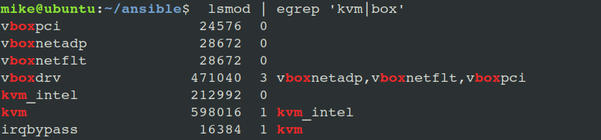
Verify:
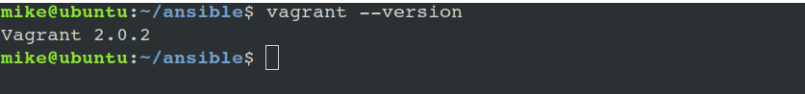
vagrant Commands:
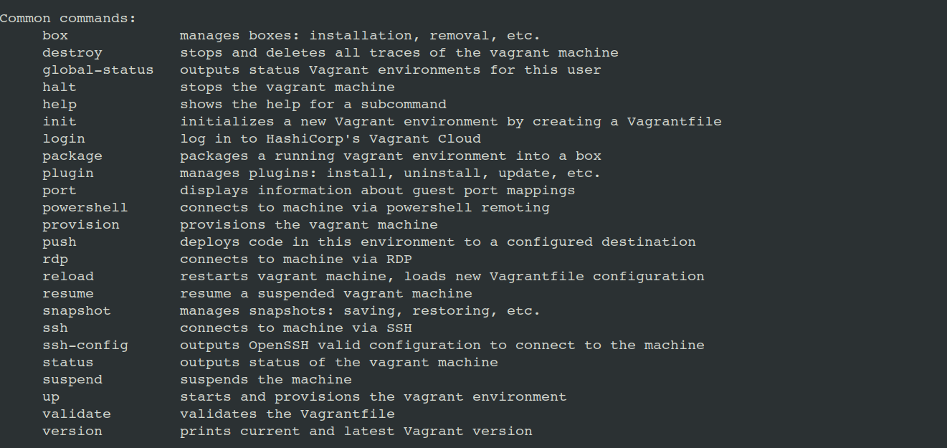
how to use Vagrant command
