**Prometheus** is an open-source systems monitoring and alerting toolkit originally built at SoundCloud.

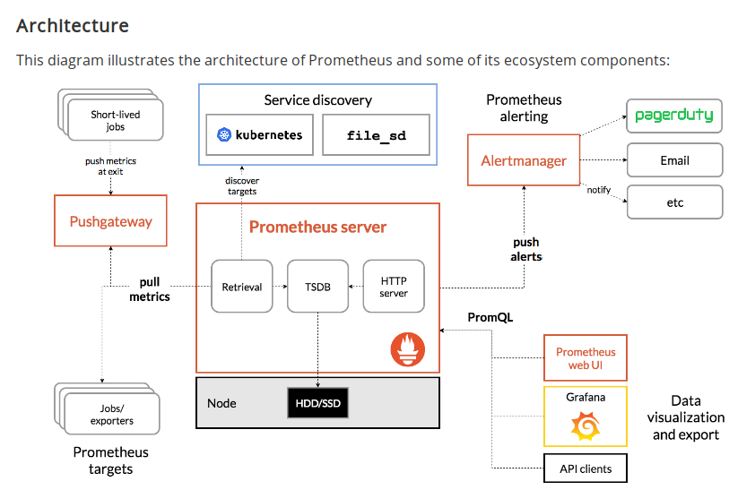

**What is prometheus**

Prometheus is a monitoring platform that collects metrics from monitored targets by scraping metrics HTTP endpoints on these targets.

**Our Lab Environment**

server 1 ----> prometheus server + Alert Manager + Grafana

server 2 ----> Monitering Node1 --> node_exporter

server 3 ----> Monitering Node2 --> node_exporter

**Promotheous Downloading url**

[https://prometheus.io/download/#prometheus](https://prometheus.io/download/" \l "prometheus)

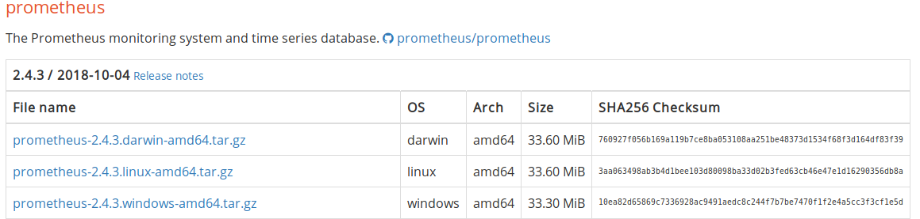

server 1:

Promotheus Server Installation on Server 1

Monitering User Creation:

**server1**# useradd prometheus -s /bin/nologin -c Prometheus Monitoring User

**server1**# wget <https://github.com/prometheus/prometheus/releases/download/v2.4.3/prometheus-2.4.3.linux-amd64.tar.gz>

**server1**# tar -xvzf prometheus-2.4.3.linux-amd64.tar.gz

**server1**# cp -r prometheus-2.4.3.linux-amd64/prometheus /usr/local/bin/

**server1**# cp -r prometheus-2.4.3.linux-amd64/promtool /usr/local/bin/

**server1**# mkdir -p /var/moniter/prometheus/

**server1**# cp -r prometheus-2.4.3.linux-amd64/{console_libraries,consoles,data} /var/moniter/prometheus/

**server1**# chown -R prometheus: prometheus /var/moniter/prometheus/



**server1**# mkdir -p /etc/prometheus/

**server1**# touch prometheus.yml

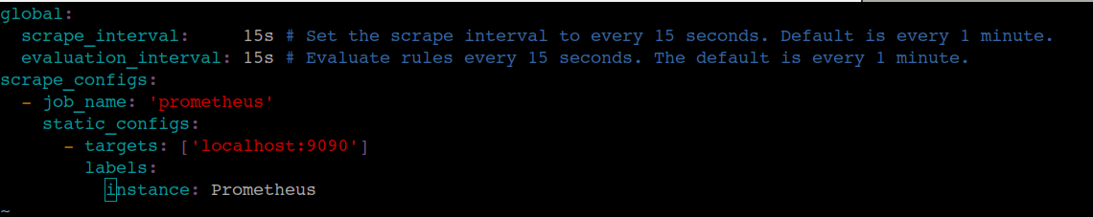

create systemd service

server1# vim /etc/systemd/system/prometheus.service

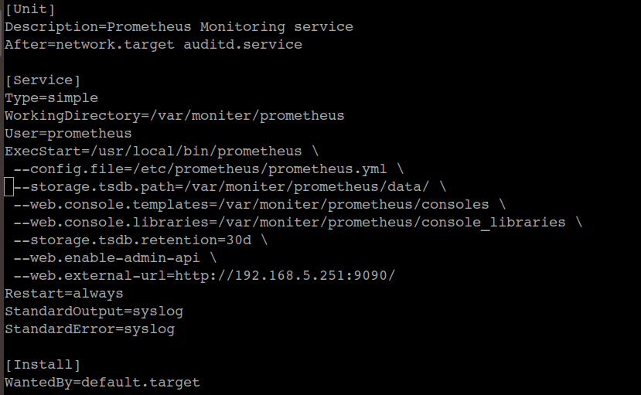

Server1# systemctl daemon-reload

server1# systemctl restart prometheus.service

server1# systemctl enable prometheus.service

check service run or not

server1# netstat -tulpn

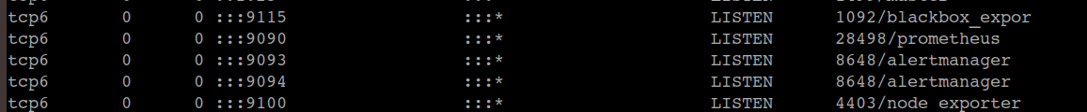

By default Prometheus Server rund 9090 port. If you want change the port number use this option

--web.listen-address="0.0.0.0:9090" .Just add in

(vim /etc/systemd/system/prometheus.service) instead of 9090 to your port.

**Check prometheus**

**server1**# prometheus --version

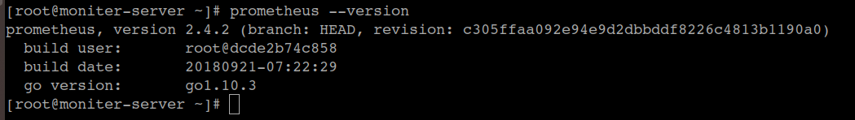

Verify the Browser:

[http://](http://ip/)localhost :9090 or server ip:9090

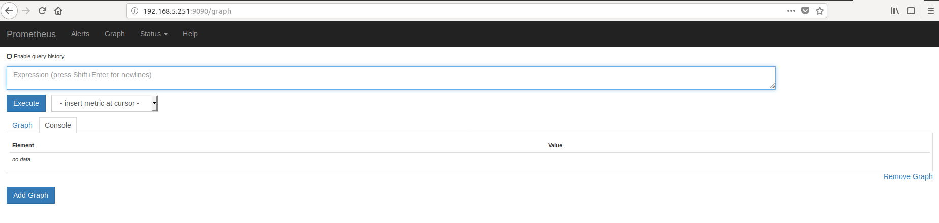

**Server2 & Server3 Node_Exporter Configuration:**

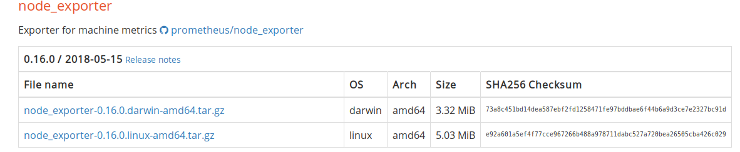

**server2 & server3**# wget <https://github.com/prometheus/node_exporter/releases/download/v0.16.0/node_exporter-0.16.0.linux-amd64.tar.gz>

**server2 & server3**# tar -xvzf node_exporter-0.16.0.linux-amd64.tar.gz

**server2 & server3**# cp -r node_exporter-0.16.0.linux-amd64/node_exporter /usr/local/bin/

**server2 & server3**# node_exporter –version

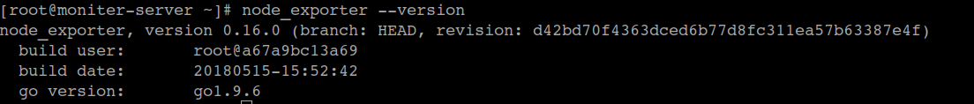

**server2 & server3#** vim /etc/systemd/system/node_exporter.service

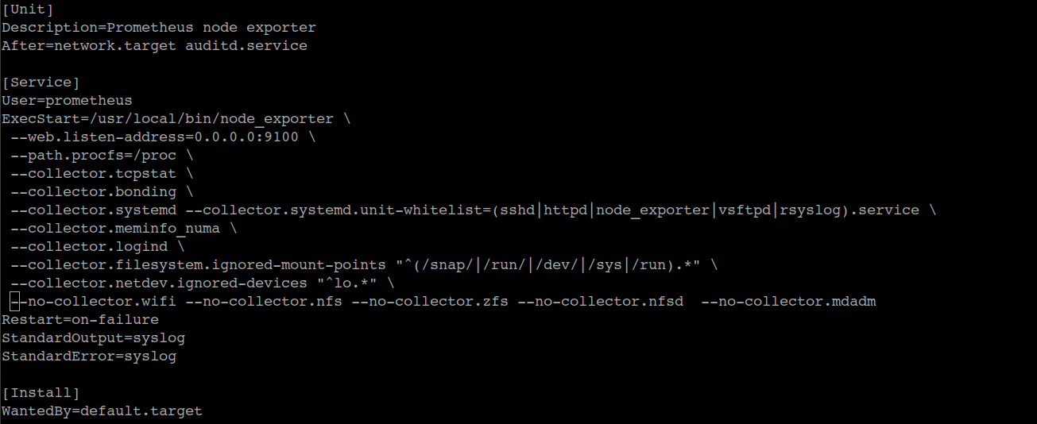

**server2 & server3#** systemctl daemon-reload

**server2 & server3#** systemctl restart node_exporter.service

**server2 & server3#** systemctl enablenode_exporter.service

check service run or not

**server2 & server3#** netstat -tulpn



By default Prometheus Server rund 9100 port. If you want change the port number use this option

--web.listen-address="0.0.0.0:9100" .Just add in

(vim /etc/systemd/system/node_exporter.service) instead of 9100 to your port.

**Verify the Browser:**

**server2 & server3#** [http://](http://ip/)localhost :9100 or server ip:9100

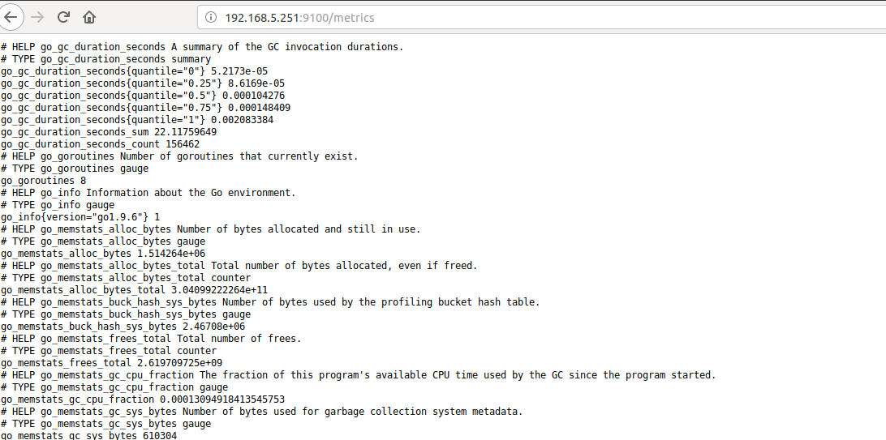

**Node_exporter Connected to Prometheus:**

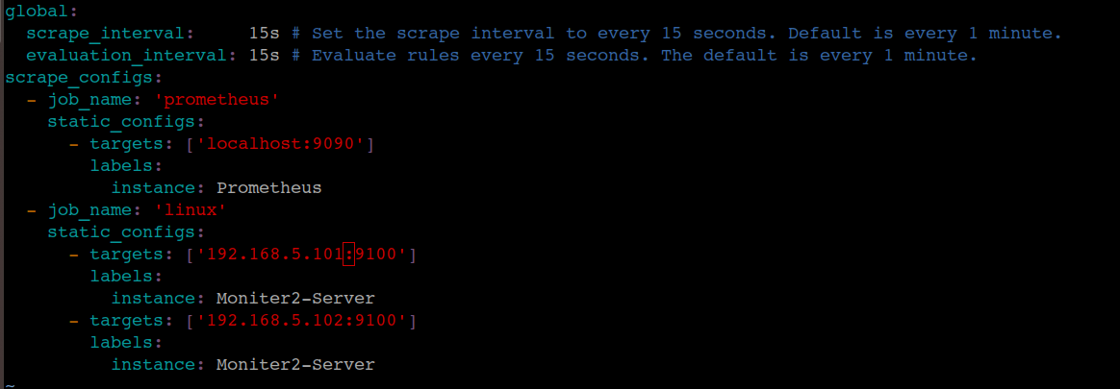

**server1#** systemctl restart prometheus.service

